Your supermarket company is in the process of improving their Docker-based applications. They have built a set of three RESTful data services that communicate with each other as part of a larger infrastructure. You have been given the task of designing a Docker application stack so that these three services can be easily managed and scaled as a unit. A Docker Swarm cluster has already been set up by you to use in previous execises.

Here is some background information on the three services:

1. Fruit Service

a. Provides a list of fruits sold in the company's stores.

b. You can use the Docker image tag linuxacademycontent/fruit-service:1.0.1 to run this service.

c. Listens on port 80.

d. The service should be named fruit inside the stack.

2. Vegetable Service

a. Provides a list of vegetables sold in the company's stores.

b. You can use the Docker image tag linuxacademycontent/vegetable-service:1.0.0 to run this service.

c. Listens on port 80.

d. The service should be named vegetables inside the stack.

3. All Products Service

a. Queries the other two services, combining their data into a single list of all produce.

b. You can use the Docker image tag linuxacademycontent/all-products:1.0.0 to run this service.

c. Listens on port 80.

d. Use the environment variables FRUIT_HOST and FRUIT_PORT to set the host and port which will be used to query the fruit service.

e. Use the environment variables VEGETABLE_HOST and VEGETABLE_PORT to set the host and port which will be used to query the vegetable service.

Step 1

Deploy a Docker application stack that meets the following specifications:

1. The stack is called produce.

2. The stack runs the Fruit, Vegetable, and All Products services.

3. The All Products service is able to query the Fruit and Vegetable services.

4. The All Products service is published on port 8080.

One you have deployed the stack, you can verify whether it is working by querying the All Products service:

curl localhost:8080

If the stack is set up correctly, you should get a combined list of fruits and vegetables.

Step 2

Once you have deployed the stack and verified that it is working, modify the stack by scaling both the Fruit and Vegetable services up to 3 replicas.

Good luck!

version: '3'

services:

fruit:

image: linuxacademycontent/fruit-service:1.0.1

ports:

- "8081:80"

deploy:

replicas: 3

vegetables:

image: linuxacademycontent/vegetable-service:1.0.0

ports:

- "8082:80"

deploy:

replicas: 3

all-products:

image: linuxacademycontent/all-products:1.0.0

environment:

- FRUIT_HOST=fruit

FRUIT_PORT=8081

VEGETABLE_HOST=vegetables

VEGETABLE_PORT=8082

ports:

- "8080:80"

deploy:

replicas: 3

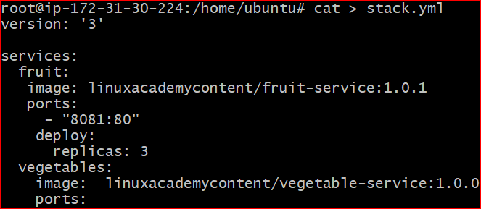

docker stack deploy -c stack.yml products