Reports With Quarto

Testing Stuff

J. W.

2025-03-12

# Report from already generated Image

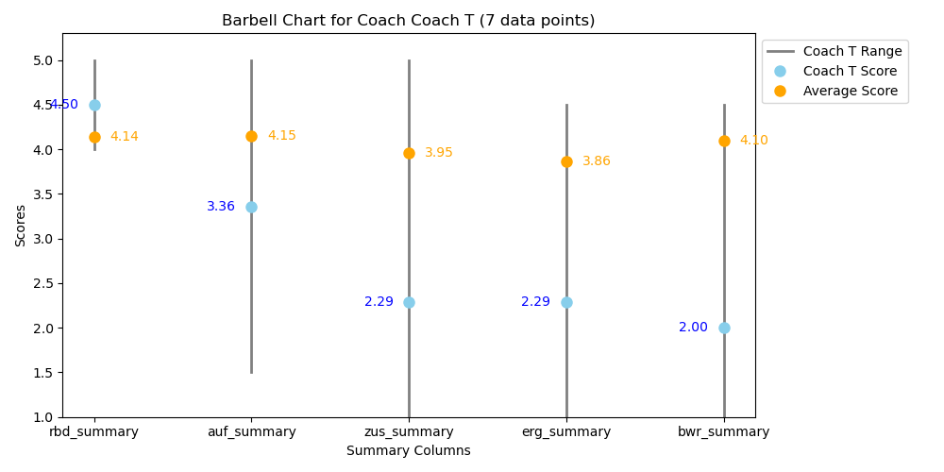

Alt text

# Report from Python Code

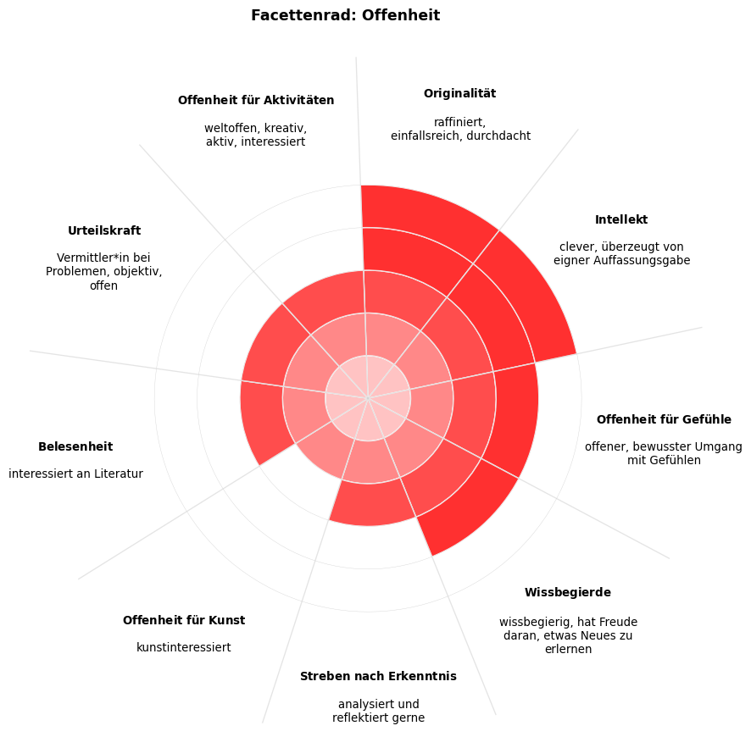

random text here

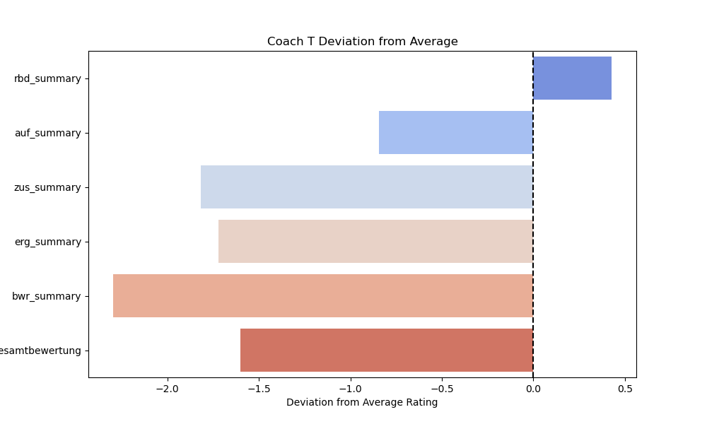

Left aligned Figure

## Another subtitle

Some more random text here

### A third subtitle

|  |  |
| --- | --- |
| This is a test about line up pictures next to text. This is a test about line up pictures next to text. This is a test about line up pictures next to text. | Alt text  Alt text |

### Python Testing

test = 'PYTHON TESTING'  
print(test)

PYTHON TESTING

Python Inline Example

**Title**: Inception

**Description**: A thief who steals corporate secrets through the use of dream-sharing technology is given the inverse task of planting an idea into the mind of a CEO.

## Text in columns

|  |  |
| --- | --- |
| Here is some text in the first column. | Here is some text in the second column. |