OOP Submission Report

Week 11

Shashank K

SE21UCSE198

CSE 3

Concat and substring

Output

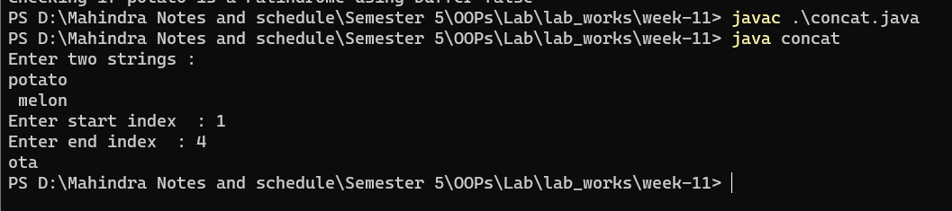

Code

import java.util.**\***;

public class concat{

    public static void main(String[] *args*) {

        System.out.println("Enter two strings : ");

        Scanner scanner = new Scanner(System.in);

        String str1 = scanner.nextLine();

        String str2 = scanner.nextLine();

        String concat_string = str1+str2;

        System.out.print("Enter start index  : ");

        int index1 = scanner.nextInt();

        System.out.print("Enter end index  : ");

        int index2 = scanner.nextInt();

        String sub_string = concat_string.substring(index1,index2);

        System.out.println(sub_string);

        scanner.close();

*// System.out.println(str1+str2);*

*// System.out.println(str2);*

    }

}

Reverse and Replace

Output

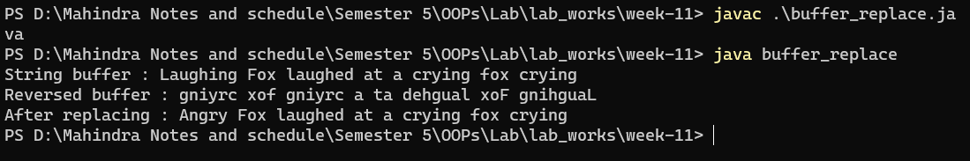

Code

import java.util.**\***;

public class buffer_replace {

    public static void main(String[] *args*) {

        StringBuffer buff = new StringBuffer();

        String str = new String("Laughing Fox laughed at a crying fox crying");

        buff.append(str);

        int index1 = 0,index2 = 8;

        System.out.println("String buffer : " + str);

        buff.reverse();

        System.out.println("Reversed buffer : " + buff);

        buff.reverse();

        buff.replace(index1, index2, "Angry");

        System.out.println("After replacing : " + buff.toString());

    }

}

String Compare

Output

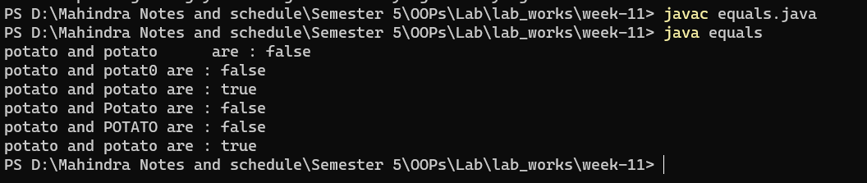

Code

class Compare{

    public boolean compare_str(String *str1*,String *str2*){

        if(*str1* == null || *str2* == null){return false;}

        if(*str1*.length() != *str2*.length()){

            return false;

        }

        for(int i=0; i < *str1*.length() ; i++){

            if  (*str1*.charAt(i) != *str2*.charAt(i)){

                return false;

            }

        }

        return true;

    }

}

public class equals {

    public static void main(String[] *args*) {

        String str = new String("potato");

        String str1 = new String("potato     ");

        String str2 = new String("potat0");

        String str3 = new String("potato");

        String str4 = new String("Potato");

        String str5 = new String("POTATO");

        String str6 = new String("potato");

        Compare comparator = new Compare();

        System.out.println(str + " and "+str1+" are : "+comparator.compare_str(str, str1));

        System.out.println(str + " and "+str2+" are : "+comparator.compare_str(str, str2));

        System.out.println(str + " and "+str3+" are : "+comparator.compare_str(str, str3));

        System.out.println(str + " and "+str4+" are : "+comparator.compare_str(str, str4));

        System.out.println(str + " and "+str5+" are : "+comparator.compare_str(str, str5));

        System.out.println(str + " and "+str6+" are : "+comparator.compare_str(str, str));

    }

}

StringBuffer Append and insert

Output

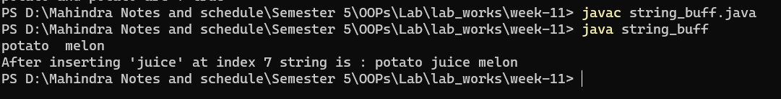

Code

public class string_buff{

    public static void main(String[] *args*) {

        StringBuffer buff1 = new StringBuffer("potato  ");

        StringBuffer buff2 = new StringBuffer("melon");

        buff1.append(buff2);

        int index = 7;

        String temp = "juice";

        System.out.println(buff1);

        System.out.println("After inserting '"+temp+"' at index "+index+" string is : "+buff1.insert(index, temp));

    }

}

Palindrome check

Output

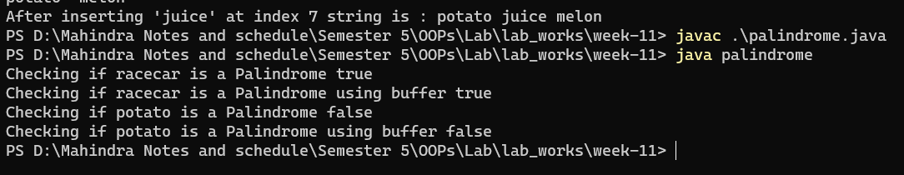

Code

import java.nio.Buffer;

class Checker{

    public boolean palindrome_checker_string(String *str1*){

        if(*str1* == null){return false;}

        int len = *str1*.length();

        for(int i=0; i < len ; i++){

            if  (*str1*.charAt(i) != *str1*.charAt(len-i-1)){

                return false;

            }

        }

        return true;

    }

    public boolean palindrome_checker_buffer(StringBuffer *buff1*){

        if(*buff1* == null){return false;}

        int len = *buff1*.length();

        for(int i=0; i < len ; i++){

            if  (*buff1*.charAt(i) != *buff1*.charAt(len-i-1)){

                return false;

            }

        }

        return true;

    }

}

public class palindrome {

    public static void main(String[] *args*) {

        Checker obj = new Checker();

        String str1 = "racecar";

        StringBuffer buff1 = new StringBuffer(str1);

        String str2 = "potato";

        StringBuffer buff2 = new StringBuffer(str2);

        System.out.println("Checking if "+str1+" is a Palindrome "+obj.palindrome_checker_string(str1));

        System.out.println("Checking if "+str1+" is a Palindrome using buffer "+obj.palindrome_checker_buffer(buff1));

        System.out.println("Checking if "+str2+" is a Palindrome "+obj.palindrome_checker_string(str2));

        System.out.println("Checking if "+str2+" is a Palindrome using buffer "+obj.palindrome_checker_buffer(buff2));

    }

}