|  |
| --- |
| **NAME : Shashank K**  **SECTION : CSE-3**  **ID : SE21UCSE198** |

**Question 1 : Swap two numbers without a temporary variable.**

**File Name : swap_nums.java**

**Output:**



**Question 2: Check even or odd.**

**File Name : even_odd.java**

**Output:**



**Question 3: Leap year checker.**

**File Name : leap_year.java**

**Output:**



**Question 4: Check for Prime number.**

**File Name: prime_num.java**

**Output:**



**Question 5 : bitwise operations**

**File name : bitwise_op.java**

**Output:**



**Question 6: Temperature Converter**

**File Name : temp_conv.java**

**Output:**



**Question 7: Calculate area and perimeter**

**File Name: area_peri.java**

**Output:**

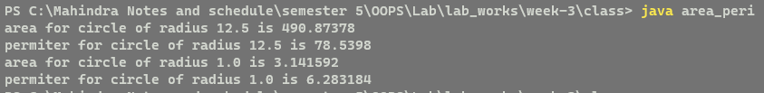

**Question 8 : Calculate Compound interest**

**File Name : compound_interest.java**

**Output:**



**THE END**