|  |
| --- |
| **NAME : Shashank K**  **SECTION : CSE-3**  **ID : SE21UCSE198** |

**Question :**

Write a Java program that calculates the average of a list of numbers. You should create a class called***NumberCalculator***that has the following attributes and methods:

* An instance variable ***numbers***that is an array of integers to store the list of numbers**.**
* A constructor that takes an array of integers as an argument and initializes the***numbers***array**.**
* A method***calculateAverage()***that calculates and returns the average of the numbers in the numbers array.
* In your main program, create an object of th**e *NumberCalculator***class and use it to calculate the average of a list of numbers provided by the user. Use a loop to take the numbers from the array and display the result.

**Output:**

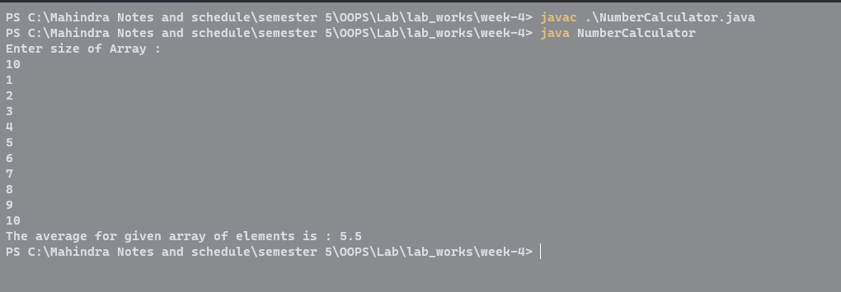

The output for the question is as expected.