**Name : Shashank K**

**ID : SE21UCSE198**

**Lab Submission 5**

**Input :**

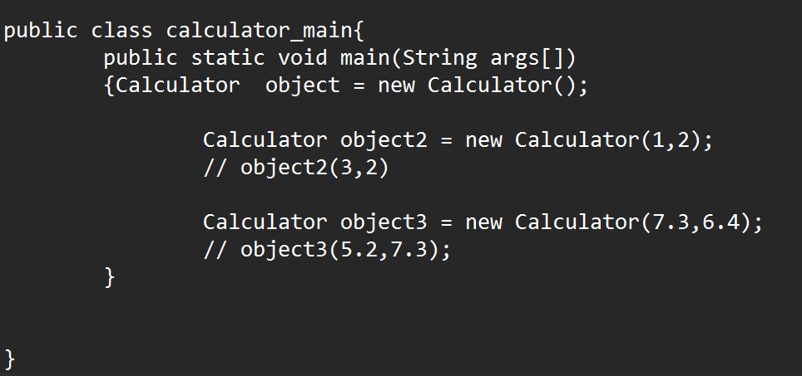

**Output:**

