**OBJECT DETECTION**

**Team Members: -**

* Lakshay Gupta - E23CSEU0383
* Yash Verma - E23CSEU0372
* Anshuman Mathur - E23CSEU0373

Under the guidance of Dr. Yajnaseni Dash

Department Of Computer Science

Bennett University

Greater Noida, Uttar Pradesh, India

**Certificate**

This is to certify that the project report entitled: **“Object Detection”** submitted by **Lakshay Gupta** **(Roll No: E23CSEU0383)** in partial fulfillment of the requirements for the award of the degree of **Bachelor of Technology in Computer Science**, is a record of original work carried out by him under my supervision and guidance.

To the best of my knowledge, this project report has not been submitted earlier, either in part or full, for the award of any degree or diploma in any university or institute.

**Dr. Yajnaseni Dash**Project Guide

Bennet University, Greater Noida April 2025

**Acknowledgement**

We, the project team, would like to express our heartfelt gratitude to our project guide, **Dr. Yajnaseni Dash**, for her invaluable guidance, motivation, and continuous support throughout the course of this project. Her expertise and insightful suggestions played a pivotal role in shaping the direction and outcome of our work.

We are also thankful to one another for the strong sense of teamwork, mutual support, and dedication that each member brought to the project. The spirit of collaboration was crucial in overcoming challenges and ensuring the successful completion of this work.

Our sincere thanks extend to our friends for their encouragement and moral support, and to our families for their patience, understanding, and constant motivation during the entire journey.

This project would not have been possible without the collective efforts and support of all the individuals mentioned above.

**Team Members:**   
Lakshay Gupta (Roll No: E23CSEU0383)   
Yash Verma (Roll No: E23CSEU0372)

Anshuman Mathur (Roll No: E23CSEU0373)

**1. Introduction**

Object detection is a key area in computer vision that involves identifying and locating objects within images or videos. This project focuses on building an object detection system that can accurately detect and classify multiple objects in real time. Using deep learning models such as CNN, SVM and SVM + mobilenet, the system processes visual data to draw bounding boxes around detected objects and label them accordingly. Applications of object detection include autonomous driving, surveillance, medical imaging, and more. This project aims to explore the capabilities of object detection models and demonstrate their effectiveness through a practical implementation.

**2. Objective**

To build a reliable and efficient object detection model using traditional ML techniques, capable of identifying the shown objects. The ultimate goal is to create a robust solution that can be applied to diverse real-world scenarios, such as security surveillance, autonomous vehicles, and inventory management.

**3. Tools & Technologies Used**

* **Programming Language:** Python
* **Libraries & Frameworks:** cv2, scikit-learn, PIL, numpy, flask, tensorflow, os, joblib
* **Machine Learning Models:** CNN, SVM (poly), SVM+Mobilenet

**4. Methodology**

**4.1 Data Collection**

One of the primary challenges was acquiring a sufficient amount of labeled data. The dataset we used is the CIFAR-10 dataset by the university of Toronto. This is divided into 10 distict categories to create a balanced and diverse dataset suitable for image classification.

**4.2 Preprocessing & Feature Extraction**

* In object detection, data preprocessing involves resizing images, normalizing pixel values, and formatting labels for training. Techniques like flipping and rotation are used to improve model robustness. Feature extraction is the process where the model learns important visual patterns (like edges and shapes) to detect and classify objects accurately.

**4.3 Model Development**

* **Convolutional Neural Network (CNN):** Served as a deep learning model that helps computers understand images. It learns to find patterns like edges, shapes, and objects, making it useful for things like recognizing faces or detecting objects.
* **Support Vector Machine (SVM):** Used with polynomial kernel. Classifying non-linearly separable data by mapping input features to a higher-dimensional space.
* **Random Forest:** Provided robustness and was effective in handling noisy and unbalanced features.
* **Mobilenetv2 + SVM (rbf):** This is a hybrid approach where MobileNetV2 extracts deep features from images, and an SVM with RBF kernel classifies them. This combines MobileNetV2’s efficient feature extraction with SVM’s strong classification power, especially for non-linear data. It is effective for lightweight and accurate image classification tasks.

**4.4 Model Deployment**

* We used Flask to build the backend of our web app and load the trained model. It handled user inputs, processed them, and returned predictions. HTML was used to create a simple frontend where users could upload inputs (like images) and view results. This setup allowed us to deploy the model in an interactive, user-friendly way through a web browser

**5. Challenges Faced**

* **Overfitting & Underfitting:** Early versions of models either overfit on training data or underperformed on unseen data. This was seen majorly in SVM(rbf) + mobilenetv2
* Low Accuracy: Got low testing accuracy in the model even after multiple tries, this was seen majorly in SVM(poly) model.

**6. Results & Evaluation**

* **Accuracy:** CNN outperformed others with the most consistent accuracy.
* **Speed:** SVM was relatively faster but less accurate.
* **User Experience:** The deployed flask interface provided an interactive and understandable experience, even for non-technical users.
* **Metrics Used:** Accuracy, Validation Accuracy graph were analyzed for each model.

**7. Learnings**

* In-depth understanding of feature extraction techniques and traditional ML algorithms.
* Hands-on experience with real-world challenges like dataset imbalance.
* Developed problem-solving skills by continuously improving the model based on test results.
* Gained exposure to collaborative coding, project division, and teamwork dynamics.

**8. Accuracy**

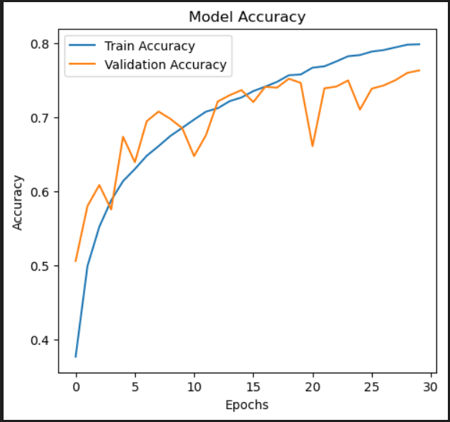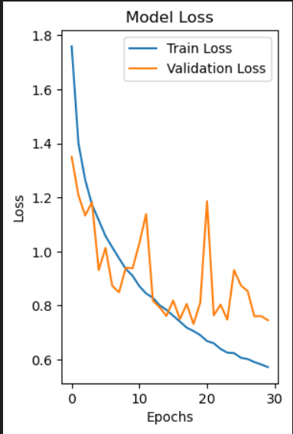

**9. Working**

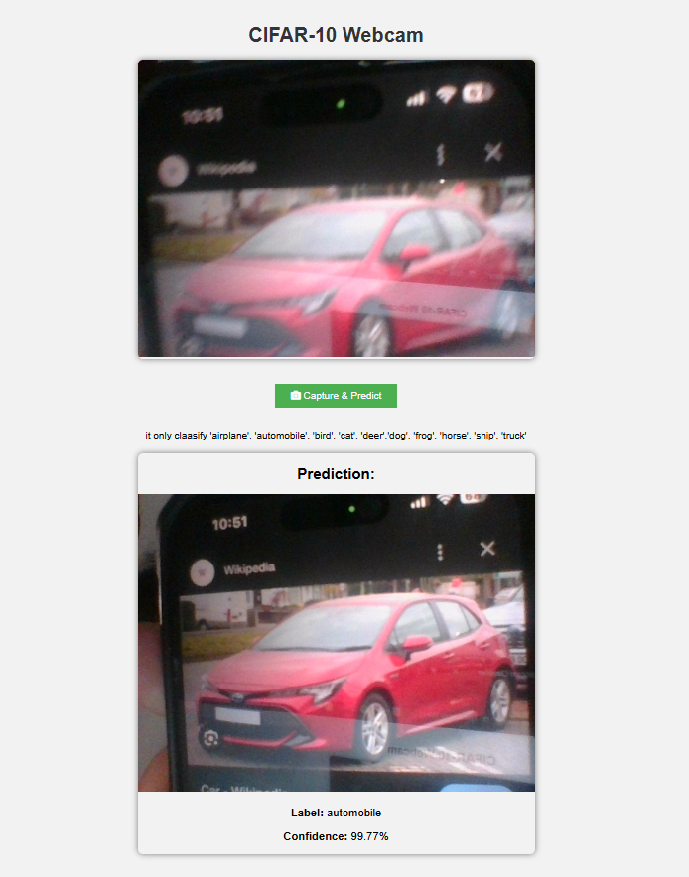

**10. Conclusion**

This project proved to be a dive into the world of object detection using deep learning approaches. We demonstrated that algorithms, when paired with powerful feature extraction techniques, can still deliver reliable results in domains like object classification.

**11. Future Scope**

* Improve speed and use techniques like quantization and pruning to make models faster and lighter.
* Expand the dataset with more real-world objects.
* Extend the project to handle multiple object detection from a complex scene.

**Team Members: Lakshay** Gupta, Yash Verma, Anshuman Mathur

**Subject:** CSET-301  **Semester:** 4th Semester