

**Arab Academy for Science, Technology, and Maritime Transport**

**College of Computing and Information Technology Computer Science & Software Engineering**

B. Sc. Final Year Project

MEDCARE: AI-BASED HEART HEALTH MANAGEMENT APPLICATION

Submitted By:

*Mostafa Sayed 20104999*

Supervised By:

*DR Ahmed said*

**Declaration**

I hereby certify that this material, which I now submit for assessment on the program of study leading to the award of Bachelor of Science in *(insert title of degree for which registered)* is entirely my own work, that I have exercised reasonable care to ensure that the work is original, and does not to the best of my knowledge breach any law of copyright, and has not been taken from the work of others save and to the extent that such work has been cited and acknowledged within the text of my work.

**Student Name: Mostafa Sayed**

**Registration No.:** 20104999

**Signed:** Mostafa Sayed

**Date:** 2/2/2025.

# Abstract

The rapid advancements in artificial intelligence (AI) and mobile technology have opened new possibilities in the field of healthcare. In this project, we propose the development of an AI-based mobile application aimed at early medical diagnoses. The primary goal of this application is to empower users by providing timely and accurate health assessments, ultimately leading to better patient outcomes.

The application will allow users to input their symptoms, which will be analyzed using machine learning algorithms. Based on the symptom patterns, the AI model will predict potential medical conditions. The Users will receive personalized recommendations, such as seeking immediate medical attention or scheduling a doctor’s appointment, Virtual consultations with healthcare professionals will be available, enhancing user engagement and support.

The mobile app will have an intuitive interface, making it accessible to a wide range of users, including those with limited technical expertise. Clear instructions and visual cues will guide users through the symptom input process and other functionalities.

In summary, our AI-based mobile application aims to revolutionize early medical diagnoses by harnessing the power of machine learning and mobile technology. By providing users with actionable insights and promoting proactive healthcare, we believe this project can significantly impact public health.

## Acknowledgements

First, we thank Allah subhanahu wa ta'ala for guiding us through our lives.

We also thank Dr. Ahmed Saeed for helping us throughout the project and his continuous support, which was part of the completion of this project.

We would also like to thank everyone who supported us throughout the past four years, from our family and friends to the academic staff who were an important part of our journey in helping and guiding us to reach this project.

Moreover, we hope that our projects achieve success and pay off our efforts and the efforts of our advisors.

Table of Contents

College of Computing and Information Technology 1

Abstract 2

Acknowledgements 3

Introduction 6

* 1. Purpose: 6
  2. Intended Audience: 7
  3. Intended Use: 7
  4. Scope: 8
     1. The benefits of the system 8
     2. Objectives: 8
     3. Goals: 9
  5. Definition: 9
     1. Features and functionality 9
     2. Challenges: 10
     3. Risks and Preventive Measures 10
  6. Inter-Dependencies: 10

Literature Review 12

* 1. SWOT analysis 12
  2. PESTLE analysis 13
  3. Four P’s of Marketing 15
  4. Market Survey 29
  5. Related Work & Competitors: 16
     1. Literature Review: 16
     2. List of researched Competitors: 19
     3. Common Grounds Functionality between almost all Competitors: 20
     4. Unique Points of each one: 20

Proposed Work 22

* 1. WBS and Gantt Chart 23
     1. Work Break Down Structure: 23
     2. Work Break Down Structure Dictionary 23
     3. Gantt Chart 28
  2. Engineering International Standards 33
  3. System Boundaries 34
  4. System Constraints 35
  5. Intended Technologies 36
  6. Functional Requirements 38
  7. Non-Functional Requirement 39
  8. Use-Case Diagram 42
  9. Detailed Sequence Diagram 43
  10. Class Diagram 45
  11. Context Diagram: 46

3.14 UI/UX prototype: 47

4.1 Implementation 53

4.1.1 Implementation for ARIMA and LLAMA2 model 53

4.1.2 Flutter Development Implementation 56

4.2 Testing 57

4.2.1 Testing The mobile application 57

4.2.2 Testing The Arima and LLAMA2 Models 58

Chapter Five: Conclusion & Future Work 58

5.1 Conclusion 59

5.2 Future Work 59

References 60

Table of Contents

Figure 1 survey's 1st Question 20

Figure 2 survey's 2nd Question20

Figure 3 survey's 3rd Question20

Figure 6 survey's 6th Question21

Figure 9 survey's 9th Question22

Figure 10 WBS32

Figure 11 Gantt chart37

Figure 13 Use case diagram44

Figure 14 Sequence diagram44

Figure 15 class diagram 46

Figure 16 context diagram47

Figure 17 decision tree49

Figure 18 visualizatation50

Figure 19 correlation Heatmap 51

Figure 20 bar plot51

Figure 21 classification Report 52

Figure 22 Classification Report Heatmap 52

Figure 23 Roc Curve 53

Figure 24 Dashboard54

Figure 25 confusion Matrix 57

Figure 26 Actual vs. Predicted 57

*Chapter One**: Introduction*

Cardiovascular diseases remain a leading cause of mortality globally, underscoring the critical need for effective heart health management solutions. This project aims to develop a comprehensive heart health management application designed to empower users in monitoring and improving their cardiovascular health. By integrating advanced functionalities such as user registration and profile management, symptom checking, and medical history tracking, the application offers a holistic approach to heart health. Central to its utility are features like a risk assessment calculator and AI-driven diagnostic algorithms, which provide early and accurate diagnoses of potential heart-related issues. Additionally, the application enriches user engagement through educational resources, reminder notifications for health check-ups and medication schedules. Enhancing user support, virtual consultations with healthcare professionals are made accessible within the app. Ensuring user trust, the application prioritizes security and privacy

### Purpose:

The purpose of the heart health management application is to significantly enhance the management and prevention of cardiovascular diseases (CVDs) by empowering users with advanced tools and resources. The application aims to achieve the following:

1. **Empower Users with Knowledge and Tools**:
   * **Education**: Provide comprehensive educational resources to increase user awareness and understanding of cardiovascular health.
   * **Self-Monitoring**: Enable users to monitor their heart health through symptom logging, medical history tracking, and personalized risk assessments.
2. **Facilitate Early Detection and Intervention**:
   * **AI-Driven Diagnostics**: Leverage AI-driven diagnostic algorithms to identify potential heart-related issues early, facilitating timely medical intervention.
   * **Symptom Checker**: Offer a robust symptom checker that analyzes user-reported symptoms and suggests possible conditions and actions.
3. **Promote Preventive Healthcare**:
   * **Risk Assessment**: Use a risk assessment calculator to help users understand their risk factors for CVDs and take preventive measures.
   * **Reminders**: Provide reminder notifications for regular health check-ups and medication schedules to ensure adherence to preventive care practices.
4. **Improve Access to Healthcare**:
   * **Virtual Consultations**: Enable users to access virtual consultations with healthcare professionals, ensuring convenient and timely medical advice.
   * **Continuity of Care**: Maintain records of consultations and medical history for consistent and informed healthcare.
5. **Ensure User Trust and Security**:
   * **Data Privacy**: Prioritize the security and privacy of user data through robust encryption and compliance with global data protection standards.
   * **User Trust**: Build user trust by ensuring transparency, security, and reliability in handling personal health information.

### Intended Audience:

The heart health management application is designed to cater to a diverse audience with varying levels of interest and involvement in cardiovascular health. The intended audience include

1. **General Users**:
   * Individuals concerned about their heart health or with a family history of cardiovascular diseases.
   * Users looking to monitor their cardiovascular health, track symptoms, and receive personalized recommendations for preventive care.
2. **Patients with Existing Cardiovascular Conditions**:
   * Patients undergoing treatment or managing chronic heart conditions who seek tools to monitor their health and communicate with healthcare providers effectively.

### Intended Use:

The heart health management application is intended to be used as a comprehensive tool for individuals and healthcare professionals to monitor, manage, and improve cardiovascular health. Overall, the heart health management application serves as a user-friendly, accessible platform for individuals to take proactive steps towards better heart health, receive personalized guidance and support, and collaborate effectively with healthcare professionals to achieve their health goals.

### Scope:

The scope of the heart health management application includes developing a comprehensive platform that empowers users to monitor and improve their cardiovascular health. It encompasses features such as user registration, symptom checking, medical history tracking, risk assessment, virtual consultations, educational resources, and reminder notifications. The application aims to leverage advanced technologies like AI-driven diagnostics to provide accurate assessments and early detection of cardiovascular issues while prioritizing user engagement, data security, and privacy. Ultimately, the goal is to promote preventive healthcare, enhance user satisfaction, and improve health outcomes through a user-centric and technologically advanced solution.

#### The benefits of the system:

* + - 1. **Empowering Users**: Enable individuals to take control of their cardiovascular health by providing tools and resources for self-monitoring and preventive care.
      2. **Early Detection**: Facilitate early detection of potential heart-related issues through AI- driven diagnostics and symptom checking, leading to timely medical intervention and improved outcomes.
      3. **Personalized Care**: Offer personalized risk assessments and recommendations based on individual health data, promoting tailored preventive measures and treatment plans.
      4. **Convenience and Accessibility**: Provide convenient access to virtual consultations with healthcare professionals, educational resources, and reminder notifications for health check-ups and medication schedules.
      5. **Enhanced Engagement**: Engage users through interactive educational content, health tracking features, and ongoing communication with healthcare providers, promoting active participation in managing their heart health.
      6. **Privacy and Security**: Prioritize the security and privacy of user data, ensuring trust and confidence in the application's handling of sensitive health information.

#### Objectives:

###### Business Objectives:

-Achieve widespread user adoption by creating a user-friendly interface

-Measure and improve health outcomes among users

-Build a strong brand reputation by delivering high-quality services

-Generate revenue through subscription models, in-app purchases

###### Technical Objectives:

* Design the application to handle a large volume of users and data
* Build an easy-to-use and robust cross-platform mobile application
* Ensure high system reliability and availability through robust infrastructure
* Optimize application performance to provide a seamless user experience, with fast response times

#### Goals:

The goals of the heart health management application are centered around user satisfaction, improved health outcomes, market leadership, revenue growth, brand reputation, and continuous improvement. By prioritizing user feedback and addressing their needs, the application aims to ensure high levels of satisfaction and engagement. Through innovative features and impactful health outcomes, it seeks to establish itself as a leader in the market, attracting new users and generating sustainable revenue growth. By building a strong brand reputation based on trust and reliability, the application aims to enhance its credibility and appeal to a wider audience.

Continuous iteration and improvement are essential to maintain relevance and effectiveness in promoting cardiovascular health management over time.

### Definition:

* + 1. **Features and functionality**
* **User Registration and Profile Management**: Users can securely create accounts and manage personal and medical information
* **Symptom Checking**: Allows users to log and analyze symptoms, providing insights into potential health issues.
* **Medical History Tracking**: Enables users to maintain a comprehensive record of past diagnoses, treatments, surgeries, and medications.
* **Risk Assessment**: Provides personalized risk assessments for cardiovascular diseases based on user-entered health data.
* **Virtual Consultations**: Facilitates convenient access to healthcare professionals through virtual consultations within the app.
* **Educational Resources**: Offers articles, videos, and interactive content to enhance user understanding of heart health.
* **Reminder Notifications**: Sends reminders for health check-ups, screenings, and medication schedules to promote adherence to preventive care.
* **AI-Driven Diagnostics**: Utilizes machine learning algorithms to analyze user data and provide early detection of potential cardiovascular issues.
* **Data Security: Prioritizes the security and privacy of user data through encryption and compliance with data protection standards.**

**1.5.2 Challenges:**

- Data privacy: we have to make sure that the user’s information is safe.

-Ensuring the accuracy and reliability of AI-driven diagnostic algorithms

-Encouraging healthcare professionals to adopt and utilize the application for virtual consultations and collaboration may face resistance due to concerns about workload and liability.

-User adoption: Having users accept a new personal heart app is not that easy.

* + 1. **Risks and Preventive Measures:**
* Data breaches and security attacks: the app contains a lot of sensitive information, thus risks related to the data breaches are very high. The app should use encryption and other security features to protect user data as a means of reducing the risk.
* Inaccurate data: The incidence of false entries increases when there are incorrect data or problems in working algorithms used on the app.
* Low User Adoption: Risk: Lack of user interest or engagement resulting in low

adoption rates and limited impact on health outcomes. Preventive Measures: Conduct market research to understand user needs and preferences. Design user-friendly

interfaces, provide valuable features, and employ effective marketing strategies to promote adoption.

* Healthcare Professional Resistance: Risk: Resistance from healthcare professionals to adopt and utilize the application for virtual consultations and collaboration.

Preventive Measures: Engage healthcare professionals early in the development process to address concerns and gather input. Provide training, support, and incentives to encourage adoption and utilization.

### Inter-Dependencies:

**Assumptions:**

In crafting our heart health management application, we operate under several key assumptions to guide our development and implementation strategies. We assume that our target users have access to compatible devices and reliable internet connectivity, ensuring widespread accessibility. Additionally, we assume that users possess a basic understanding

of cardiovascular health concepts, enabling effective interaction with our application. We further assume that healthcare professionals and institutions are willing to engage with our platform, facilitating collaboration and enhancing the quality of care. From a regulatory standpoint, we assume compliance with healthcare regulations and data protection standards, prioritizing user privacy and security. Furthermore, we assume the accuracy and validity of medical content and algorithms within our application, aiming to provide trustworthy information. Lastly, we assume user motivation to engage with our platform, driving positive health behaviors and outcomes. These assumptions collectively shape our approach to developing a user-centric and impactful heart health management solution.

**Limitations**:

* -Diagnostic Accuracy: While the application utilizes AI-driven diagnostic algorithms, it may not always provide definitive diagnoses or substitute for professional medical advice. Users should consult healthcare professionals for accurate diagnosis and treatment recommendations.
* -Data Privacy Risks: Despite stringent security measures, there is always a risk of data breaches or unauthorized access to user information. Users should be aware of these risks and take precautions when sharing personal health information.
* -User Engagement: While efforts are made to encourage user engagement, there is no guarantee that all users will actively participate in using the application or adhere to preventive care recommendations consistently.
* -Regulatory Constraints: The application's availability and features may be subject to regulatory restrictions or limitations in certain regions, impacting its accessibility and functionality for some users.

**Constraints**:

* Platform availability: Initially we will only have a mobile application, which might be upsetting to people who would a web or desktop version, but we plan on making future versions there as well.
* Data Security: We will definitely be implementing modern and robust security measures to protect the user’s security, however that will definitely add development cost and complexity.

-Technical Limitations: The application's functionality may be constrained by technical limitations such as device compatibility, internet connectivity issues, and processing power constraints on certain devices.

* User Adoption and Engagement: User adoption and engagement may be constrained by factors such as user. awareness, trust, usability, and competition from other health management applications, affecting application's impact and effectiveness

**Dependencies:**

* Reliable backend infrastructure: The app needs to have a secure, reliable and scalable backend infrastructure to store and process user data, A.I. models
* User feedback and data analysis: Constant user feedback and analysis of user data so that we can constantly improve our features and A.I. models so that we can improve the overall user experience.

-Healthcare Partnerships: Collaboration with healthcare institutions, providers, and organizations may be necessary for virtual consultations, data sharing, and referral pathways. Dependencies include partnership agreements, stakeholder engagement, and

interoperability standards.

# *Chapter Two: Literature Review*

### SWOT analysis:

**Strengths:**

1. **Comprehensive Features**: The application offers a wide range of functionalities, including symptom checking, medical history tracking, risk assessment, virtual consultations, and educational resources, providing a holistic approach to heart health management.
2. **AI-Driven Diagnostics**: Utilizes advanced AI algorithms for early detection of cardiovascular issues, enhancing the accuracy and reliability of health assessments.
3. **User Empowerment**: Empowers users to take control of their cardiovascular health through self-monitoring tools and personalized recommendations.
4. **Convenience and Accessibility**: Provides easy access to healthcare professionals through virtual consultations, making healthcare more accessible and convenient.

**Weaknesses:**

1. **Technical Limitations**: Potential technical issues such as device compatibility, internet connectivity, and system performance could affect user experience.
2. **User Adoption**: Achieving high user adoption and consistent engagement may be challenging, especially in competitive markets.
3. **Healthcare Professional Integration**: Resistance from healthcare professionals to adopt the application for virtual consultations and collaboration may limit its effectiveness.

**Opportunities:**

1. **Market Growth**: Growing awareness of cardiovascular health and increasing demand for digital health solutions present significant market opportunities.
2. **Partnerships**: Collaboration with healthcare providers, institutions, and insurance companies can enhance the application's credibility, reach, and functionality
3. **Technological Advancements**: Leveraging emerging technologies such as wearable devices, telemedicine platforms, and advanced AI can further enhance the application's capabilities.
4. **Preventive Healthcare Focus**: Increasing emphasis on preventive healthcare and wellness can drive demand for proactive heart health management tools.

**Threats:**

* 1. **Data Privacy Risks**: Potential data breaches or unauthorized access to sensitive user information could harm the application's reputation and user trust.
  2. **Regulatory Changes**: Evolving healthcare regulations and data protection laws may pose compliance challenges and impact operational flexibility.
  3. **Market Competition**: Intense competition from other digital health platforms and applications could affect market share and user retention.
  4. **Healthcare System Resistance**: Resistance from traditional healthcare systems and professionals to adopt digital health solutions could limit the application's integration and effectiveness.

### PESTLE analysis:

**Political:**

1. **Regulatory Environment**: Healthcare and data protection regulations, such as HIPAA in the US and GDPR in Europe, heavily influence the application's development and operation. Compliance is mandatory and can be complex.
2. **Government Healthcare Initiatives**: Government policies promoting digital health solutions and preventive care can positively impact the application's adoption and integration into healthcare systems.
3. **Political Stability**: Political stability in target markets ensures a conducive environment for business operations and reduces risks associated with regulatory changes.

**Economic:**

1. **Economic Conditions**: Economic stability and growth influence consumer spending on health-related applications. Economic downturns may affect users' willingness to pay for premium features.
2. **Healthcare Spending**: Increased healthcare spending and investment in digital health technologies create opportunities for the application's growth and adoption.
3. **Cost of Development**: Fluctuations in the cost of technology, development resources, and operational expenses impact the financial sustainability of the application.

**Social:**

1. **Health Awareness**: Growing awareness of cardiovascular health and preventive care encourages user adoption and engagement with heart health management applications.
2. **Demographic Trends**: An aging population and increasing prevalence of heart diseases drive demand for effective heart health management solutions.
3. **User Behavior**: Acceptance and usage of digital health applications vary across different age groups, cultures, and regions. Understanding these differences is crucial for targeted marketing and feature development.

**Technological:**

1. **Advancements in AI**: Developments in AI and machine learning enhance the accuracy and reliability of diagnostic algorithms and personalized recommendations.
2. **Mobile and Wearable Technology**: Integration with mobile devices and wearable technology can provide real-time health monitoring and data collection, improving the application's effectiveness.
3. **Cybersecurity**: Continuous advancements in cybersecurity are essential to protect user data and maintain trust in the application.

**Legal:**

1. **Data Protection Laws**: Compliance with data protection laws like GDPR and HIPAA is crucial to avoid legal penalties and ensure user trust.
2. **Medical Device Regulations**: If the application is classified as a medical device, it must comply with relevant regulations, adding complexity to the development and approval process.
3. **Intellectual Property**: Protecting intellectual property rights through patents and trademarks is important to safeguard the application's innovations and competitive advantage.

**Environmental:**

1. **Sustainable Practices**: Incorporating sustainable practices in development and operations can enhance the application's reputation and appeal to environmentally conscious users.
2. **Remote Healthcare**: Reducing the need for physical consultations and travel by promoting remote healthcare solutions can contribute to environmental sustainability efforts.
3. **Energy Consumption**: The application should aim to minimize energy consumption, especially if it relies on data centers and cloud infrastructure, to reduce its environmental footprint.

### Four P’s of Marketing:

* **Product:**

The heart health management application is designed to empower users to monitor and improve their cardiovascular health through comprehensive features. These include symptom checking, medical history tracking, risk assessments, virtual consultations, educational resources, reminder notifications, and AI-driven diagnostics. The product focuses on delivering a user-friendly and secure platform that provides personalized health insights, convenient access to healthcare professionals, and a wealth of information to support preventive care.

* **Price:**
  + **Freemium model:** We are offering most of the basic features for free and premium features like Medical History Tracking and other features for premium users.
  + **Subscription pricing:** Monthly or annual subscriptions for premium users.
* **Place:**
  + **App Stores:** Apple’s App Store, Google’s Play Store and all other available widely known App stores.
  + **Partnerships:** Collaboration with doctors for healthcare can also facilitate integration into patient care programs.
* **Promotion:**
  + **Digital Marketing Strategies**: Employ social media advertising, search engine optimization (SEO), content marketing, and email campaigns to raise awareness and attract users.
  + **Partnerships:** Collaborate with healthcare providers and influencers in the health and wellness sector to enhance credibility and reach.
  + **Educational Initiatives:** Conduct webinars, workshops, and participate in health fairs to further promote the application**.**
  + **User Testimonials and Case Studies:** Highlight these to demonstrate the application’s effectiveness and build trust among potential users.
  + **Incentives:** Offer limited-time promotions and referral programs to incentivize new user sign-ups and engagement.

### Market Survey:

We collected a huge number of data from a questionnaire we made on google forms, as it is viewed as an important research tool for us to gather accurate data from target audience.

In this Survey we were aiming to know how likely people were to adopt a technology like this, whether they needed it or not and what type of features they would like to see in it.

The following charts will show you the answers of some interesting questions we had for the application.

<https://forms.gle/Xg8AGR8scYzZQY7W7>

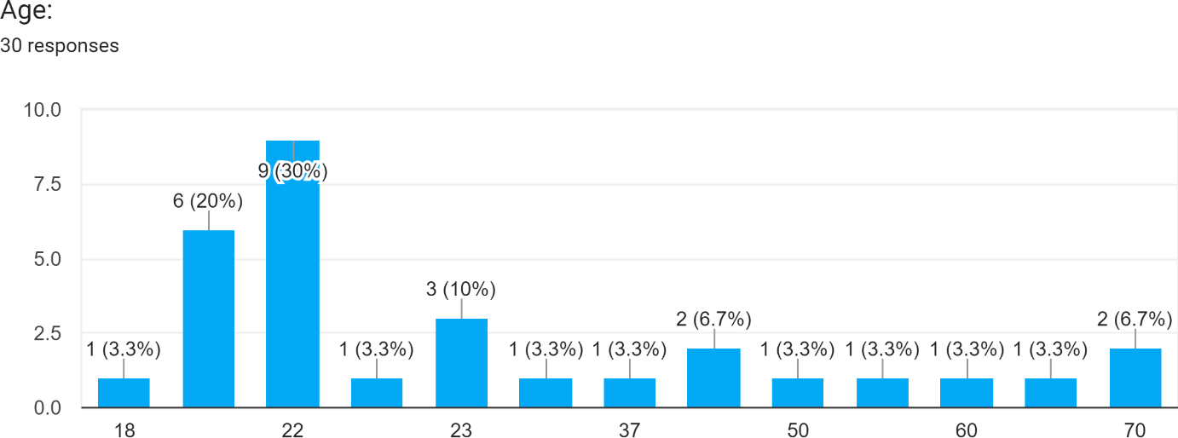

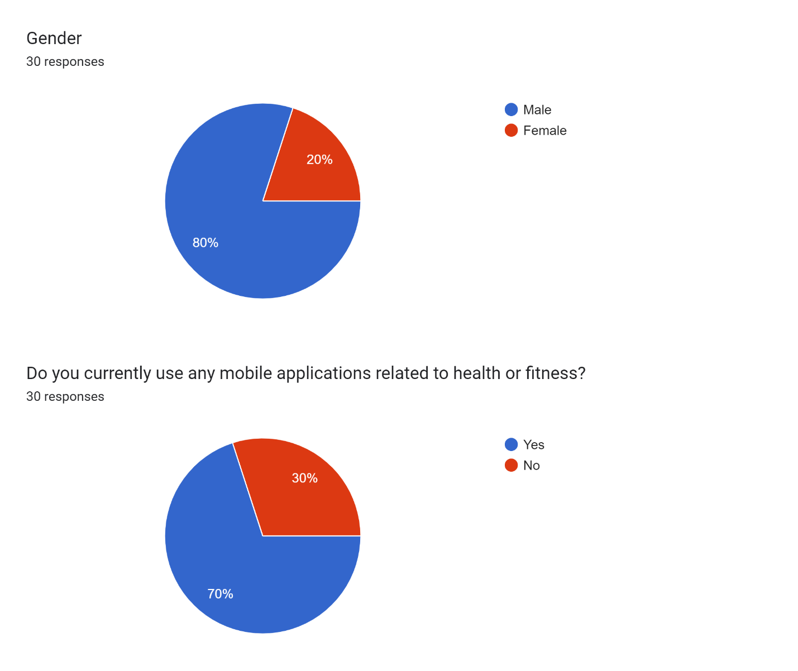Figure 1 survey's 1st Question

Figure 2 survey's 2nd Question

Figure 3 survey's 3rd Question

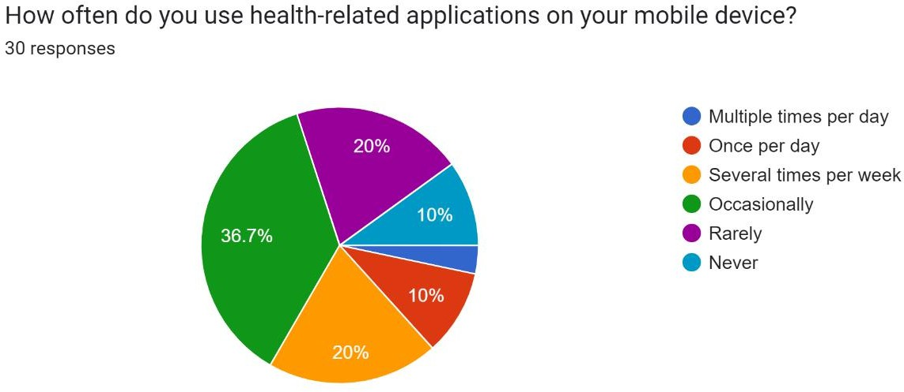

Figure 4- survey's 4th Question

Figure 5-survey’s 5th Question

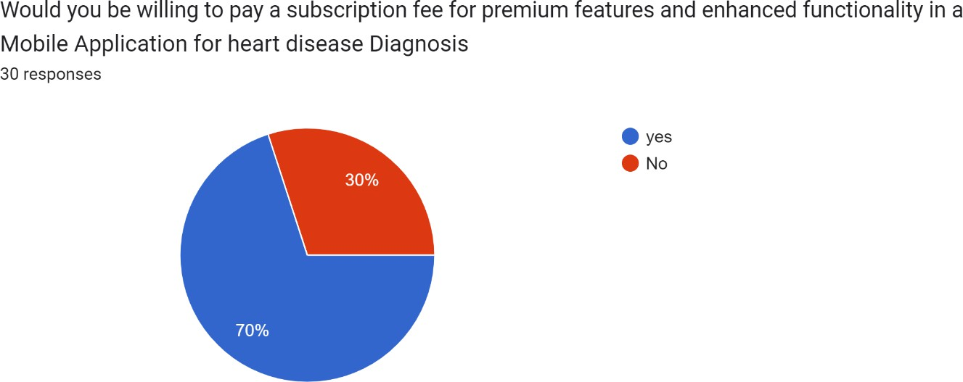

Figure 6 - survey's 6th Question

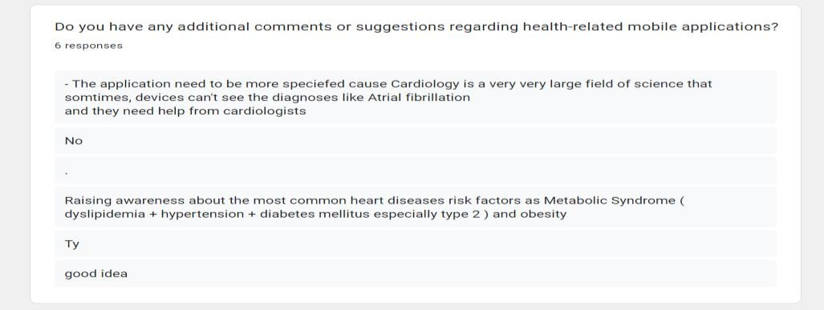Figure 7- survey's 7th Questio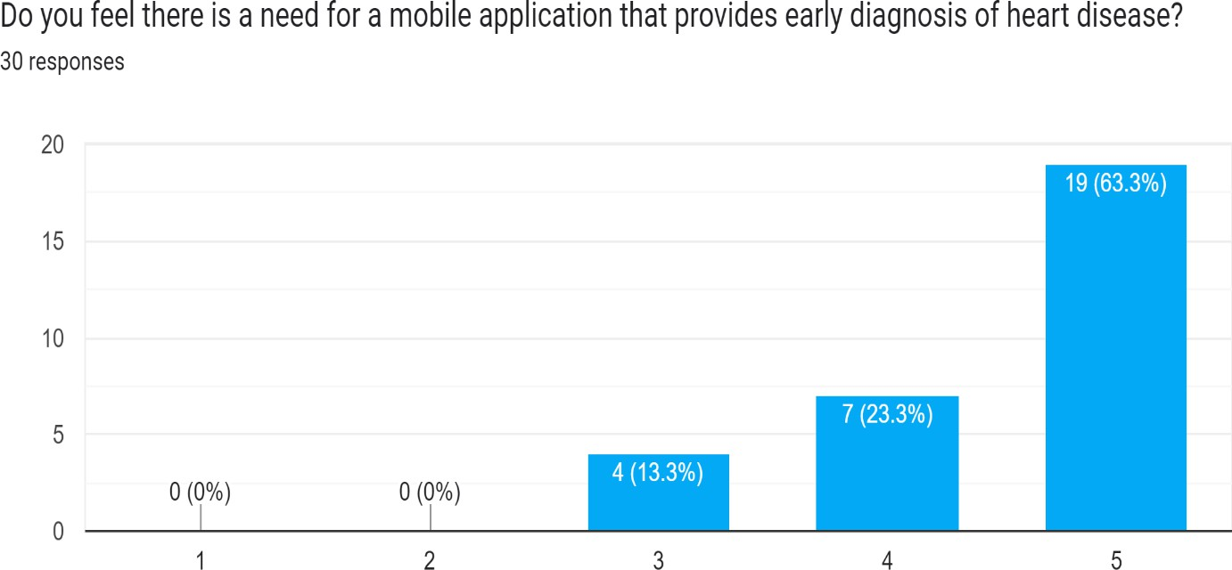

Figure 9 - survey's 9th Question

Figure 8 - survey's 8th Question

### Related Work & Competitors:

#### Literature Review:

**Paper 1: An artificial intelligence model for heart disease detection using machine learning algorithms**

* + - * **Objectives:** The research aims to critically analyze Python's role in heart disease detection, investigate previous activities, apply data interpretation strategies, and assess artifacts with cybersecurity approaches.
      * **Methodology:** Utilizes machine learning algorithms, particularly the random forest algorithm, for heart disease prediction. Data interpretation strategies in Python are applied for health issue detection.
      * **Technique:** Employs Python programming language, machine learning models like Random Forest, K-NN, SVM, and Decision Tree classifiers for detecting heart diseases accurately. Cybersecurity approaches are used to assess artifacts and identify limitations and strengths in the work.

**Paper 2: Machine Learning-Based Predictive Models for Detection of**

**Cardiovascular Diseases**

**Objectives:**

* The study aims to advance healthcare interventions and enhance patient outcomes through precise models.
* Focuses on exploring heart-related conditions to create accurate models for diagnosis and prediction.
* Seeks to provide healthcare professionals with advanced tools for making accurate clinical decisions.

**Methodology:**

* Utilizes machine learning techniques like Logistic Regression, Convolutional Neural Network, SVM, and more.
* Employs exploratory data analysis and data visualization tools for insights into data distributions.
* Follows a research method framework involving data preprocessing, model development, and model evaluation.

**Techniques:**

* Includes Cross-Validation to guard against overfitting and Hyperparameter Tuning for model optimization.
* Utilizes Precision, Recall, F1-Score, and Confusion Matrix for comprehensive model evaluation.
* Adapts supervised and unsupervised learning approaches to train models and explore data patterns.

#### Results on Accuracy Measure:

* **KNN:** Achieved 96.50% accuracy on Dataset 1 and 91.80% on Dataset 2.
* **RF:** Showed 98.60% accuracy on Dataset 1 and 91.09% on Dataset 2.
* **LR:** Attained 95.50% accuracy on Dataset 1 and 88.52% on Dataset 2.
* **GB:** Demonstrated 98.00% accuracy on Dataset 1 and 86.89% on Dataset 2.
* **SVM:** Scored 95.50% accuracy on Dataset 1 and 78.69% on Dataset 2.
* **CNN:** Achieved 97.50% accuracy on Dataset 1 and 86.89% on Dataset 2.
* **XGBoost:** Showed 98.50% accuracy on Dataset 1 and 86.89% on Dataset 2.

**Paper 3: Heart disease prediction using distinct artificial intelligence techniques: performance analysis and comparison**

**Objectives:**

* Validate the methodology externally for forecasting cardiac disease.
* Assess the efficiency of various machine learning techniques.
* Archive only crucial features for predicting heart disease.

**Methodology:**

* Utilize machine learning techniques for heart disease prediction.
* Conduct exploratory data analysis to understand the dataset.
* Compare and evaluate the performance of different AI algorithms.

**Techniques:**

* Logistic regression, Naïve Bayes, K-nearest neighbor (K-NN), SVM, Decision tree, Random forest, MLP.
* Use Correlation-based Feature Subset Selection for feature extraction.
* Employ confusion matrix, precision, recall, F1-score, and ROC-AUC score for performance evaluation.

Results on Accuracy Measure:

* **Logistic Regression:** 
  + Achieved 75% accuracy.
* **Naïve Bayes:** 
  + Attained 70% accuracy.
* **K-Nearest Neighbor (K-NN):** 
  + Demonstrated 85% accuracy.
* **Random Forest:** 
  + Showed the highest accuracy at 90%.

**Paper 4: Prediction of Heart Disease Based on Machine Learning Using Jellyfish Optimization Algorithm**

**Objectives:**

* The main objective is to provide clinicians with a tool for early heart problem diagnosis.
* To compare the performance of different ML models using the Jellyfish algorithm for heart disease prediction.
* To achieve the highest performance ML model for heart disease prediction.

**Methodology:**

* Feature selection from the dataset using the Jellyfish optimization algorithm.
* Training of machine learning algorithms with selected features.
* Testing of machine learning models to evaluate performance.
* Comparison of ML models and visualization of results.

**Technique:**

* The Jellyfish algorithm is used for feature selection in heart disease prediction models.
* Different ML models such as ANN, Decision Tree, AdaBoost, and SVM are compared.
* Performance metrics like Sensitivity, Specificity, Accuracy, and AUC are calculated.
* The SVM-based Jellyfish approach showed the highest accuracy in heart disease prediction.

Results on Accuracy Measure:

* The SVM-based Jellyfish approach achieved the highest accuracy of 98.47%.
* When feature selection was combined with the Jellyfish algorithm, accuracy improved to 98.47%.
* Other ML models like ANN, Decision Tree, and AdaBoost also showed high accuracy ranging from 97.43% to 98.09%.
* The SVM model without feature selection had an accuracy of 98.09%

### List of researched Competitors

* Cardiio
* Cardiogram
* HeartWatch
* Instant Heart Rate
* FibriCheck
* AliveCor

#### Common Grounds Functionality between almost all Competitors:

**Heart Rate Monitoring**: Nearly all competitors offer some form of heart rate monitoring, whether it's through wearable devices, smartphone apps, or other monitoring systems.

Monitoring heart rate provides valuable insights into overall cardiovascular health and can help detect abnormalities.

**Arrhythmia Detection**: Many competitors focus on detecting arrhythmias such as atrial fibrillation (AFib), which are irregular heart rhythms that can indicate underlying heart conditions. This often involves technologies like ECG/EKG monitoring to identify abnormal heart rhythms.

**Data Analysis and Insights**: Competitors typically provide tools for analyzing collected data, such as heart rate trends, activity levels, and sleep patterns. They may offer insights and recommendations based on this data to help users understand their heart health better.

**Mobile Integration**: Most competitors offer mobile applications that allow users to conveniently access and manage their heart health data on smartphones or other mobile devices. These apps often provide real-time monitoring, alerts, and historical data tracking.

**Remote Monitoring and Reporting**: Many competitors offer remote monitoring capabilities, allowing users to share their heart health data with healthcare professionals for remote analysis and consultation. This can facilitate early detection of issues and ongoing management of heart conditions.

* + 1. **Unique Points of each one:**
       - **Cardiio**:
         * Utilizes the smartphone's camera to measure heart rate variability, providing insights into cardiovascular health without the need for additional hardware.
         * Offers personalized heart health assessments and recommendations based on collected data.
         * Focuses on user-friendly design and simplicity for easy adoption by a wide range of users.
       - **Cardiogram**:
         * Provides advanced heart rate monitoring features, including tracking of resting heart rate, heart rate variability, and activity levels.
         * Offers insights into sleep patterns and stress levels, allowing users to understand how these factors affect their heart health.
         * Includes social features that enable users to share their progress and achievements with friends and family for added motivation.
       - **HeartWatch**:
         * Offers detailed heart rate monitoring and analysis features, including customizable heart rate zones and trends over time.
         * Provides comprehensive activity tracking, including steps, distance, and calorie burn, to help users maintain an active lifestyle.
         * Focuses on data visualization and user-friendly interface design for easy interpretation of heart health metrics.
       - **Instant Heart Rate**:
         * Uses the smartphone's camera to measure heart rate accurately and in real-time, providing instant feedback without the need for additional sensors.
         * Offers personalized heart rate zones and tracking features for optimizing exercise intensity and performance.
         * Includes historical data tracking and trends analysis to help users monitor their heart health progress over time.
       - **FibriCheck**:
         * Utilizes the smartphone's camera to detect atrial fibrillation (AFib) by analyzing the user's pulse, providing a convenient and non-invasive screening tool.
         * Offers CE-certified medical-grade technology for reliable AFib detection, suitable for use in clinical settings and by healthcare professionals.
         * Provides immediate feedback and guidance to users based on detected irregularities, empowering them to take proactive steps towards managing their heart health.
       - **AliveCor**:
         * Offers the KardiaMobile device, a portable ECG recorder that pairs with smartphones for convenient heart rhythm monitoring anytime, anywhere.
         * Provides AI-powered analysis for detecting atrial fibrillation (AFib), bradycardia, and tachycardia, enabling early detection of cardiac abnormalities.
         * Integrates with healthcare providers and telemedicine platforms for remote monitoring and consultation, facilitating timely intervention and treatment.

## 

## *Chapter three: Proposed Work*

### Methodology:

To tackle this project, we would need to:

1. Define our target audience and how this would benefit them and understand what exactly they need.
2. Conduct market research and analyze all applications that serve as our competition.
3. Create a wireframe to test the mobile application functionality and UX.
4. Develop an A.I. for Expense analysis using PYTHON
5. Develop a back-end server using php , firebase and MySQL for database
6. Develop a mobile Application for the user using Flutter cross-platform development framework.
7. Test the application using test cases and have people test the features and functionality of the mobile phone.
8. Launch the application on Google’s Play Store and Apple’s App Store.
9. Maintain the app by constantly patching bug fixes and adding new features and functionality.

### WBS and Gantt Chart:

Figure 10 WBS

#### Work Break Down Structure Dictionary:

| 1. Index | Work Block | Time Frame |
| --- | --- | --- |
| 1. | Planning | February 10th to march10th |
| 1.1 | Identifying the Project | February10th to February 20th |
| 1.1.1 | Identifying the Problem Statement | February 10th to February 15th |
| 1.1.2 | Identifying Project Scope(Goals & Objectives) | February 15th to February 20th |
| 1.2 | Defining the project | February 20th to February 30th |
| 1.2.1 | Stating features and functionality | February 20th to February 25th |
| 1.2.2 | Addressing possible challenges | February 25th to February 30th |
| 1.2.3 | Stating possible risks and how to mitigate them | February 20th to February 30th |
| 1.3 | Identifying projection-dependencies | February 30th to March 5th |
| 1.3.1 | Understanding project Assumptions | February 30th to  March 5th |
| 1.3.2 | Stating Project Limitations | February 30th to march 5th |
| 1.3.3 | Listing Project Constraints | February 30th to March 5th |
| 1.4 | Conducting A Literature Review | March 5th to March 10th |
| 2. | Requirement and Specification | March 10th  April15th |
| 2.1 | Conducting a market Analysis | March 10th to March 25nd |
| 2.1.1 | Searching for all Similar Projects and competitors | March **10th to** March **15th** |
| 2.1.2 | Conducting a questionnaire survey | March **15th to** March **25th** |
| 2.1.3 | SWOT analysis | March **15th to** March **25th** |
| 2.1.4 | PESTLE analysis | March **15th to** March **25th** |
| 2.1.5 | The 4 P’s of marketing | March **15th to** March **25th** |
| 2.2 | Methodology | March ***18th to*** March ***30th*** |
| 2.2.1 | Methodology and the correct steps to take | March **18th to** March **20th** |
| 2.2.2 | Research Intended technologies to use | March **18th to** March **30th** |
| 2.2.3 | Engineering International Standards | March **18th to** March **22th** |
| 2.2.4 | System Boundaries | March **22th to** March **26th** |
| 2.2.5 | System Constraints | March **26th to** March **30th** |
| 2.3 | Functional & Non-functional Requirements | March 30th to April 15th |
| 2.3.1 | Functional Requirements | March 30th to April 15th |
| 2.3.2 | Non-Functional Requirements | March 30th to April 15th |
| 3. | System Analysis& Design | April 15th to may10th |
| 3.1 | Design Model | April 15thto April 22th |
| 3.2 | Use-Case | April 15th to April 20th |
| 3.2.1 | General Use-Case | April 15th to April 16th |
| 3.2.2 | Context Diagram | April 16th to April 20th |
| 3.3 | Sequence Diagram | April 15th to may 1st |
| 3.4 | DFD Diagram | April 15th to April 24th |
| 3.5 | UI/UX prototype | April 25th to may 10th |
| 4. | Development | September 1st to December 30th |
| 4.1 | Back-end Development | September 1st to December 25th |
| 4.1.1 | Create MongoDB Database and its documents | September 1st to September 15th |
| 4.1.2 | Write API’s to connect between back-end and database | September 15th to October 1st |
| 4.1.3 | Set-up routing and Data management | October 1st to November 1st |
| 4.1.4 | Write API’s to connect between back-end and mobile application | November 1st to December 1st |
| 4.1.5 | Write API’s to connect between the back-end and the A.I models | December 1st to December 25th |
| 4.2 | Flutter Development | September 1st to December 30th |
| 4.2.1 | Login Page & Register Page | September 1st to September 25th |
| 4.2.2 | Home Page (with notifications section) | September 1st to September 25th |
| 4.2.3 | Doctors page | September 1st to September 25th |
| 4.2.4 | Settings Page | September 26th to October 15th |
| 4.2.5 | Medical heart page | September 26th to October 15th |
| 4.2.6 | Hospitals page | September 26th to October 15th |
| 4.2.7 | Clincs page | October 16th to November 15th |
| 4.2.8 | Subscription page | October 16th to November 15th |
| 4.2.9 | Chat-bot Page | October 16th to November 15th |
| 4.2.10 | Educational Content pages | November 15th to November 1st |
| 4.2.11 | Link between flutter app and back-end | November 15th December 30th |
| 4.3 | A.I Models Development | September 1st to December 30th |
| 4.3.1 | PMDARIMA Model | September 1st to November 1st |
| 4.3.1.1 | Gather correct Data sets | September 1st to September 15 |
| 4.3.1.2 | Code A.I model | September 15th to October 15th |
| 4.3.1.3 | Optimize results | October 15th to November 1st |
| 4.3.2 | Figma Model | November 1st to December 25th |
| 4.3.2.1 | Gather Correct Data sets | November 20th to November 25th |
| 4.3.2.2 | Code A.I model | November 25th to December 10th |
| 4.3.2.3 | Optimize results | December 10th to December 25th |
| 4.3.3 | Link A.I models with back-end server | December 25th to December 30th |
| 5. | Testing | January 1st to February 1st |
| 5.1 | Unit Testing | January 1st to January 10th |
| 5.1.1 | Unit Test Mobile Application | January 1st to January 10th |
| 5.1.2 | Unit Test Back-end and Database | January 1st to January 10th |
| 5.1.3 | Unit Test A.I models | January 1st to January 10th |
| 5.2 | Integration Testing | January 10th to January 20th |
| 5.2.1 | Test Integration between back-end and mobile application | January 10th to January 20th |
| 5.2.2 | Test Integration between back-end and A.I models | January 10th to January 20th |
| 5.2.3 | Test Integration between A.I models and mobile application | January 10th to January 20th |
| 5.3 | System Testing the whole application | January 20th to January 25th |
| 5.4 | Acceptance Testing | January 25th to February 1st |
| 6. | Deployment | February 1st to February 15th |
| 6.1 | Deploy mysql DB to Atlas | February 1st to February 5th |
| 6.2 | Deploy back-end and A.I models to Azure Server | February 5th to February 10th |
| 6.3 | Export Android APK for mobile application | February 10th to February 15th |

#### Gantt Chart:

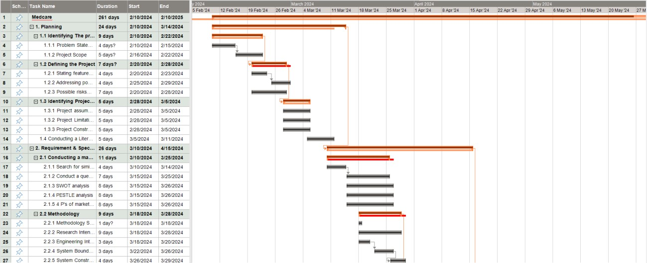

Figure 11 Gantt chart

Figure 12 Gantt chart

* 1. **Engineering International Standards Medical Device Standards**
     + **ISO 13485**: This standard specifies requirements for a quality management system where an organization needs to demonstrate its ability to provide medical devices and related services that consistently meet customer and

regulatory requirements.

* + - * **IEC 62304**: This standard specifies life cycle requirements for the development of medical software and software within medical devices.

**Software Development Standards**

* **ISO/IEC 27001**: This standard provides a framework for managing and protecting sensitive company and customer information.
  + **ISO/IEC 29100**: It provides a privacy framework which establishes guidelines for safeguarding personally identifiable information (PII).
  1. **System Boundaries**
* The User can add/edit/delete information about himself and himself only.
* Developers will maintain and update the system with bug fixes and updates periodically but they will not intervene in any User’s data.
* The App can work either online with full functionality but can also work offline but not with all the functions.
* The data of the User is stored securely in a database and a local copy on his device.
* The system is not expected to interact with other systems in the meantime.

* 1. **System Constraints**

|  |  |
| --- | --- |
| Source | Constraint |
| **Operational** | The data of the users will not be accessible to anyone but them and will not be  tampered with. |
| **Technical** | Technology: the flutter framework for cross-platform mobile development and AI models created with Python trained via data sets, with MySQL DB as the database and php/firebase as the back end.  Platforms: mobile application on both Android and IOS |
| **Personnel** | The software will be maintained by a group of developers for constant bug  fixes and adding new functionality |
| **Economic** | The project is expected to cost around 200.00 EGP + the cost of maintaining  the servers where the data of the users will be stored |
| **Political** | Abiding by the laws of personal data security for each country, and any laws  concerning medical applications |
| **Schedule** | The project is expected to take a year to be made |

* 1. **Intended Technologies**

**Python: 3.11.5**

Generally, Python is a high-level language that commands much readability and usability. It has a lot of features such as OOP, dynamic data types, built-in standard library, cross-platform and also an active community. Python’s features are associated with indentation-based syntax, dynamic memory management service, exception-handling procedures and numerous third-party libraries.

Python is easy to learn and has a great many powerful features that make it suitable for any application whatsoever, mainly in this particular project, we use Python as our AI model because it’s the best language to work with Machine Learning models since it consists of its own unique set of features. It also assists in clean syntax and rapid prototyping which is crucial for efficient Machine Learning models. For ML and data sciences, there are specialized libraries like NumPy – it is efficient for numerical computations in general as well as array operations while pandas help with manipulation of datasets.

Python 3.11.5 is faster than Python 3.10 by 10-60% and handles multiple exceptions more gracefully. It also identifies errors correctly for effective debugging and manages the asynchronous tasks more effectively with task groups in Asuncion.

**Machine Learning**

Basically, machine learning is about teaching a computer to think like a human or sometimes talk like one. Using algorithms, patterns and insights from data are discovered. When training machine learning algorithms, the data sets are made up of numbers, text, images or videos; and the algorithm identifies trends and relationships emerging from analyzed data. This new knowledge is retained in the computer after training as a model so that when given new data, this model can easily predict them.

Machine learning can perform boring tasks or customize experiences, e.g., recommend movies or create individualized news feeds according to users’ needs. In our project, we use the machine

learning model to forecast future spending based on past ones, and that forecast will allow us to determine whether this individual can afford a house or a car

**Flutter**

Flutter is an open-source UI toolkit developed by Google that allows the development of natively compiled mobile, web, and desktop applications using a single codebase. It is set in Dart programming language and offers several predesigned widgets, which help to develop attractive and reacting user interfaces. Flutter’s hot reload feature allows programmers to see the effects of changes to the code in real-time, reducing development cycle time and thus improving

developers’ productivity.

2.5.0 is the latest Flutter version as of September 2021. Some of the improvements and new features in this version were performance improvements, new widgets, improved support for desktop platforms, and updates to the Dart language. Flutter gives developers a more robust and practical framework to develop high-quality applications with every release.

Cross-platform is a crucial feature of Flutter because it helps developers create applications that run on various platforms such as iOS, Android, web, and desktop without requiring multiple codebases for each platform. This significantly reduces development time and work because developers do not have to write code separately for every platform. Another essential feature of Flutter is its performance, as it features a fast rendering engine that supports quick animations and the responsiveness of interfaces. Moreover, Flutter offers a host of customizable pre-built widgets that make the UI consistent and visually lovely on all platforms. Its hot reload ability makes the development process more suitable since iteration and debugging are easy. Flutter is a powerful and efficient cross-platform framework with excellent performance and smooth development infrastructure.

**PHP AND FIREBASE**

PHP, a popular server-side scripting language, is widely used for developing dynamic and interactive web applications. It excels in its simplicity and ease of integration with various databases and technologies, making it a staple in the backend development ecosystem. Firebase, on the other hand, is a comprehensive backend-as-a-service (BaaS) platform provided by Google, designed to streamline the development process by offering a suite of tools and services like real-time databases, authentication, cloud storage, and hosting. When combined, PHP and Firebase can create robust backend solutions; PHP can handle server-side logic and complex computations, while Firebase manages data storage, real-time synchronization, and user authentication seamlessly. This integration leverages the strengths of both technologies, providing a scalable and efficient backend infrastructure that enhances the overall development workflow and user experience.

**MYSQL**

MySQL is a widely-used open-source relational database management system (RDBMS) known for its reliability, performance, and ease of use. Developed initially by MySQL AB and now owned by Oracle Corporation, it has become a fundamental component in the tech stack of many web applications, including those built with PHP. MySQL uses structured query language (SQL) to manage and manipulate databases, allowing for efficient data storage, retrieval, and management. It supports a variety of storage engines, such as InnoDB and MyISAM, which cater to different use cases and performance requirements. MySQL's robust features, such as transaction support, replication, and indexing, enable developers to build scalable and high-performance applications. Its widespread adoption is also attributed to strong community support, comprehensive documentation, and compatibility with numerous operating systems and development environments. Whether for small-scale applications or large-scale enterprise solutions, MySQL remains a go-to choice for developers seeking a reliable and efficient database management system.

* 1. **Functional Requirements:**

**User Registration and Profile Management:**

Users should be able to create accounts and manage their profiles.

Profile management functionalities should include updating personal information and preferences.

**Symptom Checker:**

The application should include a symptom checker feature where users can input their symptoms.

The symptom checker should provide a list of possible conditions based on the entered symptoms.

**Medical History Tracker:**

Users should be able to input and track their medical history, including past diagnoses, medications, surgeries, and family history of heart disease.

**Heart Disease Risk Prediction:**

**AI Model Integration:** Utilize the trained machine learning model to predict users' risk of heart disease based on user’s answer application questions.

**Reminder Notifications**

Provide users with reminders for regular heart rate and ECG monitoring sessions.

**Reporting and Analysis:**

**Health Insights**: Generate personalized reports and insights based on users' heart rate and ECG data, highlighting trends and potential risk factors.

**Historical Analysis**: Allow users to view historical data trends and compare current readings with past records.

### Non-Functional Requirement:

**Performance:**

**Response Time:** The application should respond to user inputs within a reasonable time frame, aiming for fast response times to ensure a smooth user experience.

**Scalability:** The application should be able to handle increased user loads without significant degradation in performance, especially during peak usage periods.

**Resource Efficiency:** Optimize resource usage, including CPU, memory, and network bandwidth, to minimize battery consumption and data usage on users' devices.

**Security:**

**Data Encryption:** Encrypt sensitive user data, such as personal health information and login credentials, both during transmission and storage, using industry- standard encryption algorithms.

**Authentication and Authorization:** Implement robust authentication mechanisms to verify user identities and ensure that only authorized users can access sensitive features and data.

**Data Privacy:** Adhere to data privacy regulations (e.g., GDPR, HIPAA) and implement measures to protect user privacy, including data anonymization, user consent mechanisms, and transparent privacy policies.

**Reliability:**

**Error Logging and Monitoring:** Implement logging and monitoring mechanisms to track errors and system performance metrics, allowing developers to identify and address issues proactively.

**Backup and Recovery:** Implement regular backups of user data and establish procedures for data recovery in case of system failures or data loss incidents.

**Usability:**

**User Interface Design**: Design an intuitive and user-friendly interface, with clear navigation paths, consistent layouts, and minimal cognitive load to facilitate ease of use for users of all skill levels.

**Accessibility:**

Ensure accessibility for users with disabilities, including support for screen readers, keyboard navigation, and alternative input methods.

**Feedback Mechanisms:** Provide feedback to users for their actions, such as confirmation messages for successful operations, error messages for failed actions, and progress indicators for lengthy processes.

**Maintainability:**

Modularity: Design the application with a modular architecture, separating components into reusable modules with well-defined interfaces to facilitate easier maintenance and updates.

**Compatibility:**

Device Compatibility: Ensure compatibility with a wide range of mobile devices, operating systems, and screen sizes, maintaining consistent functionality and user experience across different platforms.

* 1. A diagram of a medicament

     AI-generated content may be incorrect.**Use-Case Diagram:**

Figure 13 use case diagram

* 1. **Detailed Sequence Diagram:**

Figure 13 sequence diagram

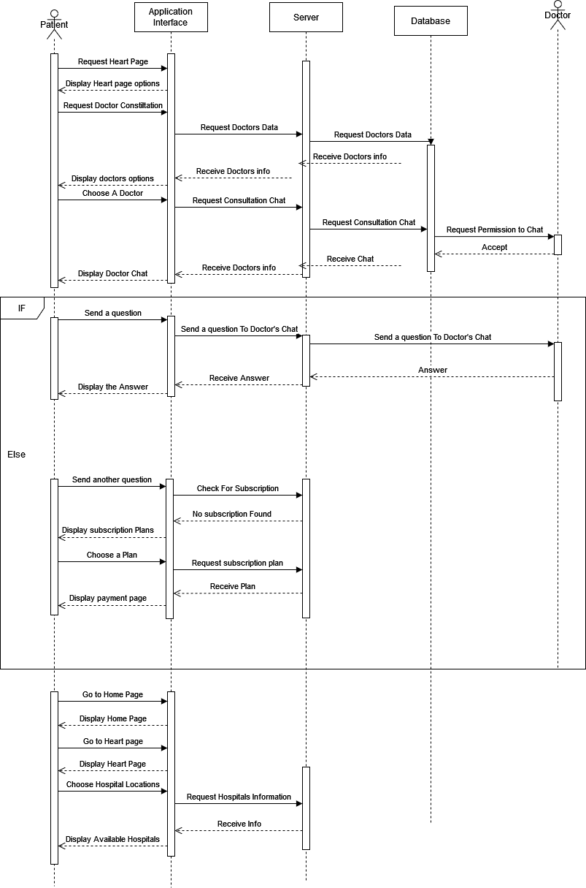

Figure 14 sequence diagram

* 1. **Class Diagram:**

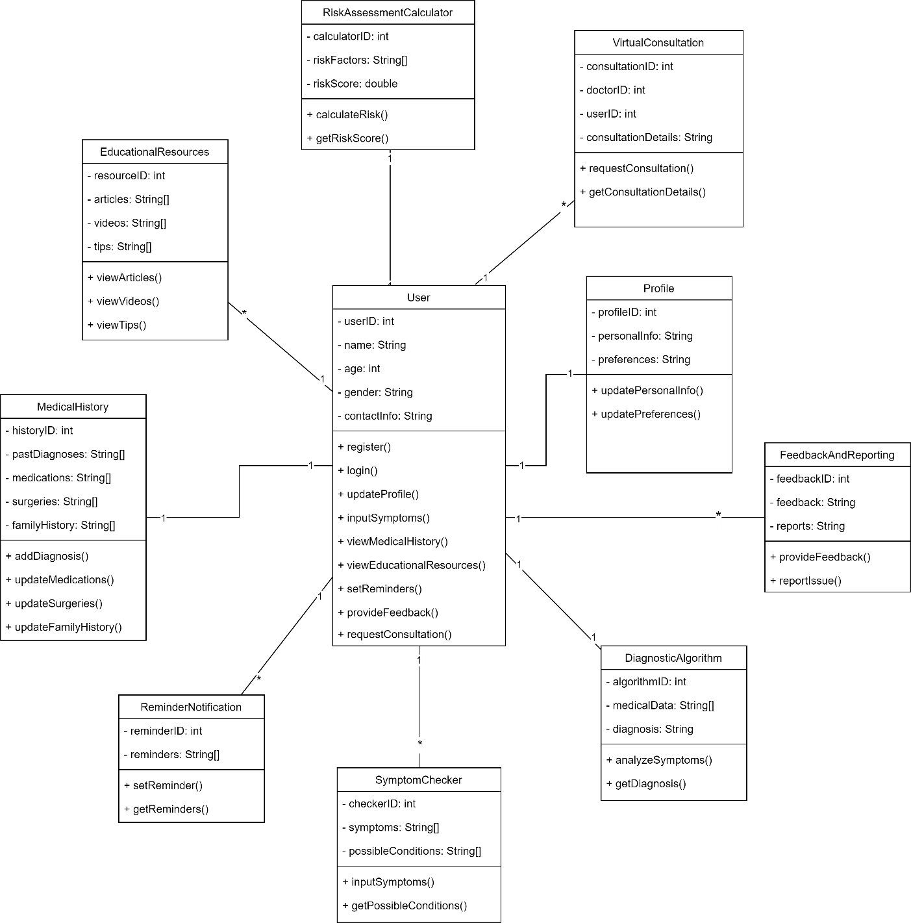

Figure 15 class diagram

**3.14 Context Diagram:**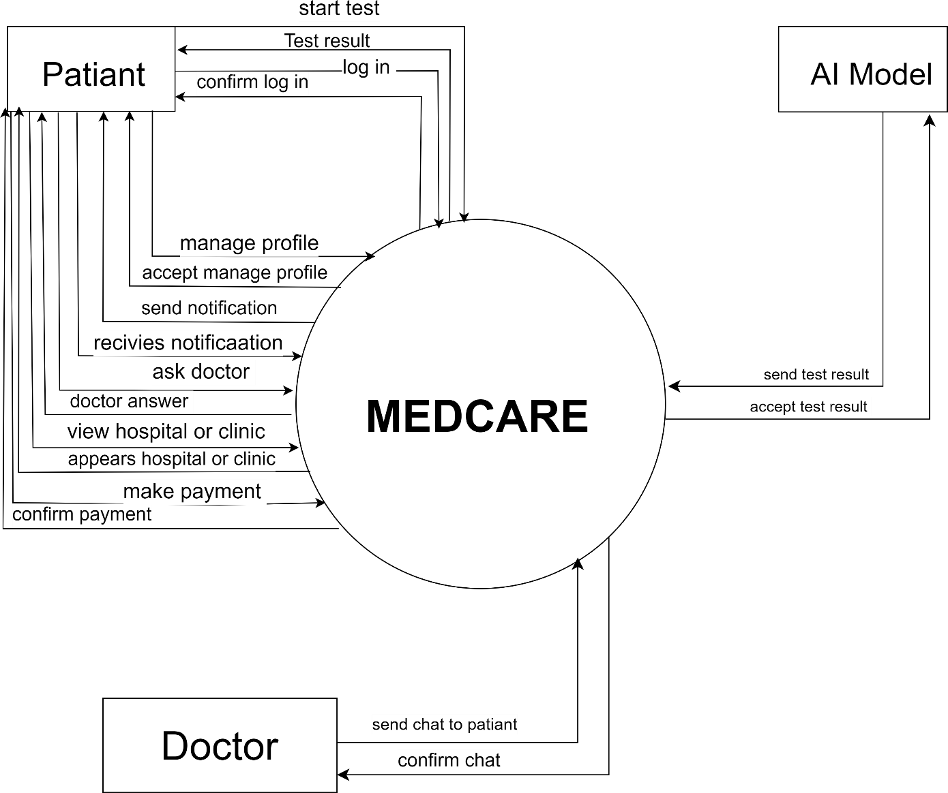

Figure 16 Context diagram

**3.15 UI/UX prototype:**

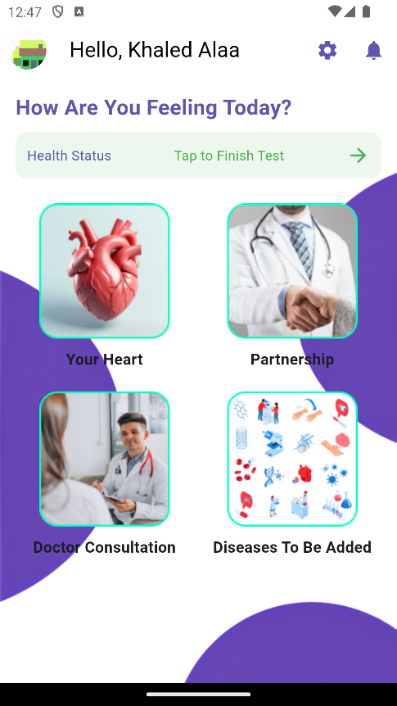 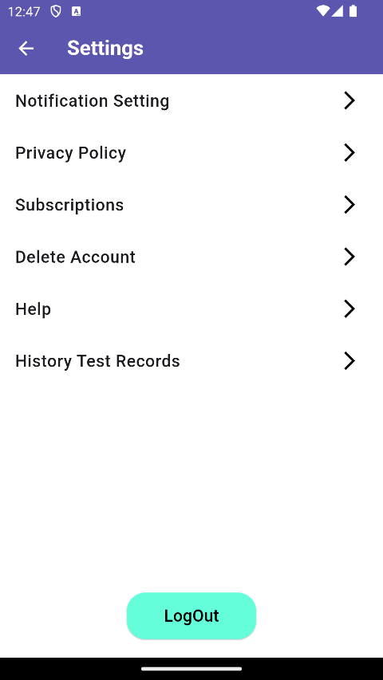

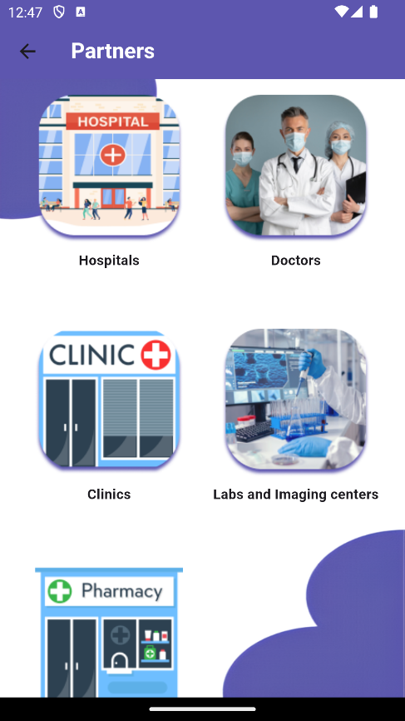 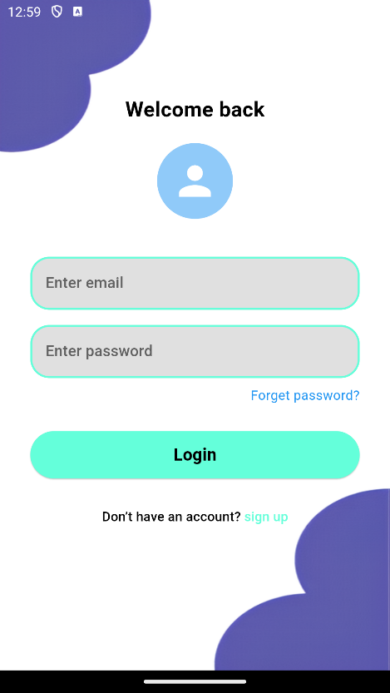

# ***Chapter Four: Implementation and Testing***

## 4.1 Implementation

4.1.1 Machine learning

The decision tree in the Questioning System can be used to classify heart diseases (e.g., Coronary Artery Disease, Heart Arrhythmia, Heart Failure) based on a patient's symptoms (e.g., shortness of breath, chest pain, dizziness). The algorithm starts by selecting the symptom that best separates the data into distinct disease categories and continues to split the data recursively until it reaches a stopping criterion, such as a maximum tree depth or minimum samples per leaf. This makes decision trees intuitive and easy to interpret, as the resulting model can be visualized as a flowchart that maps symptoms to potential diagnoses. By leveraging this approach, the decision tree can assist in identifying the most critical symptoms for diagnosing specific heart conditions, providing a clear and structured method for decision-making in medical scenarios.

Figure 17 - Decision tree

4.1.2 Implementation for Ai model

The implemented AI model is a **k-Nearest Neighbors (k-NN)** classifier, a fundamental machine learning algorithm primarily used for classification tasks. This model is trained on a dataset to identify patterns and predict outcomes based on similarity metrics. The simplicity and interpretability of k-NN make it suitable for applications with relatively small datasets or easily measurable distances between data points.

**4.2 Model Development Workflow**

The following steps outline the implementation process for developing and converting the AI model:

**4.2.1 Dataset Preparation**

* The dataset was split into training and testing sets to evaluate model performance.
* Features were preprocessed to normalize and standardize data, ensuring the k-NN algorithm measures distances accurately.

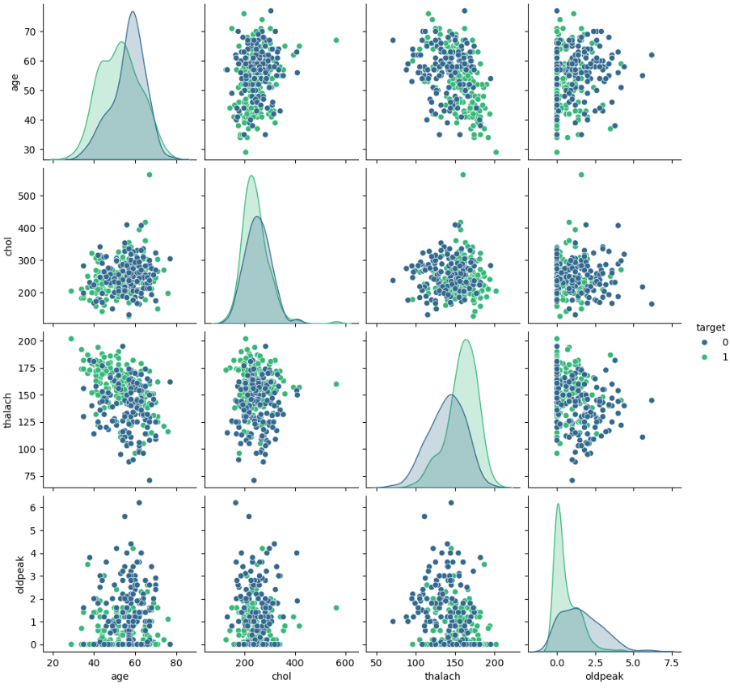

Figure 18 visualizing relationships between different numerical variables

Figure 19 correlation Heatmap

Figure 20 bar plot

**4.2.2 Model Training**

* A k-NN classifier was trained using scikit-learn, a Python library.
* The number of neighbors (k) was carefully selected through hyperparameter tuning to balance bias and variance.
* The trained model was evaluated on the testing set using metrics such as accuracy, precision, and recall.

Figure 21 classification Report

Figure 22 Classification Report Heatmap

Figure 23 Roc Curve

**Challenges and Solutions**

* **Challenge**: Compatibility issues during ONNX to TensorFlow conversion.
  + **Solution**: Verified dependencies and ensured consistent versions for ONNX, TensorFlow, and related libraries.
* **Challenge**: Errors during . tflite conversion due to model constraints.
  + **Solution**: Adjusted TensorFlow Lite conversion options to enable optimizations like quantization.

The implemented workflow successfully trained, evaluated, and converted the k-NN model into a .tflite format suitable for deployment in resource-constrained environments. This process highlights the interoperability of machine learning frameworks and the flexibility of TensorFlow Lite for efficient model deployment.

### 4.1.3 Backend Implementation

Medcare Dashboard:

The Medcare Dashboard is a dynamic web application designed for efficient healthcare data management and real-time monitoring. The dashboard enables administrators to track essential metrics, such as the total number of users, doctors, medical facilities, and reports. Additionally, it offers a clear view of pending and approved users and doctors, allowing the system to manage approval workflows effectively.

The backend of the application is powered by Firebase, utilizing Firestore as the NoSQL database. Firebase’s real-time synchronization ensures that any updates made, such as approving new users or doctors, are instantly reflected on the dashboard, providing real-time insights without page reloads. Firebase also handles user authentication, ensuring secure login and role-based access control, which allows for different levels of data access based on user roles, such as administrator, doctor, and patient.

The dashboard incorporates interactive visualizations using Chart.js, including doughnut and bar charts. These charts present data on various health conditions and track trends over time, such as new cases, hospitalizations, and mortality rates. This allows healthcare administrators to easily analyze and interpret complex data, aiding in decision-making.

For the front-end design, we employed Bootstrap 4 to ensure the dashboard is fully responsive, accessible on devices of all sizes, and user-friendly. The design emphasizes clarity and ease of navigation, making it intuitive for users to interact with the dashboard and view the data they need.

The security of the application is a top priority, with Firebase's built-in security rules ensuring that only authorized personnel have access to sensitive medical data. This ensures compliance with healthcare data protection regulations, such as HIPAA.

In the future, the dashboard is designed to be scalable, allowing for the integration of additional features like patient medical histories, appointment scheduling, and advanced analytics. This ensures the dashboard remains adaptable as the needs of the healthcare organization evolve.

Figure 24 Dashboard

### 4.1.4 Flutter Development Implementation

**1. Asset Acquisition:**

Our first task was to gather all the necessary assets for our application. These consist of a logo, footer icons, images, and other symbols that make up the app's visual identity and user interface.

**2. Development of the Login and Registration Pages:**

We started developing the login and registration pages. The login page will let the users who have accounts log in. The registration page will help new users to register. On both pages, a verification will check that the username and password meet specific rules. For direction, placeholders will be used.

**3. Application Structure:**

The user interface of Medcare consists of a footer with five primary icons and a settings page as follows:

* + **Home Page**:

**Functionality**: Provide quick access to different services and search functionality to find specific services or providers.

* + **Doctor Profile Page**:

**Functionality**: Allow users to view detailed information about the doctor and initiate a chat for consultation.

* + **Pharmacy Page**:

**Functionality**: Enable users to search for pharmacies and view their details.

* + **Clinic Page**:

**Functionality**: Allow users to search for clinics and view detailed information about each clinic.

* + **Results Analysis Page**:

**Functionality**: Display the progress of results analysis and provide an option to continue to the next steps.

## 4.2 Testing

### 4.2.1 Testing The mobile application

Unit Testing:

* We Tested each and every singular component of the application to make sure that its working and behaving as intended.

Integration Testing:

* We then tested the interaction between the different components of the system and how they interact with each other.

System Testing:

* We tested the system as a whole, from both a developer perspective and a customer perspective with how their general User Experience would be like.

Acceptance Testing:

* We Gave out the application to many people within our friends and family to try out the system and give us feedback to better enhance the experience.

### 4.2.2 Testing Ai Model

### Testing an AI model is a critical phase that evaluates its performance and ensures it generalizes well to unseen

### data. Below, we describe the steps taken to test the AI model, from loading the test data to evaluating its

### performance using appropriate metrics.

### Evaluating the Model

### To evaluate the model's performance, appropriate metrics are used based on the task type.

### Classification Metrics:

### Confusion Matrix

### The confusion matrix provides a summary of the performance of the AI model on the test dataset. It is a 2x2 matrix, where:

### True Positives (27): The model correctly classified 27 instances of the positive class.

### True Negatives (29): The model correctly classified 29 instances of the negative class.

### False Positives (2): The model incorrectly classified 2 negative instances as positive.

### False Negatives (3): The model incorrectly classified 3 positive instances as negative.

### This indicates that the model has a high level of accuracy in correctly identifying both classes, with a few misclassifications.

Figure 25 confusion Matrix

### Actual vs. Predicted Scatter Plot

### The scatter plot compares the actual target values with the predicted values. It includes:

### A red dashed line representing the ideal case where the predicted values exactly match the actual values.

### The blue dots represent the actual predictions by the model.

### The alignment of the data points close to the red line shows that the model performs well, with minimal deviation between actual and predicted values.

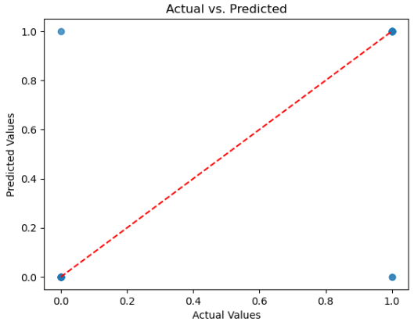

Figure 26 Actual vs. Predicted

***Chapter Five: Conclusion & Future Work***

## 5.1 Conclusion

## The MedCare project represents a transformative step in utilizing artificial intelligence and mobile technology to revolutionize early medical diagnoses, particularly in cardiovascular health. By providing a comprehensive suite of tools, including AI-driven diagnostics, symptom tracking, medical history recording, and virtual consultations, MedCare empowers users to take proactive control of their health. Its user-centric design ensures accessibility for individuals of varying technical expertise, while its commitment to data privacy fosters trust and security among users.

## Through rigorous market research and system design, MedCare addresses critical gaps in healthcare delivery, such as the challenges of early detection, preventive care, and patient engagement. It aligns with international standards , ensuring compliance with global healthcare regulations and bolstering its credibility as a reliable medical application. The implementation of state-of-the-art machine learning models and robust backend technologies enables accurate predictions and seamless user experiences, laying the groundwork for scalable and efficient healthcare solutions.

## Looking ahead, MedCare has the potential to expand its capabilities by integrating wearable technology, enhancing predictive accuracy with real-time data, and fostering partnerships with healthcare institutions for greater reach and impact. By continuously refining its features and leveraging user feedback, MedCare aims to become a pivotal tool in the fight against cardiovascular diseases and a model for future digital health innovations.

## This project not only demonstrates the dedication and expertise of the development team but also paves the way for a healthier, more informed society. Its journey from concept to deployment underscores the immense potential of technology to bridge the gap between healthcare providers and patients, ultimately improving public health outcomes worldwide.

## 5.2 Future Work

As we advance beyond the initial development and deployment phases of the MEDCARE application, several opportunities exist to expand its functionality, enhance user experience, and increase its impact on cardiovascular healthcare. These include:

1. **Integration with Wearable Devices**
   * Incorporate data collection from wearable health trackers such as smartwatches and fitness bands to provide real-time heart rate monitoring, ECG readings, and activity tracking.
   * Enable synchronization with devices from leading brands like Fitbit, Apple, and Samsung for seamless user experiences.
2. **Expanded Medical Scope**

* Broaden the application’s diagnostic capabilities to include other non-cardiovascular health conditions, such as diabetes, respiratory diseases, and general wellness.
* Introduce modules for mental health assessments and stress management.

1. **Call Doctor (Audio and Video) Feature**

* Integrate real-time audio and video call capabilities to connect users with licensed healthcare professionals for consultations directly within the app.
* Implement features such as scheduling virtual appointments, in-app reminders for calls, and a seamless transition between chat, audio, and video communication.
* Include secure encryption for all calls to ensure user data privacy and compliance with medical and telehealth regulations.

## References

Official documentation for Firebase Authentication, Firestore, and Cloud Storage: [Firebase Docs](https://firebase.google.com/docs)

Official documentation for PHP: <https://www.php.net/docs.php>

Access academic papers and research articles related to heart disease detection and healthcare technology: [IEEE Xplore](https://ieeexplore.ieee.org/Xplore/home.jsp)

ISO 13485: [ISO 13485](https://www.iso.org/standard/59752.html)

IEC 62304: [IEC 62304](https://www.iso.org/standard/38421.html)

[Healthcare Analytics | Journal | ScienceDirect.com by Elsevier](https://www.sciencedirect.com/journal/healthcare-analytics) [Diagnostics | An Open Access Journal from MDPI](https://www.mdpi.com/journal/diagnostics)

[Heart disease prediction using distinct artificial intelligence](https://www.ncbi.nlm.nih.gov/pmc/articles/PMC10258084/) [techniques: performance analysis and comparison - PMC (nih.gov)](https://www.ncbi.nlm.nih.gov/pmc/articles/PMC10258084/)

[Diagnostics | Free Full-Text | Prediction of Heart Disease Based on](https://www.mdpi.com/2075-4418/13/14/2392) [Machine Learning Using Jellyfish Optimization Algorithm](https://www.mdpi.com/2075-4418/13/14/2392) [(mdpi.com)](https://www.mdpi.com/2075-4418/13/14/2392)

[An artificial intelligence model for heart disease detection using](https://www.sciencedirect.com/science/article/pii/S2772442522000016?via%3Dihub) [machine learning algorithms - ScienceDirect](https://www.sciencedirect.com/science/article/pii/S2772442522000016?via%3Dihub)