# CERTIFICATE OF EXCELLENCE

The International Laboratory Branch

Division of Global HIV and TB

Centers for Disease Control and Prevention

Awards

**${LABNAME}**

For Outstanding Performance using ${ASSAYNAME} Test

In the **2017 HIV-1 Viral Load Proficiency Testing Program**

|  |  |
| --- | --- |
| **${DATE}**  Date |  |

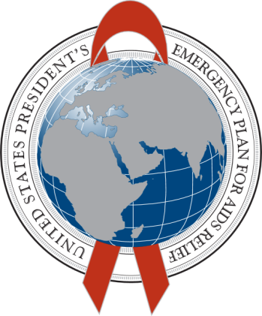

  

________________________ __________________________

Shon Nguyen, BS, MPH Clement Zeh, PhD, MPH

EID & VL PT Manager Team Lead

**Viral Load and Early Infant Diagnosis Team**