Musical Instruments Website Site Plan

Alexis Chater

WDD 130

Overview

Purpose
To educate people on different sounds, cultural backgrounds and purposes of a variety of musical instruments. This is supposed to be an informational site for learning about music and its importance in world history, culture, expression and human development.

Audience
Musicians, historians, curious people. This site is meant for anybody interested in music or human history. It will be informational/educational for people of most ages (toddlers to elderly people).

Branding

Website Logo
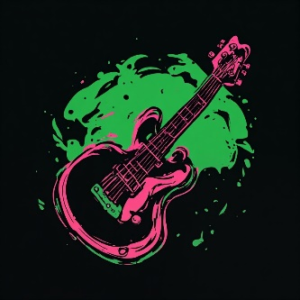

Style Guide

Color Palette
Primary | Secondary | Accent 1 | Accent 2
#386641 | #A7C957 | #F2E8CF | #BC4749

Typography

Heading Font: Notable (regular 400)

Paragraph Font: Merriweather (light 300)

Navigation
Home historical context types of instruments

Content

Musical history:

Woodwinds:

Brass:

Percussion:

String:

Differences in/types of instruments:

Woodwinds:

Brass:

Percussion:

String:

Wireframes

Home
