COMPSYCH
React Native Component Library

17 Components • Version 1.0.0 • May 2026
Built on the ComPsych Four-Tier Token System

Version: 1.0.0

Alert
Inline feedback banner used to communicate status, warnings, errors, or success messages. Supports an optional title, leading icon, action button, and dismiss control.

Import
import { Alert } from '@/components/ds/Alert';
Component File: components/ds/Alert.tsx

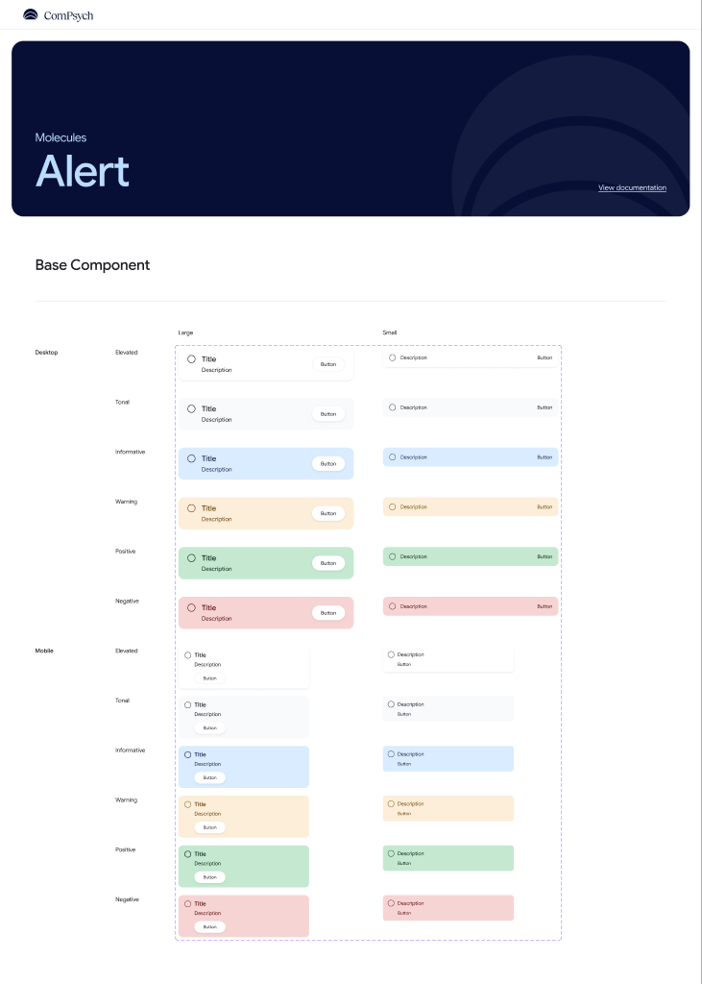

Usage

Variants
There are six alert variants covering the full range of feedback contexts.
<Alert variant="default" description="Neutral information message." />
<Alert variant="informative" description="Tips, help, or guidance." />
<Alert variant="warning" description="Recoverable issue." />
<Alert variant="positive" description="Action completed successfully." />
<Alert variant="danger" description="Error or destructive state." />

With Action
An optional action button prompts the user to take a next step.
<Alert
variant="informative"
title="New feature available"
description="Update the app."
actionLabel="Update now"
onAction={handleUpdate}
/>

Dismissible
Add a dismiss button by setting dismissible to true.
<Alert variant="danger" description="Failed to save." dismissible onDismiss={() => setVisible(false)} />

Props
Name | Type | Default | Description
variant | 'default'|'elevated'|'informative'|'warning'|'positive'|'danger' | 'default' | Controls background color and icon
size | 'sm' | 'lg' | 'lg' | lg shows a bold title; sm is compact
description | string | — | Required. Body text
title | string | — | Bold heading — rendered only when size='lg'
hideIcon | boolean | false | Removes the leading icon entirely
actionLabel | string | — | Label for the optional action button
onAction | () => void | — | Called when the action button is pressed
dismissible | boolean | false | Shows a dismiss button
onDismiss | () => void | — | Called when the dismiss button is pressed

Version: 1.0.0

Avatar
Circular user representation that can display text initials, a photo, or an icon. Supports an optional presence badge and activity ring.

Import
import { Avatar } from '@/components/ds/Avatar';
Component File: components/ds/Avatar.tsx

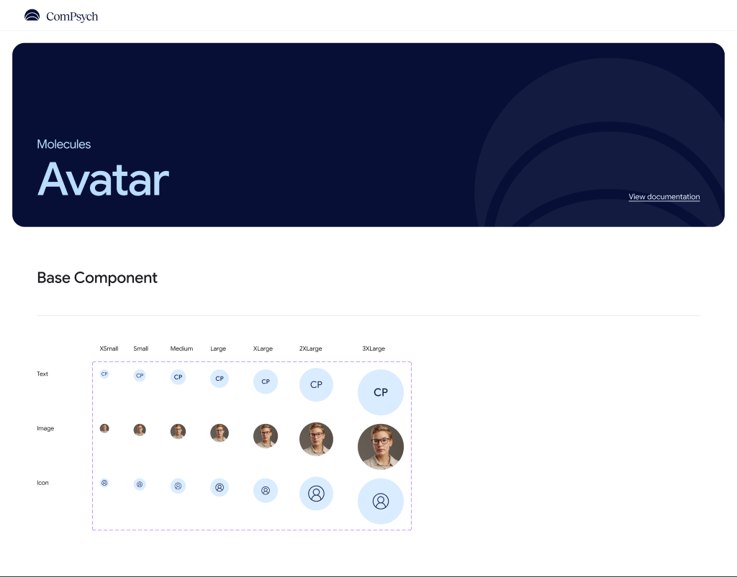

Usage

Sizes
Avatar can be rendered in seven sizes from extra-small to triple-extra-large.
<Avatar variant="text" initials="CP" size="xs" />
<Avatar variant="text" initials="CP" size="sm" />
<Avatar variant="text" initials="CP" size="md" />
<Avatar variant="text" initials="CP" size="lg" />
<Avatar variant="text" initials="CP" size="xl" />

Image Avatar
Display a user's photo by providing an image source.
<Avatar variant="image" source={{ uri: "https://example.com/photo.jpg" }} size="md" />

Letter Avatar
Render up to two initials when no photo is available.
<Avatar variant="text" initials="JD" size="md" />
<Avatar variant="text" initials="AB" size="lg" />

Props
Name | Type | Default | Description
variant | 'text' | 'image' | 'icon' | 'text' | How the avatar content is rendered
size | 'xs'|'sm'|'md'|'lg'|'xl'|'2xl'|'3xl' | 'md' | Circle diameter
initials | string | — | Up to 2 characters (text variant)
source | ImageSourcePropType | — | Image source (image variant)
activityRing | boolean | false | Renders a coloured ring around the circle
presenceBadge | boolean | false | Renders a shield-check badge at bottom-right

Version: 1.0.0

Badge
Small status indicator rendered as a pill, dot, or count. Used to surface counts, status labels, or notification states.

Import
import { Badge } from '@/components/ds/Badge';
Component File: components/ds/Badge.tsx

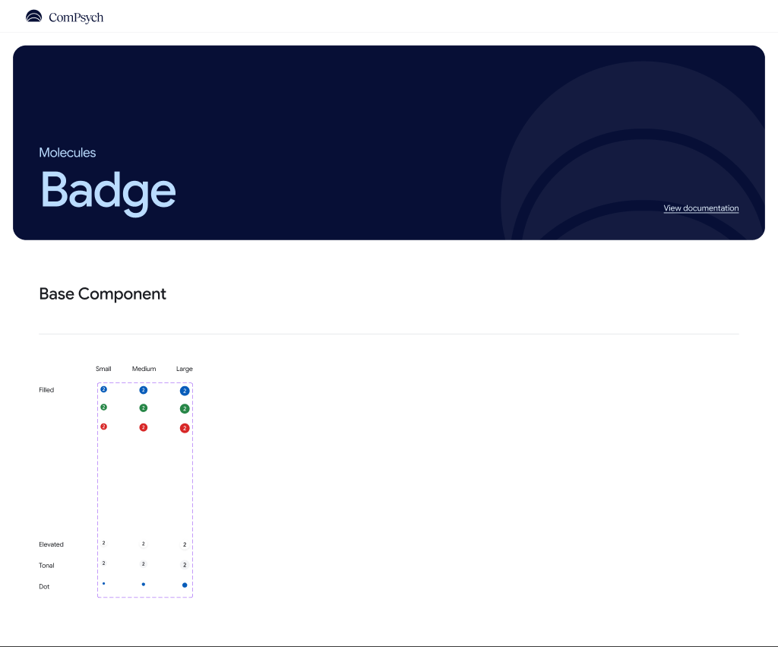

Usage

Styles
Badge supports six visual styles covering neutral, semantic, and dot presentations.
<Badge label={5} badgeStyle="filled" />
<Badge label="New" badgeStyle="positive" />
<Badge label="99+" badgeStyle="danger" />
<Badge label={3} badgeStyle="tonal" />
<Badge badgeStyle="dot" />

Sizes
Badge can be rendered in three sizes.
<Badge label={5} size="sm" />
<Badge label={5} size="md" />
<Badge label={5} size="lg" />

Props
Name | Type | Default | Description
label | number | string | — | Text or count displayed inside the badge
size | 'sm' | 'md' | 'lg' | 'md' | Controls diameter and font size
badgeStyle | 'filled'|'positive'|'danger'|'elevated'|'tonal'|'dot' | 'filled' | Color scheme and shape variant

Version: 1.0.0

Breadcrumb
Horizontal scrollable navigation trail showing the user's location in the app hierarchy. Supports a home icon and overflow truncation.

Import
import { Breadcrumb } from '@/components/ds/Breadcrumb';
Component File: components/ds/Breadcrumb.tsx

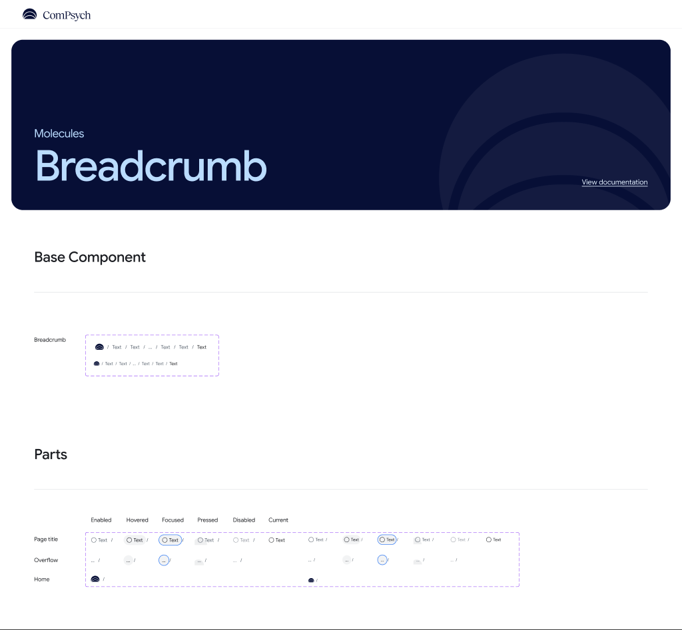

Usage

Basic
Provide an ordered array of items. The last item is always the current page.
<Breadcrumb
items={[
{ label: "Home", onPress: () => navigate("/") },
{ label: "Settings", onPress: () => navigate("/settings") },
{ label: "Profile" },
]}
/>

With Home Icon
Use isHome: true on the first item to render a home icon.
<Breadcrumb items={[{ isHome: true, onPress: goHome }, { label: "Page" }]} />

Props
Name | Type | Default | Description
items | BreadcrumbItem[] | — | Required. Ordered list of crumb items
size | 'sm' | 'lg' | 'lg' | Controls font size and vertical padding

Version: 1.0.0

Button
Buttons are touchable elements used to trigger actions. They support seven visual variants, four sizes, leading and trailing icons, a loading state, and full-width layout.

Import
import { Button } from '@/components/ds/Button';
Component File: components/ds/Button.tsx

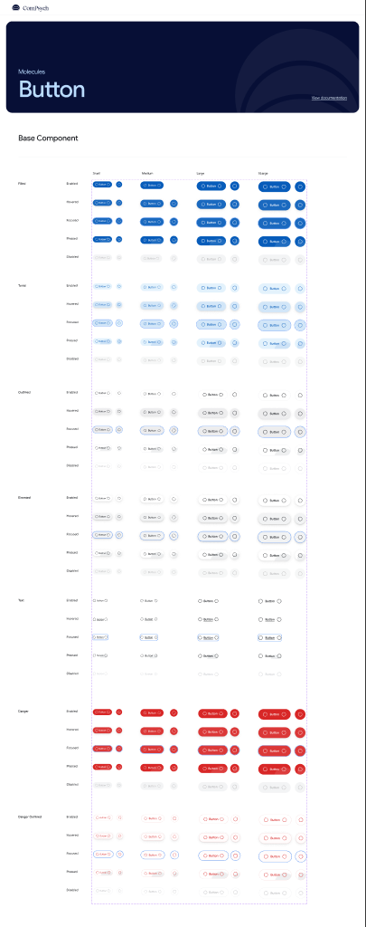

Usage

Variants
There are filled, tonal, outlined, elevated, text, danger, and danger-outlined button types.
<Button label="Filled" variant="filled" onPress={handlePress} />
<Button label="Tonal" variant="tonal" onPress={handlePress} />
<Button label="Outlined" variant="outlined" onPress={handlePress} />
<Button label="Text" variant="text" onPress={handlePress} />
<Button label="Danger" variant="danger" onPress={handlePress} />

Sizes
Button can be small, medium, large, or extra-large.
<Button label="Small" size="sm" onPress={handlePress} />
<Button label="Medium" size="md" onPress={handlePress} />
<Button label="Large" size="lg" onPress={handlePress} />

Disabled
Disabled buttons reduce opacity and ignore press interactions.
<Button label="Filled" variant="filled" disabled />
<Button label="Outlined" variant="outlined" disabled />

Loading
Use the loading prop to show an activity indicator during async operations.
<Button label="Saving..." loading />

Icon Button
Buttons can contain a leading or trailing icon.
<Button label="Delete" variant="danger"
leadingIcon={<Ionicons name="trash-outline" size={16} />}
/>

Props
Name | Type | Default | Description
label | string | — | Required. Button text
variant | 'filled'|'tonal'|'outlined'|'elevated'|'text'|'danger'|'danger-outlined' | 'filled' | Visual style
size | 'sm' | 'md' | 'lg' | 'xl' | 'md' | Height and padding
disabled | boolean | false | Disables interaction and reduces opacity
loading | boolean | false | Replaces label with an ActivityIndicator
fullWidth | boolean | false | Stretches to fill the parent container
iconOnly | boolean | false | Square layout for single-icon usage
leadingIcon | React.ReactNode | — | Icon placed before the label
trailingIcon | React.ReactNode | — | Icon placed after the label
onPress | () => void | — | Press handler

Version: 1.0.0

Card
Surface container for grouping related content. Supports three visual variants, four padding sizes, interactive press states, and a current/selected highlight.

Import
import { Card } from '@/components/ds/Card';
Component File: components/ds/Card.tsx

Usage

Variants
There are outlined, filled, and gradient card types.
<Card variant="outlined"><Text>Outlined card</Text></Card>
<Card variant="filled"><Text>Filled card</Text></Card>
<Card variant="gradient"><Text>Gradient card</Text></Card>

Interactive
Set interactive to enable press feedback.
<Card interactive onPress={handleCardPress}><Text>Tap me</Text></Card>

Current State
The current prop applies a primary-colored border to indicate the selected card.
<Card interactive current onPress={handlePress}><Text>Selected</Text></Card>

Props
Name | Type | Default | Description
variant | 'outlined' | 'filled' | 'gradient' | 'outlined' | Visual treatment
size | 'sm' | 'md' | 'lg' | 'xl' | 'md' | Inner padding and gap
interactive | boolean | false | Wraps in a Pressable with press feedback
disabled | boolean | false | Reduces opacity; non-interactive
current | boolean | false | Applies sysPrimary border for selected state
fullWidth | boolean | false | Stretches to fill the parent
onPress | () => void | — | Press handler (requires interactive=true)
children | React.ReactNode | — | Card content

Version: 1.0.0

Checkbox
Binary or indeterminate selection control with full support for controlled and uncontrolled usage.

Import
import { Checkbox } from '@/components/ds/Checkbox';
Component File: components/ds/Checkbox.tsx

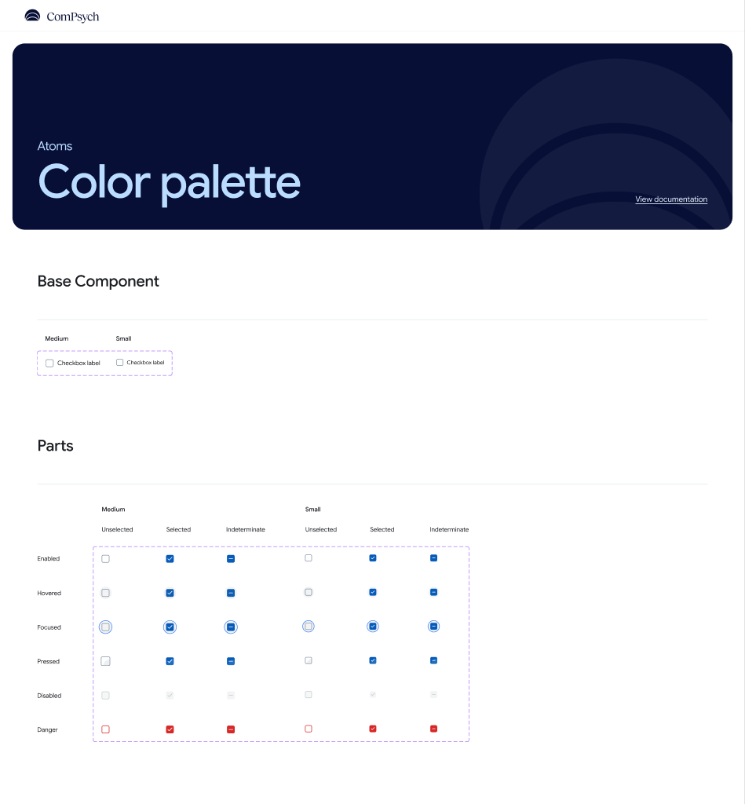

Usage

States
Checkbox can be unchecked, checked, indeterminate, or disabled.
<Checkbox defaultChecked={false} onValueChange={console.log} />
<Checkbox defaultChecked={true} onValueChange={console.log} />
<Checkbox checked="indeterminate" onValueChange={handleChange} />
<Checkbox disabled />

Controlled
Use the checked prop with onValueChange for controlled usage.
const [checked, setChecked] = useState(false);
<Checkbox checked={checked} onValueChange={setChecked} />

Sizes
Checkbox supports medium (default) and small sizes.
<Checkbox size="md" defaultChecked />
<Checkbox size="sm" defaultChecked />

Props
Name | Type | Default | Description
checked | boolean | 'indeterminate' | — | Controlled checked state
defaultChecked | boolean | false | Initial state for uncontrolled usage
onValueChange | (value: boolean | 'indeterminate') => void | — | Called when the value changes
size | 'sm' | 'md' | 'md' | Controls hit area and box size
disabled | boolean | false | Disables interaction
accessibilityLabel | string | — | Screen-reader label

Version: 1.0.0

Chip
Compact label pill for displaying status, category, or filter values. Supports a leading icon, trailing dismiss button, and inline badge count.

Import
import { Chip } from '@/components/ds/Chip';
Component File: components/ds/Chip.tsx

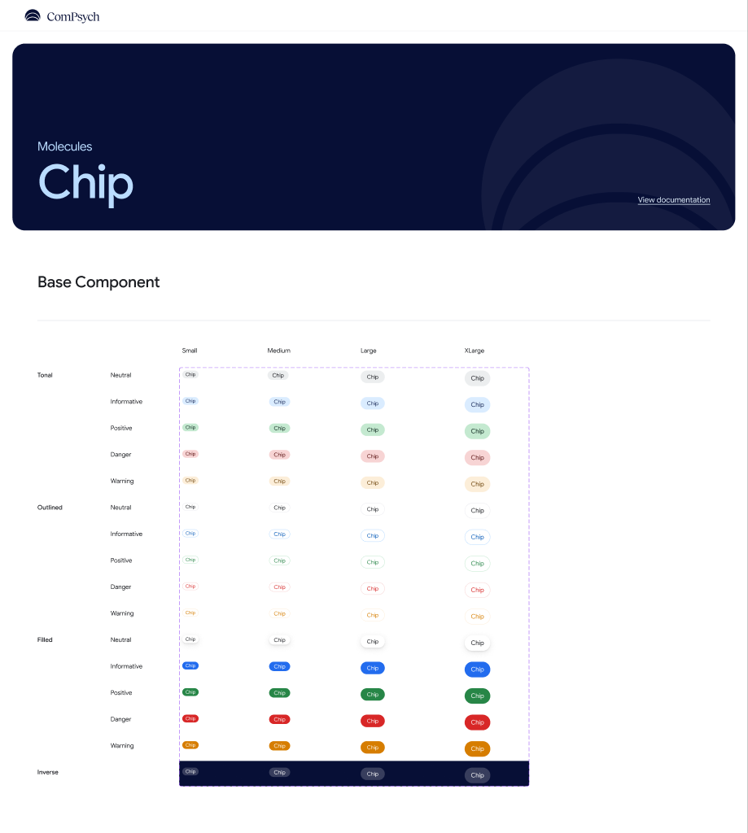

Usage

Colors
Chip supports neutral, informative, positive, danger, and warning semantic colors.
<Chip label="Neutral" usage="neutral" />
<Chip label="Info" usage="informative" />
<Chip label="Completed" usage="positive" />
<Chip label="Overdue" usage="danger" />
<Chip label="Pending" usage="warning" />

Sizes
Chip can be rendered in four sizes.
<Chip label="Small" size="sm" />
<Chip label="Medium" size="md" />
<Chip label="Large" size="lg" />

Dismissible
Add a dismiss button at the trailing end.
<Chip label="Filter" dismissible onDismiss={handleDismiss} />

Props
Name | Type | Default | Description
label | string | — | Required. Chip text
size | 'sm' | 'md' | 'lg' | 'xl' | 'md' | Controls height and font
usage | 'neutral'|'informative'|'positive'|'danger'|'warning' | 'neutral' | Semantic color
leadingIcon | React.ReactNode | — | Icon before the label
dismissible | boolean | false | Shows a dismiss button at the trailing end
onDismiss | () => void | — | Called when the dismiss button is pressed
badge | number | string | — | Count or short text at the trailing end

Version: 1.0.0

Divider
Decorative separator line used to create visual hierarchy between sections or list items. Supports horizontal and vertical orientations.

Import
import { Divider } from '@/components/ds/Divider';
Component File: components/ds/Divider.tsx

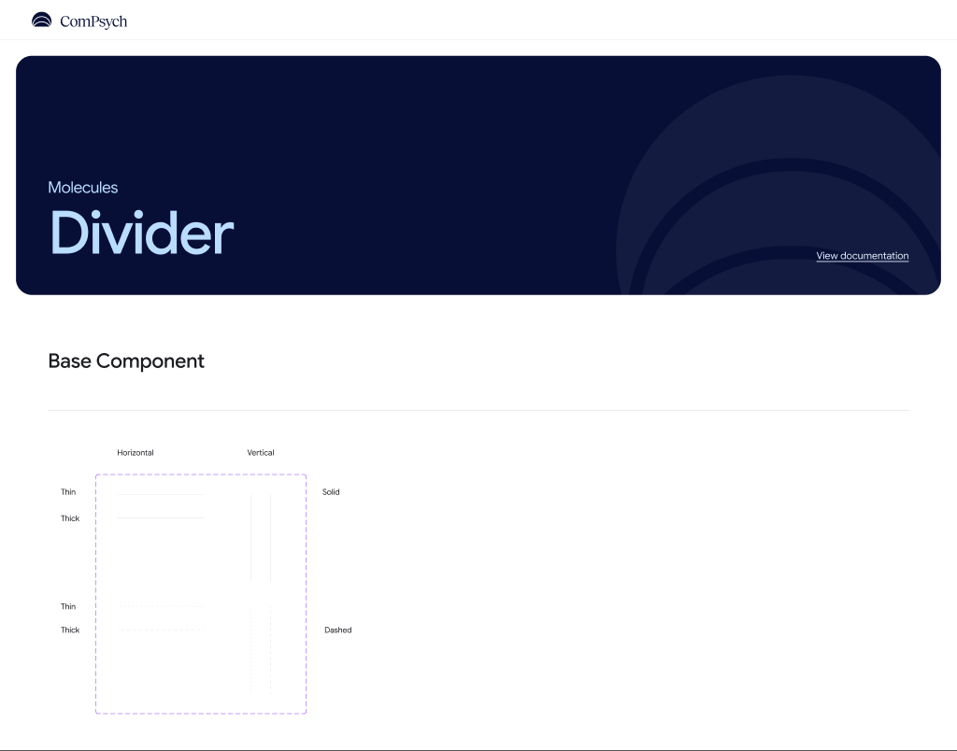

Usage

Horizontal
A horizontal divider stretches to fill its parent width.
<Divider />
<Divider weight="thick" />

Vertical
A vertical divider fills its parent height inside a row layout.
<View style={{ flexDirection: "row", height: 40 }}>
<Text>Left</Text>
<Divider variant="vertical" />
<Text>Right</Text>
</View>

Dashed
The dashed style is used for section breaks.
<Divider dashed />
<Divider weight="thick" dashed />

Props
Name | Type | Default | Description
variant | 'horizontal' | 'vertical' | 'horizontal' | Orientation
weight | 'thin' | 'thick' | 'thin' | Line thickness (1px or 2px)
dashed | boolean | false | Renders a dashed line pattern

Version: 1.0.0

EmptyState
Full-panel placeholder shown when a screen or list has no content. Supports an icon circle or illustrated card-collage graphic, optional description, and an action button.

Import
import { EmptyState } from '@/components/ds/EmptyState';
Component File: components/ds/EmptyState.tsx

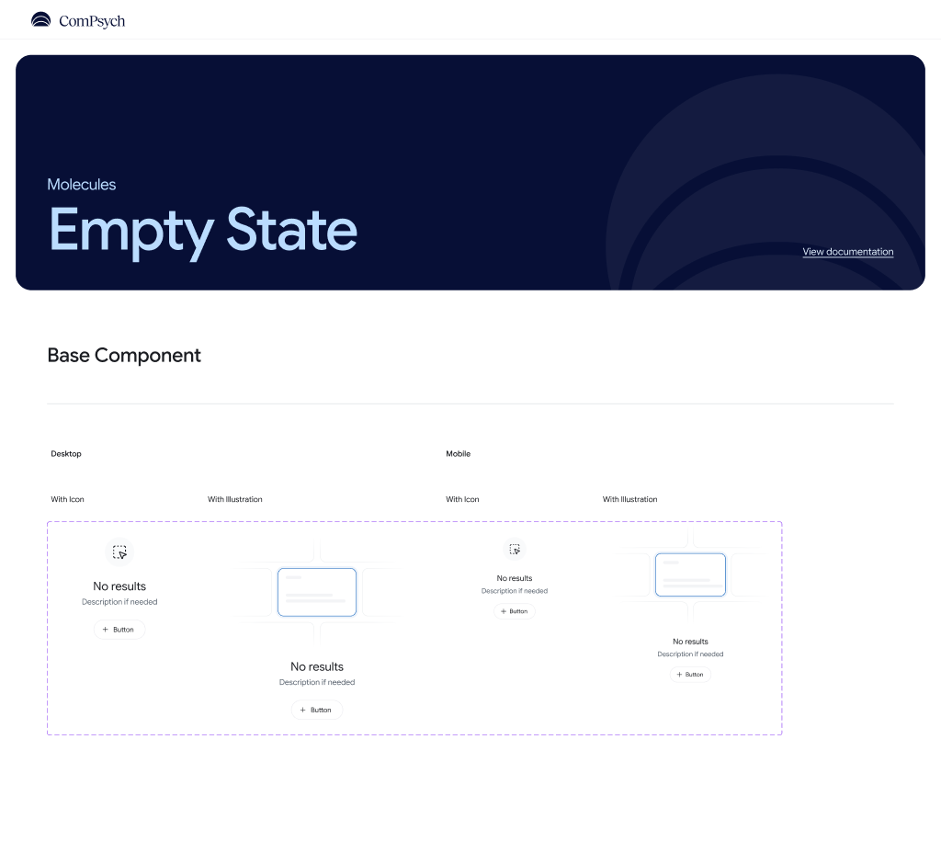

Usage

Icon Style
The default style renders an icon inside a circular container above the title.
<EmptyState
title="No messages"
description="When you receive messages they will appear here."
/>

Illustration Style
The illustration style renders a pure-View card collage — no image assets required.
<EmptyState
style="illustration"
title="Nothing here yet"
description="Get started by creating your first item."
/>

With Action
An optional action button prompts the user to take a next step.
<EmptyState title="No results" actionLabel="Clear filters" onAction={clearFilters} />

Props
Name | Type | Default | Description
style | 'icon' | 'illustration' | 'icon' | Graphic treatment above the text
viewport | 'desktop' | 'mobile' | 'mobile' | Token set for type scale and sizing
title | string | 'No results' | Heading text
description | string | 'Description if needed' | Body copy
showDescription | boolean | true | Hides the description when false
icon | React.ReactNode | — | Custom icon inside the circle
actionLabel | string | — | Label for the action button
onAction | () => void | — | Called when the action button is pressed

Version: 1.0.0

Input
Single-line text field with a floating label, helper and error text, and leading and trailing icon slots. Built on React Native's TextInput.

Import
import { Input } from '@/components/ds/Input';
Component File: components/ds/Input.tsx

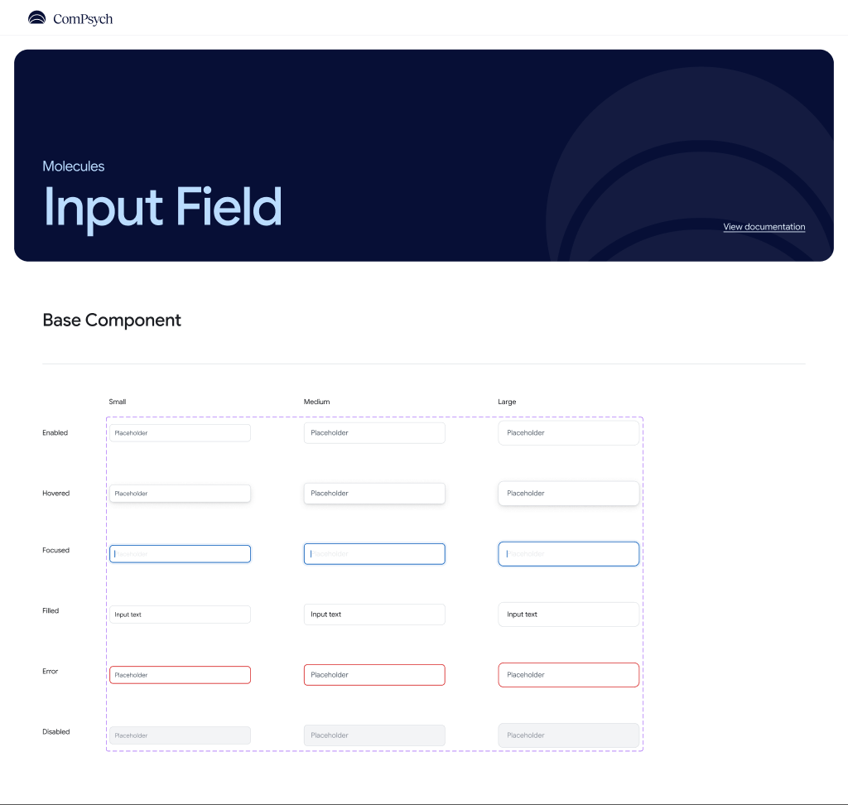

Usage

Basic
A simple text field with a floating label and placeholder.
<Input label="Email" placeholder="you@example.com" />

Sizes
Input supports three sizes controlling height, padding, and font scale.
<Input size="sm" label="Small" placeholder="Small field" />
<Input size="md" label="Medium" placeholder="Medium field" />
<Input size="lg" label="Large" placeholder="Large field" />

Error State
Use invalid and errorText to communicate a validation error.
<Input label="Username" invalid={!!errors.username} errorText={errors.username} />

With Icons
Leading and trailing icons can be placed inside the field.
<Input label="Search" leadingIcon={<Ionicons name="search" size={20} />} />

Props
Name | Type | Default | Description
size | 'sm' | 'md' | 'lg' | 'md' | Controls height, padding, and font
label | string | — | Floating label above the field
helperText | string | — | Subdued hint text below the field
errorText | string | — | Error message; replaces helperText
invalid | boolean | false | Applies error styling (red border)
leadingIcon | React.ReactNode | — | Icon at the leading edge
trailingIcon | React.ReactNode | — | Icon at the trailing edge

Version: 1.0.0

Pagination
Page navigation control with smart truncation. Supports a numbered layout or a compact prev/next-only mode for narrow mobile layouts.

Import
import { Pagination } from '@/components/ds/Pagination';
Component File: components/ds/Pagination.tsx

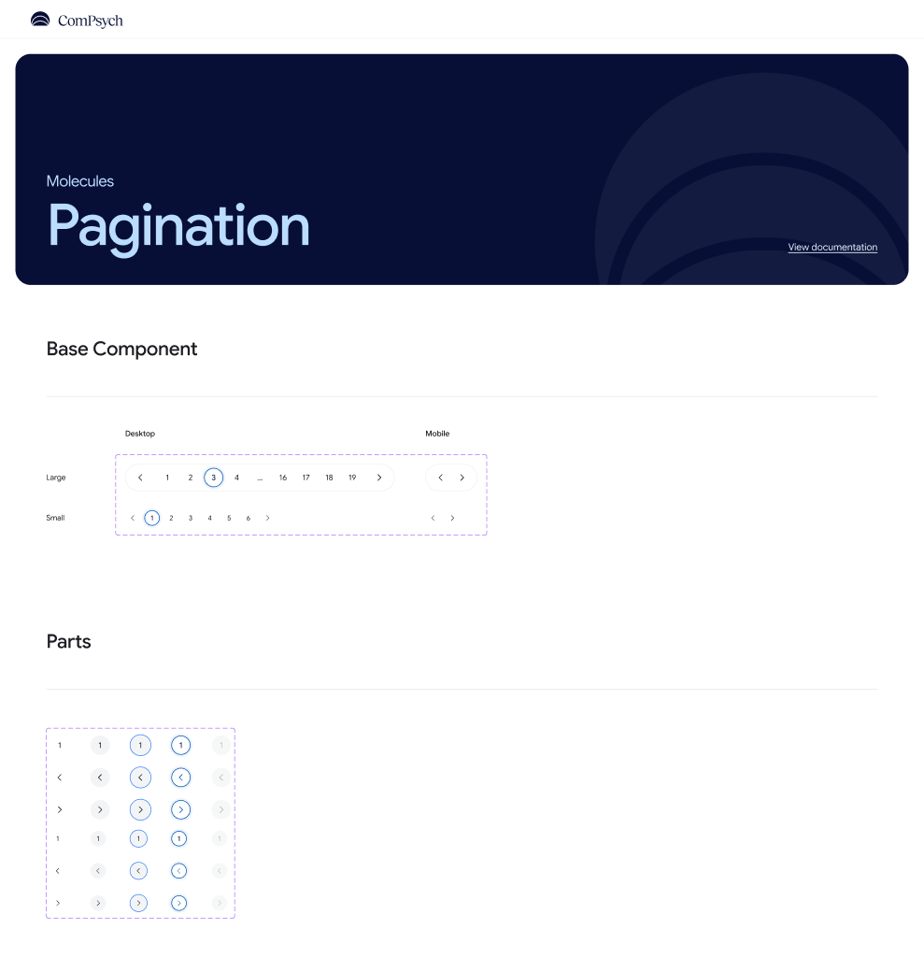

Usage

Standard
The default layout renders numbered page buttons inside a pill container.
const [page, setPage] = useState(1);
<Pagination totalPages={12} currentPage={page} onPageChange={setPage} />

Compact
Compact mode renders only prev/next arrows — ideal for narrow screens.
<Pagination compact totalPages={20} currentPage={page} onPageChange={setPage} />

Props
Name | Type | Default | Description
totalPages | number | — | Required. Total number of pages
currentPage | number | — | Required. Active page (1-based)
onPageChange | (page: number) => void | — | Required. Called on page selection
size | 'sm' | 'lg' | 'lg' | lg renders inside a pill; sm is bare
siblingCount | number | 1 | Page buttons on each side before truncating
compact | boolean | false | Renders only prev/next arrows

Version: 1.0.0

ProgressTracker
Multi-step progress indicator with labelled steps and per-step progress bars. Used to communicate where a user is in a multi-page flow.

Import
import { ProgressTracker } from '@/components/ds/ProgressTracker';
Component File: components/ds/ProgressTracker.tsx

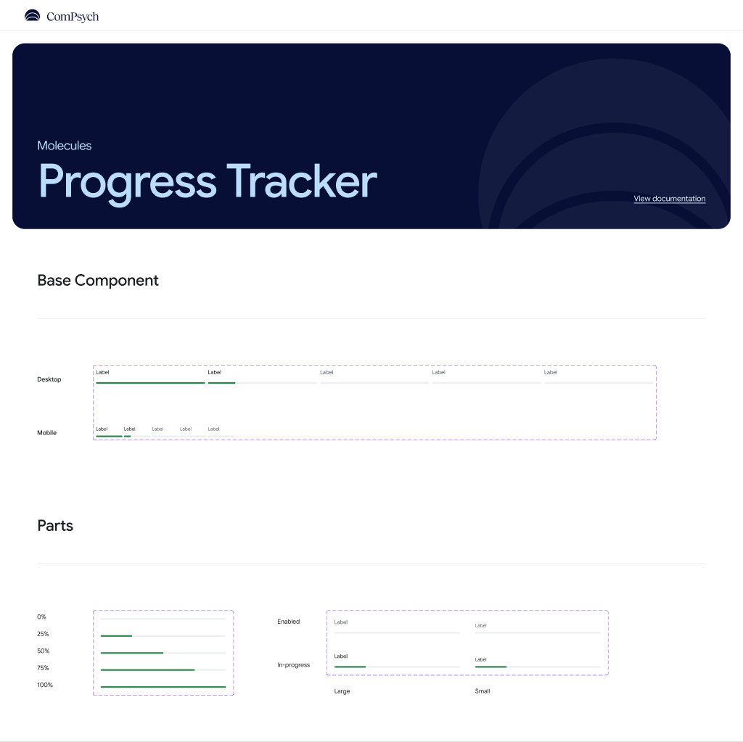

Usage

Basic
Provide an array of steps with a label and state for each.
<ProgressTracker
steps={[
{ label: "Personal info", state: "completed" },
{ label: "Address", state: "completed" },
{ label: "Review", state: "active" },
{ label: "Submit", state: "pending" },
]}
/>

Without Labels
Set showLabels to false for a compact bar-only indicator.
<ProgressTracker showLabels={false} steps={steps} />

Props
Name | Type | Default | Description
steps | TrackerStep[] | — | Required. Ordered array of step descriptors
size | 'sm' | 'lg' | 'lg' | Label font size
showLabels | boolean | true | Whether to render step labels below the bars

Version: 1.0.0

RadioButton
Single-selection control. Use within a group where only one option can be selected at a time. Supports controlled and uncontrolled usage.

Import
import { RadioButton } from '@/components/ds/RadioButton';
Component File: components/ds/RadioButton.tsx

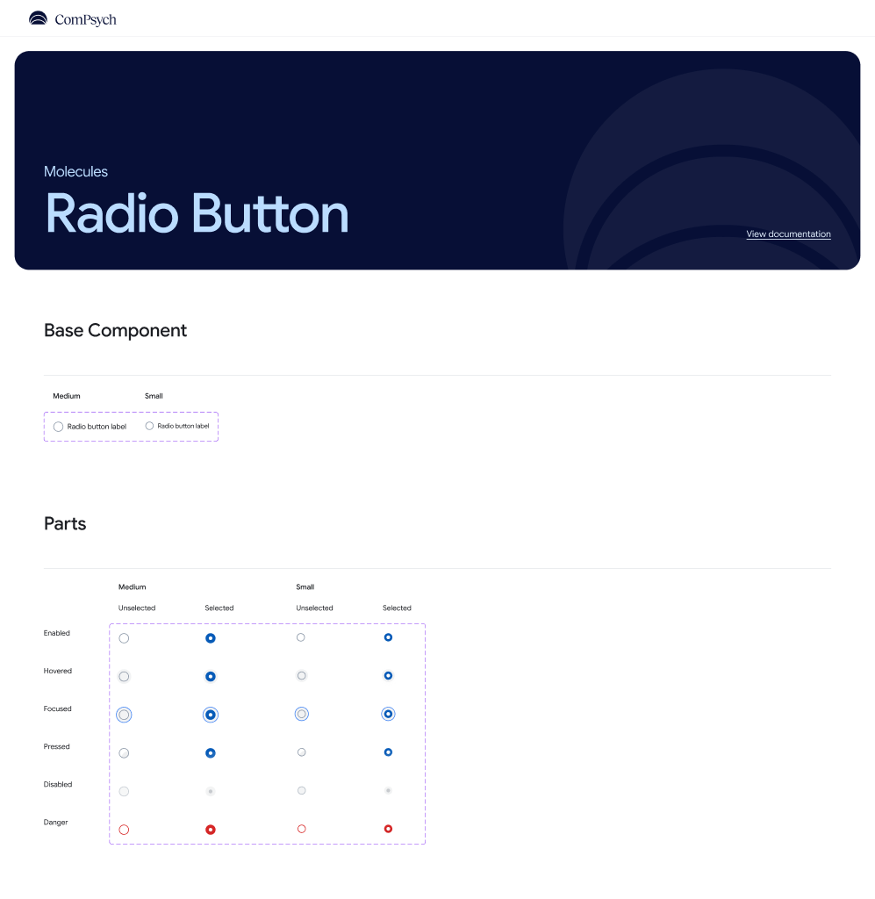

Usage

States
RadioButton can be unselected, selected, or disabled.
<RadioButton defaultSelected={false} />
<RadioButton defaultSelected={true} />
<RadioButton disabled />

In a Group
Manage selection state externally and pass selected and onValueChange.
const [selected, setSelected] = useState("a");
<RadioButton selected={selected === "a"} onValueChange={() => setSelected("a")} accessibilityLabel="Option A" />
<RadioButton selected={selected === "b"} onValueChange={() => setSelected("b")} accessibilityLabel="Option B" />

Props
Name | Type | Default | Description
selected | boolean | — | Controlled selected state
defaultSelected | boolean | false | Initial state for uncontrolled usage
onValueChange | (value: boolean) => void | — | Called when the value changes
size | 'sm' | 'md' | 'md' | Controls hit area and ring size
disabled | boolean | false | Disables interaction
accessibilityLabel | string | — | Screen-reader label

Version: 1.0.0

Slider
Continuous value selector with a draggable thumb. Tapping anywhere on the track jumps the thumb to that position.

Import
import { Slider } from '@/components/ds/Slider';
Component File: components/ds/Slider.tsx

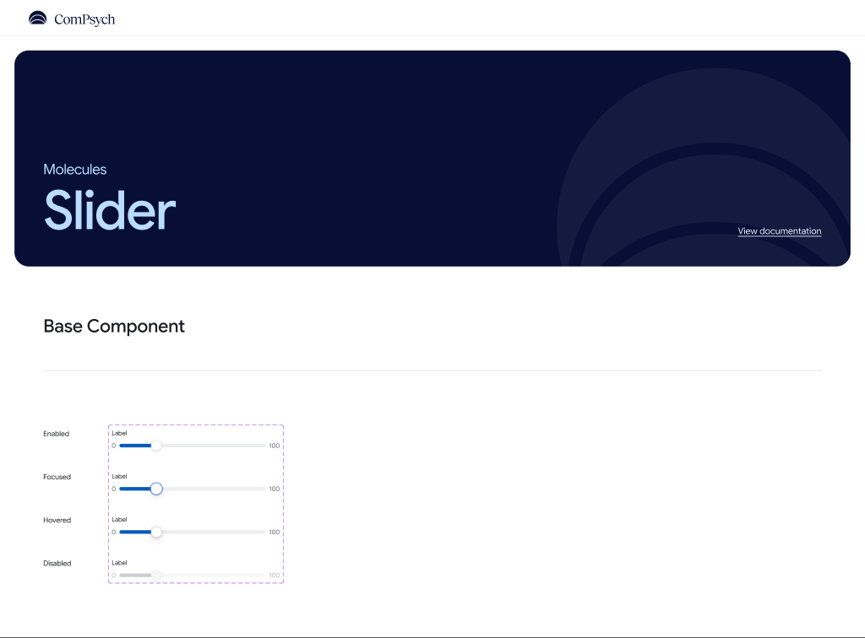

Usage

Basic
A simple uncontrolled slider with default min (0) and max (100).
<Slider onSlidingComplete={(v) => console.log(v)} />

With Label
Use the label prop to render a descriptor above the track.
const [volume, setVolume] = useState(50);
<Slider label="Volume" value={volume} onValueChange={setVolume} />

Step
Use the step prop to snap the thumb to fixed intervals.
<Slider defaultValue={0} min={0} max={100} step={10} showMinMax />

Disabled
A disabled slider reduces opacity and ignores interaction.
<Slider value={40} disabled label="Locked setting" />

Props
Name | Type | Default | Description
value | number | — | Controlled value
defaultValue | number | min | Initial value for uncontrolled usage
min | number | 0 | Minimum value
max | number | 100 | Maximum value
step | number | 1 | Snapping interval
onValueChange | (value: number) => void | — | Called continuously while dragging
onSlidingComplete | (value: number) => void | — | Called once when the user releases the thumb
label | string | — | Label rendered above the track
showMinMax | boolean | true | Renders min/max labels on either side
disabled | boolean | false | Disables interaction

Version: 1.0.0

Switch
Binary toggle with an animated thumb slide and background color transition. Supports controlled and uncontrolled usage.

Import
import { Switch } from '@/components/ds/Switch';
Component File: components/ds/Switch.tsx

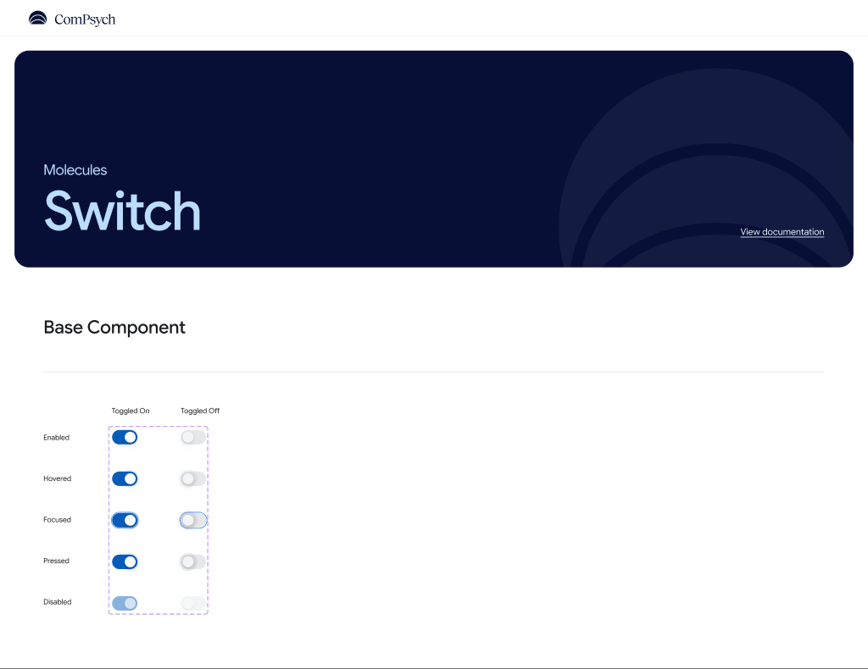

Usage

On and Off
Switch can be toggled between on and off states.
<Switch defaultValue={false} onValueChange={console.log} />
<Switch defaultValue={true} onValueChange={console.log} />

Controlled
Use the value prop with onValueChange for controlled usage.
const [enabled, setEnabled] = useState(false);
<Switch value={enabled} onValueChange={setEnabled} accessibilityLabel="Notifications" />

Disabled
Disabled switches reduce opacity and ignore press interactions.
<Switch value={false} disabled />
<Switch value={true} disabled />

Props
Name | Type | Default | Description
value | boolean | — | Controlled value
defaultValue | boolean | false | Initial value for uncontrolled usage
onValueChange | (value: boolean) => void | — | Called when the user toggles the switch
disabled | boolean | false | Disables interaction
accessibilityLabel | string | — | Screen-reader label

Version: 1.0.0

Tooltip
Short contextual label attached to a target element and positioned with a directional arrow. Use to clarify icon buttons or truncated text.

Import
import { Tooltip } from '@/components/ds/Tooltip';
Component File: components/ds/Tooltip.tsx

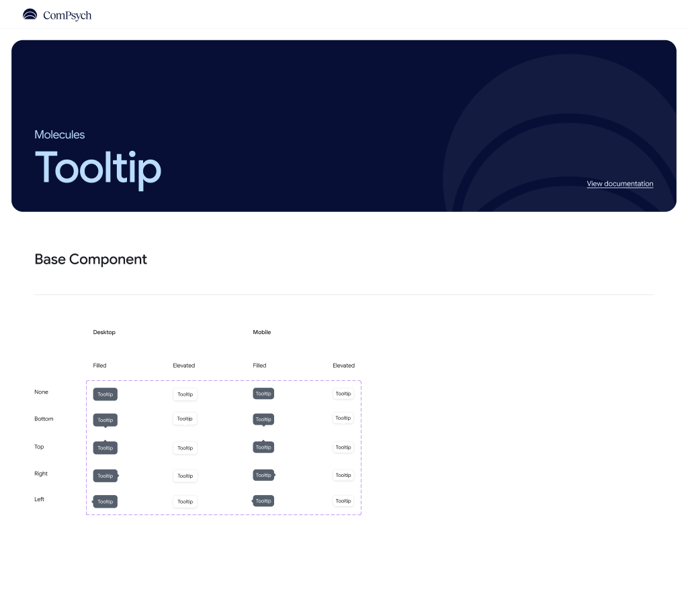

Usage

Filled
The filled variant uses a dark inverse surface — the default and most common style.
<Tooltip text="More options" />
<Tooltip text="Delete item" direction="bottom" />

Elevated
The elevated variant uses a white surface with a border and shadow.
<Tooltip text="Save your work" variant="elevated" direction="bottom" />

Directions
The direction prop controls where the arrow is drawn relative to the bubble.
<Tooltip text="No arrow" direction="none" />
<Tooltip text="Arrow up" direction="top" />
<Tooltip text="Arrow down" direction="bottom" />
<Tooltip text="Arrow left" direction="left" />
<Tooltip text="Arrow right" direction="right" />

Props
Name | Type | Default | Description
text | string | — | Required. Tooltip content
variant | 'filled' | 'elevated' | 'filled' | Visual style
direction | 'none'|'top'|'bottom'|'left'|'right' | 'none' | Where the target is relative to the bubble

