- EXCUTIVE SUMMARY
This project analyzes the Superstore dataset to evaluate sales performance, profitability, customer value, and regional performance. Through data cleaning, analysis, and visualization, the project aims to identify key trends, top-performing products, valuable customers, and the impact of discounts on profitability, providing insights to support business decision-making.
- BUSINESS QUESTIONS/PROBLEMS
Background
Due to increasing competition in the retail market, Superstore is seeking a data-driven approach to have a better understanding of what works best for them. They gathered data about their orders, customers, profits and relevant data to make sure that analysts can help them with making more efficient data-driven decisions.
Questions
- How have sales and profit changed over time?
- Which product generated highest profit?
- Which regions contributed most sales and profit?
- Who are the most valuable customers?
- Does discount help increase profit?
- DATASET OVERVIEW
Source: Superstore Dataset from Vivek Chowdhry on Kaggle
Data Structure
Category | Fields
Orders | Order ID, Order Date, Ship Date, Ship Mode
Customers | Customer ID, Customer Name, Segment
Products | Product ID, Category, Sub-Category, Product Name
Geography | Country, City, State, Postal Code, Region
Performanc Metrics | Sales, Quantity, Discount, Profit
Dataset Summary
Rows (records) | 9994
Columns (fields) |  | 21
Time Period |  | 2014 - 2018
Regions |  | 4
Customers |  | 793
Category |  | 3
Total Sales |  | 2297200.86 | Profit/Sales
Total Profit |  | 286397.020 | 12.47%

- DATA CLEANING CHECKLIST
Expected Outcome
Ensure the dataset is clean, reliable, and suitable for analysis by validating data quality, consistency, completeness, and business logic.
Cleaning Checklist
Area | Description | Status
Missing values | Using filter to check for null and blank values | Checked
Duplicates | Using “Remove Duplicates” in Data | Checked
Data types | Check which data type is suitable for which fields | Checked
Consistency | Using dropdown in filter to check whether values/records are consistent in spelling or case. | Checked
Extra spaces | Using “TRIM” function and Paste Value to remove extra spaces | Checked
Formats | Formatting all records of a field into a correct data type. | Checked
Business logic | Checking data if it is correct, logical with the business logical rules | Checked
Business Logic rules reviewed:
- Ship date should occur on or after Order date
- Discount value should be between 0 and 1
- Sales should not contain negative values and quantity should be a natural number
Outcome
After completing on cleaning data according to the checklist, no critical issue was found and expected final outcome should be the same as previous dataset summary:
Rows (records) | 9994
Columns (fields) |  | 21
Time Period |  | 2014 - 2018
Regions |  | 4
Customers |  | 793
Category |  | 3
Total Sales |  | 2297200.86 | Profit/Sales
Total Profit |  | 286397.020 | 12.47%

- ANALYSIS AND FINDINGS (biểu đồ, nhận xét, đánh giá, ý nghĩa kinh doanh)
In order to answer 5 analysis questions above effectively, I decided to split those 5 into 5 big objective analysis: Sales and Profit, Regional, Product, Customer, Discount.
- Sales and Profit Analysis
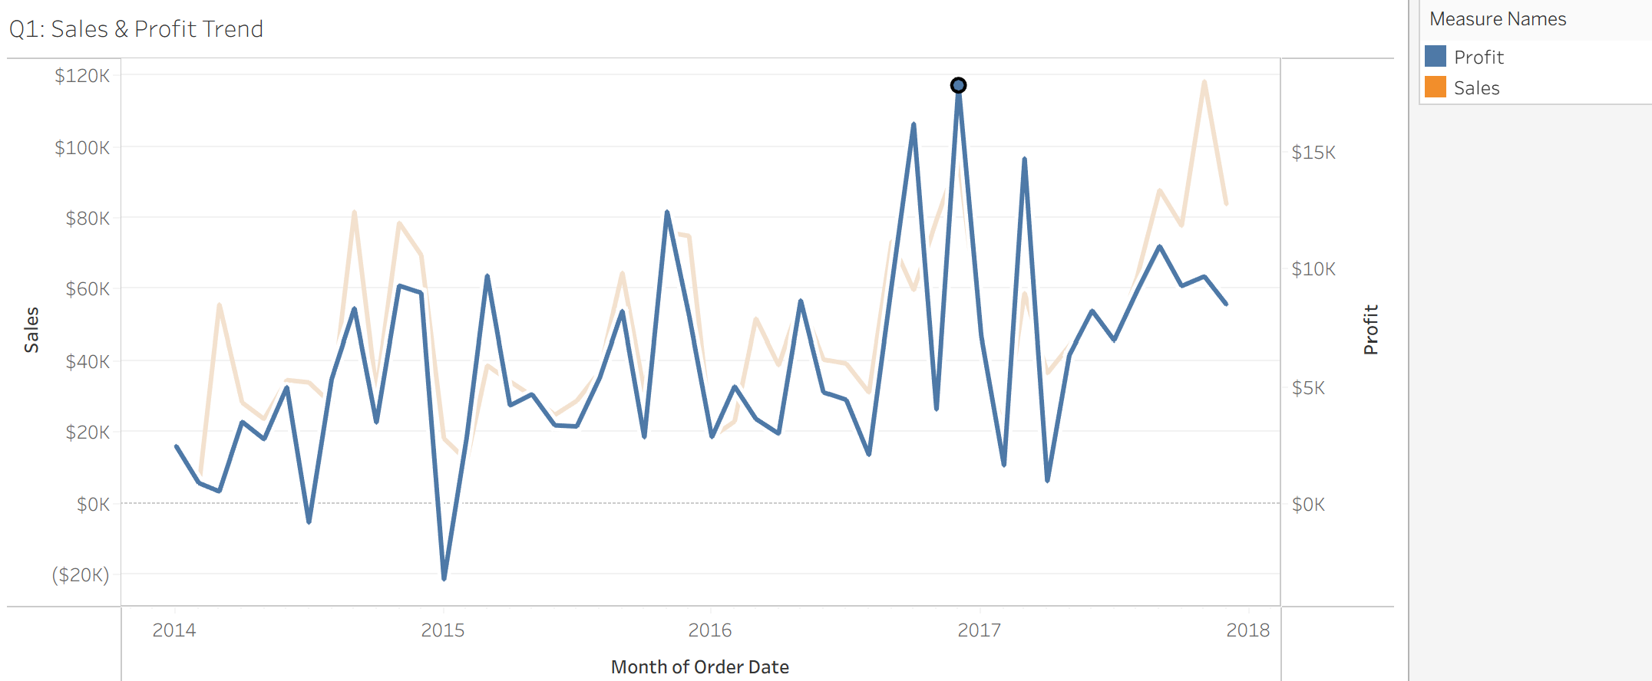
Figure 1: Profit
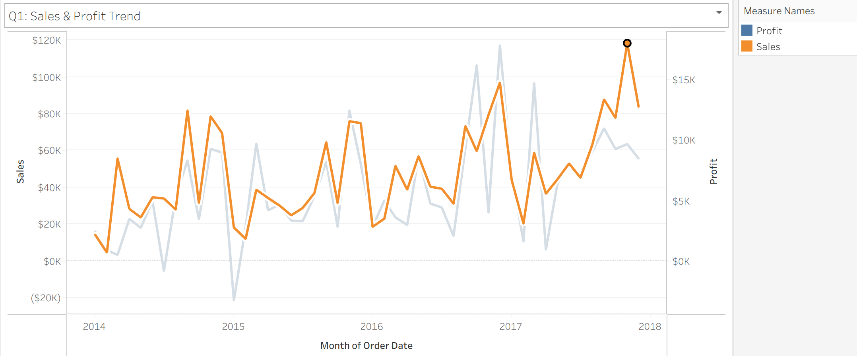
Figure 2: Sales
Finding 1: Sales and Profit showed an overall upward trend between 2014 and 2018
- Profit generally increased throughout the period despite a significant decline in early 2015.
- Sales increased gradually from 2014 to 2018, indicating steady business growth.
Finding 2: Profit was highly volatile despite increasing in sales
- A loss of approximately $20K occurred in early 2015.
- Profit fluctuated significantly across diferent months, even during periods of strong sales performance.
Finding 3: Sales performance appears to follow a seasonal pattern
- Higher sales levels frequently occurred during the second half of each year.
- Sales reached their highest level of approximately $120K in late 2017.
- Regional Analysis
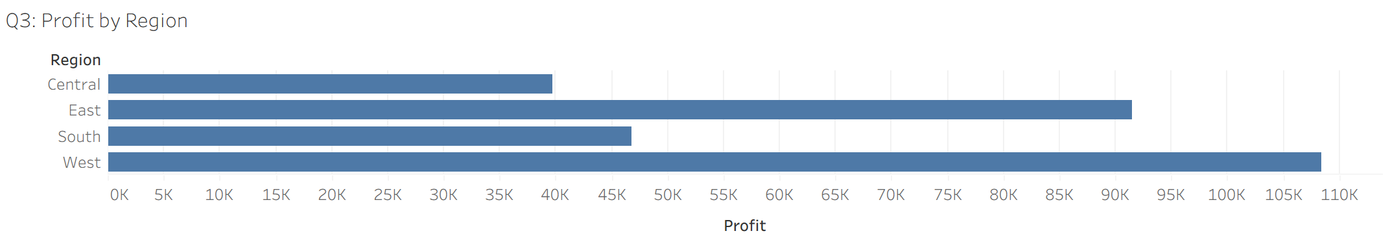
Figure 3: Profit by Region
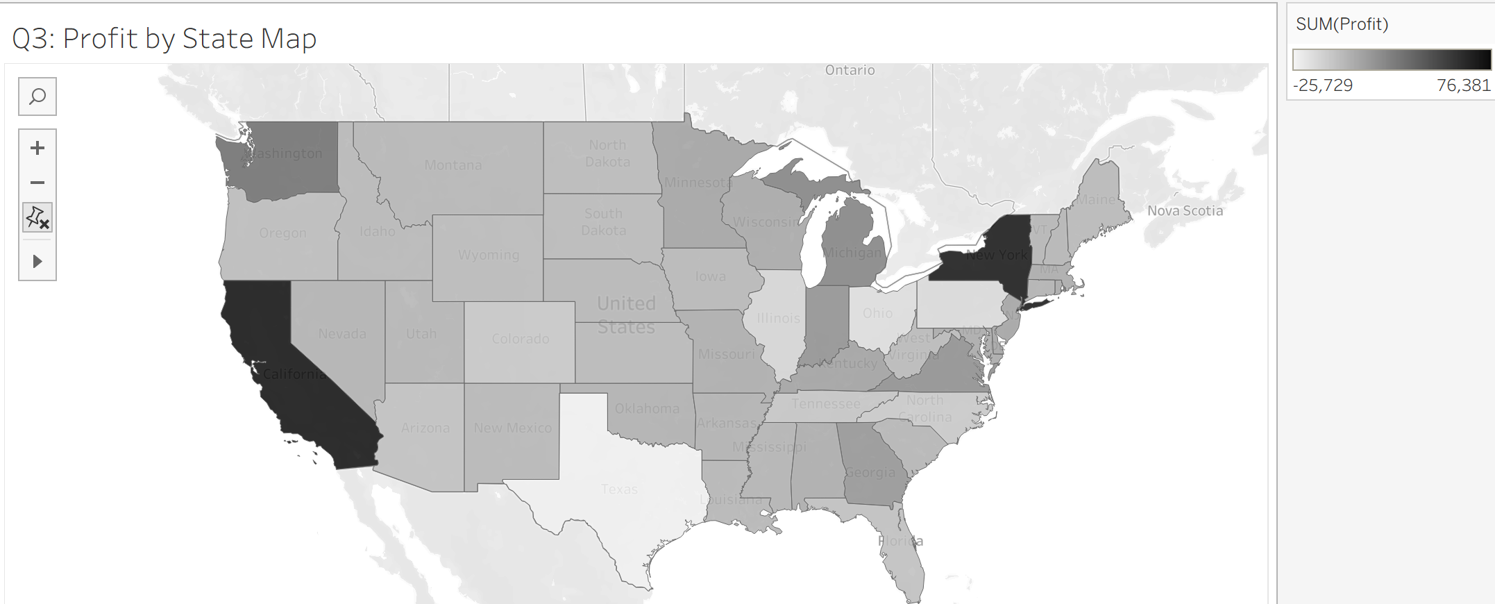
Figure 4: Profit by State

Finding 4: The West generated the highest profit among all regions
- West recoreded the highest profit.
- East recored the second highest profit, while Central generated the lowest profit.
Finding 5: Profit varies significatly across states
- Several states generated substantially higher profits than others.
- Certain states contributed little profit despite generating sales activity.
- Product Analysis
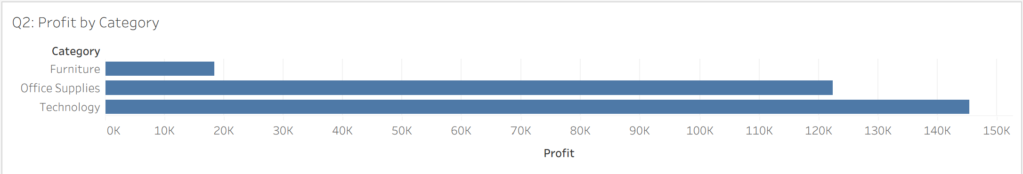
Figure 5: Profit by Category

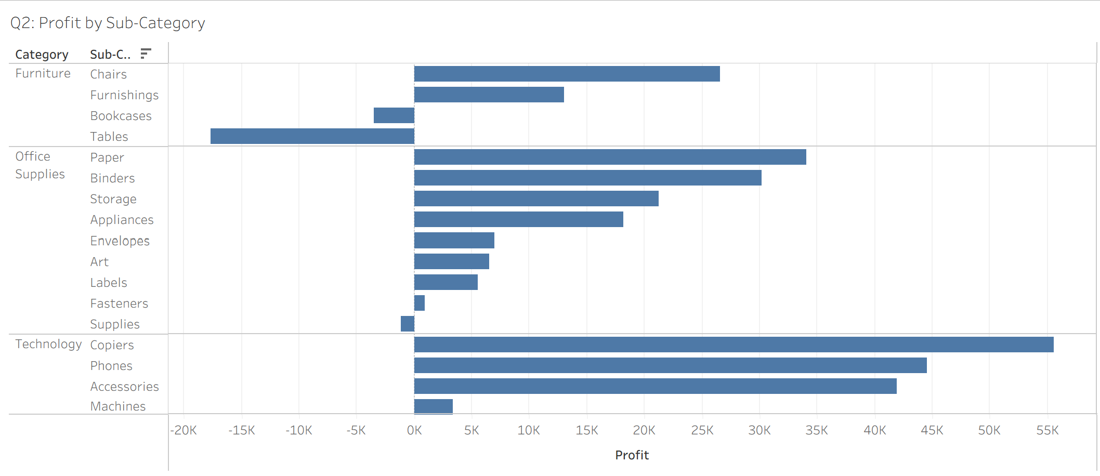
Figure 6: Profit by Sub-category
Finding 6: Techonology is the most profitable product category
- Technology generated approximately $145K profit.
- It outperformed Office Supplies and Furniture by a significant margin.
Finding 7: Furniture underperformed due to losses in specific sub-categories
- Tables and Bookcases recored negative profits.
- Furniture generated the lowest categroy profit overall.
Finding 8: Copiers, Phones, and Accessories are key profit drivers.
- Copiers generated the highest profit among all sub-categories.
- Phones and Accessories also contributed substantial profits.
- Customer Analysis
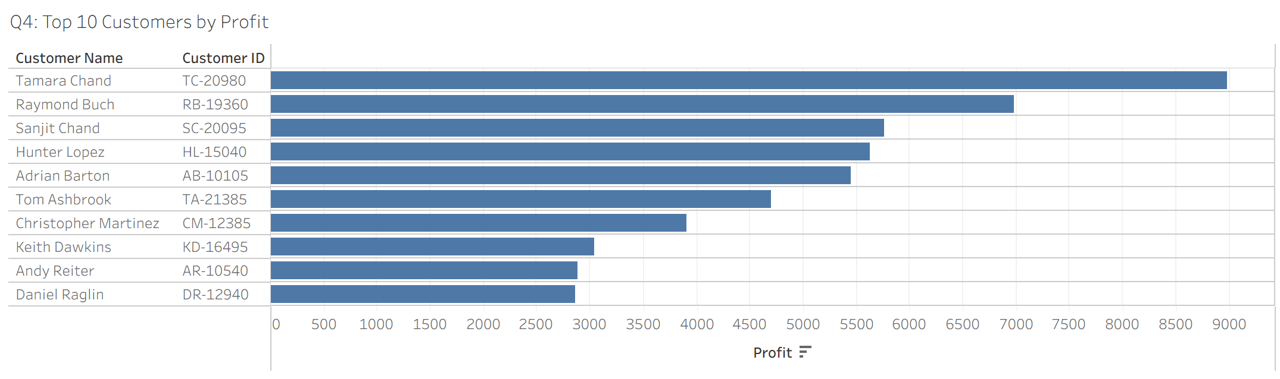
Figure 7: Top 10 Customers by Profit
Finding 9: A small number of customers contribute a disproportionately high share of profit
- The top 10 customers generated significantly higher profit than the average customer.
- Several customers consistently appeared as major contributors.
- Discount Impact Analysis
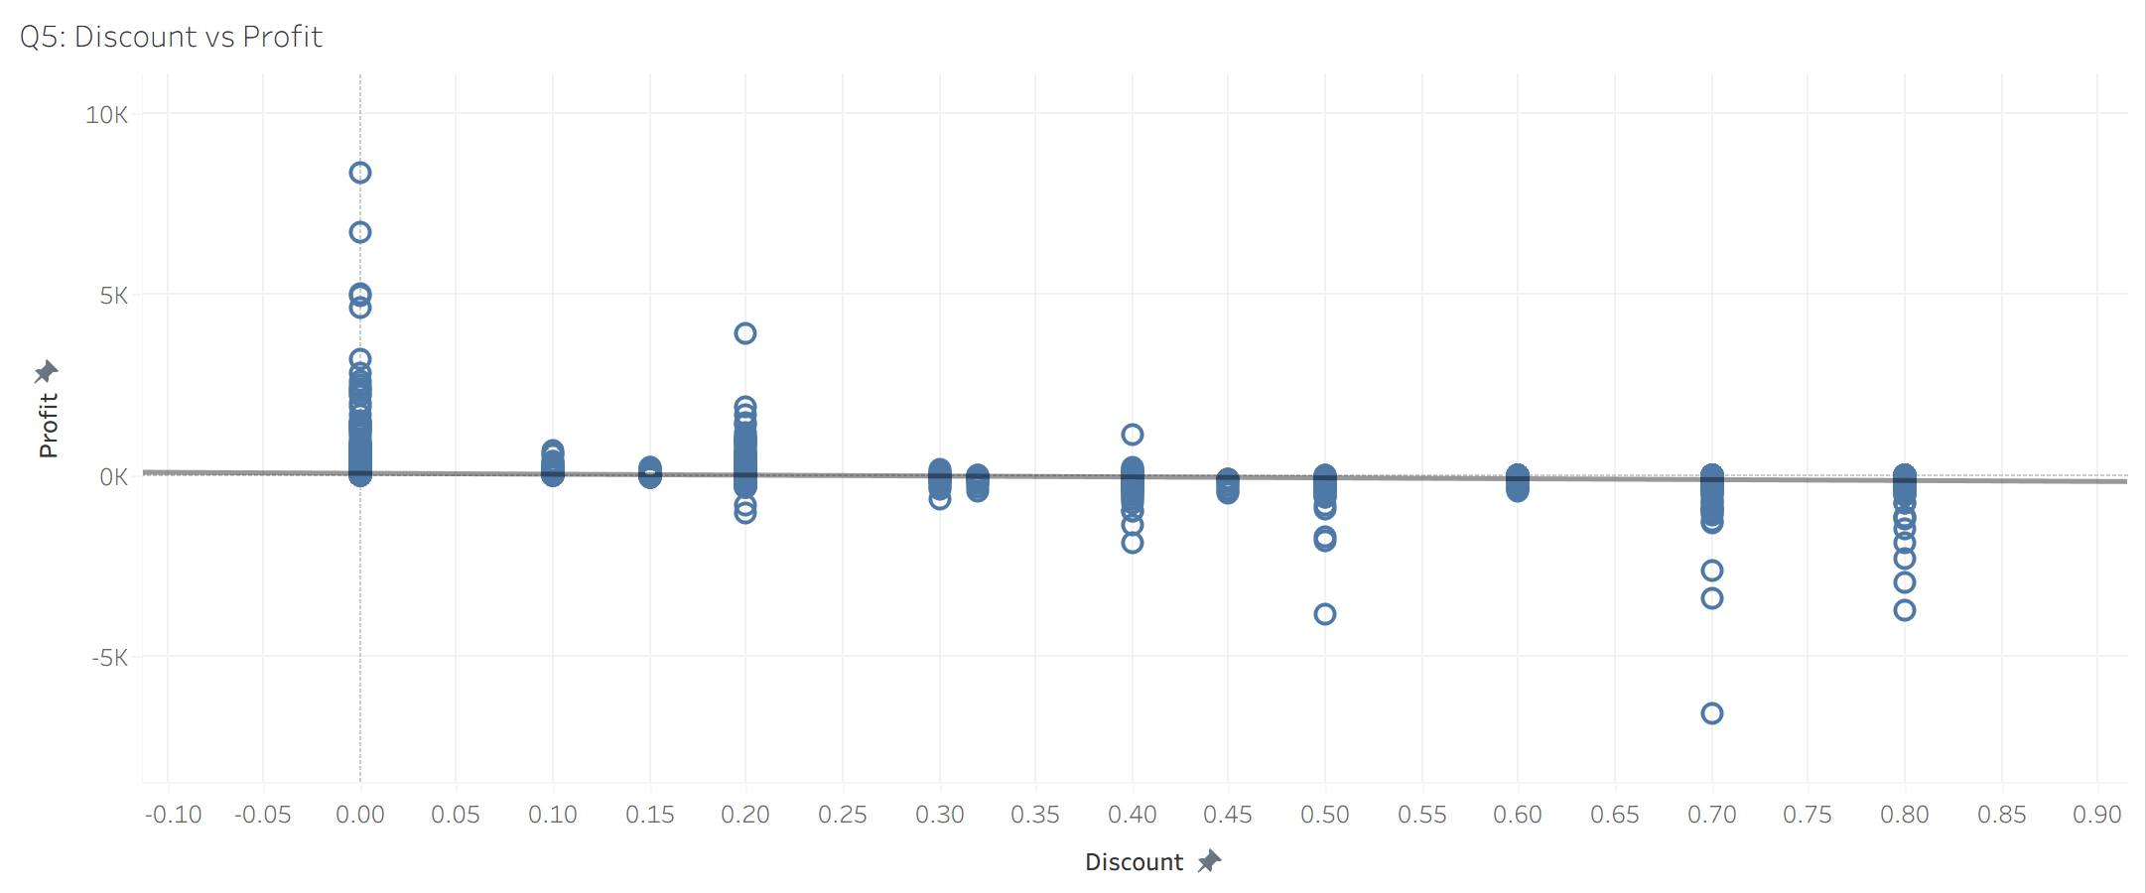
Figure 8: Discount vs Impact Analysis
Finding 10: Higher discounts do not necessarily lead to higher profit
- Many transactions with high discount rates generated low or negative profits.
- Profit generally decreased as discount levels increased.
- RECOMMENDATIONS
Recommendation 1 (Finding 6 and 8): Increase investment in Technology products, particularly Copiers, Phones, and Accessories, as they generated the highest profit.
Recommendation 2 (Finding 7): Review pricing strategies, discount policies, and operational costs associated with Tables and Bookcases to improve Furniture profitability.
Recommendation 3 (Finding 4 and 5): Allocate more resources to high-performing regions while investigating the causes of weak performance in lower-profit states.
Recommendation 4 (Finding 9): Develop loyalty programs and retention strategies for high-value customers to maximize long-term customer value.
Recommendation 5 (Finding 10): Implement stricter discount management policies and evaluate promotional campaigns based on profit impact rather than sales volume alone.
Recommendation 6 (Finding 3): Prepare inventory, staffing, and marketing campaigns ahead of year-end peak demand periods to capitalize on seasonal sales opportunities.
- DASHBOARD
Dashboard Overview
The dashboard was designed to provide management with and interactive overview of business performance by integrating sales trends, profitability analysis, regional performance, customer value, product profitability, and discount impact into a single interface.
Dashboard enables decision-makers to monitor key performance indicators efficiently, identify profitable products and regions, recognize valuable customer, and evaluate the impact of discount strategies on profitability. By consolidating multiple analyses into a single dashboard, management can make faster and more informed business decisions.
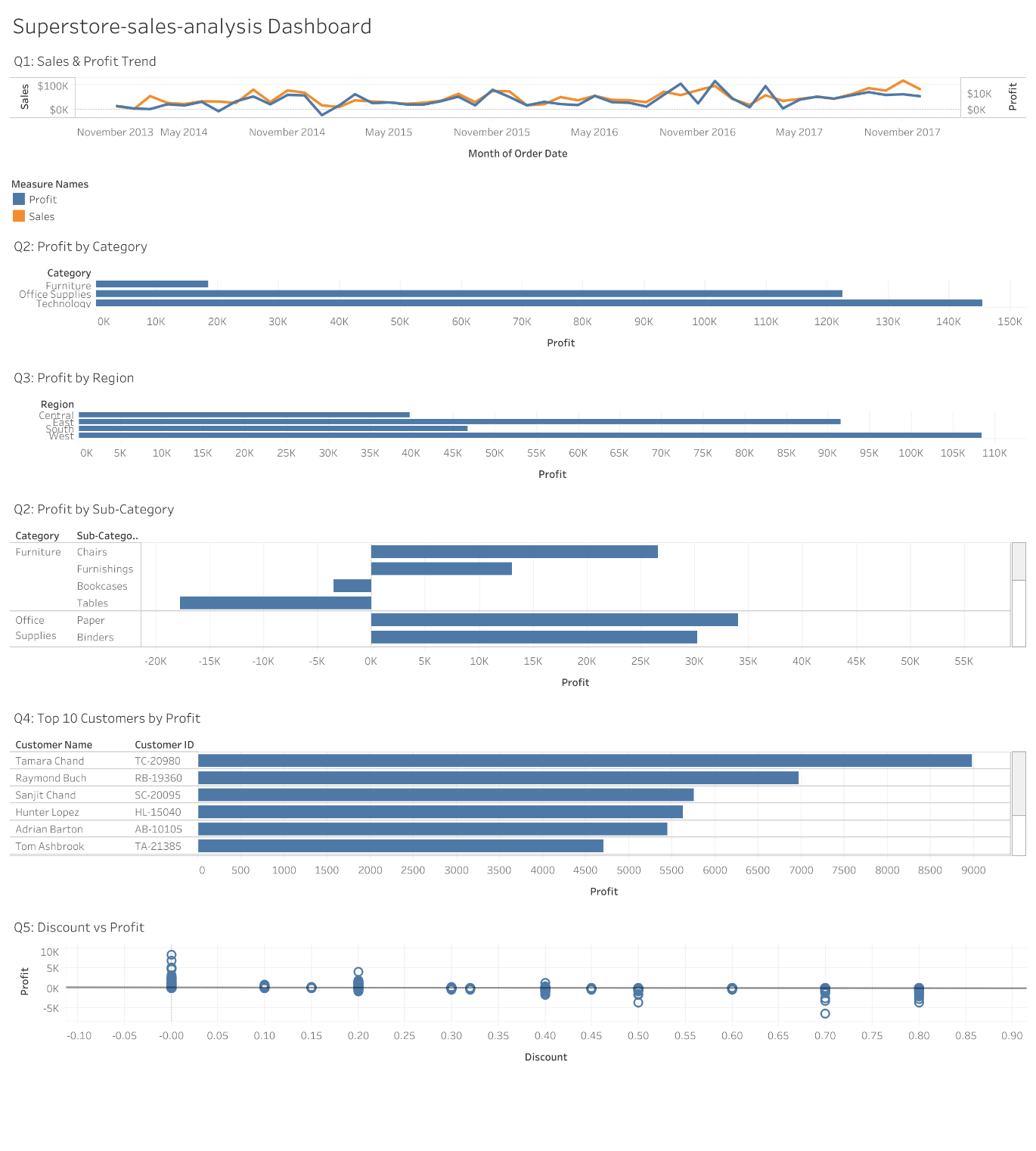
Figure 9: Ecom-sales-Analysis Dashboard

