**Aviva Test Assignment Execution Report Document**

**Aviva Web Assignment consists of below files:**

1. Features – feature files
   1. Aviva_Assignment.feature
2. Hooks – Preconditions
   1. Hooks.cs
3. Pages – WebPages
   1. Google_Page.cs
   2. Aviva_Application.cs
4. Steps – Definition Files
   1. VerifyTheCountOfLinksDisplayedForTheSearchTextAndPrint5ThLinkTextSteps.cs

**Step1: Steps to Execute AvivaWebAssignment from command Prompt:**

1. Extract Aviva_Assignment folder
2. Navigate to below path from cmd:

D:\Users\vekishor\Documents\Visual Studio 2015\Aviva_Assignment_Csharp\Aviva_Assignment\packages\SpecRun.Runner.1.7.0\tools>

1. Run with the below command:

**SpecRun.exe run Default.srprofile "/baseFolder:D:\Users\vekishor\Documents\Visual Studio 2015\Aviva_Assignment_Csharp2\Aviva_Assignment\Aviva_Assignment_Kishore\\bin\Debug" "/outputFolder:D:\Users\vekishor\Documents\Visual Studio 2015\Aviva_Assignment_Csharp2\Aviva_Assignment\TestResults" /report:MyReportstemp.html /log:specrun.log**

**OR**

**Step2: Steps to Execute AvivaWebAssignment from command Prompt:**

1. Build project from visual Studio 2015
2. Navigate to Folder Aviva_Assignment
3. Double click on “ runtests.cmd”

It will launch command prompt with the execution of Specflow scripts.

Execution report will be updated with screenshots can be found at

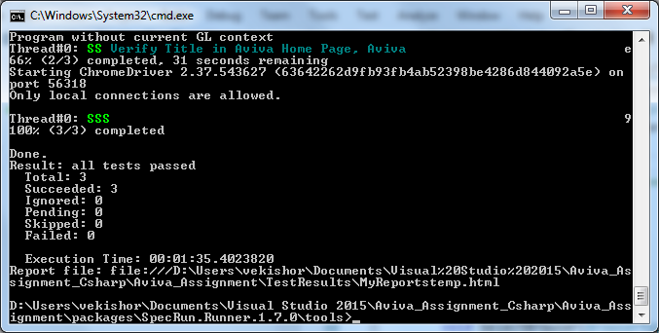

**Steps to Execute AvivaWebAssignment from Visual Studio IDE :**

1. **Extract Aviva Test Solution to a folder.**
2. **Click on AvivaWebAssignmentTest.sln to launch project in visual studio in 2015 IDE.**
3. **Build Project and click on “RUN ALL” . This will launch execution of 2 feature files positive and negative scenarios.**
4. **Execution reports can be found in output console.**

Output Screenshot :

**Path: ex: D:\Users\vekishor\Documents\Visual Studio 2015\Aviva_Assignment_Csharp\Aviva_Assignment\TestResults**

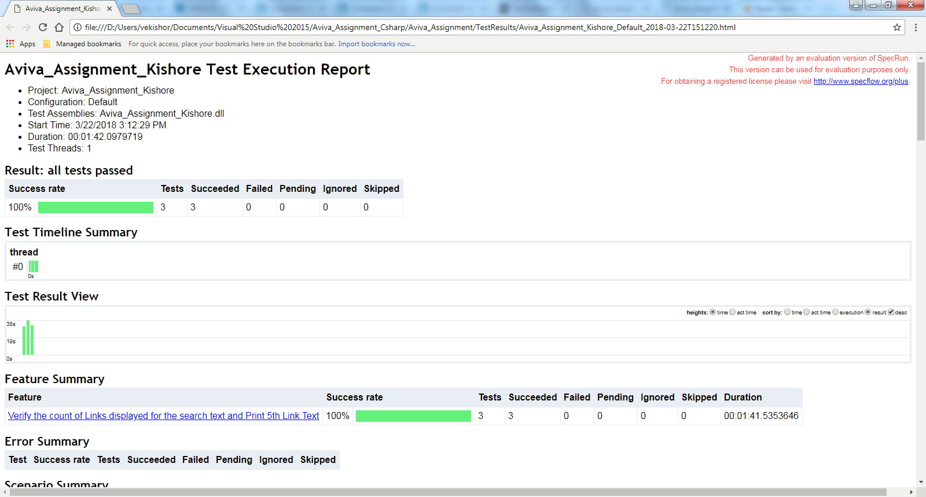

Extended Reports:

**Path: ex: D:\Users\vekishor\Documents\Visual Studio 2015\Aviva_Assignment_Csharp2\Aviva_Assignment\Aviva_Assignment_Kishore\Reports**

