Repair Options
Giving your customer a choice on how to fix each concern
User Guide · Vehicle Health Check

What are Repair Options?
Repair Options let you price up more than one way of fixing the same concern, so your customer can choose the alternative that suits them best.
For example, for a single concern — "Front brake pads worn" — you could offer two ways to put it right:
- Genuine Parts — manufacturer (OEM) pads, longer warranty, higher price
- OE Quality Parts — equivalent-quality aftermarket pads, lower price
Both options sit under the same concern. Each one carries its own labour and parts, so each gets its own price worked out automatically. You can highlight one as recommended, your customer picks the one they want, and the quote total updates to match their choice.

In short
One concern, several priced choices — the customer decides which one to go ahead with.

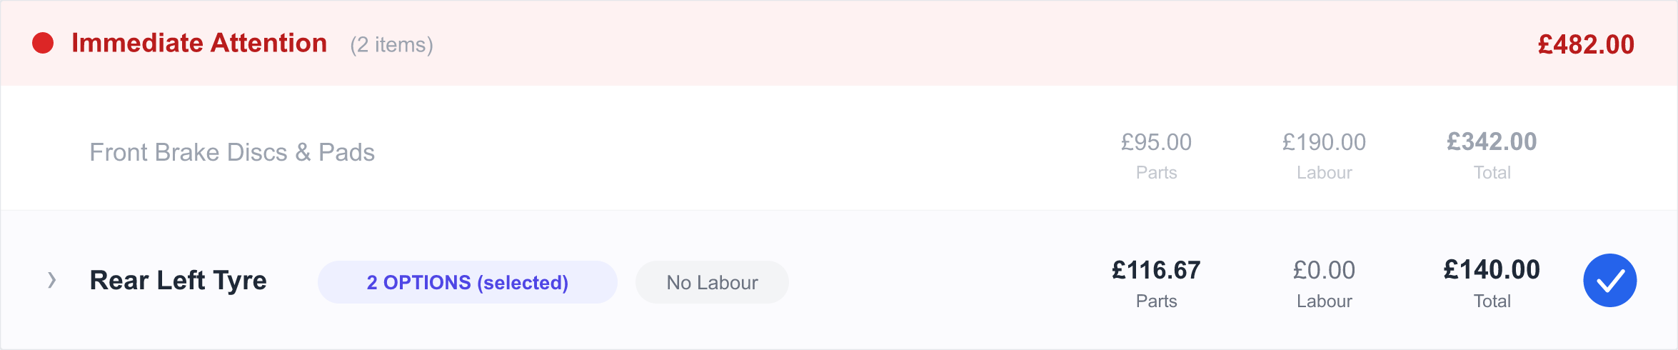
On the health check, a concern with options shows a "2 OPTIONS (selected)" badge and the chosen option’s price.

When would I use this?
Repair Options are ideal whenever there is more than one sensible way to carry out the same job. Common cases:
- Parts quality choices — Genuine vs OE quality vs budget parts
- "Good / better / best" — give the customer a price ladder to pick from
- Repair vs replace — e.g. refurbish an existing part or fit a brand-new one
- Warranty levels — a cheaper part now, or a premium part with longer cover

If a concern only has one sensible fix, you don’t need options at all — just price the labour and parts straight onto the concern as normal.

A few words you’ll see
Word | What it means
Concern | A single job or fault on the health check, such as "Rear Left Tyre". Sometimes called a repair item.
Option | One priced way of fixing that concern, such as "Premium Tyre". A concern can have as many options as you need.
Recommended | A label you can put on the option you’d suggest. It shows a badge and becomes the customer’s default choice.
Selected option | The option that has been chosen — by you or by the customer. This is the one that counts towards the quote.

Setting up options for a concern
Work through the concern on the health check, then follow these steps.

Step 1 — Open Manage Options
- On the concern you want to offer choices for, open Manage Options.
- If there are no options yet, you’ll see a prompt inviting you to add the first one.

Step 2 — Add each option
Click Add Option and fill in:
- Name (required) — for example Genuine Parts, OE Quality, Premium or Budget
- Description (optional) — a friendly note the customer will see, e.g. "OEM pads with a 2-year warranty"
- Mark as recommended (optional) — tick this on the option you’d suggest
Repeat for each alternative you want to offer.

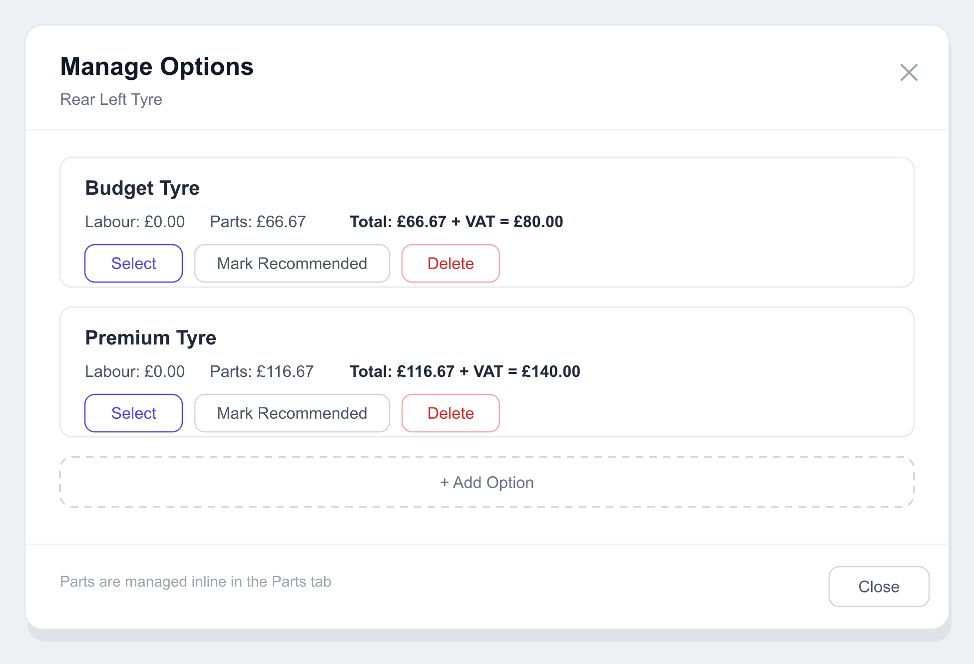
The Manage Options window — here one concern is priced two ways, Budget (£80) and Premium (£140).

Step 3 — Price each option
Add the labour and parts for each option in the Parts tab, where every option appears as its own section. Put the right parts and labour under each one.

No maths to do
As soon as you add or change labour or parts, each option’s totals — labour, parts, VAT and the final price — are worked out for you automatically. There’s nothing to add up or re-save by hand, and VAT-exempt items (such as MOT) are handled correctly.

Step 4 — Recommend one (optional)
Use Mark Recommended on the option you’d suggest. It gets a RECOMMENDED badge and becomes the option your customer sees selected first.

What your customer sees
When the quote reaches the customer’s online portal, any concern with options is shown as a choice rather than a single price.
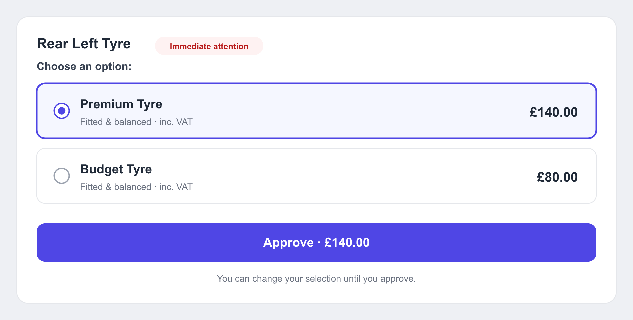
In the portal the customer picks an option, then approves — the price updates to match their choice.
- Each option appears with its name, your description and its full price (including VAT).
- The recommended option is ticked by default (or the first option, if you didn’t mark one).
- The customer selects the option they want.
- They approve (or decline) the option they’ve chosen.
- Once approved, their choice is locked in and shown clearly, for example "Selected: Premium Tyre".

Their choice comes straight back to you, so your screen and the final quote always reflect exactly what the customer picked.

How the choice affects the quote
The quote total is always built from the option that has been selected:
- If a concern has a selected option, its chosen option’s price is used.
- If a concern has no options, its normal price is used as usual.
So the grand total is never misleading — it reflects the alternatives your customer actually chose. If they switch from Premium to Budget, the total updates straight away.

A complete example
Offering a Premium and a Budget tyre on one concern.
- A technician flags "Rear Left Tyre" (red) on the health check. It becomes a concern.
- You open Manage Options and add two options:
  - Budget Tyre — a quality budget tyre, fitted & balanced
  - Premium Tyre — a premium branded tyre — marked recommended
- You add the parts to each option. The totals work themselves out:

Option | Labour | Parts | Total (inc VAT)
Budget Tyre | £0.00 | £66.67 | £80.00
Premium Tyre RECOMMENDED | £0.00 | £116.67 | £140.00

- You send the quote. In the portal the customer sees both choices, with Premium ticked first because it’s recommended.
- The customer chooses Budget Tyre to save money, and approves it.
- The quote total updates to the Budget price (£80.00), and your screen shows the customer chose Budget Tyre. The line is locked as approved.

Good to know
Handy tips
Labour and parts are added in the Parts tab — not inside the Manage Options window, which is for naming, recommending and selecting options.
Each option’s price stands alone — parts and labour belong to one option only, so prices never get mixed up or double-counted.
You can add as many options as you like — two is typical, but there’s no limit if a concern needs more.
Removing the chosen option is safe — the concern simply falls back to its normal price; nothing breaks.
You can choose on the customer’s behalf — handy when you’re taking the decision over the phone.

Screens shown are illustrative recreations of the live app, using real example data.

