DAD HEALTH
Brief Addendum A — Merge Score into Today
Amends: Next Milestone Brief — Dad Health Journey & Personalisation · September 2026
For Khushbu Baloch · From Jamie Smith · Dad Health Ltd

Overview
The Score tab and the Today tab currently show the same information — the same score ring, the same pillar bars, the same trends — and in several places they now disagree with each other. This addendum removes the Score tab and defines exactly where every element on it moves to, so that nothing is lost and every number comes from one place.
THE RULE
Today shows today: how the dad is doing, and the one thing to do next.
Anything historical lives in one of two places — the Score detail sheet (opened by tapping the score ring) or the relevant pillar tab (Mind, Body, Bond).
Every score number in the app is read from one shared source. No screen calculates its own score.

WHAT THIS CHANGES IN THE MAIN BRIEF
Decision 1 is answered: five tabs, not six (see A1).
Change 01 — the Today hierarchy is replaced by the version in A4.
Change 04 — upgrade moments 5 and 6 move location (see A9).
All other sections of the main brief stand as written.

Current state
Score tab — top to bottom:
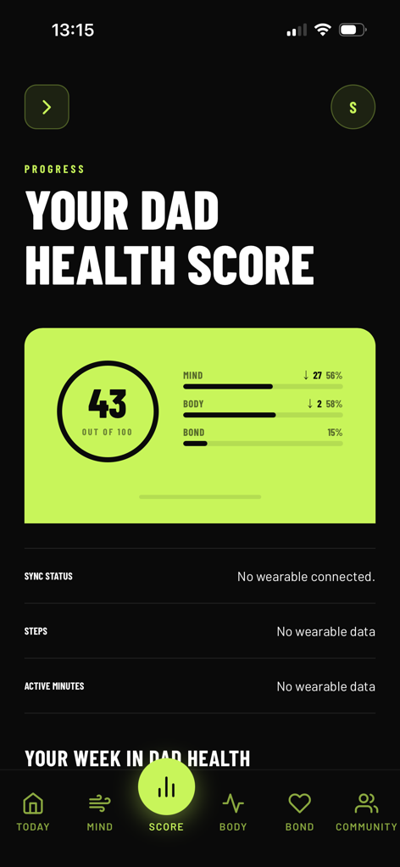 | 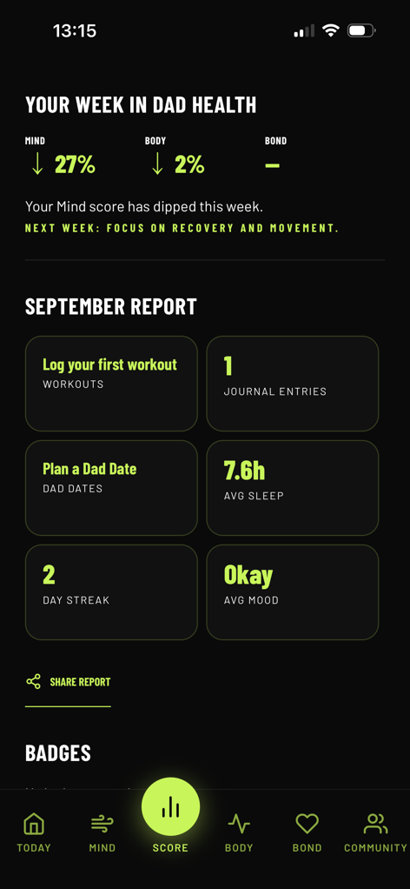 | 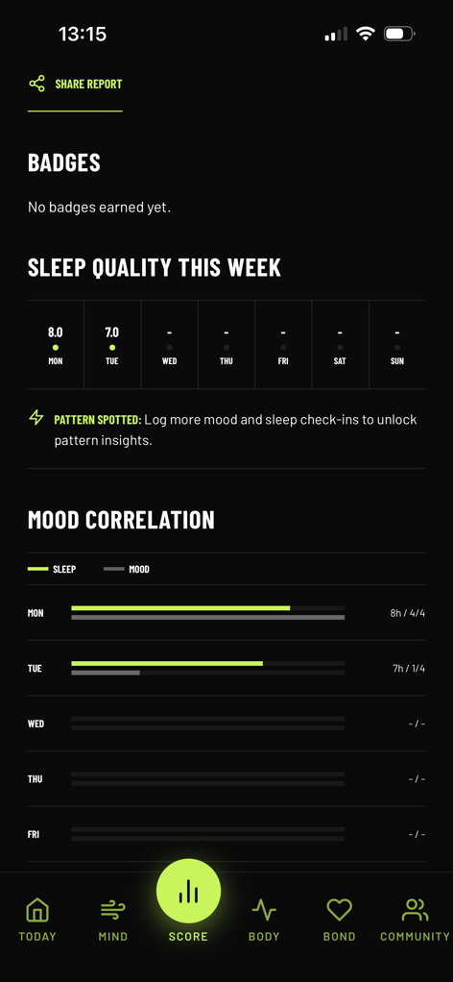
Fig 1. Score — score card, wearable rows | Fig 2. Score — weekly card, September report | Fig 3. Score — badges, sleep, mood correlation
Today tab — top to bottom:
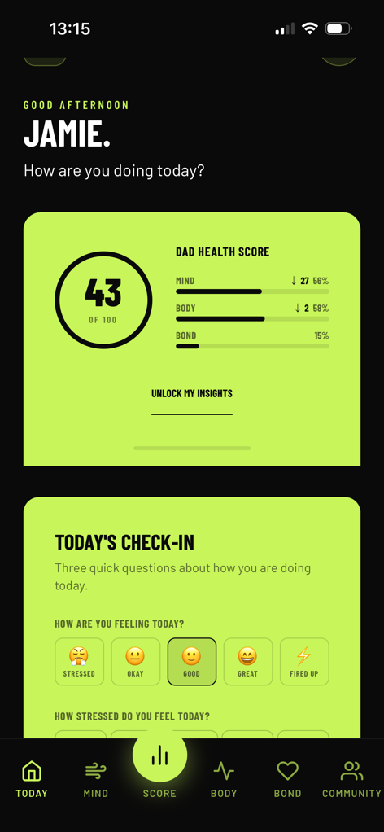 | 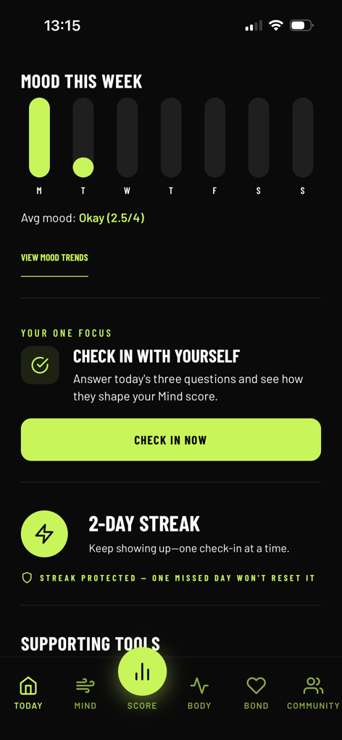 | 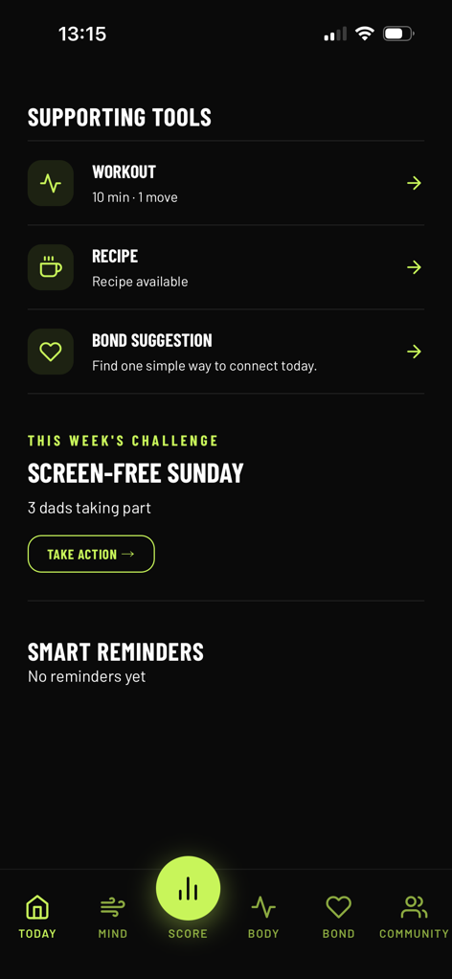
Fig 4. Today — greeting, score card, check-in | Fig 5. Today — mood this week, one focus, streak | Fig 6. Today — supporting tools, challenge
The score card in Fig 1 and Fig 4 is the same component rendered twice. Fig 2 and Fig 3 contain the only content unique to the Score tab.

A1 — MUST
Navigation: Five Tabs
Answers Decision 1 in the main brief

Position | Current | New
1 | Today | Today
2 | Mind | Mind
Centre (raised) | Score | + LOG (quick action, not a tab) — see note
3 | Body | Body
4 | Bond | Bond
5 | Community | Community

- Remove the Score tab and its route. Any deep link, notification or push that currently opens Score should open Today with the Score detail sheet expanded.
- Recommended: reuse the raised centre button as a + LOG action. Tapping it opens a bottom sheet with three options — Log workout, Log Bond time, Log Mind activity — which open the manual logging forms from Change 07. This puts the new free core feature in the most prominent position in the app. Jamie to confirm before build; if not confirmed, the centre slot is removed and the bar becomes five equal tabs.

A2 — MUST
One Source of Truth for the Score
Fixes the conflicting numbers between screens

All score values — total, three pillars, week-on-week trends, weakest pillar and recommended action — must come from a single score service (for example, one shared hook or query such as useDadHealthScore) backed by one Supabase view or function. Every component listed below reads from it; none recalculates.
Consumer | Reads
Today score card | Total, pillar %, trend per pillar, weakest pillar
Your One Focus | Weakest pillar → recommended action (Decision 3 mapping)
Weekly card (Your Week in Dad Health) | Pillar trends for the agreed window (Decision 2), weakest pillar → next-week focus
Score detail sheet | All of the above plus history
Pillar tabs (Mind, Body, Bond) | That pillar's score and trend

- Recalculation triggers stay as specified in Change 07: on every new log, on check-in submission, and nightly.
- Trend display format, used everywhere: pillar score first, then arrow and change — e.g. MIND 56 ↓27%. The current "↓ 27 56%" reads as two unrelated numbers.

A3 — MUST
Data Transfer Map
Every element on the Score tab and where it goes

Element (current Score tab) | Fig | New home | Free / Pro | Notes
Score ring + Mind / Body / Bond bars | 1 | Today (already there) | Free | Delete the duplicate. Tapping the ring opens the Score detail sheet.
Sync status, Steps, Active minutes | 1 | Body tab | Free | Hide all three rows when no wearable is connected. Show a single "Connect Apple Health" card instead.
Your Week in Dad Health | 2 | Today — weekly card | Pro (tease for free) | Upgrade moment 7. Timing per Decision 5.
September Report tiles | 2 | Score detail sheet | Pro (locked preview) | This is the Monthly report card in Section 5. Replace "Plan a Dad Date" tile (see A8).
Share Report | 1, 2 | Score detail sheet | Free | One Share button only — currently appears twice.
Badges | 1 | Score detail sheet | Free | Empty state should show the first badge to earn, not "No badges earned yet".
Sleep quality this week | 3 | Mind tab | Free | Below the action-first block (Change 02).
Mood correlation + Pattern spotted | 3 | Mind tab | Pro (locked preview) | Counts as "mood history and pattern insights" in Section 5.
Mood This Week (currently on Today) | 5 | Mind tab | Free | Moved off Today to keep it focused. VIEW MOOD TRENDS stays as the Pro entry point.

A4 — MUST
Today Screen — Updated Hierarchy
Replaces the table in Change 01

Position | Element | Detail
1 | Greeting | Good [morning/afternoon/evening], [name]. How are you doing today?
2 | Dad Health Score card | Score ring, three pillars in the A2 format, weakest pillar highlighted. Tap anywhere on the card → Score detail sheet.
3 | Pro tease | Upgrade moment 1 / 6 — one line inside the score card, e.g. UNLOCK MY INSIGHTS →
4 | Daily check-in | Three questions. On submit, animate the Mind bar updating so the connection is visible.
5 | Your One Focus | One action for the weakest pillar (Decision 3). Once today's check-in is done, this must not show "Check in" again.
6 | Streak | As now. Streak protection line only shown if the user has it (see A8).
7 | Weekly card | Your Week in Dad Health — appears on report day only (Decision 5). Pro, with tease for free users.
8 | Supporting tools | Workout · Recipe · Bond suggestion, as now.
9 | This week's challenge | As now.

Removed from Today: Mood This Week (moved to Mind), and the Smart Reminders section whenever it is empty — do not show "No reminders yet".

A5 — MUST
Score Detail Sheet
New — replaces the Score tab

A full-height bottom sheet opened by tapping the score card on Today. It is where a dad goes to understand his score. It is not a tab.
Order | Section | Free | Pro
1 | Score + pillars (same component as Today, larger) | Yes | Yes
2 | What feeds each pillar — one line each (e.g. "Mind: check-ins, journal, Mind logs") | Yes | Yes
3 | Upgrade moment 6 — "You've improved your Body score by 6% this week. See what's driving your score →" | Tease | —
4 | Score trend history (4+ weeks) | Locked preview | Yes
5 | Monthly report card (the current September Report) | Locked preview | Yes
6 | Badges | Yes | Yes
7 | Share report | Yes | Yes

A6 / A7 — MUST
Mind and Body Tab Additions
Receiving content from the Score tab

A6 — Mind tab
Add below the action-first opening from Change 02, in this order: Mood This Week (free), Sleep Quality This Week (free), Mood Correlation with Pattern Spotted (Pro, locked preview for free users). Action always stays above data.

A7 — Body tab
Add a Wearable section below the three feature cards from Change 06. If no wearable is connected, show one card: "Connect Apple Health to add steps and active minutes to your Body score." with a full-width lime CONNECT button in the Change 06 format. If connected, show Steps and Active minutes. Sync status moves to Settings.

A8 — MUST
Conflicts to Fix During the Merge
Found by comparing Fig 1–6

# | Issue | Where | Fix
1 | Three different recommendations. Bond is lowest (15%) but One Focus says check in (Mind) and the weekly card says "recovery and movement" (Body). | Fig 2, 5 | All recommendations come from the weakest-pillar logic in A2 (Decision 3 mapping). With these numbers, Bond action should show.
2 | Trend reads as two numbers: "↓ 27 56%". | Fig 1, 4 | Use A2 format: MIND 56 ↓27%.
3 | Bond shows 15% on the score card but "–" on the weekly card. | Fig 1, 2 | Both read from the A2 source. If there is no prior-week Bond data, show the score with a neutral trend, not a dash.
4 | "Plan a Dad Date" tile — Dad Dates is removed from scope. | Fig 2 | Replace with "Log Bond time" → opens manual Bond logging.
5 | Weekly report and "Streak protected" are shown — both are Pro-only in Section 5. | Fig 2, 5 | Confirm gating is correct for a free account. Free users see the tease only.
6 | Check-in has 5 mood options but mood is scored out of 4 ("2.5/4", "1/4"). | Fig 3, 4, 5 | Store mood 1–5 to match the five options. In the UI show the label ("Okay"), not the fraction.
7 | Share Report appears twice on the Score tab. | Fig 1, 2 | One Share button, in the Score detail sheet.

A9
Amendments to the Main Brief
For clarity when reading the two documents together

Main brief reference | Amendment
Section 9, Decision 1 | Answered: five tabs — Today / Mind / Body / Bond / Community, plus + LOG centre action if confirmed.
Change 01 — home hierarchy | Replaced by A4.
Change 04 — moment 5 (Progress / trends) | Location becomes the Body tab and the Score detail sheet.
Change 04 — moment 6 (Score screen) | Location becomes the Score detail sheet (A5, row 3).
Change 03 — trend arrows | Display format as set in A2.

Acceptance checklist
- The Score tab no longer exists and no link or notification leads to a dead route.
- The same score, pillar values and trends appear on Today, the Score detail sheet, the weekly card and each pillar tab.
- With Bond as the lowest pillar, One Focus and the weekly card both recommend a Bond action.
- Every element in the A3 table is reachable in its new location.
- A free account sees locked previews (not blank space) for trend history, monthly report, mood correlation and the weekly report.
- No empty-state rows are shown for wearables or reminders when there is no data.
STILL NEEDED FROM JAMIE BEFORE BUILD
Confirm the + LOG centre button (A1).
Decisions 2, 3 and 5 from the main brief — conflicts 1 and 3 can only be fully fixed once the trend window and the weakest-pillar mapping are set.

