**WSL – Windows Subsystem for Linux (aka how you can run Linux Commands on Windows locally)**

For Windows users to enable WSL, you may need to do more than just  wsl --install .

**Here's the complete process: Windows 10 (Version 2004+) or Windows 11: Simple method:**

**Run as Administrator**

wsl --install

**Restart computer**

Windows 10 (Older versions) or if above fails: Manual method: Enable Windows features:

**Run as Administrator**

**Open up powershell as admin - dism.exe /online /enable-feature /featurename:Microsoft-Windows-Subsystem-Linux /all /norestart dism.exe /online /enable-feature /featurename:VirtualMachinePlatform /all /norestart**

**Restart computer** Download WSL2 kernel update:

Go to: <https://aka.ms/wsl2kernel>:

* Download and install the update
* **Set WSL2 as defaul**t:
  + wsl --set-default-version 2
* **Install Ubuntu**: wsl --install -d Ubuntu

**Alternative GUI Method**:

1. **Windows Features**:
   * Press  Windows + R ,
   * type  optional features
   * Check "Windows Subsystem for Linux"

* Check "Virtual Machine Platform"

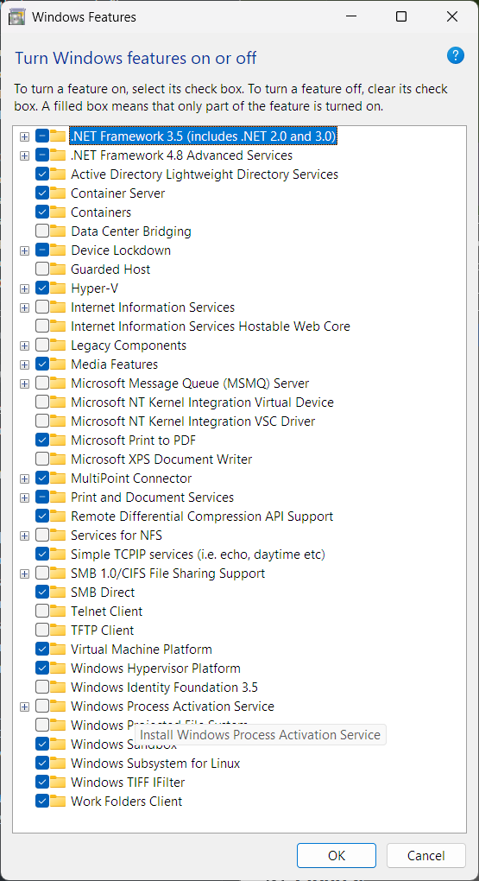

* **Restart computer**

1. **Microsoft Store**: Open Microsoft Store:
   * + - * Search "Ubuntu"
         * Install Ubuntu 22.04 LTS

(***Requirements: Windows 10 version 2004+ (Build 19041+) or Windows 11***)

* + **Administrator** **privileges**
  + **Virtualization enabled in BIOS** (usually enabled by default)

**Note:** Most modern Windows systems can use the simple  wsl --install  command, but older versions need the manual steps.