# Contact Details Management System

Create a dynamic web application that allows the user to store multiple contact details in a database table. The application also lists all the contact details and allows the user to delete individual contact details.

When the application is run for the first time, since the table does not have any data, the following form is shown, using which, the user can add a contact details of a person.

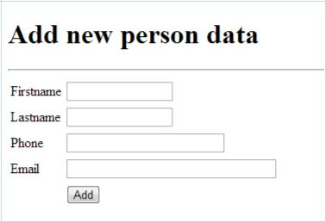

Once the user fills some details and clicks the “Add” button, the data is stored in the database table. Also, the data added to the database table is retrieved and shown below the form (ref picture below).

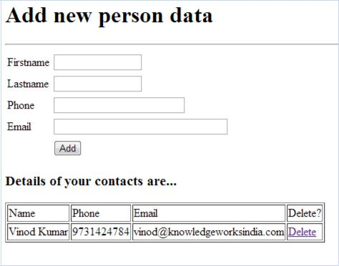

Note that the “Name” column shows the concatenated firstname and lastname.

After adding few details, the page looks like this:

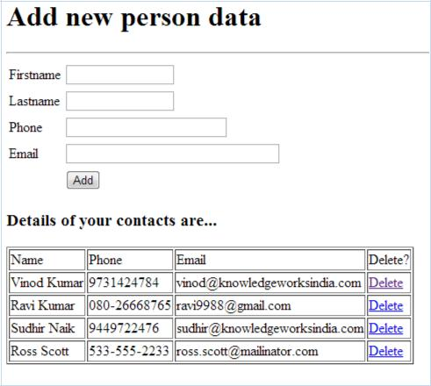

On clicking the “Delete” hyperlink, the corresponding record should be deleted from the database table. For example, clicking the “Delete” link for “Ravi Kumar”, would result in the following page:

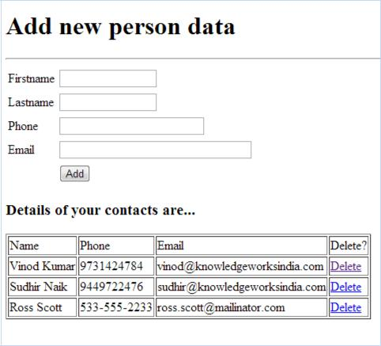

You must use the following classes for the implementation of the above logic:

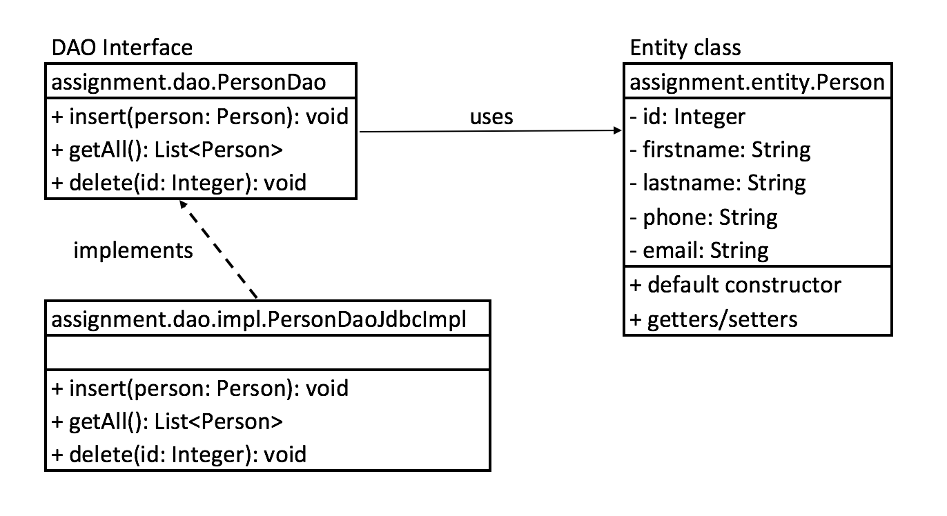

Hint:

1. Keep an object of the DAO implementation in the user’s session, so that the data is preserved for each user, in his/her session scope.
2. Other files you may have to create are:
   1. index.jsp (for the form)
   2. showPersons.jsp (includes the index.jsp and displays all the persons)
   3. com.unisys.web.FrontController (servlet to handle requests)

Mandatory:

1. DO NOT USE JAVA IN JSP (USE EL/JSTL)
2. DO NOT PRODUCE HTML CONTENT FROM SERVLET (MUST ADHERE TO MVC)