2022-02-22

p_high = 0.99999

xmin = 152840.0

alpha = 2.1167241847000158

sigma = 0.07997027988632402

D = 0.13335789937581355

(-32.131601438565184, 9.160434420163935e-09)

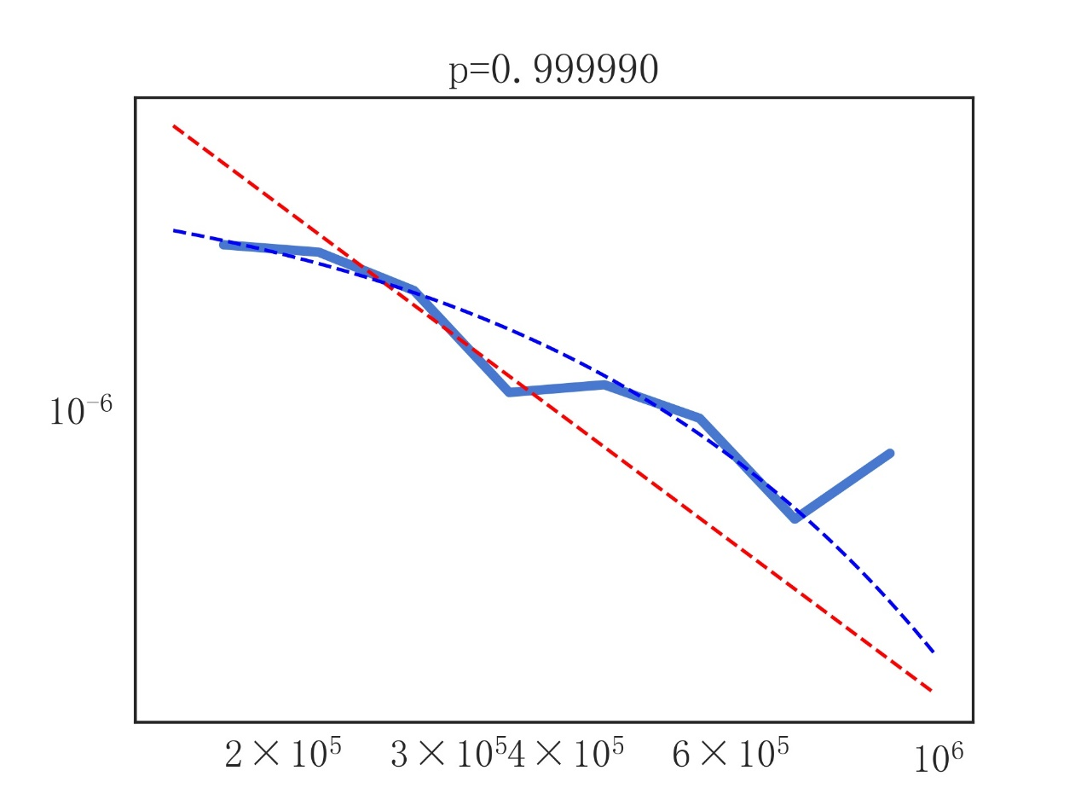

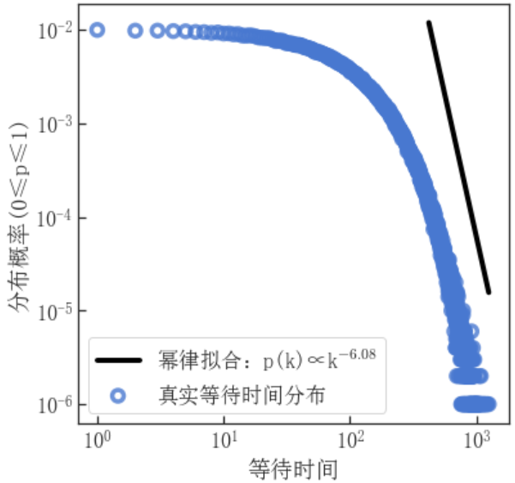

p_high = 0.00001

xmin = 419.0

alpha = 6.077884213458618

sigma = 0.04156061644854193

D = 0.04020383110247017

(-138.35359185873352, 2.8663603708425654e-17)

