## Library Module – Shared Library

1. Create 3 files as below.
   * libapplication.c – will contain main() and will invoke functions in cal_utility.c

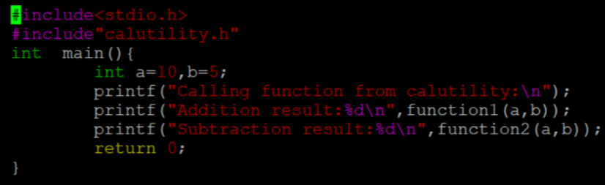

* + cal_utility.c – will contain atleast 2 or more functions [ You may add definitions of the functions in this file ]

* + cal_utility.h – will contain the extern declarations/prototypes of the functions in cal_utility.c

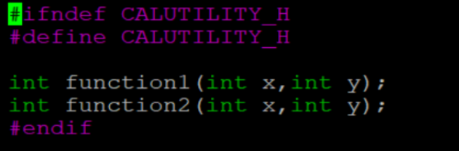

1. Refer the steps for shared library and create a shared library comprising of cal_utility.c,.h files

Ans) >>gcc -FPIC -c calutility.c

>>gcc -shared -o libcalutility.so calutility.o

1. Create an executable using shared library.

Ans) >>gcc -o apllication libcalutility.c -L. lcalutility

1. Execute the application created step 3.

Ans) >>./application

