## Commands Utilities

This assignment expects the participant to identify specific command(s) OR perform the given action using one or commands as per the given question. You are requested to maintain the answers (i.e. command(s) as per given question) for all questions below.

**Mandatory Questions**

1. Which command is used to know the current working directory?

Ans) pwd

1. How would you find out its contents?

Ans) ls

1. Identify the commands with inputs to do the following
   1. create a directory d1
   2. create a subdirectory d2 in d1
   3. change to directory d2
   4. create an empty file “f1.txt”
   5. display the contents of “f1.txt”
   6. view the contents of d1 from current directory d2

Ans)

1. Use the ls command with its options. How will you identify directories from the listing?

Ans) ls ../

1. Use ls to do the following
   1. List files with single character names. Ans) ls ?
   2. List hidden files also. [ Note: Hidden files are files having name started with a “.”] Ans) ls -a
   3. Suppose there are files tb1.1, tb2.1, tb3.1, ….tb10.1. Write command to list all the files [Hint: use wild card characters] Ans) ls tb*.1
2. Write the command to list all files in descending order of their size.

Ans) ls -lS (will give files in ascending order) so we can use reverse to get descending order i.e. ls -lSr

1. Suppose there are files temp1, temp2, temp3. Write command to remove the files without listing them explicitly

Ans) rm temp*

1. Which command is used to list top few lines in the file?

Ans) head -n file

1. Create a directory “testdir”

Ans) 

1. Use cp command to do the following
   1. Copy the file tb1.1 (created above) in the same directory.
   2. Write a command to copy all the files i.e tb1.1,tb2.1,tb3.1,…..tb10.1 in a new directory –“new”
   3. Create a subdirectory in new in named “new1”.
   4. Write a command to copy selectively only tb2.1, tb6.1, tb7.1 and tb10.1 in the directory new1.
   5. Write a command to copy the entire directory “new” to a directory “newprogs”. [Note: use the –R option of “cp” command]

Ans) 

cp source destination

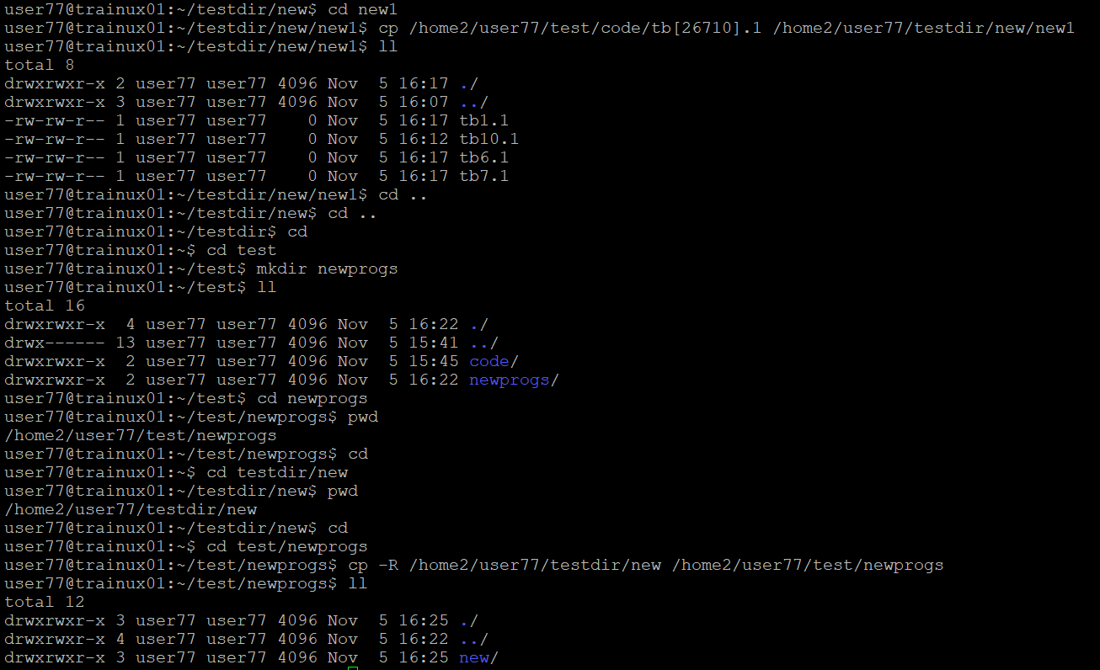

1. Find out the difference between
   1. “mv” & “cp”
   2. “rm”, “rmdir”
   3. “mkdir” and “mkdir -p”

Ans) a) mv : moves or renames files/directories. Deletes original after moving.

cp : copies files/directories. Keeps original file intact

b) rm : delete files or directories. Permanently deletes and have no recovery.

rmdir : deletes only empty directories. Fails if the directory is not empty.

c) mkdir : creates a new directory. Fails if the directory already exists.

Mkdir -p : creates a directory and necessary paret directories.

1. Use a single command rmdir once to remove “testdir” and all its sub directories and files created above.

Ans)

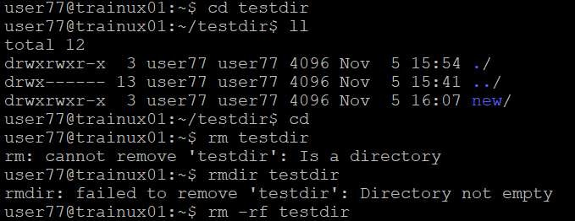

We can’t do because the directory is not empty.

1. Which command is used to get the manual information of a command?

Ans) man command

1. If you are not able to change to a directory what could be the likely cause?

Ans) the cause can be like directory does not exist, incorrect path, insufficient permissions, file instead of directory,too many symbolic links and current directory limits.

1. Explain the differences among the following commands:  
                 a. cd / : changes to root directory

  b. cd .. : change to parent directory

  c. cd : change to home directory

  d. cd ../..  : change to grandparent directory

**Advanced Optional Questions**

1. How could you display the inode number of a file? Ans) ls -i filename
2. What is the pipe symbol? What effect does it have?

Ans) the pipe symbol is a operator used to users to chain commands together to create compleax processing sequence.

Effect: chaining commands – it enables the output of one cmd to be processed by another without needing to write intermediate files.

1. Find out the details of “ps” command?

Ans) It is used to display information about currently running processes in the system. It stands for “process status”.