# Shell Script Assignment

**Mandatory:**

1. Create a script named “myscript” in current directory to do the following.
2. display “hello user” – cat command
3. list files in current directory – ls command
4. name of logged in user - whoami
5. date

Ans)

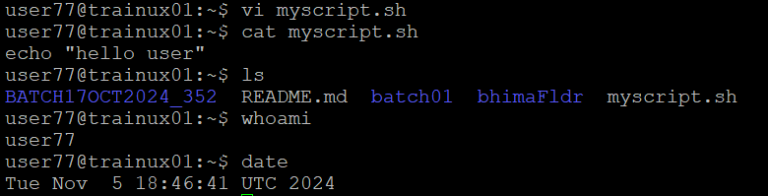

1. Add execute permission and Run the script from
2. current directory – “./myscript.sh” is used and to execute permission “chmod +x myscript.sh”

1. Create a subdirectory named “test” – “mkdir test” is used

Ans) 

1. Change to “test” directory. Run the script “myscript” [Hint: You will have to update PATH to include the directory containg script to run script from any location].

Ans)

