# grep Assignment

**Mandatory:**

1. Use any .c file. Using grep command extract and display
   1. all lines beginning with #include with line numbers

Ans) The file name is a1.c so to display all lines begin with #include , along with line numbers . we used grep command i.e

>>grep -n ‘^#include’ a1.c



* 1. display all lines which do not begin with #include

Ans) Not begin with #include we use -v (inverts the match, so it displays lines that do not match)

>>grep -v ‘^#include’ a1.c

* 1. display the line number of main()

Ans) we use -n which shows line number and ‘main()’ for search

>>grep -n ‘main()’ a1.c



* 1. extract all lines containing characters of opening and closing parathesis {(,))

Ans) to extract lines containing any of these characters {, (, }, or )

>>grep’[{}()]’ a1.c

1. Perform the above operations on a set of *.c files

Ans) If we want to perform above commands on multiple .c file we use *.c

>> grep -n ‘^#include’ *.c

>> grep -v ‘^#include’ *.c

>> grep -n ‘main()’ *.c

>> grep’[{}()]’ *.c

The below are the contents in day08

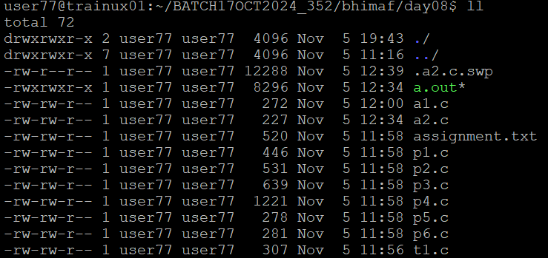

Performing commands in multiple *.c files

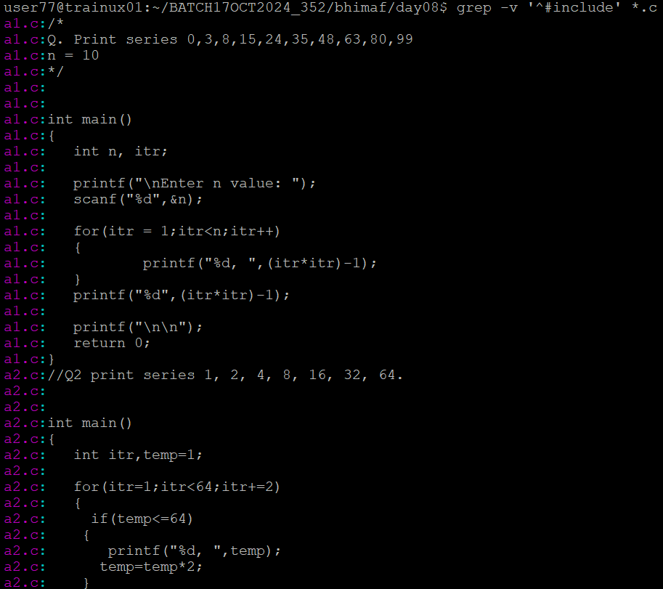

And so on code of multiple .c files

