# Printf Scanf Assignment

**Mandatory:**

Q1. WAP with

1a. function readdisplay() to read the following data types only one at a time at run time and to display.

1. char type
2. integer type
3. char array of maximum 80 characters
4. short type
5. float type

TestData:

‘c’, 8978, “hello”, 8, 45.678

‘H’, 254, “hello Hi How”, 256, 145.2678

Ans) Code:

#include <stdio.h>

void readdisplay();

void readdisplay()

{

char c;

int i;

char str[50];

short s;

float f;

printf("Enter a character: ");

scanf("%c", &c);

printf("Enter a integer: ");

scanf("%d",&i);

printf("Enter a string: ");

scanf("%s", str);

printf("Enter a short integer: ");

scanf("%hd",&s);

printf("Enter of float: ");

scanf("%f",&f);

printf("\'%c\', %i , \"%s\", %hd, %.4f", c, i, str, s, f);

}

int main()

{

readdisplay();

return 0;

}

1b. Create a copy of readdisplay() as function readdisplay2() with changes below

* Instead of reading 1 data at a time, read all inputs using a single scanf().

Test readdisplay2() by changing the read order. Do you observe any issue?

Code:

#include <stdio.h>

#include <string.h>

void readdisplay(char, int, char [], short,float);

void readdisplay2(int, char, float, char [], short);

void readdisplay(char c, int i, char str[], short s, float f)

{

printf("readdisplay: \'%c\', %i , \"%s\", %hd, %.4f\n", c, i, str, s, f);

}

void readdisplay2(int i, char c, float f,char str[], short s)

{

printf("readdisplay2: %i, \'%c\', %.4f, \"%s\", %hd", i, c, f, str, s );

}

int main()

{

char c;

int i;

char str[50];

short s;

float f;

printf("Enter a character: ");

scanf("%c", &c);

printf("Enter a integer: ");

scanf("%d",&i);

printf("Enter a string: ");

scanf("%s", str);

printf("Enter a short integer: ");

scanf("%hd",&s);

printf("Enter of float: ");

scanf("%f",&f);

readdisplay(c, i, str, s, f);

readdisplay2(i, c, f, str, s);

return 0;

}

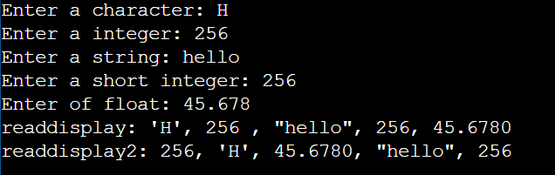

1c. display the char array content in upper case

Ans) Code:

#include <stdio.h>

#include <string.h>

#include <ctype.h> // for toupper

void readdisplay(char, int, char [], short,float);

void readdisplay2(int, char, float, char [], short);

void readdisplay(char c, int i, char str[], short s, float f)

{

int j;

char upper[50];

for(j=0;str[j] != '\0';j++)

upper[j]=toupper(str[j]);

upper[strlen(str)]='\0';

printf("readdisplay: \'%c\', %i , \"%s\", %hd, %.4f\n", c, i, upper, s, f);

}

void readdisplay2(int i, char c, float f,char str[], short s)

{

int j;

char upper[50];

for(j=0;str[j] != '\0';j++)

upper[j]=toupper(str[j]);

upper[strlen(str)]='\0';

printf("readdisplay2: %i, \'%c\', %.4f, \"%s\", %hd", i, c, f, upper, s );

}

int main()

{

char c;

int i;

char str[50];

short s;

float f;

printf("Enter a character: ");

scanf("%c", &c);

printf("Enter a integer: ");

scanf("%d",&i);

printf("Enter a string: ");

scanf("%s", str);

printf("Enter a short integer: ");

scanf("%hd",&s);

printf("Enter of float: ");

scanf("%f",&f);

readdisplay(c, i, str, s, f);

readdisplay2(i, c, f, str, s);

return 0;

}

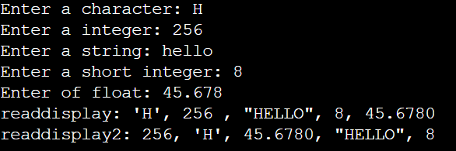

1d. Add code to display the size of each data type mentioned in Q1a and sizeof the variables of each datatype (You may refer sample code in data_type_size.c )

Ans) Code:

#include <stdio.h>

#include <string.h>

#include <ctype.h> // for toupper

void readdisplay(char, int, char [], short,float);

void readdisplay2(int, char, float, char [], short);

void size(int, char, float, char [], short);

void readdisplay(char c, int i, char str[], short s, float f)

{

int j;

char upper[50];

for(j=0;str[j] != '\0';j++)

upper[j]=toupper(str[j]);

upper[strlen(str)]='\0';

printf("readdisplay: \'%c\', %i , \"%s\", %hd, %.4f\n", c, i, upper, s, f);

}

void readdisplay2(int i, char c, float f,char str[], short s)

{

int j;

char upper[50];

for(j=0;str[j] != '\0';j++)

upper[j]=toupper(str[j]);

upper[strlen(str)]='\0';

printf("readdisplay2: %i, \'%c\', %.4f, \"%s\", %hd", i, c, f, upper, s );

}

void size(int i, char c, float f,char str[], short s)

{

printf("\nSizes of each type are int:%lu, char:%lu, float:%lu, string:%lu, short:%lu\n",

sizeof(int),sizeof(char),sizeof(float),sizeof(char[80]),sizeof(short));

printf("Sizes of each variable are int:%lu, char:%lu, float:%lu, string:%lu, short:%lu",

sizeof(i),sizeof(c),sizeof(f),sizeof(str[50]),sizeof(s));

}

int main()

{

char c;

int i;

char str[50];

short s;

float f;

printf("Enter a character: ");

scanf("%c", &c);

printf("Enter a integer: ");

scanf("%d",&i);

printf("Enter a string: ");

scanf("%s", str);

printf("Enter a short integer: ");

scanf("%hd",&s);

printf("Enter of float: ");

scanf("%f",&f);

readdisplay(c, i, str, s, f);

readdisplay2(i, c, f, str, s);

size(i, c, f, str, s);

return 0;

}

Q2. Try to run the program with code snippet below. Check the output and analyse. Fix it to get correct result.

#include<stdio.h>

int main()

{

unsigned long int ul = 200333333334340;

printf("value is:%d\n", ul);

return 0;

}

Ans) In the given code, the unsigned long int variable is ul is being printed with format specifier %d.

We need to use %ul in the print statement.

The correct output is:

Value is: 200333333334340