# Recursive Function Assignment

1. WAP to calculate the maximum stack depth of a recursive call to a function. (For eg a factorial function ).

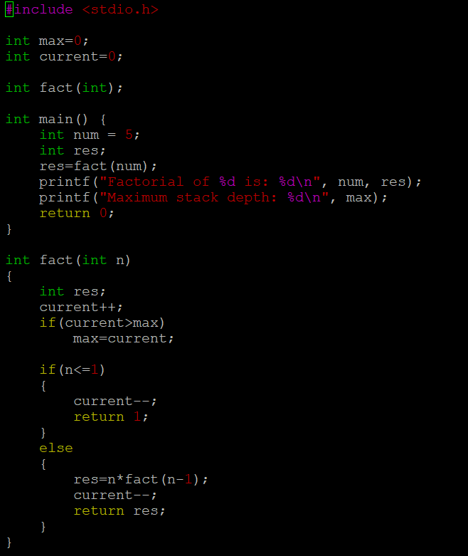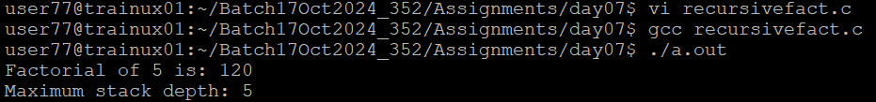

1. What is tail recursion? Why is it important? Give an example

Ans) Tail recursion refers to the recursive call is the last operation in the function, with no further computation after the call. This allows the function to reuse the current stack frame, making it more memory efficient.

It is important for optimization and prevents stacks overflow.

Example:

int factorial(int n, int a)

{

if (n <= 1)

return a;

return factorial(n - 1, n * a);

}

int factorial(int n)

{

return factorial(n, 1);

}