Multithreading – Thread Creation assignments

Mandatory

- Refer code in “simple_thread.c”.
- Modify the thread function to read and return username read from the user. Allocate heap memory for the user name and free in caller after displaying it.
- Display the thread id’s of parent and child thread
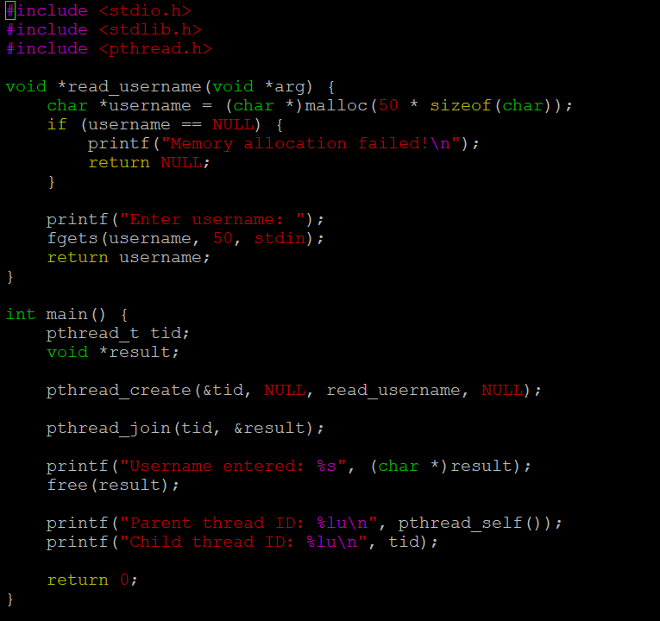
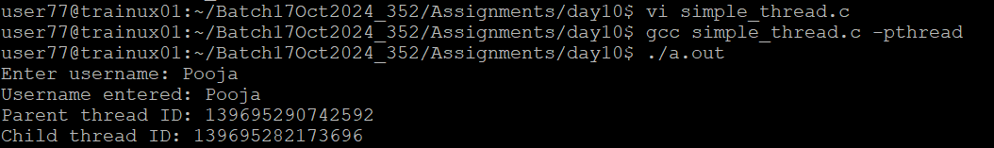
- Refer the code “pthread_creation.c”. Modify the existing functions as below.
- Main()- read a line of text and pass to new threadproc function below
threadproc() – to create 2 child threads to count words and to count characters, display the received values, return the values to the caller
Other thread functions to be used by threadproc() are given below
startroutine1()—to count words and return word count to caller
startroutine2() – to return the character count to the caller
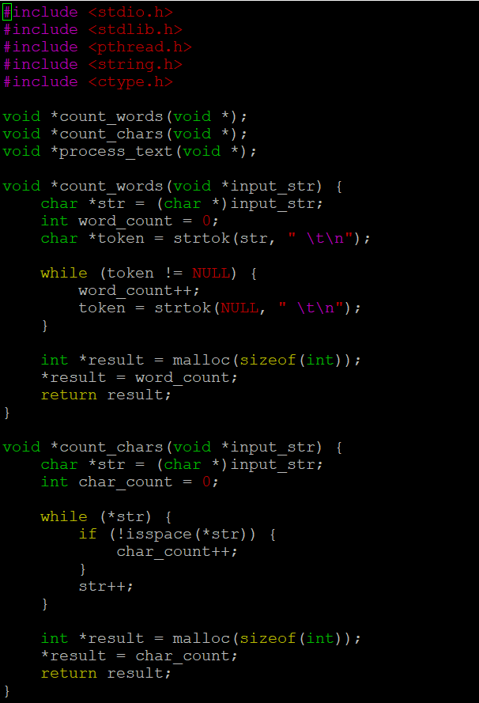
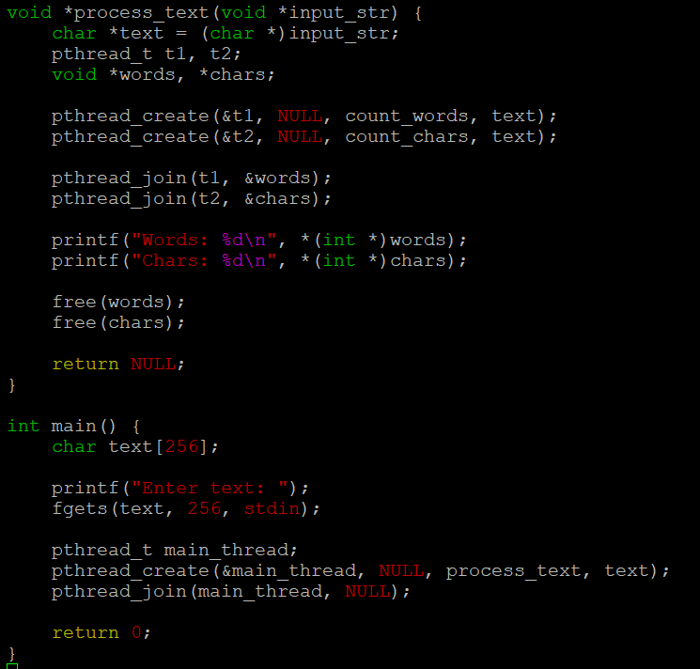
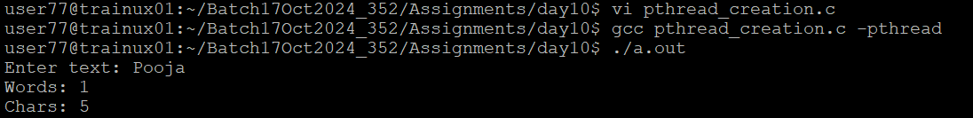

- Refer the program in “thread_prg.c”. Complete the TBD sections , check the final solution for memory leak if any
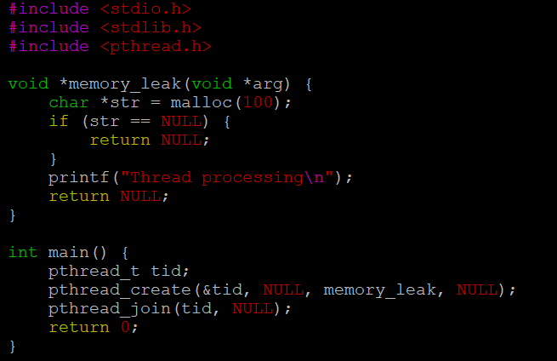

- Write a program
- to read a set of words as command line arguments and to create an array of threads (Consider a maximum of 5 words )
- process each word using an separate thread. Let each thread append “_ed” to the input word and return to main thread
- main thread to wait for completion of each thread, retrieve returned string display with thread number, free memory

