Vi Editor - Assignments
- Invoke the vi editor with a filename (which is to be created)
Ans) vi filename

- Type a few lines(at least 10) in the editor. Let one or more lines contain the words given below.
delhi mumbai chennai Mumbai
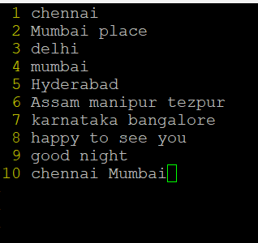

- Save the file without exiting the editor
Ans) :w will save the editor without exiting .

- Navigate quickly to the beginning & end of the file
Ans) Beginning navigation is “gg” in ESC mode
End of the file is “G”

- Delete first two lines & copy it after the last line.
Ans) Deleting first two lines is “2dd”
Copying it can be “p”
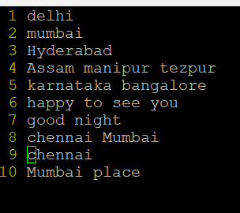
- Now Copy the last two lines & paste them before the first line.
Ans) copying back two lines is “2yy”
Pasting is “p”
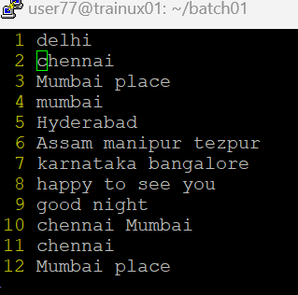

- Combine last two lines of the file in a single line.
Ans) 11 Join

- How will you insert a line before the first line? (Hint : Find such an option in the tutorial document)
Ans) by using ‘O’ we can insert a line
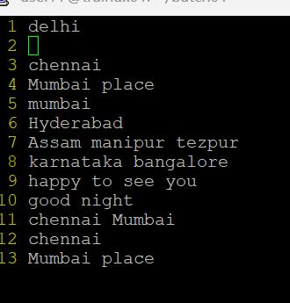
- How will you paste a yanked buffer before the current line?
Ans) use ‘|’ before the current line

- Search the document for a string “delhi”
Ans) in esc mode type “/delhi”
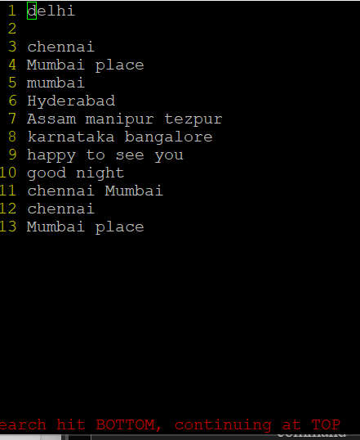

- Replace a single occurrence of “delhi” with “Mumbai”
Ans) in esc mode “:s/delhi/Mumbai”
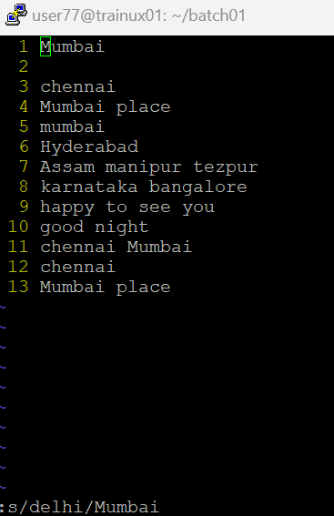
- Replace all occurrences of “delhi” on a particular line with “Mumbai” using one command
Ans) in esc mode “:s/delhi/Mumbai/g”
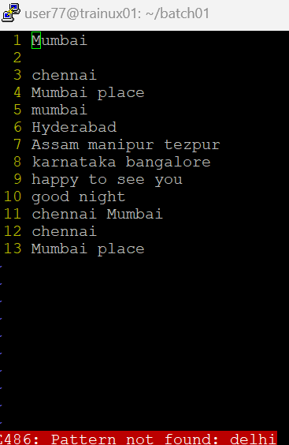
- Replace “delhi” with “mumbai” for the entire document using one command.
Ans) :1,$s/delhi/Mumbai/g
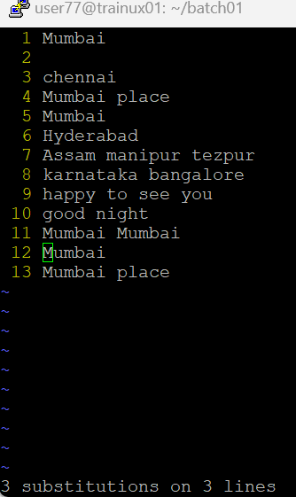
- Replace all occurrences of “delhi” with “mumbai” for part of a document (e.g. line number 13 to 37).
Ans) :n,ms/delhi/Mumbai
- Undo the above command
Ans) u
- Replace only the first occurrence of “delhi” with “mumbai” in each line, for part of a document (e.g. line number 13 to 37).
Ans) :1,$s/delhi/Mumbai
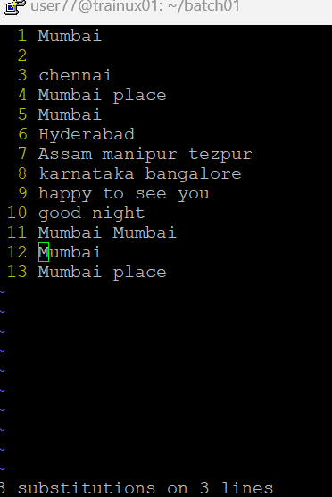
- Undo the above comment. Redo it. Undo it again.
Ans) for undo “u”
For redo “ctrl+r”

- Replace all occurrences of “delhi” with “mumbai” for complete file interactively.
Ans) :%s/delhi/Mumbai/gc
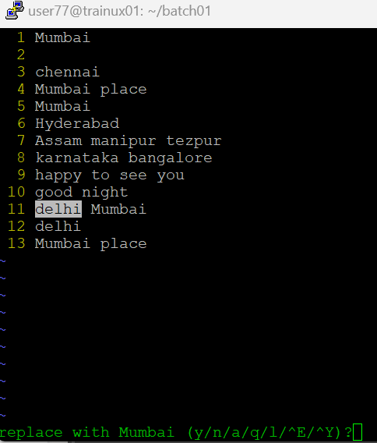
- Search for a word backwards. Loop through all matches.
Ans) searching word backword “?delhi”
“n” for loop

- Search for a word forwards. Loop through all matches
Ans) “/delhi”
- Join two lines together.
Ans) 4join
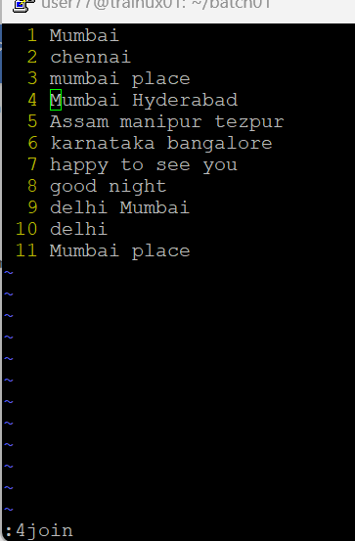
- Enable line numbering and then disable it
Ans) Enable: set number
Disable: set nonumber
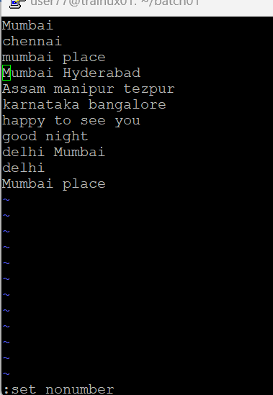
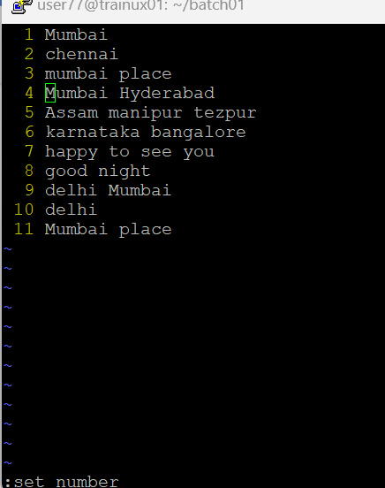
- Make the search case insensitive
Ans) /delhi\c
- Delete 4 lines (and then paste them somewhere else)
Ans) 4dd
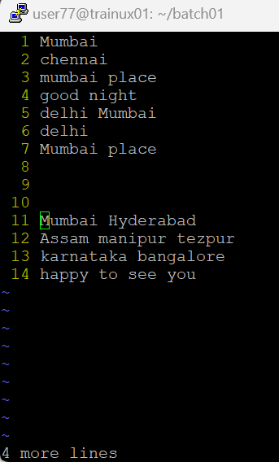
- What is the command to delete part of the line starting from the current cursor position?
Ans) d$
- What is the command to delete the current word?
Ans) :dw

