Code coverage practice session

Typographical conventions

We use the following conventions in this guide:
emacs The name of a specific command or file
file You should replace file with a specific name

Exit abc Output that you see on the screen

Getting Started with gcov

- Login into the Linux server with your login Ids
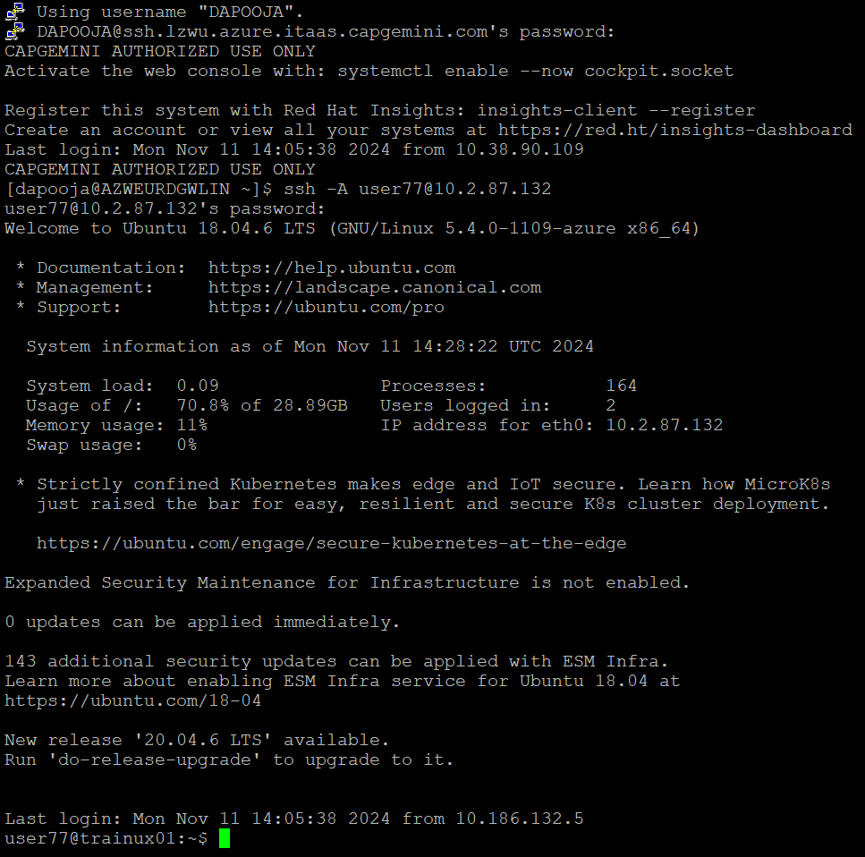

- Create a new directory called code_cov in your home directory <home>
mkdir code_cov

- Go inside the directory you have created in (2) /<home>/code_cov
cd code_cov

- Copy the following files from the path as mentioned by the trainer:
  - sample.c
  - link.c
  - link.h
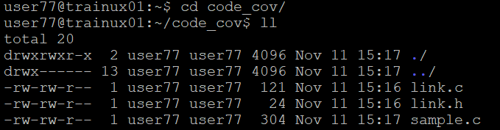

- Take a look at the example programs sample.c and link.c
We can display it by cat command
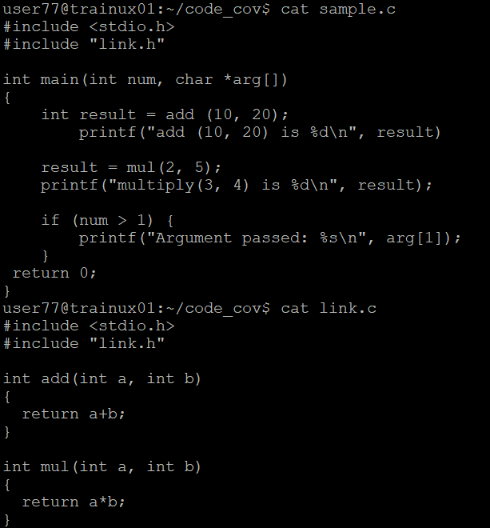

Compilation

- Compile the files sample.c and sample1.c and put the output in the executable file called output
gcc –o output –ftest-coverage –fprofile-arcs sample.c link.c

The .gcno file is generated when the source file is compiled with the GCC -ftest-coverage option and .gcda file is generated when a program containing object files built with the GCC -fprofile-arcs option is executed

Execution

- Execute the file output
./output
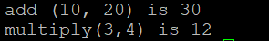

- Now run gcov for each source file one by one
gcov sample.c

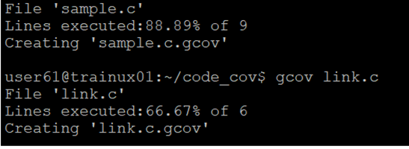

- Run output again, this time with command line arguments:
./output a a b b

Check!
oops
Check!

This function is just called to link this file
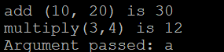

- Now run gcov for sample.c again

What do you observe?
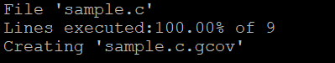

NOTE : If the code coverage is not 100% , it can be achieved by using gdb (For that, you need to compile with -g as well as -ftest-coverage -fprofile-arcs options)

