Thread Management using POSIX Library - Detachment and Cancellation assignments

Mandatory

- Write a program to create 3 threads with the detach and cancel status as below.

Thread# | Detached (Y/N) | Cancel type | Cancel status
1 | Y | PTHREAD_CANCEL_DISABLE
2 | N | PTHREAD_CANCEL_ENABLE | PTHREAD_CANCEL_DEFERRED
3 | N | PTHREAD_CANCEL_ENABLE | PTHREAD_CANCEL_ASYNCHRONOUS

- Let all the threads read and display their detach, cancel type and status and then display thread specific message as below.
T1: Display message in the format as below every 2 secs
<timestamp> Health OK
T2: Print numbers starting from 1000 in steps of 2 at an interval of 3 secs in format as below.
<timestamp> <threadid> <countvalue>

T3: Print numbers starting from 2000 in steps of 2 at an interval of 3 secs
<timestamp> <threadid> < countvalue >

- After creating threads, and after 3 minutes from main(), cancel all 3 threads
- From an other terminal, use command below to view the thread count of your program
    - ps -eLF
    - top
[For top command usage to refer https://www.golinuxcloud.com/check-threads-per-process-count-processes/ ]
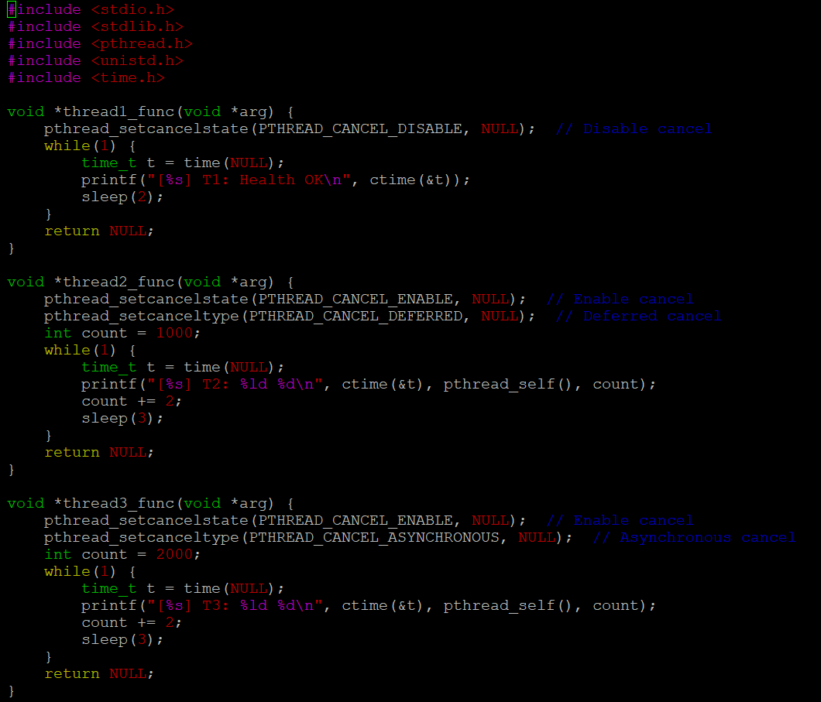
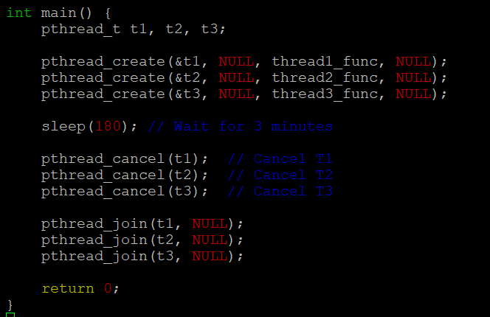

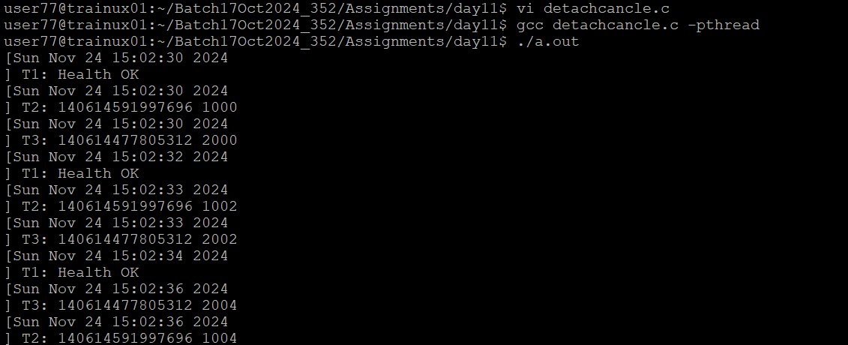

- What difference did you observe between top and ps command?
Ans) top shows real-time information about processes and threads, including CPU usage, memory, and more.
ps provides a snapshot of process/thread information at the time of execution.

- Which column shows the number of threads in ps and in top commands?
Ans) In ps, the number of threads is shown in the NLWP (Number of Light Weight Processes) column.
In top, threads are displayed under the TH (Threads) column.

- Check the last message timestamp from the threads
Ans) The last timestamp will be the time when the threads printed their final output before being canceled. This can be found in the last message printed by the threads (e.g., the last printf statement before cancellation).

- Which thread was cancelled first and why?
Ans) Thread 3 was canceled first because it was set to PTHREAD_CANCEL_ASYNCHRONOUS, which cancels the thread immediately upon pthread_cancel().

- Were all 3 threads cancelled? Justify the observation
Ans) Yes, all 3 threads were canceled. Thread 1 and 2, with deferred cancellation, were canceled when they hit a cancellation point (pthread_testcancel()), while thread 3 was canceled immediately due to its asynchronous cancellation type.

