Structure and Dynamic Memory Management assignments

Mandatory
- Refer the question 1 solved in “Structure and function”. Extend the above program to read a number of records from the user as a single command line argument (each record is delimited by a semicolon and record fields are delimited by comma) and store in an array of structures.
Sample input and output are given below.
Input: “user1,90;user21,100, userABC,56,userX,40”;
Output:
No. of records: 4
Record 1:
Name:user1, Percentage:90
Record 2:
Name:user21, Percentage:100
Record 3:
Name:userABC, Percentage:56
Record 4:
Name:userX, Percentage:40

Implement all required functions and call them to get the desired output.
Check for memory leak.
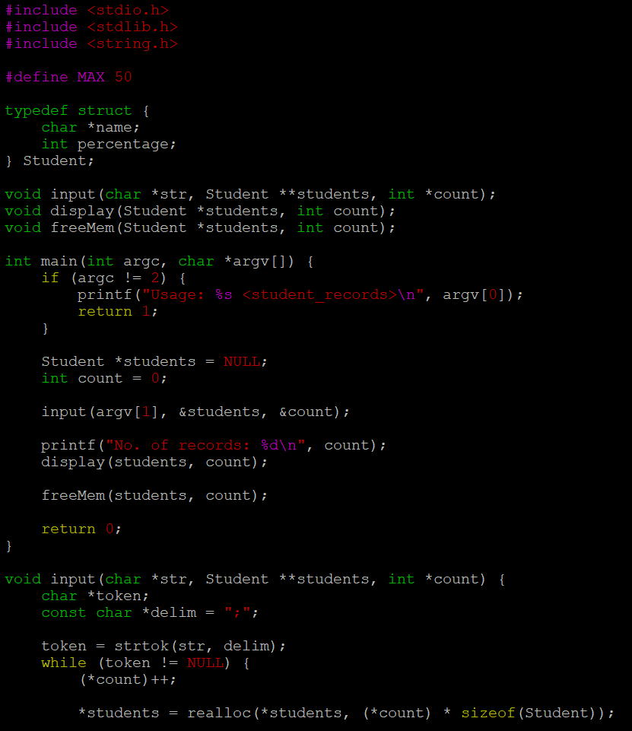
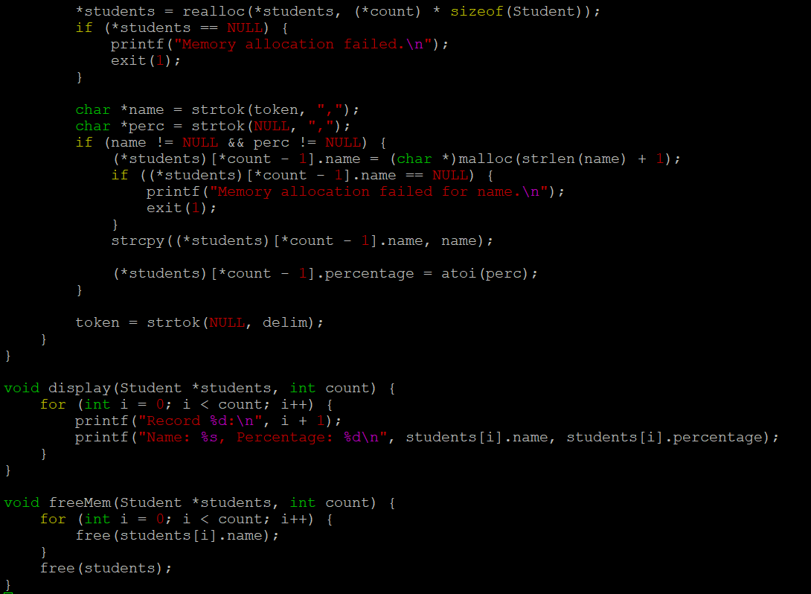
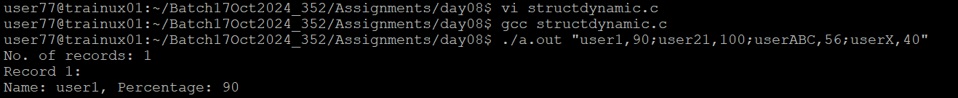
Attempt one of the following Questions below i.e 2a or 2b
2a. Extend Q1. Above and add 3 functions below.
//to search for a name and to replace it with a user defined name, return replaced string
char*search_update(char *searchstr, char *replacestr);

//search and delete the record with given name or percentage value, return SUCCESS on successful delete else FAILURE
int delete_record(char *searchstr, int percent);

//search for name and if found create a copy of the record in newstudent
and return SUCCESS, else FAILURE
int copy(char *name, struct student **newstudent);

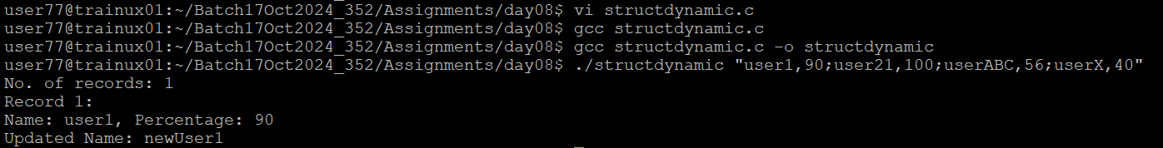
OR
2b. Refer the code in “structure_dynamic” and implement the functions below.
name_ret free_person()
name_ret update_person()

