Mini project for library Management System
Class Diagram & Short Report

Name | Elson Mashoro
Reg number | H250320A
Course | Object Oriented Programming
Lecturer | Mr Chiworera

1. Introduction
The Library Management System is a Java mini-project designed to bring together object-oriented programming concepts covered in the laboratory exercises. It models library items, registered members and borrowing transactions, and provides a menu-driven way to manage common library activities.
The project specification identifies class design, polymorphism, custom exceptions, collections and streams, file persistence, code quality, a class diagram and a short report as important assessment areas.

2. Objectives
- Represent books, DVDs, members and loans using classes with encapsulated fields.
- Use inheritance, abstraction and polymorphism to represent different library item types.
- Define a Borrowable interface for borrowing and returning items.
- Use custom exceptions to handle unavailable items and members exceeding the borrowing limit.
- Store items and members in maps keyed by their IDs and use streams for title searches and overdue-loan filtering.
- Save records to CSV files and reload them when the application starts.

3. Class Diagram
The diagram below represents the intended design of the implementation developed in this project. Inheritance, interface implementation and associations are shown by the relationships between classes.
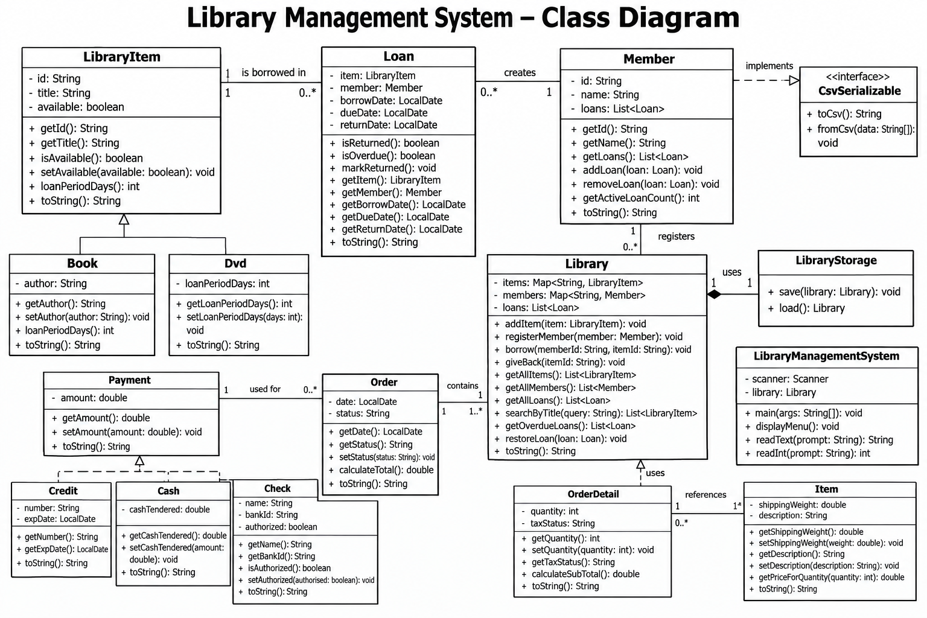

4. Main Classes and Responsibilities
Class / Interface | Responsibility
Borrowable | Interface declaring borrow(Member) and giveBack() operations.
LibraryItem | Abstract parent class containing the common item ID, title and availability status.
Book | A library item with an author and a 14-day loan period.
Dvd | A library item with a 7-day loan period.
Member | Stores member details and loan records; counts active loans.
Loan | Records the item, member, borrowing date, due date and optional return date.
Library | Maintains item/member maps and loan records; applies borrowing rules and searches records.
LibraryStorage | Saves and loads item, member and loan data using CSV files.
LibraryManagementSystem | Provides the terminal menu for library operations.
ItemNotAvailableException | Reports attempts to borrow an item that is already on loan.
MemberLimitExceededException | Reports attempts to exceed the maximum of three active loans.

5. Object-Oriented Design

5.1 Encapsulation
Class fields are private and are accessed through methods where appropriate. Constructors validate essential values such as item IDs, titles, member IDs and member names. This helps protect object state.

5.2 Abstraction and Inheritance
LibraryItem is abstract because it represents shared features of library items while leaving the loan period to concrete subclasses. Book and Dvd inherit common properties and provide their own loan-period implementations.

5.3 Polymorphism and Interfaces
The Library stores different item types using the common LibraryItem type. Calling loanPeriodDays() uses the implementation belonging to the actual item type. Borrowable defines the borrowing and returning operations that library items implement.

5.4 Exception Handling
ItemNotAvailableException and MemberLimitExceededException make two key borrowing failures explicit. The menu catches these exceptions and displays an explanatory message rather than terminating the application for these expected cases.

5.5 Collections, Streams and Persistence
HashMap collections provide ID-based lookup of items and members, while lists keep loan records. Streams support case-insensitive title searching and overdue-loan filtering. LibraryStorage writes items, members and loans to separate CSV files and reconstructs their relationships when loading.

6. System Functionality
- Add a book or DVD.
- Register a library member.
- Borrow an available item, subject to the three-active-loan limit.
- Return a borrowed item and record the return date.
- List overdue loans.
- Search for items by full or partial title, without case sensitivity.
- List all items, members and loan records.
- Save records to CSV on normal exit and reload them on startup.

7. Testing Summary
Use this checklist before submission and record actual results after running each test in your environment.
Test | Expected result
Add a book with a unique ID | Book appears in the item list.
Register a member | Member appears in the member list.
Borrow an available item | A loan is created and the item becomes unavailable.
Borrow the same item again | The system reports that the item is unavailable.
Attempt a fourth active loan for one member | The system rejects the operation.
Return an item | The item becomes available and its loan is marked returned.
Search by partial title | Matching items are shown in title order.
Exit and restart | Saved items, members and loan history are restored.

8. Limitations and Notes
The current design is a console-based application and uses local CSV files rather than a database. CSV persistence assumes the files are kept in the application's working directory. Test the final source files before submission. Possible future improvements include stronger validation for malformed CSV records, concurrent access controls, and saving after each operation rather than only on normal exit.

9. Conclusion
The Library Management System combines core Java object-oriented programming concepts with practical data handling. Its class structure separates item types, members, loans, library operations and CSV persistence. The project demonstrates encapsulation, abstraction, inheritance, polymorphism, interfaces, custom exceptions, collections, streams and file input/output in one application.

