

Declaration of Originality Form
This form must be completed and signed and submitted with all assignments.
Please complete the information below (using BLOCK CAPITALS).
Name: TAN JIAN XIN
Student Number: 2401421/3070651T
Course Name: COMPUTING SCIENCE
Assignment Number/Name: MINI PROJECT: COGNITIVE LEARNING FOR KIDS WITH IOT AI/
ML TIC TAC TOE GAME
An extract from the University’s Statement on Plagiarism is provided overleaf. Please read carefully THEN read and sign the declaration below.
I confirm that this assignment is my own work and that I have:
Read and understood the guidance on plagiarism in the Student Handbook, including the University of Glasgow Statement on Plagiarism | 
Clearly referenced, in both the text and the bibliography or references, all sources used in the work | 
Fully referenced (including page numbers) and used inverted commas for all text quoted from books, journals, web etc. (Please check with the Department which referencing style is to be used) | 
Provided the sources for all tables, figures, data etc. that are not my own work | 
Not made use of the work of any other student(s) past or present without acknowledgement. This includes any of my own work, that has been previously, or concurrently, submitted for assessment, either at this or any other educational institution, including school (see overleaf at 31.2) | 
Not sought or used the services of any professional agencies to produce this work | 
In addition, I understand that any false claim in respect of this work will result in disciplinary action in accordance with University regulations | 
DECLARATION:
I am aware of and understand the University’s policy on plagiarism and I certify that this assignment is my own work, except where indicated by referencing, and that I have followed the good academic practices noted above

Signed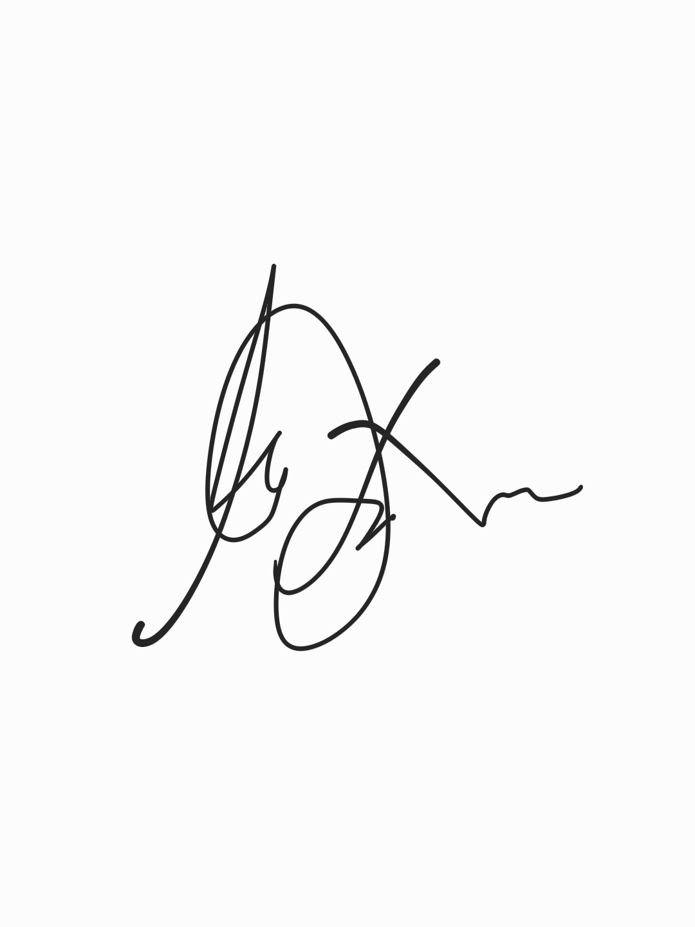

The University of Glasgow Plagiarism Statement
The following is an extract from the University of Glasgow Plagiarism Statement. The full statement can be found in the University Calendar at http://www.gla.ac.uk/media/media_238045_en.pdf#page=51&view=fitH,340.
This should be read in conjunction with the discipline specific guidance provided by the School at Insert link.
31.1 The University's degrees and other academic awards are given in recognition of a student's personal achievement. All work submitted by students for assessment is accepted on the understanding that it is the student's own effort.
31.2 Plagiarism is defined as the submission or presentation of work, in any form, which is not one's own, without acknowledgement of the sources. Plagiarism includes inappropriate collaboration with others. Special cases of plagiarism can arise from a student using his or her own previous work (termed auto-plagiarism or self-plagiarism). Auto-plagiarism includes using work that has already been submitted for assessment at this University or for any other academic award.
31.3 The incorporation of material without formal and proper acknowledgement (even with no deliberate intent to cheat) can constitute plagiarism.
Work may be considered to be plagiarised if it consists of:
- a direct quotation;
- a close paraphrase;
- an unacknowledged summary of a source;
- direct copying or transcription.
With regard to essays, reports and dissertations, the rule is: if information or ideas are obtained from any source, that source must be acknowledged according to the appropriate convention in that discipline; and any direct quotation must be placed in quotation marks and the source cited immediately. Any failure to acknowledge adequately or to cite properly other sources in submitted work is plagiarism. Under examination conditions, material learnt by rote or close paraphrase will be expected to follow the usual rules of reference citation otherwise it will be considered as plagiarism. Departments should provide guidance on other appropriate use of references in examination conditions.
31.4 Plagiarism is considered to be an act of fraudulence and an offence against University discipline. Alleged plagiarism, at whatever stage of a student's studies, whether before or after graduation, will be investigated and dealt with appropriately by the University.
31.5 The University reserves the right to use plagiarism detection systems, which may be externally based, in the interests of improving academic standards when assessing student work.
If you are still unsure or unclear about what plagiarism is or need advice on how to avoid it,
SEEK HELP NOW!
You can contact any one of the following for assistance:
Lecturer
Course Leader
Dissertation Supervisor
Adviser of Studies
Student Learning Service

