From now on the daily flow is:

1. Drop an .html file into C:\Users\babso\Desktop\BootHopPipeline\blog\pending\
2. At 09:00 every morning the script picks it up, emails it to Blogger, archives the file after 7 days
3. It appears on boothop.co.uk/blog automatically

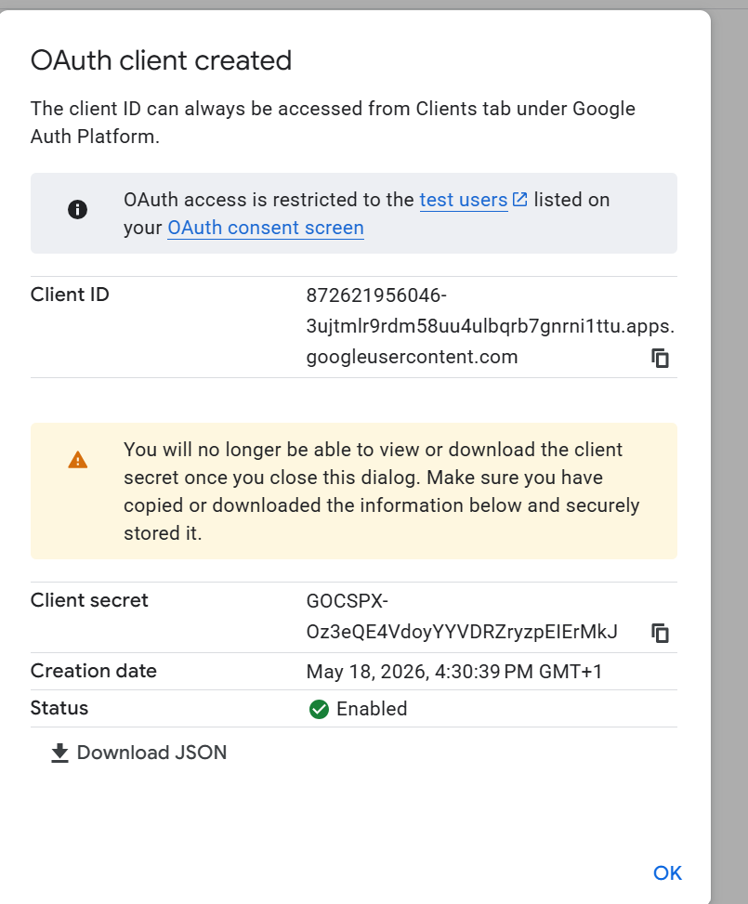
872621956046-3ujtmlr9rdm58uu4ulbqrb7gnrni1ttu.apps.googleusercontent.com client id , client secret is
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

