Term project „Static web site “
for Technologies for web publishing I (ATPW1) subject

Student data
Name and surname: | Alberto Sánchez Alén
Login (UHK intranet): | alenal1
Study branch: | Informatics
School year: | 2023/2024

Project summary

Project title: | Drug awareness
Annotation: | My website talks about drugs, types, problems, how to avoid it’s use, … I want the web to be accessible for all the people and easily to use.  The web has an attractive and friendly design.

The „Analysis and design“ part

What is the purpose of a website?
What will the site be used for?
The purpose of my website is to inform and warn about the problems of drugs, their negative effects in long and short term, … And many others facts about drugs.

State the reason why the website was created.
Why was a website created for this purpose, not another solution?
The website was created because, the use of drugs it’s a fact, it is impossible to stop their use and distribution, because of the amount of money that it move. Therefore, it is better to inform and warn consumers and potential consumers.

What do you want the website to achieve?
A list of goals you have for the website.
My principal goals for this website are at least make an easy accessible web with verified and proven information, that looks good for the users, and that be able to help people with drugs problems and disinformation.

Describe what must happen for the website to be considered successful.
Think, for example, of number of visits (site traffic), sales, place in search engine results, etc.
To be considered successful my website, should have more than 10000 menssually visits, the web do not have profit motive so it don not have directly profit. For me the most important goal is reduce the drug consume.

Who is the target audience of the website?
Describe your target audience by age, gender, socioeconomic characteristics, etc.
Because of the average age of the people who take drugs, the website target audience is young and mid-age people.

What opportunity or problem does the website address?
For example, a website can provide an opportunity to provide information about the topic to others or create an initial web presentation for a company.
I am taking the opportunity of the increasing use of the internet to solve the problem with the use of drugs, or at least making it less harming for the people.

What type of content can be used on a website?
Describe the type of text, graphics, and media you will need for the site. Although you should write text content yourself, you can use external sources for images and multimedia without royalties. Read Copyright Considerations (Lecture 13).
This website will address many content types: I am going to use graphics of the affected people to show the harm that it produce, links to videos of people talking about their experience, photos related to the drugs to make visible them and the situation.

A list of URLs for at least two related or similar websites found on the site.
https://lide.uhk.cz/fim/student/rusevma1/
https://lide.uhk.cz/fim/student/malihvi1/
https://lide.uhk.cz/fim/student/peckaan1/

Sitemap
Use a specialized wireframe program, text or graphics editor, or paper and pencil to create a website map that shows the hierarchy of pages and the relationships between pages.
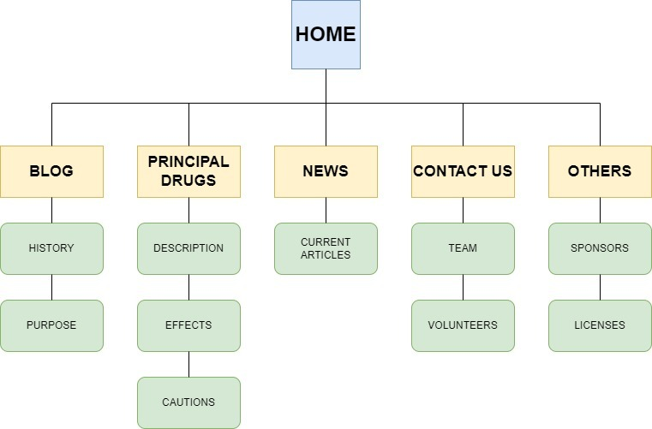

Website layout design.
Use a specialized wireframe program, text or graphics editor, or paper and pencil to create a wireframe with a layout design for your home page and content pages. Use one of the page layout designs in Figures 2 through 5 of Exercise 4. Specify where the logo, navigation, text, and images will be located. The exact wording or content of the images is not important. State the wire model for all dimensional variants of the device.
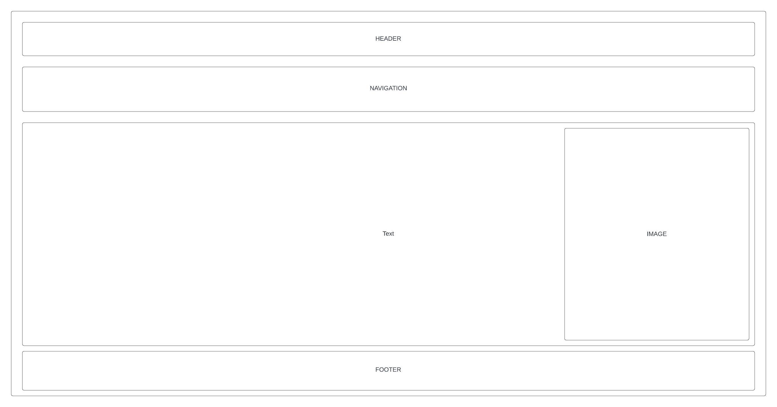

The „Implementation“ part

URL of the project
Where the project is published.

Text content size (in number of words).
Give the number of all words of the text content of all the pages of the site.

Colors
Indicate the colors used (color sample with color code as hexadecimal number).
For each color, indicate on which elements, or for what purpose, it was used.

Fonts
List the fonts used.
For each font, specify the font family, font size, and elements for which it was used.

Navigation
Indicate the ways in which navigation in the project is ensured, including alternatives to possible image navigation. List both the main and other navigation.
(copy the HTML code from the project here)

Page components
Give an example of markup and styling of basic components of a page.
(copy the HTML code from the project here)

(copy CSS code from project here)

Page layout
Give an example of tagging and formatting the layout of a page or part of a page.
(copy the HTML code from the project here)

(copy CSS code from project here)

Structural elements of HMLT5
Give an example of using HTML5 structural elements (e.g. header, nav, main, footer).
(copy the HTML code from the project here)

Responsivity
Specify breakpoints of screen dimensions (or other attributes) for which different content formatting is applied (using media queries):

Give examples of different formatting in the form of media queries, at least one CSS rule for each formatting variant:
(copy CSS code from project here)

