

Concept & Rules

The Adventures of Zombie Land



Name: John Sijs  
Student ID: 0490959  
Due Date: February 10, 2016: 11:30PM

Table of Contents

[1. Concept 2](#_Toc442905804)

[1.1. Introduction 2](#_Toc442905805)

[2. Rules 3](#_Toc442905806)

[2.1. Game Components 3](#_Toc442905807)

[2.1.1. The Mighty Queen 3](#_Toc442905808)

[2.1.2. The Mighty King 3](#_Toc442905809)

[2.1.3. The Health Potion 4](#_Toc442905810)

[2.1.4. The Zombie 4](#_Toc442905811)

[2.1.5. Move Marker 4](#_Toc442905812)

[2.1.6. Unable to Move to that Location Marker 5](#_Toc442905813)

[2.1.7. Forest Tile 5](#_Toc442905814)

[2.1.8. Dirt Tile 5](#_Toc442905815)

[2.1.9. Black Tile 6](#_Toc442905816)

[3. Game Setup 7](#_Toc442905817)

[4. Victory Conditions 8](#_Toc442905818)

[5. Sequence of Play 9](#_Toc442905819)

[7. Rules of Sequence of Play 10](#_Toc442905820)

# Concept

## Introduction

The Adventures of Zombie Land

In a faraway land surrounded by lush forests and fertile soil, there was a magnificent town with a beautiful queen and a gentle king who was loved by all their loyal citizens. One day, a devastating plague swept through the town and everyone began to get sick. Not wanting to risk the lives of his guards, the gentle king who cared so much for his citizens decided to leave his castle on his own and bring medicine to his people. But when he got to the walls of the castle, he realized the plague not only made people sick, it also turned people into brain eating zombies. The king, yielding only his mighty long sword became overwhelmed by a zombie horde and is now trapped outside the castle walls. The beautiful queen who was once a highly trained knight of the Nine Kingdoms, decided she also cared too much for her people to risk their lives to rescue the king. So it is up to her, and her alone to begin this adventure to rescue the king. She has only her skill and bravery to fight through zombies to her king.   
Do you accept this quest to save the king?

# Rules

## Game Components

### The Mighty Queen

The beautiful queen who was once a highly trained knight of the Nine Kingdoms, a sorceress of the tree ancients and trained in the arts of Kung Fu by a Shaolin monk. The player plays the role of the queen and her task is to find the lost King.



Figure 1: The mighty Queen

### The Mighty King

The Mighty king, a bastard child, heir to the throne after all his older brothers died in battle decades earlier during the Wars of the Nine Kingdoms. During the king’s epic quest to find a cure to the plague disease known as “Zombification”, the king becomes lost and unable to find his way after running away from a hoard of dreadful zombies.



Figure 2: The Mighty King

### The Health Potion

From the shrines of an eccentric healing goddess spawns random pre-set health potions on the map for our hero.



Figure 3: The Health Potion

### The Zombie

From the result of a devastating plague from no one else but Lucifer himself, comes a plague of zombies. Zombies are the enemy, if you get too close they will chase and fight you.



Figure 4: The Zombie

### Move Marker

A green symbol representing the tile the player will move to.

C:\Users\John\AppData\Local\Microsoft\Windows\INetCache\Content.Word\marker_move.png

Figure 5: Move Marker

### Unable to Move to that Location Marker

A red X symbol represents a tile the user is unable to move to.



Figure 6: Unable to Move to that Location Marker

### Forest Tile

A forest tile represents areas on the screen the user is not able to move to.



Figure 7: Forest Tile

### Dirt Tile

A dirt tile represents areas on the map the user is able to click on to move to.



Figure 8: Dirt Tile

### Black Tile

A black tile represents an area on the map the user is unable to move to.



Figure 9: Black Tile

# Game Setup

The game was designed as a 2-D RPG game. The player spawns as the Mighty Queen when they press “New Game” from the main menu. Zombies and health potions and the King all spawn on the map as well. The player uses wasd or the arrow keys to move the camera. The player must use the left click mouse button to go to a tile they wish to. The HUD or heads up display is displayed in the upper left corner. This HUD shows the players health, current level, and an experience bar is shown as the progress of the current level to the next level.

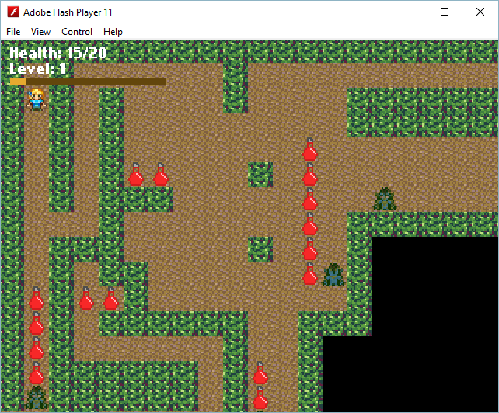

# Victory Conditions

The games victory conditions are very simple, the player must fight the hordes of zombies in order to find and rescue the Mighty King. When reaches the same tile as the Mighty King, the player has found and rescued the King and the game is finished.

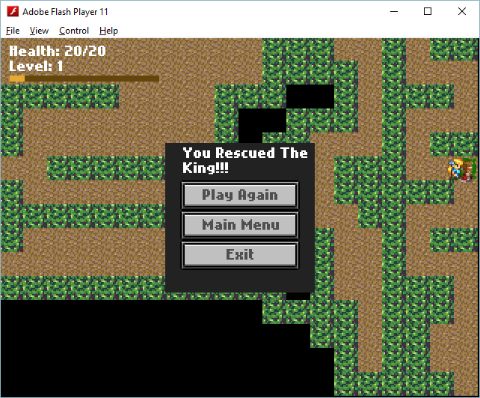

# Sequence of Play

The games sequence of play is as follows:

1. In order to move the camera the player must use the wasd or arrow keys.
2. The player clicks with the left mouse button a tile to go to.
3. If the player is able to go to the chosen tile the Mighty Queen will move there.
4. Upon moving near a zombie, the zombie will chase you if you try to run away to another tile.
5. If the zombie reaches you, the player enters a “combat” mode.

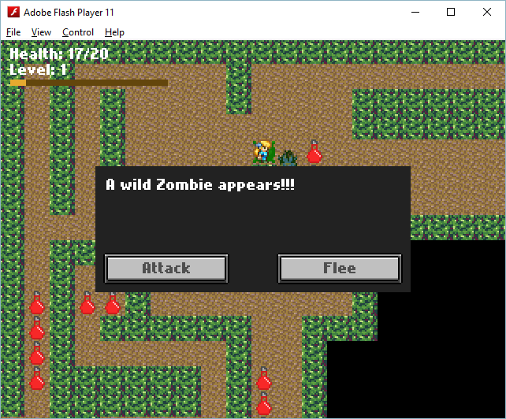

1. A screen will appear allowing the player to “Attack” or “Flee”.
   1. Attack will attack the zombie.
   2. Flee will allow the player to flee and move away from the zombie.
   3. If “Attack” is chosen, the player must keep attacking or flee upon each attack.

# Rules of Sequence of Play

The rules of sequence of play are as follows:

1. The player is unable to move during “combat” mode.
2. Other zombies including the one the player is attacking will not move when the player is in “combat” mode.
3. The player must choose “Attack” or “Flee” upon entering “combat” mode.
4. The player is only able to move to tiles that represent the dirt tile, seen in Figure 8.
5. The player is not able to move to tiles that represent forest tile, Figure 7, or the Black tile as seen in Figure 9.
6. To pick up a health potion, the player must move to the tile the health potion is at.