Pointer 복습!

Dangling pointer

Memory leakage

Pointer의 pointer

C언어에서의 동적메모리.

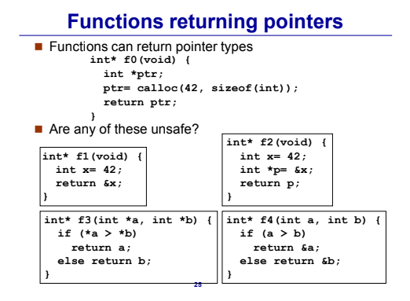

1)declare ex1 as pointer to char  
**2)** declare ex2 as pointer to pointer to char  
**3)** declare ex3 as array 10 of pointer to char  
**4)** declare ex4 as pointer to array 30 of char

**5)** write a function that takes a pointer to char named pc, and returns it  
**6)** write a function that takes a pointer to int named pi, and returns it.  
**7)** write a function that takes a pointer to int named pi, and verifies if the value pointed to by pi is odd or even.

8) declare ex5 as pointer to dynamically allocated array 30 of char.

Memory layout

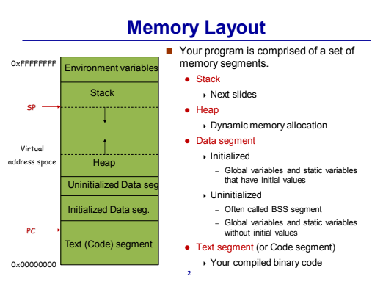

#include <iostream>

**using** **namespace** std;

**int** MAX=**100**; // Initialized Data Seg.

**int** MIN; //Uninitialized Data Seg.

**int** **main**()

{

**int** var =**100**; //Stack

**int** *ptr = **new** **int**; //Heap

*ptr = **4**;

}

프로그램 구동에 연관 -> Stack Memory

Stack이란? FILO(First In Last Out)

예시) 접시쌓기

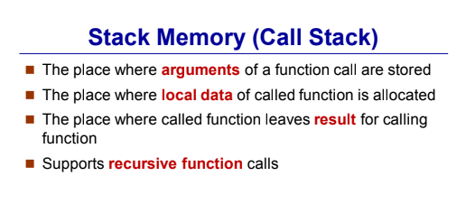

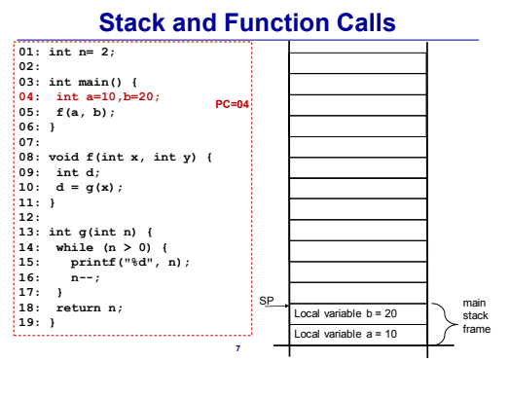

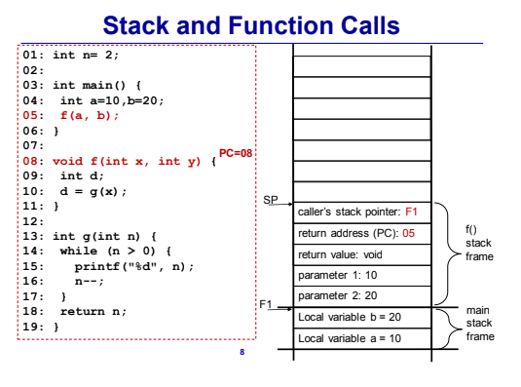

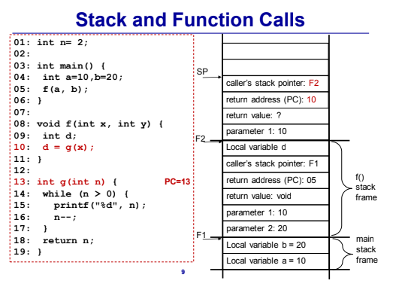

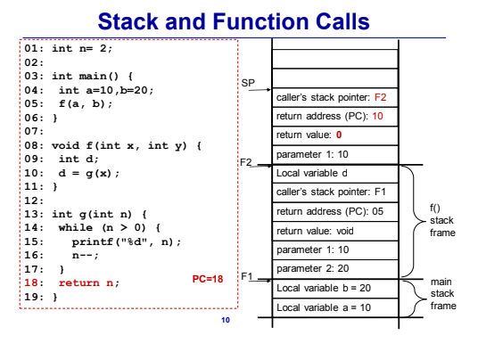

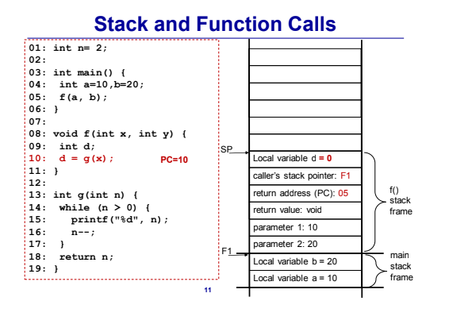

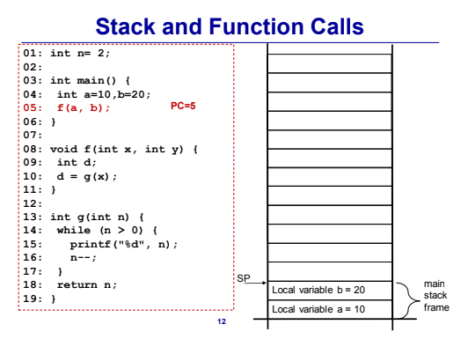

Main – Local variable

Other functions – Parameters, return value, return address, caller’s stack pointer, local variable.

Valgrind – memory leakage를 찾아준다!