MyUniTracker v0.0.2

Samuel Heath

2016

Table of Contents

Introduction: 1

Key Features: 2

Installation: 2

What You Need: 2

How To Get It: 2

Step 1: Accepting the user agreement 2

Step 2: Choosing the one for your machine 3

Step 3: Installing your download and set up 4

Step 4: Opening the app 4

How To Use: 5

Adding units and assessments: 5

Editing and removing units and assessments: 5

Adding a Final Exam Weighting: 5

Conclusion: 6

# Introduction:

MyUniTracker is an easy to use tool, designed to give university students and overview of their units semester by semester. It gives them a general overview of how they are going in all their units, as well as giving useful statistics on their GPA (grade point average) and WAM (weighted average mark). It also has a breakdown of each individual unit, by allowing students to add assessments as they get the marks back, and to receive useful statistics such as their current percentage and grade. At the end of semester it will show students what percent they need in the final exam to achieve a selected grade.

## Key Features:

The application facilitates the common requirements a university student wants to be able to see but at the press of the button, instead of tediously figuring out these measures.

The key features of the application include:

* Adding, editing and removing current units.
* Adding, editing and removing assessments completed (or even future assessments, by predicting your mark and editing that assessment later).
* Viewing your progress in a specific unit via a graph of assessment results.
* Gives a combined overview of all your results and presents it in just one graph, and also shows your WAM and GPA (see next point).
* Adding past results so the app can calculate your current GPA and WAM (following how the UWA does it), and predicts the future values for this based on your results for your units, at that point in time.

# Installation:

## What You Need:

You will need the most recent version of this application (ofc) which can be found on my [GitHub](https://github.com/Daedalos97/MyUniTracker/releases) page.­­ You will also need at an absolute **minimum** Java Runtime Environment 7 or up (It should work fingers crossed). If you use a Mac, they are stupid and will need you to use the Java Development Kit 7 or up (8 is preferable), because Apple made it stupidly difficult to change the Runtime Environment. I strongly recommend you use the JDK on any machine you have as it is guaranteed to work.

That’s it, that’s all you need.

## How To Get It:

To get the Java Development Kit you can simple search Google for it, or if your lazy here is a link to the most [recent](http://www.oracle.com/technetwork/java/javase/downloads/jdk8-downloads-2133151.html) (at the moment).

You can also get the correct Java Runtime Environment, by searching Google for the version you want (7 and up) and follow the same process.

## Step 1: Accepting the user agreement

Your will have the option to choose a number of different sub versions of the JDK or JRE, it doesn’t matter what you choose, but latest is usually the way to go.

Once you’ve decided which version you want accept the user agreement (seen in red) for that version, and continue to the next step.

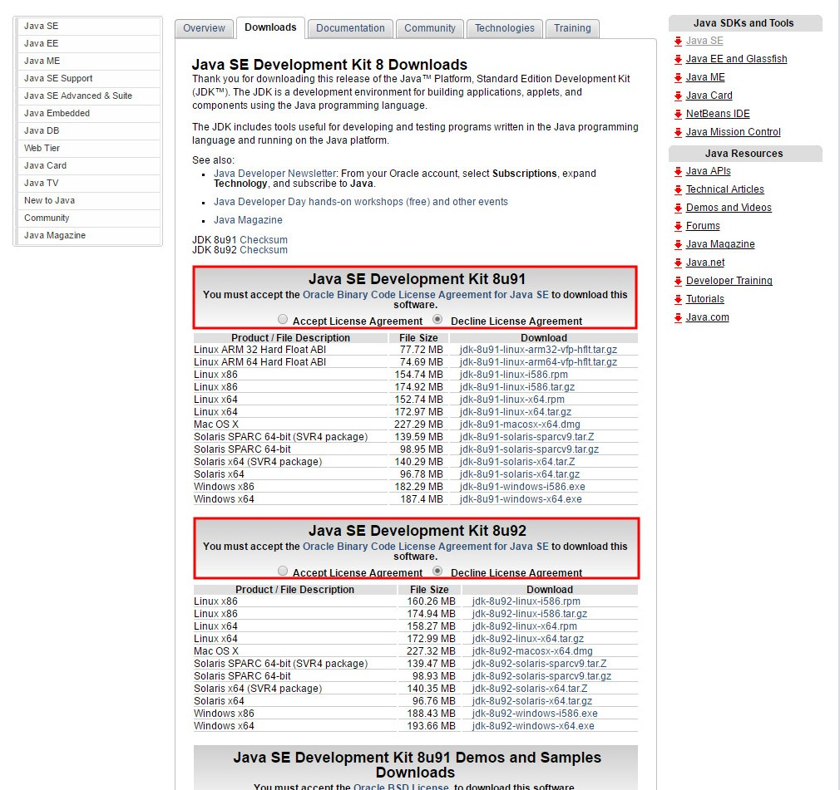

Step : Accept the user agreement.

## Step 2: Choosing the one for your machine

Once the agreement is selected you need to choose the version that will work on your machine. There are a lot of options, for Mac this step is pretty simple because there is only one option, but for other machines you may need to consult system information to find the correct version for you.

Once you do that it’s probably easier to just get the non-compressed versions as it adds an extra step.

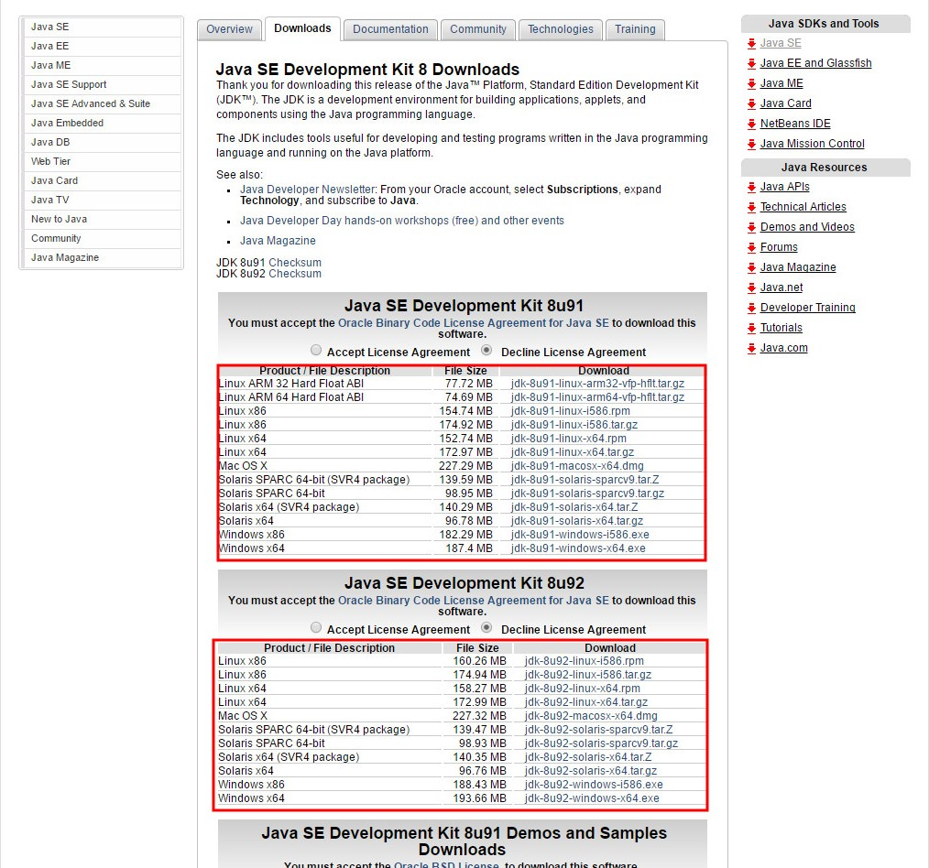

Step : Choose the download that suits your machine.

## Step 3: Installing your download and set up

Your downloaded version will have a simple installation process and if you install it in the same location as your previous Java version, it should automatically update it for you (The JDK definitely should). To check type open up Terminal (Mac) or Command Prompt (Windows) or equivalent on other machines, and type in *java –version* and press enter and it should tell you the current version 1.*… where the * should be the new version you just installed e.g 1.7… or 1.8…

## Step 4: Opening the app

I strongly suggest you put the MyUniTracker.jar file and this guide in a separate folder as the app will generate a .txt file which holds your data, and it could get lost on your desktop.

To open, simply double click the MyUniTracker.jar file and it will create a file called *units* (a text file) where it stores data. If you have data already in a file called *units* make sure it is in the same directory as the jar file.

# How To Use:

If it is your first time using the app, you will see a summary page with nothing on it, this will later be filled with all your unit results and also give you your current and expected GPA and WAM.

## Adding units and assessments:

To get started click the add unit button on the Overview page.

Once you have added your first unit you can start adding assessments, by using the appropriate buttons below the graph.

## Editing and removing units and assessments:

To edit or remove a unit, make sure you are currently viewing the unit you wish to modify. (When adding a unit it doesn’t matter) Once you have done this, click file in the top left and select the menu option, then make the changes you need in the new window.

When editing or removing the assessments of a unit, use the selection box to choose the assessment you need to modify and then press the respective buttons nearby as to edit or remove it. Editing will open the same option pane as, when adding assessments, so make the changes you need to and press save changes.

## Adding a Final Exam Weighting:

To add a final exam weighting so the application can tell you what mark you need in the exam, simply create a new assessment and title it AS written, Final Exam (This is case sensitive so it needs to be exactly as written). There is no need to add a mark, but the weighting of this assessment is **VITAL** in the calculation of your mark. This “assessment” won’t be added to your graph but it is editable.

# Conclusion:

This application is just used as an estimation of how the university works this shit out. I am not responsible for any failings of the application to help you achieve your hopes, dreams or ice creams. I’m not an expert so I hope it helps ya out.

If you get stuck remember the data is in a text file for a reason. You can edit that shit easily.