Kevin Bradner
Mobile Robotics ps5 writeup

Map Screenshot:

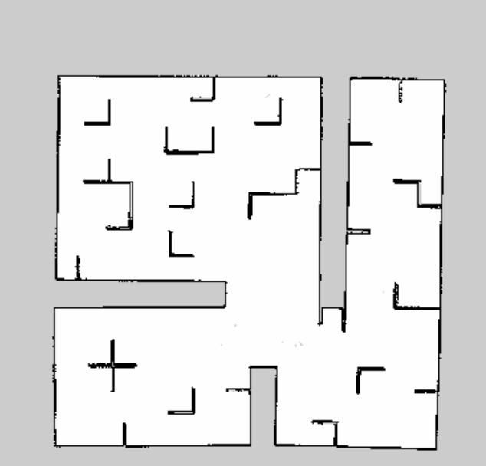
Comments: the map is a little “bent” on the right side. Probably a small error in the mapper or the odom thanks to little feedback with the rest of the map cut off.

Yaml file contents:

image: stdrMap2.pgm
resolution: 0.050000
origin: [-100.000000, -100.000000, 0.000000]
negate: 0
occupied_thresh: 0.65
free_thresh: 0.196
Meaning of yaml file:
name of image file
5cm spatial resolution of map
coordinates of the lower left corner
image not negated (black and white flipped, I assume)
thresholds for how dark a part of the map must be to signify an occupied region

Pose 1:

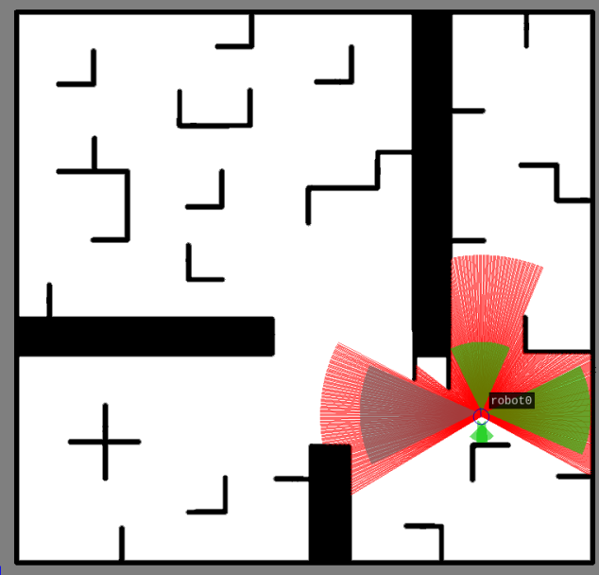

pose:
pose:
position:
x: 12.2437998408
y: 4.23523386135
z: 0.0
orientation:
x: 0.0
y: 0.0
z: 0.714737495901
w: 0.69939281663

Pose 2:

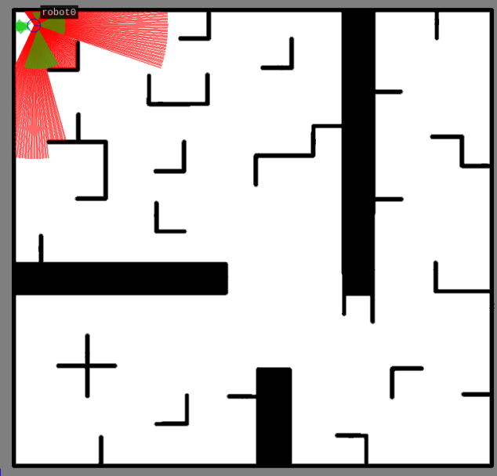

pose:
pose:
position:
x: 1.05052475903
y: 14.0417953459
z: 0.0
orientation:
x: 0.0
y: 0.0
z: 0.0416224012557
w: 0.99913341237

Pose 3:

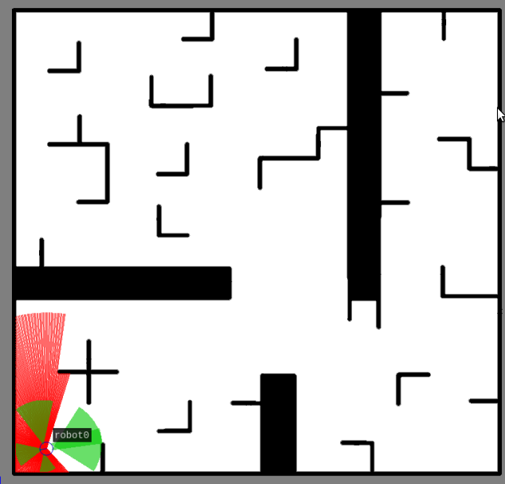
pose:
pose:
position:
x: 1.41243292204
y: 1.27347539558
z: 0.0
orientation:
x: 0.0
y: 0.0
z: -0.993867253951
w: 0.11057975187

Interpretation of poses:

+x is to the right
+y is up
heading 0 is pointing with robot front in the +x direction

dimensions of maze: roughly 15' square

