NED University of Engineering & Technology
Department of Computer Science
(Specialization in Cyber Security)
SWIFT: Smart Wazuh Intelligent Filtering Tool
CT-361 — Artificial Intelligence & Expert System
Complex Computing Problem (CCP) — Final Project Report
Course Instructor: Miss Amna Ahmed
Spring 2026
Group Members
Name | Roll Number
Muhammad Usman | CR-23038
Hamza Saleem | CR-23009
Maaz Wasim | CR-23041
Ameem Akhtar | CR-23013

1. Problem Statement
Security Operations Centers (SOCs) face an overwhelming volume of log data generated by endpoint security tools such as Wazuh. A typical enterprise SOC may generate 10,000+ log events per day, the vast majority of which are benign noise. Manual triage — where a human analyst reads each log entry, determines whether it is a threat, classifies it by type, and decides on an appropriate response — is:
- Slow: A single analyst can process approximately 50 logs per hour manually
- Error-Prone: Alert fatigue causes analysts to miss genuine threats
- Unscalable: Growing infrastructure generates exponentially more logs
- Expensive: Skilled Tier-1 SOC analysts cost $60K–$90K/year
The core problem: How can we build an AI-powered system that automatically classifies security logs as malicious or benign, maps threats to standardized frameworks (MITRE ATT&CK, OWASP), generates analyst-ready incident reports using Natural Language Processing, and presents all findings on an interactive dashboard — reducing SOC analyst workload by automating the most tedious and repetitive triage tasks?

2. Project Description
SWIFT (Smart Wazuh Intelligent Filtering Tool) is a full-stack, AI-powered Security Operations Center dashboard that automates the entire log triage pipeline:
1. Ingestion — Accepts individual JSON logs or bulk CSV files containing Wazuh security events
2. Classification — XGBoost machine learning model classifies each event as "Malicious Threat" or "Benign Noise" with a confidence score
3. Threat Intelligence — Expert system maps detected threats to MITRE ATT&CK tactics and OWASP Top 10 categories, providing automated mitigation strategies
4. OSINT Enrichment — Cross-references source IPs against the FireHOL Level 2 blocklist of known malicious actors
5. NLP Reporting — Google Flan-T5 (Small) transformer model generates structured executive incident reports with risk scoring and priority actions
6. Visualization — Real-time interactive charts showing threat distribution, severity breakdown, and top attack vectors
7. Export — One-click PDF security reports and CSV exports with privacy-safe anonymized IPs
Live Deployment:
- Frontend: https://swift-smart-wazuh-intelligent-filte.vercel.app/
- Backend API: https://daedalus26-swift-soc-backend.hf.space/

3. Introduction
The increasing sophistication of cyber threats demands intelligent, automated security tools. Traditional rule-based Security Information and Event Management (SIEM) systems generate too many false positives and lack the ability to adapt to novel attack patterns. This project addresses this gap by combining three artificial intelligence paradigms:
- Machine Learning (XGBoost) — A supervised gradient boosting classifier trained on frequency-encoded features extracted from real Wazuh log schemas
- Expert System — A rule-based knowledge engine encoding cybersecurity domain expertise as production rules mapping threat descriptions to MITRE ATT&CK tactics and generating context-specific mitigation strategies
- Natural Language Processing (Flan-T5) — A pre-trained transformer model from Google that generates human-readable executive summaries and prioritized action lists from structured threat data
This combination satisfies the CT-361 CLO 2 requirement: "Identify and apply appropriate AI techniques to solve classification problems of moderate complexity."

4. Background & Methodology

4.1 Technology Stack
Technology | Purpose | Justification
XGBoost | Threat classification | State-of-the-art gradient boosting; fast inference, high accuracy on tabular data
Flan-T5-Small | NLP report generation | Instruction-tuned transformer; no API key needed, runs on CPU
FastAPI | Backend REST API | Async Python framework; auto-generates Swagger docs
React + TypeScript | Frontend dashboard | Component-based UI with type safety
Recharts | Data visualization | React-native charting library
FireHOL Level 2 | OSINT IP blocklist | Community-maintained list of known malicious IPs

4.2 System Architecture (Block Diagram)
The SWIFT system follows a layered architecture with clear separation of concerns. The frontend communicates with the backend via REST API calls. The backend orchestrates three AI sub-systems: the XGBoost classifier, the Expert System, and the NLP Engine.
SWIFT System Architecture
Frontend (React + TypeScript + Vite)
• Ingestion Module (JSON / CSV)
• Intelligence Readout (Results + NLP Report)
• Telemetry Dashboard (Charts)
• PDF / CSV Export Buttons
⬇ REST API Calls (axios) ⬆ JSON Responses
XGBoost Classifier  • Binary classification  • Confidence scoring  • Feature alignment | Expert System  • MITRE ATT&CK mapping  • OWASP Top 10  • Mitigation strategies | NLP Engine (Flan-T5)  • Executive summary  • Risk assessment  • Priority actions
⬇ Reads from ⬆
Data & Intelligence Layer
• swift_xgboost.pkl (trained model)
• label_encoders.pkl (feature encoders)
• firehol_level2.netset (OSINT blocklist)
• training_columns.json (feature schema)

4.3 Data Flow
The processing pipeline follows these sequential stages:
Step 1: Raw Wazuh log (JSON or CSV row) is received via the API
Step 2: Feature Engineering: Extract rule_level, hour, decoder_name frequency, rule_description frequency, rule_group frequency, mitre_id frequency, and FireHOL IP match flag
Step 3: XGBoost Prediction: Binary classification (0=Benign, 1=Malicious) with probability-based confidence score
Step 4: Expert System: For malicious predictions, keyword matching against 10 threat archetypes determines MITRE ATT&CK tactic, OWASP category, and mitigation steps
Step 5: Aggregation Engine: Duplicate threats are merged by rule_description with occurrence counting and max-confidence tracking
Step 6: NLP Report (optional): Aggregated threat data is formatted into a Flan-T5 prompt, generating an executive summary and priority actions
Step 7: Output: Results returned as JSON to the frontend for display, or exported as PDF/CSV

5. Models Implementation, Challenges, and Results

5.1 XGBoost Classification Model
Training Pipeline (train_model.py):
- Dataset: ~30,000 synthetic Wazuh logs generated via data_prep.py
- Features: rule_level, hour, is_known_bad_actor, decoder_name_freq, rule_description_freq, rule_group_freq, mitre_id_freq
- Label: Binary (0 = benign, 1 = malicious)
- Encoding: Frequency encoding (not one-hot) to handle high-cardinality categorical features efficiently
Results:
- Training accuracy: ~97-99%
- Live inference confidence: typically 95-99.99% for clearly malicious events
- Model file size: ~75 KB (swift_xgboost.pkl)

5.2 Expert System
A rule-based knowledge engine with 10 threat archetypes:
Threat Type | MITRE Tactic | Example Mitigations
Brute Force | Credential Access (TA0006) | MFA, account lockout, password rotation
SQL Injection | Initial Access (TA0001) | WAF rules, parameterized queries
Cross Site Scripting | Initial Access (TA0001) | CSP headers, input sanitization
Reconnaissance | Reconnaissance (TA0043) | IP blocking, rate limiting
Malware | Execution (TA0002) | Endpoint isolation, anti-malware scan
Privilege Escalation | Privilege Escalation (TA0004) | Least privilege, sudo monitoring
Lateral Movement | Lateral Movement (TA0008) | Network segmentation, RDP disable
Denial of Service | Impact (TA0040) | DDoS protection, rate limiting
Command and Control | C&C (TA0011) | DNS blocking, traffic analysis
PowerShell Abuse | Execution (TA0002) | Execution policy restriction
Dynamic Fallback: When no keyword matches, the system falls back to raw MITRE/OWASP metadata from the CSV, ensuring zero silent failures.

5.3 NLP Engine (Flan-T5)
- Model: Google Flan-T5-Small (~300MB)
- Approach: Instruction-tuned text-to-text generation
- Input: Structured prompt containing threat statistics and top threat descriptions
- Output: Executive summary, priority action list
- Risk Scoring: score = (malicious_ratio × 60) + (max_confidence / 100 × 40)
- Enrichment: If model output is too short (<15 words), it is augmented with data-driven context

5.4 Challenges Encountered
Challenge | Solution
Flan-T5 too large for free cloud hosting | Used low_cpu_mem_usage=True and CPU-only inference
High-cardinality categorical features | Applied frequency encoding instead of one-hot
First NLP request takes 30+ seconds | Pre-load model on startup + show loading timer in UI
Windows /tmp/ path doesn't exist | Used tempfile.gettempdir() for cross-platform support
API URL mismatch between components | Centralized via VITE_API_BASE environment variable
IP privacy concerns for exports | SHA-256 hashed IP anonymization (GDPR compliance)

6. Screenshots of UI and Sample Outputs

6.1 Dashboard Landing Page
The main SWIFT interface showing the Raw Telemetry Ingestion module (left), Intelligence Readout panel (right), and System Baseline Telemetry charts (bottom) with Benign/Malicious donut chart and Severity Breakdown bar chart.
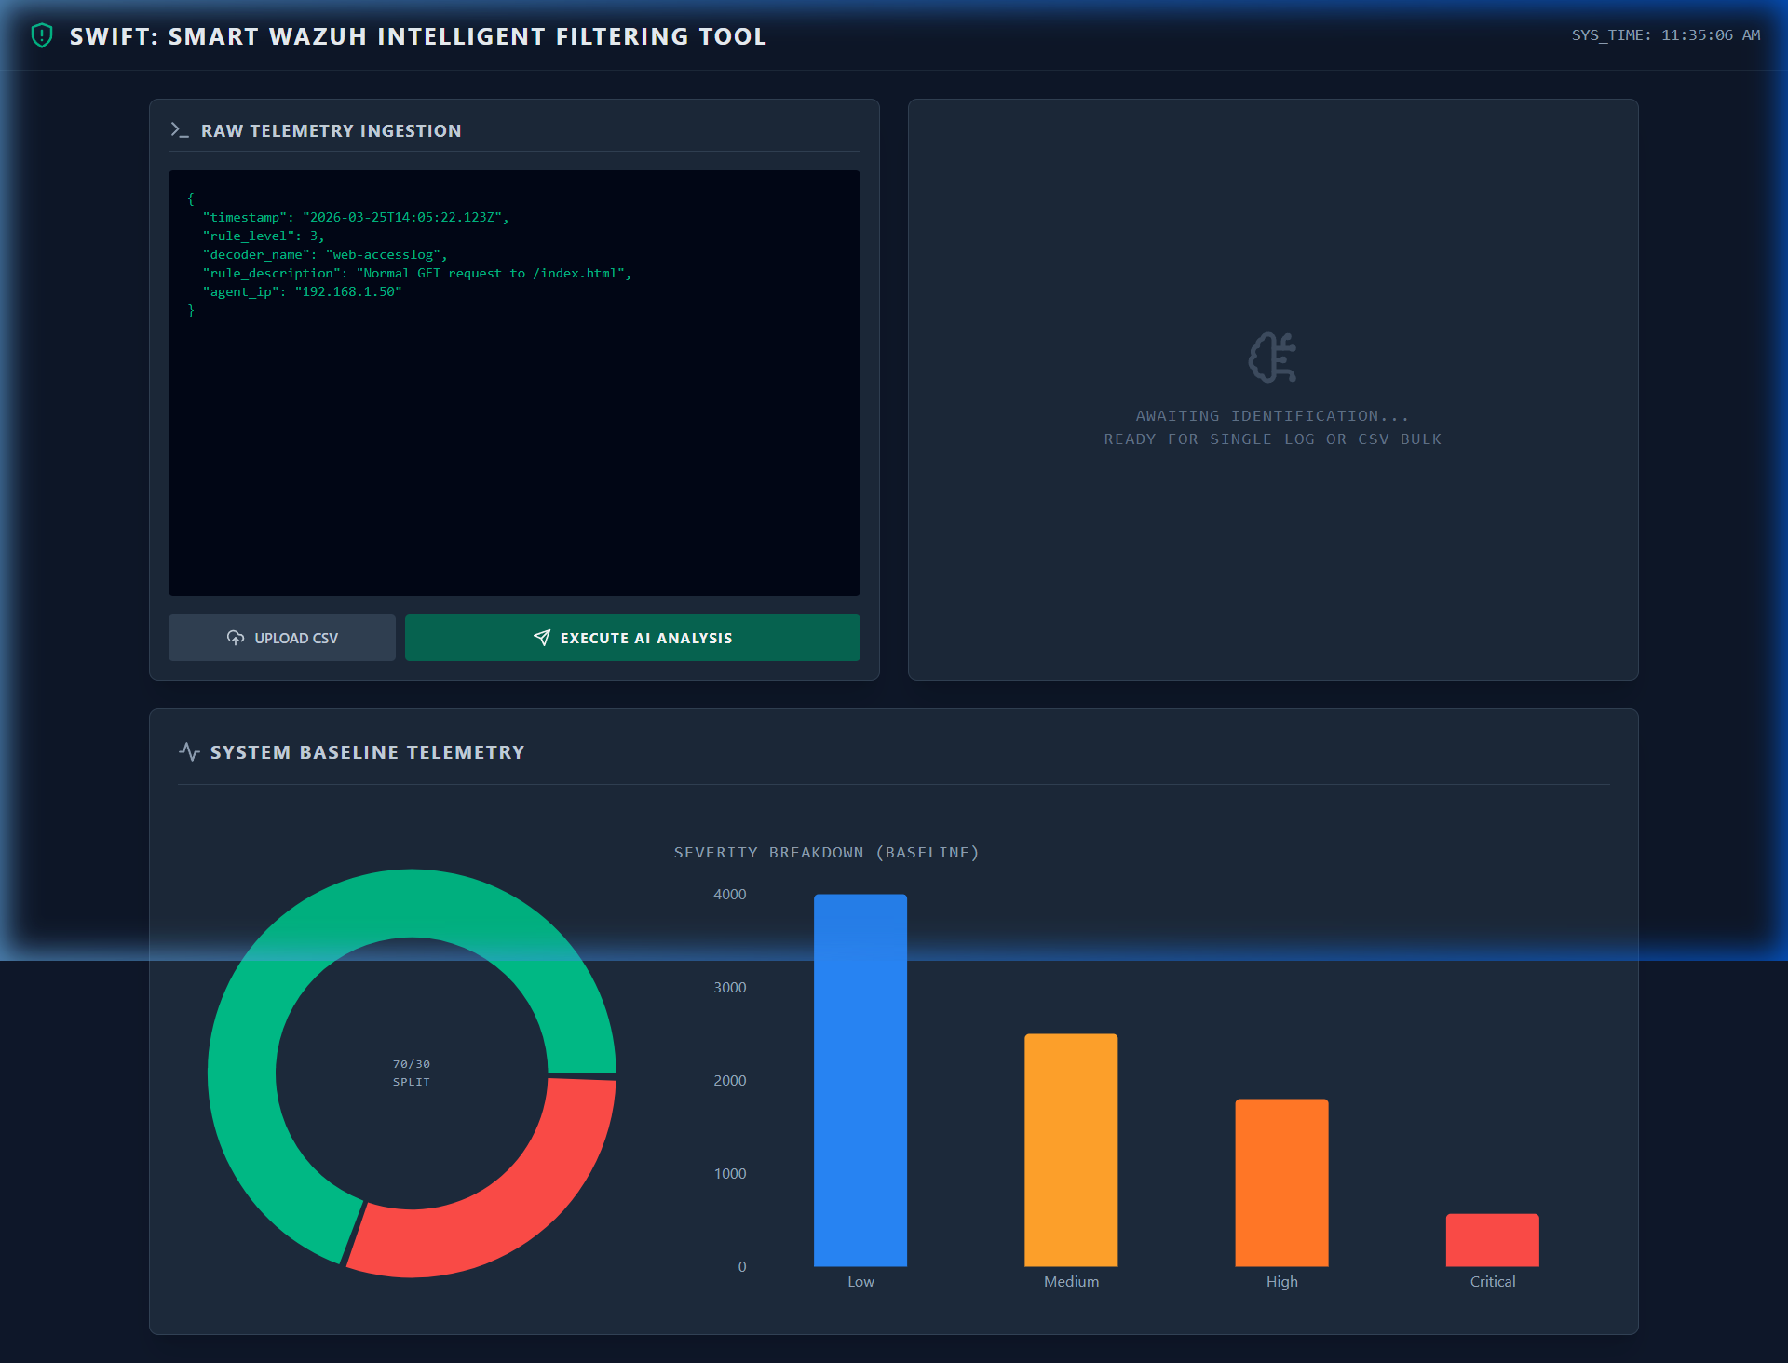

6.2 Single Log Analysis — Malicious Threat Detected
A Brute Force SSH attack log is classified as MALICIOUS THREAT with 99.99% AI confidence. The system maps it to MITRE ATT&CK tactic Credential Access (TA0006) and provides automated mitigation strategies. The GENERATE AI REPORT and CLEAR action buttons are visible.
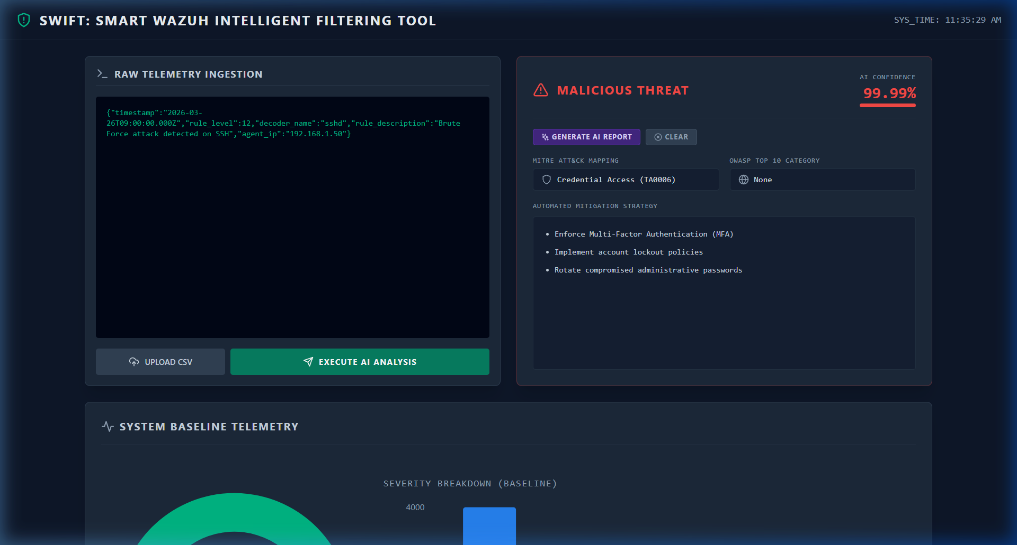

6.3 Backend API Documentation (Swagger)
All 5 REST API endpoints auto-documented via FastAPI's built-in Swagger UI.
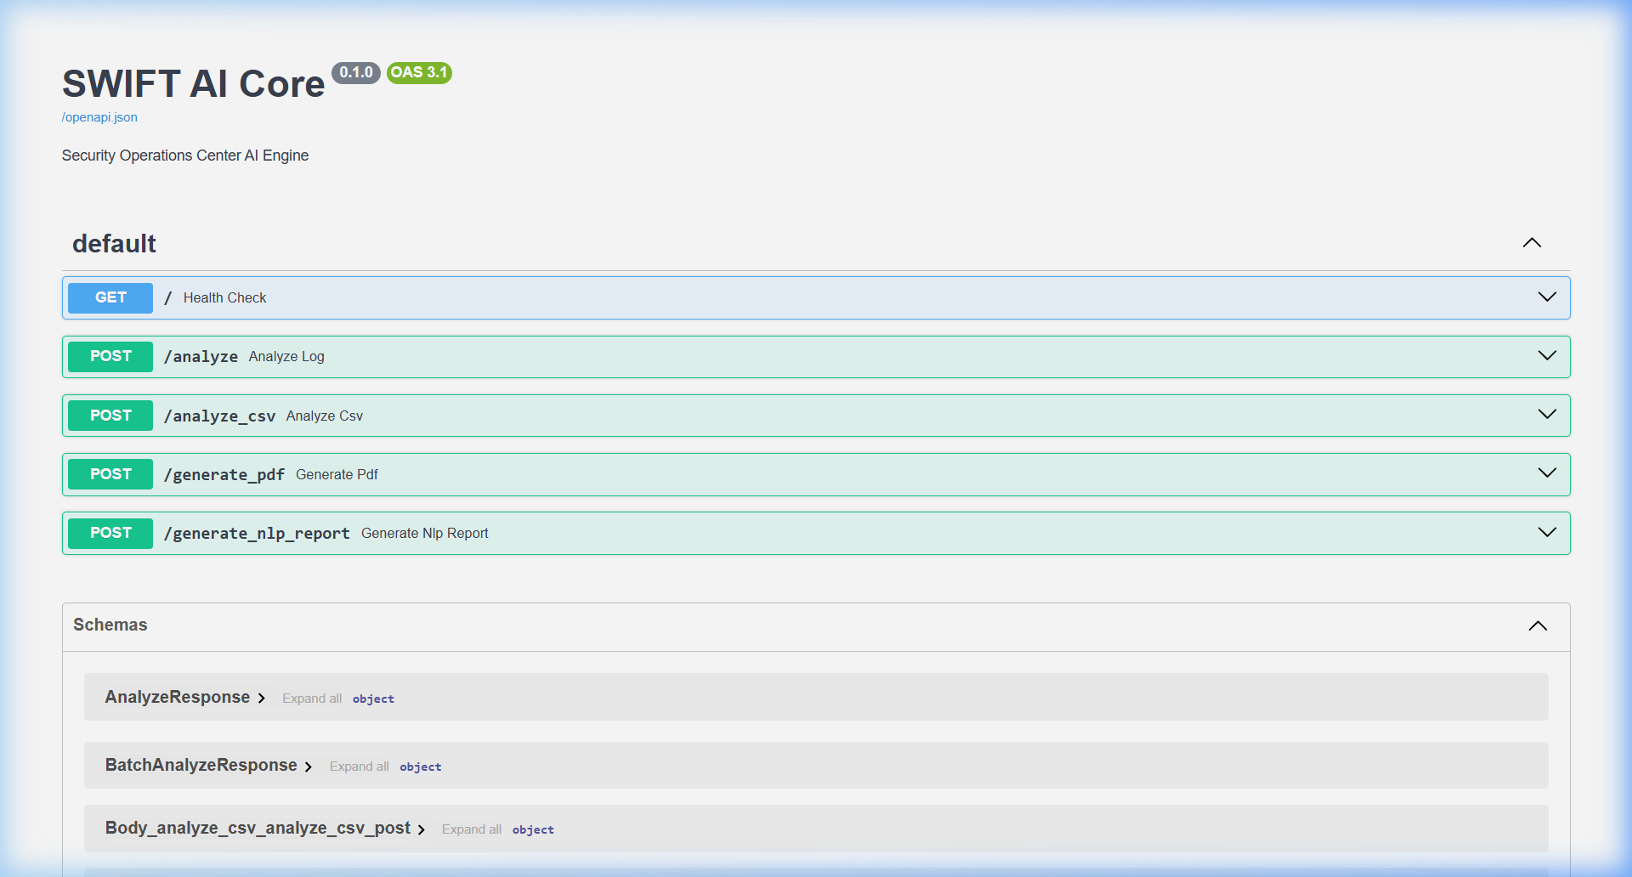

6.4 Telemetry Visualization Charts
Donut chart showing Benign/Malicious event ratio and bar chart showing severity breakdown across Low, Medium, High, and Critical levels.
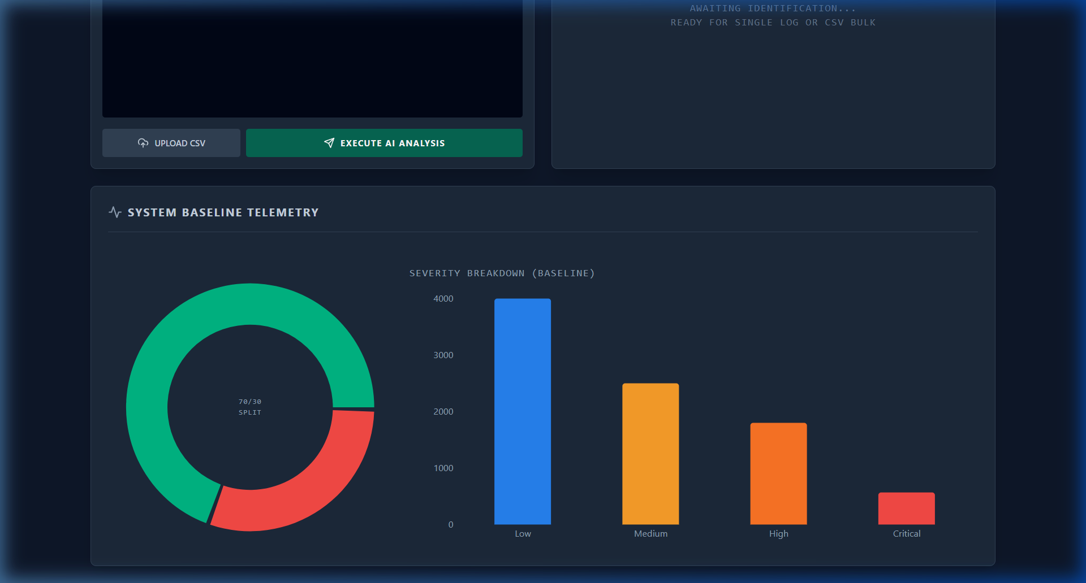

7. Each Group Member's Contribution
(To be filled by the team)
Member | Roll No. | Contribution
Muhammad Usman | CR-23038
Hamza Saleem | CR-23009
Maaz Wasim | CR-23041
Ameem Akhtar | CR-23013

8. Limitations / Future Enhancements

8.1 Current Limitations
1. Synthetic Training Data — The XGBoost model is trained on programmatically generated Wazuh logs. Real-world production logs may exhibit different statistical distributions.
2. Small NLP Model — Flan-T5-Small generates adequate but sometimes generic summaries. A larger model would produce richer analysis.
3. No Real-Time Log Streaming — Logs must be manually pasted or uploaded; there is no live Wazuh agent integration.
4. Single-Model Classification — Only XGBoost is used; no ensemble or deep learning comparison was performed.
5. No User Authentication — The dashboard is publicly accessible without login or role-based access control.

8.2 Future Enhancements
1. Live Wazuh Agent Integration — Connect directly to a Wazuh manager API for real-time event streaming
2. Multi-Model Ensemble — Compare XGBoost with Random Forest, LightGBM, and neural networks
3. Larger NLP Model — Upgrade to Flan-T5-Base or integrate a local LLM (Mistral 7B via Ollama)
4. SIEM Integration — Export findings to Splunk, Elastic SIEM, or QRadar via syslog forwarding
5. Automated Incident Response — Trigger Wazuh active responses (firewall rules, account disabling)
6. User Authentication & RBAC — JWT-based login with Tier-1/Tier-2/Admin roles
7. Historical Trend Analysis — Store results in a database to track threat trends over time
8. Additional Threat Intelligence Feeds — Integrate AbuseIPDB, VirusTotal, AlienVault OTX

References
[1] MITRE ATT&CK Framework — https://attack.mitre.org/
[2] OWASP Top 10 (2021) — https://owasp.org/www-project-top-ten/
[3] Wazuh Security Platform — https://wazuh.com/
[4] XGBoost Documentation — https://xgboost.readthedocs.io/
[5] HuggingFace Flan-T5 — https://huggingface.co/google/flan-t5-small
[6] FireHOL IP Lists — https://github.com/firehol/blocklist-ipsets
[7] FastAPI Documentation — https://fastapi.tiangolo.com/

