

**DAEDULUS**



**Design** by Alan O’Brien, Cathal O’Brien and Darryl Gahan

**Date** - 03/12/19

**Console** - For Xbox One, Playstation 4, PC (Steam)

**Ages** – 12 and up

**Ship Date** – Late September

**Game Summary:** Daedalus is a child who most overcome his fears and daily challenges through the power of lucid dreaming. Each night is a new fear. He must learn what needs to be done in each nightmare so he can return to his bedroom and sleep. Daedalus must learn to use the items in his household to help him. But unluckily for him the house is in a new pattern each time. Will he be able to find his way around and defeat his nightmares?

**Game Flow Outline:** Daedalus is a first-person horror/puzzle experience, where the player finds themselves playing as a young boy who must navigate through his labyrinthian nightmares and use his sharp mind to use household objects to find his bedroom key. But be careful as there will be enemies and hazards each night in the form of his worst fears. Watch out for the boss “Minos” and try to avoid “Athena” and “Hephaestus”. Every day the boy will read over his diary to take note of his daily events this will warn the player of what to expect each night. The player will also have to be careful about the limited use of their trusty flashlight that can be used to help solve puzzles.

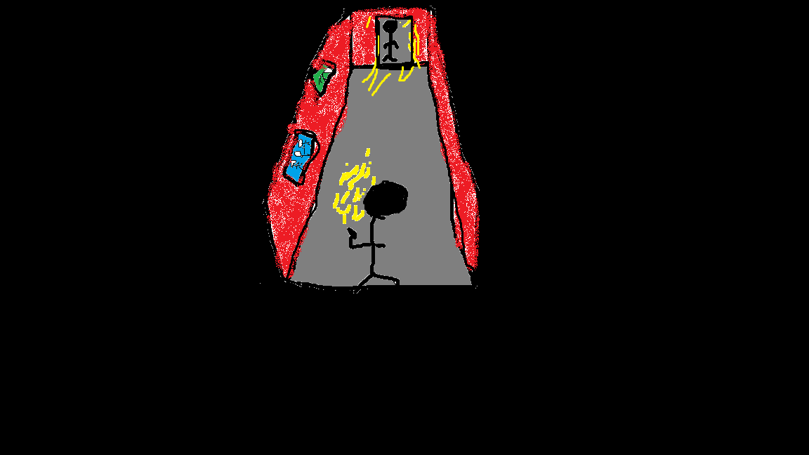

Characters

Main Characters:

**Daedalus –** A boy aged 12, who struggles with daily issues in school and life at home. He has many fears in life. He is known as a nerd and he must learn to be confident in himself. He does so through the power of lucid dreaming in the form of nightmares. But he must also be aware that he doesn’t become the enemy he is avoiding.

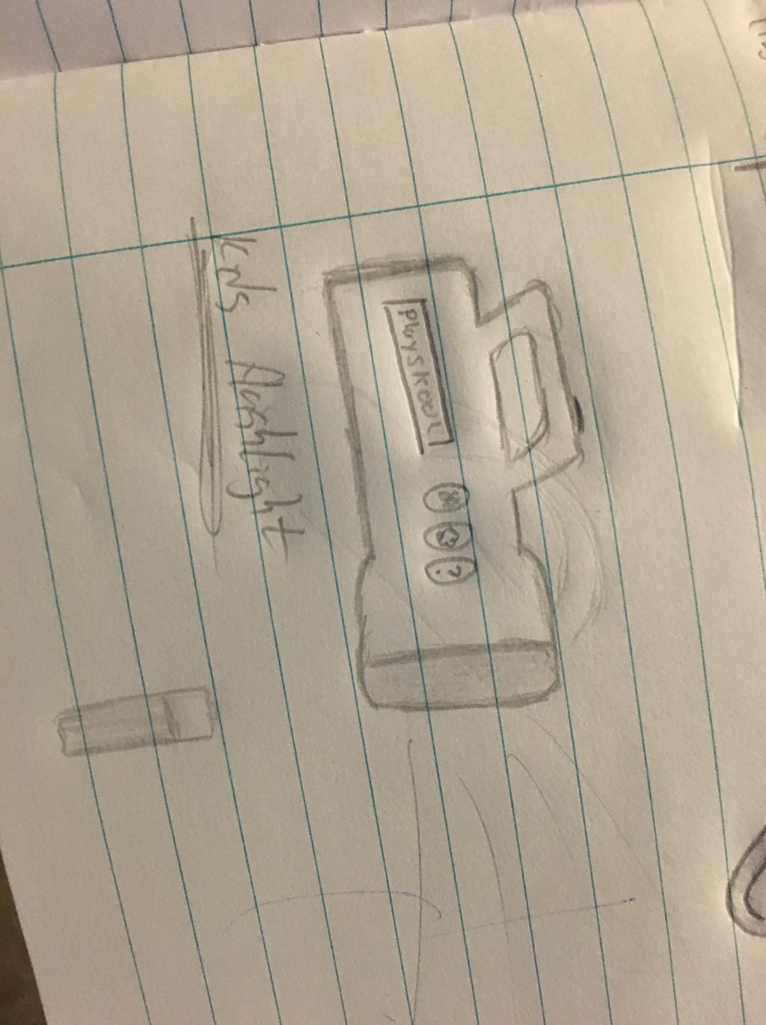

**Controls**

|  |  |  |  |
| --- | --- | --- | --- |
| **Mechanics** | **PC** | **Xbox** | **PlayStation** |
| Move | W, A, S, D | Left Analogue Stick | Left Analogue Stick |
| Look around | Mouse | Right Analogue Stick | Right Analogue Stick |
| Jump | Space | A Button | X button |
| Crouch | Shift | B Button | O Button |
| Interact | E | X Button | Button |
| Flashlight | F | RB | R1 |

*On PC key binding is available.

**GAMEPLAY: Daedalus** is a first-person horror, mystery game in which our protagonist Daedalus must defeat his worst fears in the form of his nightmares. Along the way he will face up to everything from the greatest of bullies to vicious dogs. Using his puzzle solving skills and quick thinking, he will navigate his way through the labyrinthian house.

All of the controls in Daedalus are controller or keyboard based but can be rebinded. These controls include his ability to walk, jump, crouch and use his depleting flashlight just to mention a few.

As Daedalus defeats these nightmares and the major bosses along the way, he will be able to face these fears the next day and conquer them all in real life, unfortunately however, the fears and nightmares just get progressively worse. Daedalus must take in the skills that he learns from the earlier nights. Daedalus must continue to be open to learn new tactics to defeat his nightmares as they won’t always be all that easy!

The house layout will be always randomly generated. This changes up what rooms are connecting to each other and therefore keeping the labyrinthian feel throughout the game as it’s played through no matter how many times you play through to keep everything fresh. There is also of course the option of using the creative hub to download extra maps that are created by the player which will always keep everything fresh and encouraging the creativity of the player. The creation of these maps will be available on the pc version.

Using your walking you will allow navigation through all of the rooms. Jumping will allow you to climb on top of objects in the rooms to get around your enemies and the fears. Crouching will allow you to sneak and be able to hide under the likes of tables and in cupboards.

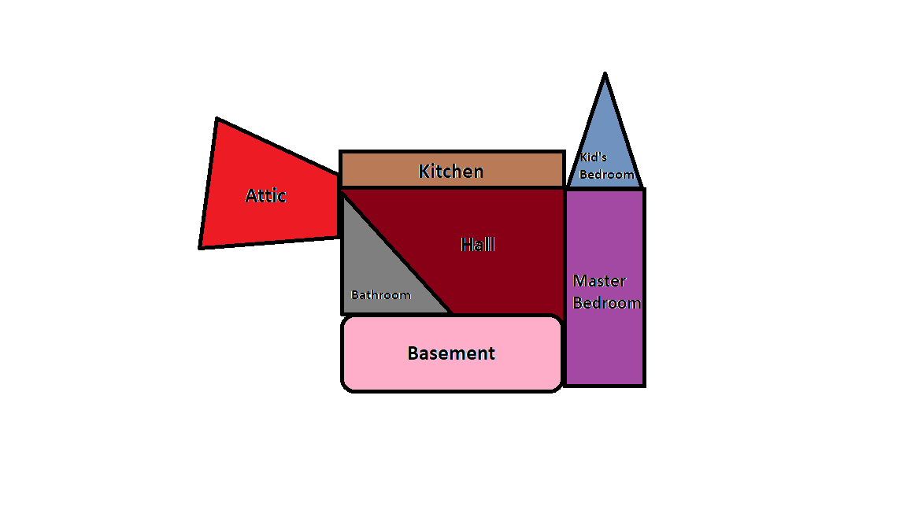

**GAME WORLD:** The nightmare world is in Daedalus’ mind and takes the form of his home, but the house is not normal. All the rooms of his house don’t connect properly making it a labyrinthian style house. In a dark house and equipped only with a flashlight, Daedalus must get through his house by conquering his fears, acquire a key and make it back to his room.

Each night Daedalus must make his way through the house going from room to room defeating small fears and/or puzzles. Only when Daedalus conquers that fear or solve the puzzle can he move on to the next room. The final room of each night is something that happened to Daedalus on that day. The final fears can range from bullying to a fear of heights.

When the final fear each night is overcome Daedalus will obtain a key and then he can start to make his way back to his bedroom, use the key to unlock the door and finish the night.

The game world is dark and mysterious and leaves the player guessing where they will end up next. This will be heightened by the intense music playing as the player is chased through the rooms.

**GAME EXPERIENCE:** As the player begins the game, they are given the difficulty option which will heavily affect the players game experience. The easy difficulty allows players who aren’t looking for a challenge the chance to just enjoy the story and gameplay. Intermediate allows the player to test their skills a bit more but allows room for error. Then Nightmare difficulty is only for the elite players who feel they can do it all with minimum time and help.

Once the player enters the game world, they will soon learn the theme in the game, which is darkness and mystery. The eerie music and miscellaneous sounds will reaffirm the players uncertainty. But before the player will be put in the game, they will be greeted by the voice of Daedalus reading out of his diary. Talking about his day. Then it’ll all fade to black and suddenly the player will wake up in a random room.

The gameplay will act similar to “little nightmares” but the art style will be more like “dead by daylight”.

The story will be very empowering and uplifting leaving the player feel like they too have learned something from the experience along with Daedalus.

**GAME MECHANICS:** There are a few mechanics and enemies available to Daedalus.

Mechanics:

* Daedalus can only walk in each nightmare.
* Jumping
* Crouching- for hiding from fears
* Interacting with objects such as doors, keys and other things in rooms
* Flashlight- the house is nearly pitch black, so the flashlight helps guide your way, but it requires batteries to keep it on.

Fears:

* Bullies - The bully will try to fight you physically in hand to hand combat, but Daedalus can fight them by not fighting by dodging out of the way of attacks and trying to wear out the bully since violence is never the answer.
* Parents - The parents during this night will talk about problems they have in real life. Examples of these would be if they talk about the water bill the room will start to fill with water.
* Principal - the principal roams the house looking for you, if you get caught the night starts over. You can hide to avoid the principal such as hiding in a closet or under a table.
* Dogs - Hellhound spawn in behind you when the night starts, and they try to catch you. Making the night a sort of time trial.
* Heights - Daedalus is the size of a doll in this fear and he must use household objects to manoeuvre around the house such as using a ruler as a catapult to get to another room. Hazards in this night will be things such as left on hobs, knives and falling off the countertop.
* Peer pressure - In this Daedalus must get through a maze of black smoke, needles and puddles of alcohol to get to the key.
* Himself - This is the final fear Daedalus himself is the fear. This fear is a mixture of the past fears, so you must learn from the past to be able to complete the final night.

**Enemies –** Daedalus must battle his way through many enemies on his way through the house on each night, aswell as navigating the labyrinthian house of his nightmare with the pressure of time against him along with a ghost chaser!

**Bosses –** Entering into the final rooms invites in the Bosses of the night. This is the final and most important challenge to complete to ensure a good night’s sleep, but of course it won’t be easy! Fear will take over, time pressure will engulf you, you must overcome this all to break through the nightmare.

* **Bullies:** The group who strike fear into every kid in school. Minos the biggest bully of them all has taken a particular fancy on bullying Daedalus by making fun of his name, do what you must to defeat them all!
* **Parents:** Always fighting, never getting along, arguing too much to fully notice Daedalus. Athena and Hephaestus will argue over anything, all having a mental effect on our Daedalus which you must fight through!
* **Teachers:** Led by the big principal, the teachers never seem to give Daedalus a break. Exams and giving out are just some of what Daedalus faces to get through this nightmare inducing experience in school.
* **Dogs:** Sometimes calm, but often vicious. How can Daedalus compete with these beasts? You must overcome them all and defeat the pack!
* **Heights:** Panic, wobbly arms, jelly legs are just some of the things that come to mind with a fear of heights, you must battle through all of these after the scarring experience of falling from a tree and injuring yourself. Can you do it in time?
* **Peer Pressure:** The older kids are always targeting the venerable kids, Daedalus is no exception to this at all. From alcohol to vape, there is nothing these kids won’t try forcing onto others, but will you be able to avoid this temptation?
* **Himself:** Who is the biggest enemy other than the creator of all of the nightmares. Who is the biggest bully apart from he who is now fighting off all the venerable kids around him? How can you defeat this all-important nightmare? The nightmare that you have become!

**ACHIEVEMENTS:** throughout the game the player will be working towards completing achievements along with the general gameplay. These achievements will be available to allow you to collect Gamerscore (on Xbox) to give alternative aims, trophies on PlayStation and Steam Achievements. Some of these achievements may include:

* Completion of the game on easy level
* Completion of the game on intermediate level
* Completion of the game on nightmare level
* Never getting caught by smaller bullies
* Take no damage in the height level
* Complete the game with no fails.

**DLC:** The first of our DLC packages we aim to have released approximately three months post game release. This will be titled Nightmare. You will be able to control the nightmare that is aiming to take down the child who is having these fears on a daily basis. Future DLC may include children from other cultures so will therefore have other fears. Other downloadable content will be the creative hub in which you can download other user created levels and modes. On PC, you can download a mod workshop tool which will extend the lifecycle of the game. We know people have great creativity and would like to embrace this in our game!!



**Monetisation**

**Monetisation Plan:** The game price at launch will be set at €20. Approximately 3 months after launch the “Nightmare” DLC will be released at the price of €10. Six months after that a mod workshop will be released for any players who wish to create their own maps or puzzles or even their own minigames. The workshop will be released for €15 as it will contain many assets and opportunities for players to try something new with the game.

The “Nightmare” DLC will allow players the chance to choose any nightmare they wish and play as the fear instead. The player will get to chase Daedalus through the house through the eyes as the chaser and will have to learn the layout of the house to beat Daedalus.

The workshop will give players access to the building blocks of the game. Such as assets and mechanics. Players can then add their creations to the workshop hub where other players can download them. The workshop tool will only available on PC but the workshop hub for maps will be available on PS4 and XBOX ONE for free.

