Allocation-aware inpainting augmentation for object detection: the class set, not the per-class weighting, determines where performance gains occur
Daehyun Yooª
ª Affiliation — TO BE COMPLETED before submission
Corresponding author: dhyoo970111@gmail.com

Highlights
- Class-set choice, not per-class weighting, decides where inpainting gains land
- Set-by-scope interaction +0.06 (corrected p = 0.017), replicated on satellite data
- Every augmentation gain vanishes under a stronger pretrained detector
- Resampling wins on deep imbalance, fails on shallow — a cheap diagnostic probe
- Pre-registered contrasts and seed-blocked statistics guard augmentation claims

Abstract
Synthetic images produced by diffusion inpainting can enlarge object-detection training sets at low cost, but a practical question remains open: given a fixed budget of generated images, which classes should receive them? The contribution in artificial intelligence is a controlled answer to this allocation question. We cross the allocation signal — a frequency-defined tail set versus a difficulty-defined weak set selected by measured per-class average precision — with the within-set weighting (uniform versus priority-weighted), holding the budget, class count, generator, prompts, and rule-based quality verification fixed, and we evaluate the four resulting augmentation arms with pre-registered, hash-frozen contrasts, seed-blocked tests, and multiple-comparison correction. The engineering application is military aircraft detection in two operationally distinct regimes: a 43-class ground-level natural-view benchmark and a 20-class satellite-view benchmark, each paired with a compact one-stage detector and a large pretrained transformer detector. Three results follow. First, the allocation signal determines where gains occur: each arm improves the classes it targets (set-by-scope interaction +0.06, corrected p = 0.017; replicated at +0.05 on the satellite benchmark), while the weighting axis is null in all four comparisons. Second, every augmentation gain vanishes under the stronger detector, whose unaugmented baseline exceeds the best augmented compact model. Third, zero-cost repeat-factor resampling dominates generation on the deeply imbalanced benchmark but is null on the shallow one, where inpainting is the only augmentation with significant gains. These findings yield a three-step engineering rule — check detector headroom, probe with free resampling, then generate for the measured-weakest classes with a uniform split. Code, generated image pools, and all training artifacts will be released.
Keywords: Data augmentation; Diffusion inpainting; Object detection; Class imbalance; Synthetic data allocation; Military aircraft detection

1. Introduction
Object detection systems deployed in specialized domains face a chronic data problem: collecting and annotating images for every class of interest is expensive, and the resulting training sets are almost inevitably class-imbalanced. Military aircraft recognition is a representative case — new airframes appear rarely in public imagery, per-class collection costs vary by orders of magnitude, and yet the operational cost of missing a rare type is high. Diffusion-based image generation has made synthetic training data cheap enough to be a practical remedy, and a growing literature shows that generated images can improve detectors. For the practicing engineer, however, the binding question is no longer whether to generate but where to spend a fixed generation budget: given the capacity to produce, say, one thousand verified synthetic images, which classes should receive them?
The long-tail literature supplies a default answer: give them to the rare classes. This prescription rests on a premise so common that it is rarely stated — that training frequency identifies the classes that need help. On our natural-view benchmark the premise fails. Per-class average precision (AP) of a strong baseline correlates negatively with training frequency (Pearson r = −0.375): the rarest aircraft types are often visually distinctive and easy, while the hardest classes — visually confusable fighter jets — sit in the middle and head of the frequency distribution. Frequency and measured difficulty therefore select disjoint sets of classes to support, and “help the rare” and “help the weak” become competing allocation policies rather than synonyms. Which signal should govern the budget, and does the choice matter at all?
We answer this with a controlled factorial experiment rather than another method. Using background inpainting as the generation mechanism — annotated objects are geometrically protected and only their surroundings are regenerated, so labels remain exact by construction — we cross the allocation signal (frequency-defined tail set vs. AP-defined weak set) with the within-set weighting (uniform vs. priority-weighted) while holding the budget, the number of target classes, the generator, the prompts, and the quality-verification protocol fixed. The four resulting augmentation arms differ in exactly one respect: how the same budget is allocated. We run this design on two public benchmarks in operationally distinct imaging regimes — a 43-class natural-view dataset and the 20-class satellite-view MAR20 — and under two detectors that differ by an order of magnitude in capacity, evaluating all arms with pre-registered contrasts, seed-level statistics, and multiple-comparison correction.
Three findings emerge. First, the allocation signal determines where performance gains occur: each arm improves the class set it targets by several points of AP while conferring only a smaller spillover elsewhere, a double dissociation confirmed by a pre-registered interaction test on the natural-view dataset and replicated in effect size on MAR20. In contrast, the within-set weighting axis is null in all four comparisons — which classes receive the budget matters; how many images each class gets does not measurably matter at the budgets we study. Second, every augmentation effect we measure is conditional on detector headroom: under a large pretrained transformer detector whose baseline already exceeds the best augmented compact model, all gains vanish. Third, the zero-cost resampling baseline — repeat-factor sampling — dominates every generative arm on the deeply imbalanced dataset yet is null on the shallowly imbalanced one, where inpainting is the only augmentation with significant gains; resampling’s outcome thus serves as a cheap diagnostic of whether generation is worth its cost. Together these results yield a three-step decision rule for practitioners — check headroom, probe with free resampling, then generate for the measured-weakest classes with a uniform split — and a caution for the literature: augmentation studies that vary a single recipe on a single detector risk reporting effects that a stronger baseline model would erase.
Our contributions are:
- An allocation-signal finding. Under a fixed budget, fixed class count, and fixed generation pipeline, the choice of class set — not the per-class weighting — determines where inpainting-augmentation gains occur (set-by-scope interaction +0.05 to +0.06 across two datasets; weighting null in all four pre-registered comparisons), and frequency is a poor default signal wherever frequency and difficulty decouple.
- An evaluation protocol for augmentation claims. A 2×2 factorial with budget control, pre-registered and hash-frozen contrasts, seed-blocked tests with Holm correction, and rule-based generation verification — a reusable template that blocks the confounds (budget differences, single-seed effects, post-hoc hypothesis selection) common in augmentation studies.
- A condition map for generative augmentation. Evidence that augmentation gains are moderated by detector headroom and by the depth of dataset imbalance, including the failure modes: all gains vanish under a strong pretrained detector, and resampling turns harmful on the weak scope of a shallowly imbalanced dataset.
- An open, deterministic pipeline. Bbox-protected inpainting with quantitative quality verification, hallucination auditing, and fully seed-deterministic regeneration, released with plans, logs, metrics, and weights for all 66 training runs.
The remainder of the paper reviews related work (Section 2), details the method and experimental setup (Sections 3–4), reports results (Section 5), develops engineering guidance, a mechanistic interpretation, and limitations (Section 6), and concludes (Section 7).

2. Related Work

2.1 Generative augmentation for object detection
Synthetic training data for detection has largely followed a foreground line of work: Copy-Paste showed that pasting real object instances into new images is a strong augmentation on its own (Ghiasi et al., 2021); X-Paste scaled the recipe by generating the pasted instances with text-to-image diffusion (Zhao et al., 2023); MosaicFusion synthesizes rare-category objects together with their masks (Xie et al., 2024); Gen2Det generates scene-centric images by grounded inpainting and couples them with image- and instance-level filtering (Suri et al., 2023); and DiverGen attributes much of the benefit to the diversity of generated data (Fan et al., 2024). Domain-specific variants fine-tune or condition the generator for a target domain, as in ODGEN for specialized detection datasets (Zhu et al., 2024) and AeroGen for layout-conditioned remote-sensing imagery (Tang et al., 2025). Closest to our pipeline is the background line: Li et al. (2024) protect annotated foregrounds and regenerate only the surroundings with Stable Diffusion inpainting, reporting that background augmentation can outperform object-centric augmentation for robustness and generalization. We adopt this mechanism deliberately — it keeps labels exact by construction — but ask a question this literature leaves open. Existing studies establish that generated data can help and how to filter it; the budget itself is typically spent uniformly or left as an unexamined implementation choice. None isolates the allocation signal — which classes receive the budget — as the experimental variable, which is precisely the factor our design manipulates under a fixed budget, generator, and quality-verification protocol.

2.2 Long-tailed detection: resampling and rebalancing
The long-tail literature defines the problem by class frequency. LVIS introduced the large-vocabulary benchmark, the rare/common/frequent reporting convention, and repeat-factor sampling (RFS), the standard image-level resampling scheme (Gupta et al., 2019); instance-aware and exponentially weighted refinements followed (Yaman et al., 2023; Ahmed et al., 2025). Loss-side rebalancing spans balanced group softmax (Li et al., 2020), Seesaw loss (Wang et al., 2021), and equalized focal loss for one-stage detectors (Li et al., 2022). Two findings from this literature shape our protocol. First, rebalancing techniques developed on two-stage detectors transfer unevenly to modern one-stage pipelines, where strong default augmentation (mosaic, mixup) already dominates sampling- and loss-based corrections (Crasto, 2024); accordingly, all of our arms are evaluated as marginal additions on top of a strong augmented baseline rather than in isolation — the reporting practice of X-Paste and Gen2Det. Second, and central to our motivation, the entire resampling tradition presumes that frequency identifies the classes that need help. Our data violate that premise — per-class average precision correlates negatively with training frequency on the natural-view dataset — and our factorial design treats the frequency-defined tail and the measured-AP-defined weak set as competing allocation signals rather than assuming either one.

2.3 Allocating and selecting synthetic data
A smaller body of work asks not whether to generate but where and what. Diffusion-curriculum approaches allocate synthetic data adaptively along an image-guidance spectrum for tail classes (Liang et al., 2025); and generating informative samples with class-aware generative adversarial networks for weak regions of a classifier was explored as early as the GAN era, in medical image classification (Bozorgtabar et al., 2019), anticipating our difficulty signal. On the selection side, quality filtering by CLIP score or detector feedback is by now a standard component (Suri et al., 2023; Fan et al., 2024), and recent work cautions that retrieved real images can match or outperform synthetic ones (Geng et al., 2024), reinforcing the need for strong non-generative baselines. These works motivate difficulty-aware allocation but evaluate it entangled with other design changes — curricula, generator fine-tuning, filtering — and without budget-controlled comparisons. Our contribution to this strand is methodological: a 2×2 factorial that crosses the allocation signal with the within-set weighting under an identical budget, class count, generator, and verification protocol, evaluated against pre-registered contrasts, so that the effect of the signal itself is identified.

2.4 Aircraft detection in surveillance imagery
Military aircraft recognition is served by dedicated benchmarks — notably MAR20, the largest public military-aircraft remote-sensing dataset (Yu et al., 2023) — and by a line of detector-architecture work, from fine-grained one-stage designs evaluated on MAR20 (FGA-YOLO; Wu et al., 2025) to small-object detection for aerial platforms published in this journal (Song et al., 2024). This literature concentrates on architectural improvements under fixed data; the complementary engineering question — how to spend a limited synthetic-data budget when per-class collection is expensive — has received little controlled study in the domain. We address that question on both a ground-level natural-view benchmark and MAR20, and use the two detector families of Section 4.2 to test whether the answer survives a change of architecture and capacity.

3. Method

3.1 Overview
Our pipeline augments a detection training set with synthetic images in which the background is regenerated by a diffusion inpainting model while every annotated object is geometrically protected (Figure 1). Given a fixed budget of B synthetic images and a fixed number of target classes K, an allocation plan assigns a per-class image quota; training images containing the targeted class are drawn as sources, inpainted outside all annotated object boxes, required to pass rule-based quality verification against quantitative criteria (Section 3.4), and inserted into the training split only. The design isolates a single question: holding the generator, prompts, quality verification, budget, and class count fixed, does the allocation signal — the rule that selects which classes receive the budget — change where performance gains occur?

3.2 Allocation design: class set × within-set weighting
We instantiate two allocation signals and two within-set weightings, yielding a 2×2 factorial over augmentation arms:
- Tail set (frequency signal). The bottom 30% of classes by training instance count — the conventional long-tail prescription.
- Weak set (difficulty signal). The K classes with the lowest baseline per-class average precision (AP), measured on the validation split by the basic_aug baseline detector and averaged over its training seeds. K is fixed to the tail-set size so that set identity, not set size, is the manipulated variable.
- Uniform weighting splits B equally across the K classes.
- Weighted allocation distributes B proportionally to a priority score: for the tail set, a convex combination of rarity and measured weakness (weight 0.6 toward rarity); for the weak set, measured weakness alone.
Quotas are computed by a deterministic capped largest-remainder allocator: each class first receives a minimum quota, the remainder is apportioned proportionally to the weighting under per-class caps, and fractional leftovers go to the largest remainders with index-ordered tie breaking. The allocator guarantees that every arm spends exactly B images on exactly K classes, so budget can never confound the comparison. Empirically, the two sets are disjoint on the natural-view benchmark and overlap only marginally on the satellite-view benchmark (Section 4.1) — frequency and measured difficulty select genuinely different classes here (Section 5.1), which is what renders the factorial informative.

3.3 Background inpainting generation
Synthetic images are produced with Stable Diffusion inpainting (Rombach et al., 2022; runwayml/stable-diffusion-inpainting, 16-bit floating-point precision, 20 denoising steps, guidance scale 7.5, strength 0.85) at 512×512 working resolution and resized back to the source resolution. For each source image we build a mask that protects all annotated boxes with a 10% padding margin and a blurred boundary band, so that diffusion may alter only the background. Scene prompts are dataset-specific (five natural-view aviation prompts for MAD; five top-down aerodrome prompts for MAR20), as are the negative prompts, which suppress — among other artifacts — the generation of new aircraft. After generation, the protected regions are pasted back from the source pixels, making object appearance and labels exact by construction; source labels are copied unchanged. Generation is fully deterministic given the plan: each output is a function of the source image, the prompt rotation, and a derived per-image seed, which enables byte-identical regeneration and safe reuse across experiments.

3.4 Rule-based quality verification and budget refill
Source images must first offer enough editable background for inpainting to be meaningful (protected regions covering no more than 95% of the frame); sources failing this pre-check are excluded before generation. Every generated image must then pass two quantitative checks: (i) the background changed substantially (mean absolute pixel difference ≥ 10 gray levels outside the boxes), and (ii) the protected interiors did not change beyond a compression-noise tolerance (≤ 5 gray levels). Failed generations are retried and, if still failing, replaced from alternative sources within a bounded attempt budget until the class quota is met, so all arms reach the same realized budget. A run aborts if more than half of all attempts fail, flagging generator malfunction. As an additional audit — reported as a robustness check, not a filter — a detector-based scan counts hallucinated objects that diffusion occasionally paints into backgrounds, and an object-level gate variant retrains the arms with all affected images removed (Section 5.4).

3.5 Training arms and baselines
All arms share the detector, schedule, and the default photometric/geometric augmentation of the Ultralytics training framework (Jocher et al., 2023); they differ only in training data. real_only disables framework augmentation (reference lower bound); basic_aug is the primary baseline that all gains are measured against. Repeat-factor sampling (RFS) is the zero-cost resampling baseline: with f(c) the fraction of training images containing class c, each image I is duplicated according to r(I) = max over classes c present in I of r(c), where r(c) = max(1, √(t/f(c))) with t = 0.1, materialized at the dataset level. The four inpainting arms add their B-image pool to the training split; validation and test splits are never touched.

3.6 Statistical protocol
We separate planning from evaluation. All plan-forming measurements (weak set selection, priority scores) use the validation split only; the test split is reserved for final reporting, and no plan or hyperparameter was revised after observing test metrics. For the full-factorial cells, five contrasts were specified and frozen — with a content hash and timestamp — before any test-split metric existed: (1) tail arms vs. baseline on the tail scope, (2) weak arms vs. baseline on the weak scope, (3) the set-by-scope interaction, (4–5) weighted vs. uniform within each set. Contrasts are evaluated on per-seed macro AP (the unweighted mean of per-class AP over the classes in a scope) with seed-blocked paired t-tests (n = 3 independent training seeds) and Holm correction (Holm, 1979) within each cell’s five-contrast family; all tests are two-sided at α = 0.05. Wilcoxon signed-rank tests on seed-averaged per-class AP provide secondary, distribution-free evidence. We report evaluation over three class scopes: all, the frequency-defined tail, and the AP-defined weak set.

4. Experimental Setup
The engineering application is military aircraft detection in two operationally distinct imaging regimes — ground-level natural views and satellite views — a setting where per-class data collection is expensive and class imbalance is unavoidable, making augmentation budget decisions a practical engineering concern. Both benchmarks are publicly available, supporting replication of every result.

4.1 Datasets
MAD (Military Aircraft Detection, natural side/ground views; public; rookieengg, 2023) contains 11,788 images (9,430/1,179/1,179 train/val/test) with 18,832 boxes over 43 aircraft types; the train-split imbalance ratio is 10.5. MAR20 (Military Aircraft Recognition dataset, satellite view, horizontal boxes; public; Yu et al., 2023) provides an official test split of 2,511 images, which we preserve untouched for final reporting; the official 1,331 training images are split 80/20 into train/val with class-stratified sampling. MAR20’s 20-class distribution is markedly shallower than MAD’s, which Section 5.3 exploits as a natural contrast in imbalance structure. The tail set is a property of the dataset; the weak set is derived from each detector’s own baseline (Section 3.2) and is therefore cell-specific. On MAD the two sets contain 13 classes each and are disjoint for both detectors; on MAR20 they contain 6 classes each, overlapping in one class for the compact detector and two for the transformer.

4.2 Detectors and training
We use two detectors spanning an order of magnitude in capacity: YOLOv8n, a compact one-stage detector of the You-Only-Look-Once (YOLO) family (3.2M parameters), and RT-DETR-L, the large variant of the Real-Time Detection Transformer (Zhao et al., 2024; 32M parameters). Both are initialized from checkpoints pretrained on the Common Objects in Context (COCO) benchmark, so the cells differ in capacity and architecture family, not in pretraining corpus. Both are trained at 640×640 for 50 epochs with early stopping (patience 15) under identical schedules across arms; the batch size is fixed to 8 for RT-DETR-L and set automatically for YOLOv8n, with all remaining hyperparameters at framework defaults. Every arm–cell combination is trained with three independent seeds; all reported statistics aggregate over seeds as described in Section 3.6.

4.3 Cells and budgets
Table 1 summarizes the four dataset × detector cells. The YOLOv8n cells run the full 2×2 factorial plus baselines; the RT-DETR-L cells run a reduced design (baseline, RFS, and the two tail-set arms) intended to test whether gains transfer to a stronger detector rather than to re-estimate the interaction. The uniform arm’s pool depends only on the dataset and is shared across the detector cells; the weighted arm’s difficulty component is recomputed from each detector’s own baseline validation AP, so its allocation is detector-specific. Budgets scale with dataset size: B = 1,000 (K = 13, per-class quota 5–200) for MAD and B = 500 (K = 6, quota 5–100) for MAR20. Realized budgets equal planned budgets in all cells (verification failure rates: ≤ 21% of attempts on MAD, 0.6% on MAR20, absorbed by the refill mechanism of Section 3.4).
Table 1. Experimental cells. All cells share the generation, verification, and statistical protocol.
Dataset | Detector | Arms | Budget B / K
MAD | YOLOv8n | full 2×2 + RFS + baselines | 1,000 / 13
MAD | RT-DETR-L | reduced (tail-set arms + RFS) | 1,000 / 13
MAR20 | YOLOv8n | full 2×2 + RFS + baselines | 500 / 6
MAR20 | RT-DETR-L | reduced (tail-set arms + RFS) | 500 / 6

4.4 Reproducibility
Generation is seed-deterministic given a plan (Section 3.3); plans, generation logs, verification reports, contrast freezes (with content hashes), per-class metrics, and trained weights for all 66 primary training runs — plus the object-gate retrainings of Section 5.4 — are archived, and the full pipeline, from dataset normalization to the statistical reports, runs from configuration files without manual intervention. Code and artifacts will be released upon publication.
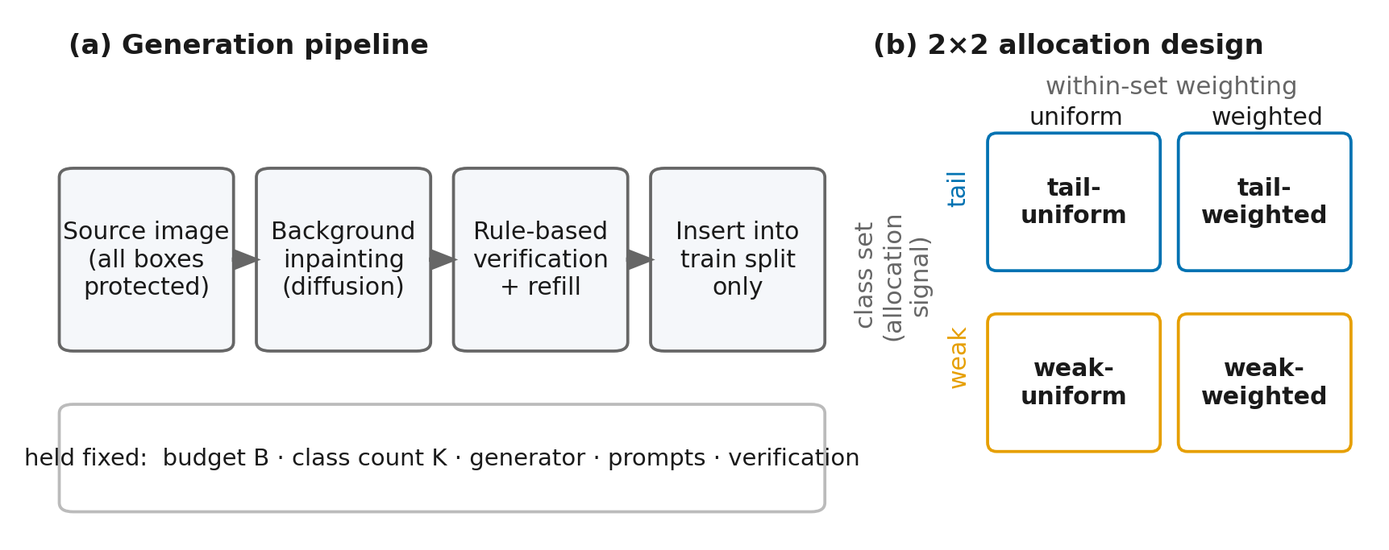
Figure 1. Overview. (a) Generation pipeline: all annotated boxes in a source image are geometrically protected; diffusion inpainting regenerates only the background; outputs must pass rule-based verification (with budget refill) before insertion into the training split. Budget B, class count K, generator, prompts, and verification are held fixed across arms. (b) The 2×2 allocation design: class set (frequency-defined tail vs. AP-defined weak) × within-set weighting (uniform vs. priority-weighted).
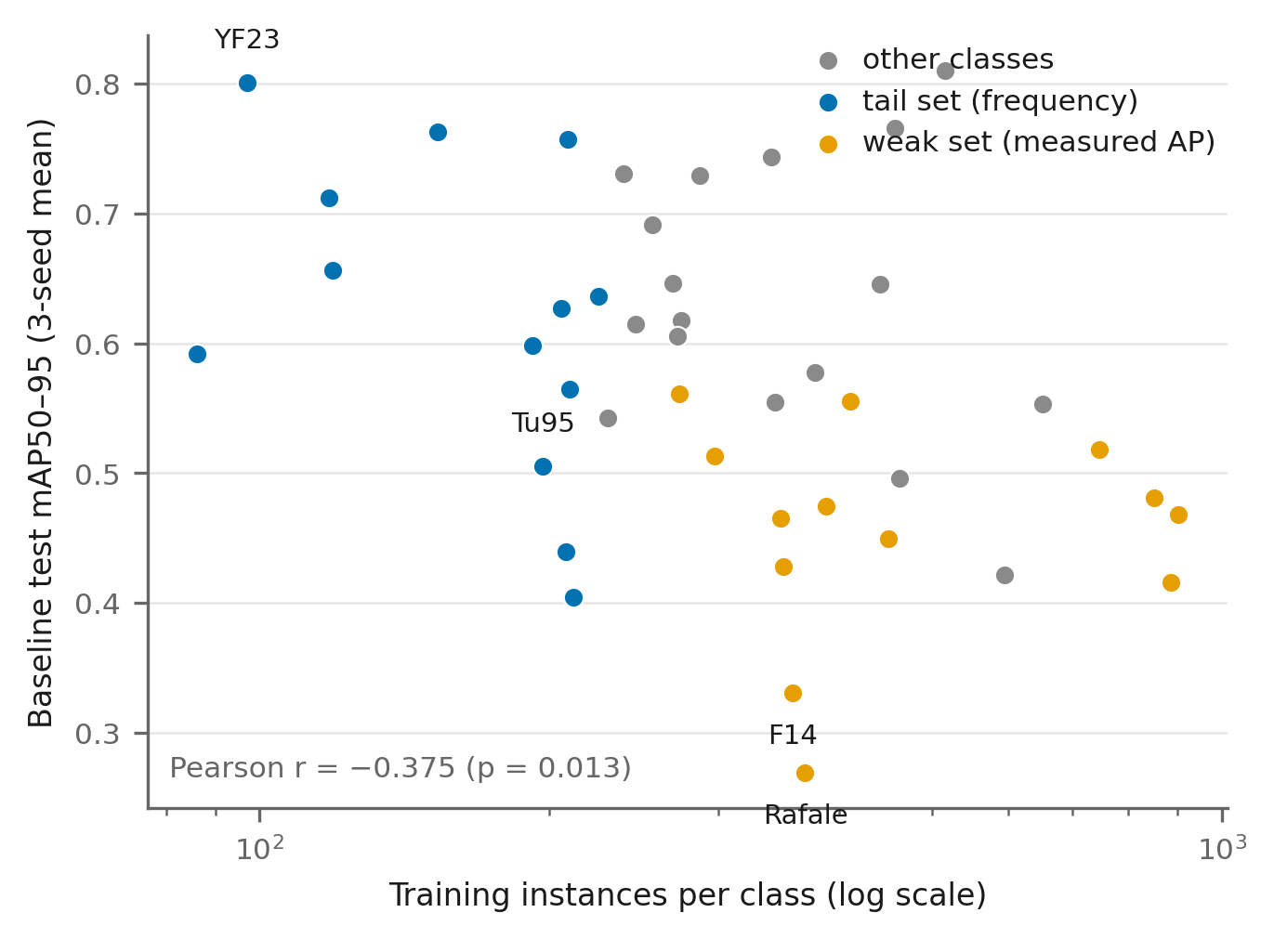
Figure 2. Frequency is a poor proxy for difficulty on MAD. Per-class baseline test mAP50–95 (three-seed mean) against training instance count (log scale). The frequency-defined tail set (blue) and the AP-defined weak set (orange) are disjoint; the rarest class (YF-23) is the easiest, while the weakest classes (Rafale, F-14) sit at medium-to-head frequency.

5. Results
We report all results on the military aircraft detection cells of Section 4 as test-split mean average precision over intersection-over-union thresholds 0.50–0.95 (mAP50–95), and give the mean over three independent training seeds with per-arm standard deviations computed across seeds. Gains (Δ) are always relative to the basic_aug baseline of the same cell. Pre-registered contrasts (Section 3.6) are evaluated with seed-blocked paired t-tests, 95% confidence intervals (CIs), and Holm correction within each cell’s five-contrast family; class-level Wilcoxon signed-rank tests on seed-averaged per-class AP serve as secondary evidence. Table 2 gives the master results for all four cells; Table 3 lists the pre-registered contrast outcomes.

5.1 The allocation signal determines where gains occur
Frequency and difficulty select different classes. On MAD, per-class training-instance count and baseline test AP correlate negatively (mAP50–95 basis; Pearson r = −0.375, p = 0.013; Spearman ρ = −0.408, p = 0.007). In AP50 terms, the rarest class (YF-23, 97 training instances) attains the highest score (0.93), whereas the weakest classes (Rafale 0.31, F-14 0.37) sit in the medium and head frequency ranges. Empirically, the frequency-defined tail set and the AP-defined weak set are disjoint on MAD (0/13 overlap) and overlap in a single class on MAR20 for the compact detector (Section 4.1). This is the premise that makes the 2×2 allocation design informative: if frequency were a good proxy for difficulty, the two signals would select the same classes and could not be dissociated.
Gains land on the targeted set (MAD, confirmatory). Figure 3 (left) shows the result on MAD with YOLOv8n as a double dissociation: each set family improves its own target scope substantially more than the other family does, and vice versa. Averaged over seeds, the two tail-set arms improved the tail scope by +0.061 over baseline while improving the weak scope by only +0.019; the two weak-set arms showed the mirrored pattern (+0.040 on weak, +0.022 on tail). The pre-registered set-by-scope interaction — the difference-in-differences of the two set families across the two scopes — was +0.0598 (95% CI [0.045, 0.075], Holm-adjusted p = 0.017), with all three seeds showing the same direction. At the class level, gains were broad rather than concentrated: 11 of 13 tail classes improved under the tail-uniform arm (largest: Tu-95 +0.169, MiG-31 +0.101), and 11 of 13 weak classes improved under the weak-uniform arm (largest: Tornado +0.123, Rafale +0.086 — the weakest class in the dataset).
The dissociation replicates in the satellite domain (MAR20). Figure 3 (right) shows the same analysis for MAR20 with YOLOv8n. The interaction estimate was +0.0523 (95% CI [0.021, 0.083]; positive in all three seeds), which lies inside the 95% CI of the MAD estimate; the tail-targeted arm again gained most on the tail scope (selective: +0.044; class-level Wilcoxon p = 0.031, the smallest attainable value at n = 6) and the weak-targeted arms most on the weak scope (+0.030 to +0.034). Because the MAR20 scopes contain only six classes each, the seed-blocked tests are underpowered and the interaction does not survive Holm correction (unadjusted p = 0.018, Holm-adjusted p = 0.091); we therefore report MAR20 as an independent replication of the effect size rather than a second confirmatory result.
Within-set weighting shows no benefit. In contrast to the choice of class set, how the fixed budget is divided inside the chosen set showed no evidence of benefit in any condition: the weighted-versus-uniform contrasts were null in all four pre-registered comparisons, with estimates centred near zero (+0.002, p = 0.81 and −0.012, p = 0.17 on MAD; +0.014, p = 0.11 and +0.004, p = 0.52 on MAR20; Table 3). The CIs do not exclude small effects in either direction, so we do not claim strict equivalence; what the data rule out is a within-set weighting benefit comparable to the set-choice effect. Given that the uniform and weighted arms shared the same class sets, generator, prompts, quality verification, and budget, we conclude that at the budgets studied the allocation signal (which classes) — not the allocation shape (how many per class) — is the operative variable.
Targeted gains come with a smaller global spillover. Augmenting one set also produced consistent but smaller gains outside it: on MAD the tail-uniform arm improved the weak scope by +0.031 (class-level p = 0.002), and on MAR20 the cross-set gains ranged from +0.004 to +0.013. Background inpainting therefore appears to combine a set-specific targeting component with a smaller domain-wide component, consistent with the recall-oriented mechanism discussed in Section 6.

5.2 A strong pretrained detector removes all augmentation gains
Replacing the compact detector with RT-DETR-L (Section 4.2) raised the baseline from 0.575 to 0.869 on MAD and from 0.572 to 0.697 on MAR20 — and eliminated every augmentation effect we measured (Figure 4, Table 2). On MAD, all deltas were zero to negative: uniform −0.004, selective −0.001, and RFS −0.016; the pooled inpainting-versus-baseline contrast on the tail scope was −0.008 (p = 0.36). On MAR20 the pattern repeated (uniform −0.007, selective −0.005, RFS +0.003; pooled tail contrast +0.004, p = 0.72). Notably, the strong detector’s baseline already exceeded the best augmented YOLOv8n result by a wide margin (0.869 vs. 0.661 on MAD).
Two observations follow. First, augmentation gains in this study are conditional on detector headroom: once a model retains little headroom on the dataset, neither resampling nor generative augmentation adds measurable value, and the largest single lever is the detector upgrade itself (a cross-cell comparison; Section 6.1). Second, the only consistently negative delta under the strong detector was RFS on MAD (−0.016 on all three scopes), suggesting that increasing duplicate exposure can be mildly harmful when capacity and pretraining already suffice; we report this as an observation without claiming a mechanism. Because the RT-DETR-L cells implemented a reduced design (baseline, RFS, and the two tail-set arms only), no interaction test is available there; the “vanishing gains” claim rests on the near-zero deltas of all measured arms.

5.3 Resampling effectiveness depends on the imbalance structure
Repeat-factor sampling — the zero-cost resampling baseline that dominated every diffusion arm on MAD (+0.086 all, +0.098 tail, +0.117 weak; class-level p ≤ 2×10⁻⁴) — transferred poorly to MAR20. With the same detector and protocol, RFS on MAR20 yielded +0.003 (all), +0.016 (tail), and −0.011 (weak; class-level p = 0.031) — the only statistically significant negative augmentation effect we observed under YOLOv8n. MAD is deeply imbalanced across 43 classes (max/min instance ratio 10.5), so re-exposing rare-class images carries additional training signal; MAR20’s 20-class distribution is comparatively shallow, and additional exposure of already-seen images adds little, while inpainting — which injects genuinely new background variation — remains effective (Section 5.1). On MAR20, inpainting was in fact the only augmentation with statistically significant gains. The practical implication is developed in Section 6: RFS is a cheap first attempt rather than a universal winner, and its failure is diagnostic of a regime where generative augmentation is worth its cost.

5.4 Robustness checks
Generation quality does not explain the dissociation. The three originally generated MAD pools passed rule-based quality verification at similar rates (79–82%), and the fourth pool reached its quota under the same criteria; per-pool Fréchet inception distance (FID; Heusel et al., 2017) and CLIP-based image–text similarity scores (Radford et al., 2021) were comparable, with the worst-FID pool (weakness) producing the significant weak-scope gain — quality differences cannot account for where gains landed. On MAR20 the verification failure rate was 0.6%, and all four pools reached the full 500-image budget.
Hallucinated objects do not drive the RFS gap on MAD. A detector-based audit found unlabeled aircraft hallucinated into 10.2% of MAD synthetic backgrounds. Removing all affected images with an object-level gate and retraining the three original diffusion arms changed their all-scope performance by at most |Δ| ≤ 0.017 (all nine gated-versus-ungated comparisons non-significant, p = 0.11–0.97), while the RFS advantage persisted essentially unchanged (Δ = −0.055 to −0.067 versus RFS, p < 10⁻⁴). Label noise from generation artifacts therefore explains neither the dissociation nor the resampling gap.
Table 2. Master results: Δ mAP50–95 versus the same-cell basic_aug baseline (mean over three seeds; baseline rows show absolute mAP ± SD). Bold marks the scope targeted by each arm; scopes are cell-specific (Section 4.1).
Dataset × detector | Arm | all | tail | weak
**MAD × YOLOv8n | basic_aug | 0.575 ± 0.007 | 0.620 ± 0.009 | 0.456 ± 0.030
 | RFS | +0.086 | +0.098 | +0.117
 | tail-uniform | +0.031 | +0.060 | +0.031
 | tail-weighted | +0.023 | +0.062 | +0.007
 | weak-uniform | +0.016 | +0.014 | +0.046
 | weak-weighted | +0.020 | +0.030 | +0.034
**MAD × RT-DETR-L | basic_aug | 0.869 ± 0.006 | 0.889 ± 0.008 | 0.842 ± 0.012
 | RFS | −0.016 | −0.010 | −0.016
 | tail-uniform | −0.004 | −0.013 | −0.006
 | tail-weighted | −0.001 | −0.004 | +0.003
**MAR20 × YOLOv8n | basic_aug | 0.572 ± 0.005 | 0.532 ± 0.013 | 0.467 ± 0.017
 | RFS | +0.003 | +0.016 | −0.011
 | tail-uniform | +0.010 | +0.030 | +0.013
 | tail-weighted | +0.012 | +0.044 | +0.008
 | weak-uniform | +0.004 | +0.008 | +0.030
 | weak-weighted | +0.003 | +0.004 | +0.034
**MAR20 × RT-DETR-L | basic_aug | 0.697 ± 0.001 | 0.676 ± 0.007 | 0.611 ± 0.010
 | RFS | +0.003 | +0.013 | 0.000
 | tail-uniform | −0.007 | +0.007 | −0.009
 | tail-weighted | −0.005 | 0.000 | −0.007
Table 3. Pre-registered contrasts (seed-blocked paired t, n = 3 seeds; Holm correction within each cell’s five-contrast family).
Dataset | Contrast | Estimate | 95% CI | p | Holm p
MAD | Tail arms vs. baseline (tail scope) | +0.061 | [+0.026, +0.096] | 0.017 | 0.069
MAD | Weak arms vs. baseline (weak scope) | +0.040 | [−0.021, +0.100] | 0.106 | 0.317
MAD | Set × scope interaction | +0.060 | [+0.045, +0.075] | 0.003 | 0.017
MAD | Weighted vs. uniform (tail set) | +0.002 | [−0.031, +0.035] | 0.808 | 0.808
MAD | Weighted vs. uniform (weak set) | −0.012 | [−0.036, +0.013] | 0.172 | 0.345
MAR20 | Tail arms vs. baseline (tail scope) | +0.037 | [+0.015, +0.058] | 0.018 | 0.091
MAR20 | Weak arms vs. baseline (weak scope) | +0.032 | [−0.024, +0.087] | 0.133 | 0.336
MAR20 | Set × scope interaction | +0.052 | [+0.021, +0.083] | 0.018 | 0.091
MAR20 | Weighted vs. uniform (tail set) | +0.014 | [−0.008, +0.035] | 0.112 | 0.336
MAR20 | Weighted vs. uniform (weak set) | +0.004 | [−0.019, +0.027] | 0.519 | 0.519
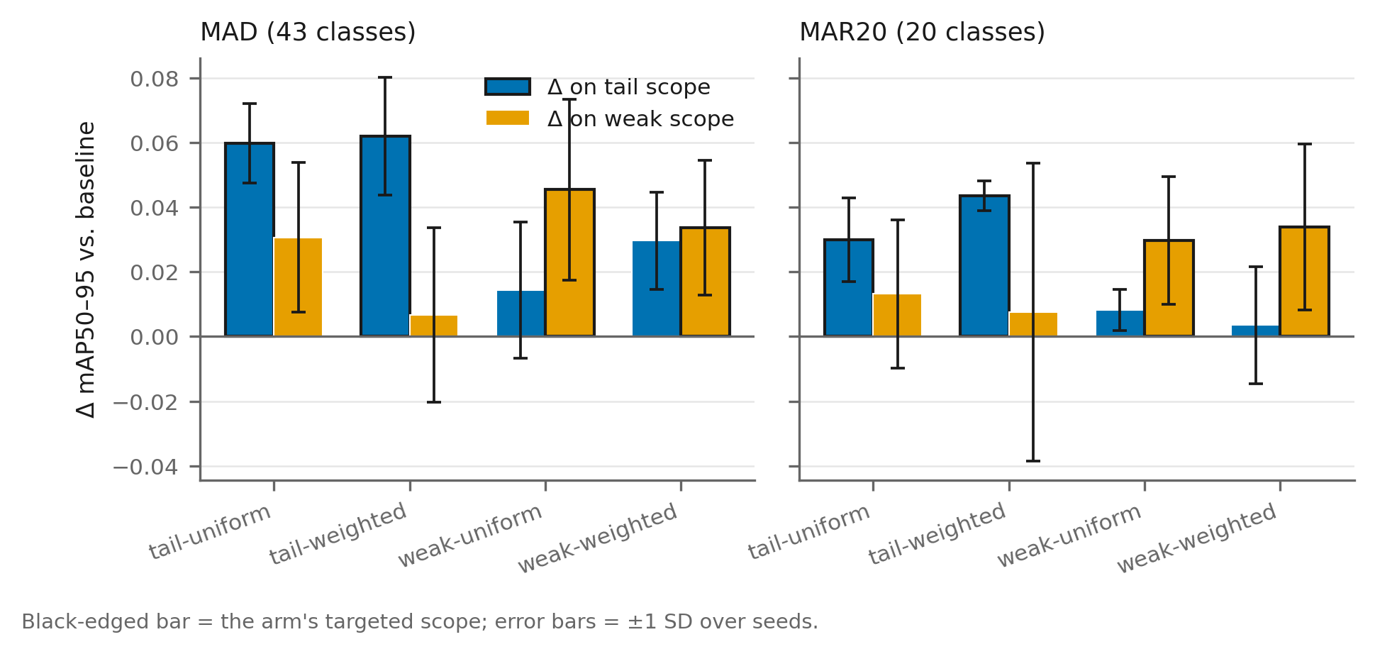
Figure 3. The allocation signal determines where gains occur. Δ mAP50–95 versus the same-cell baseline for the four inpainting arms on the tail scope (blue) and weak scope (orange); black-edged bars mark each arm’s targeted scope; error bars span ±1 standard deviation over three seeds. Left: MAD (confirmatory; interaction Holm-adjusted p = 0.017). Right: MAR20 (replication of the effect size; Section 5.1).
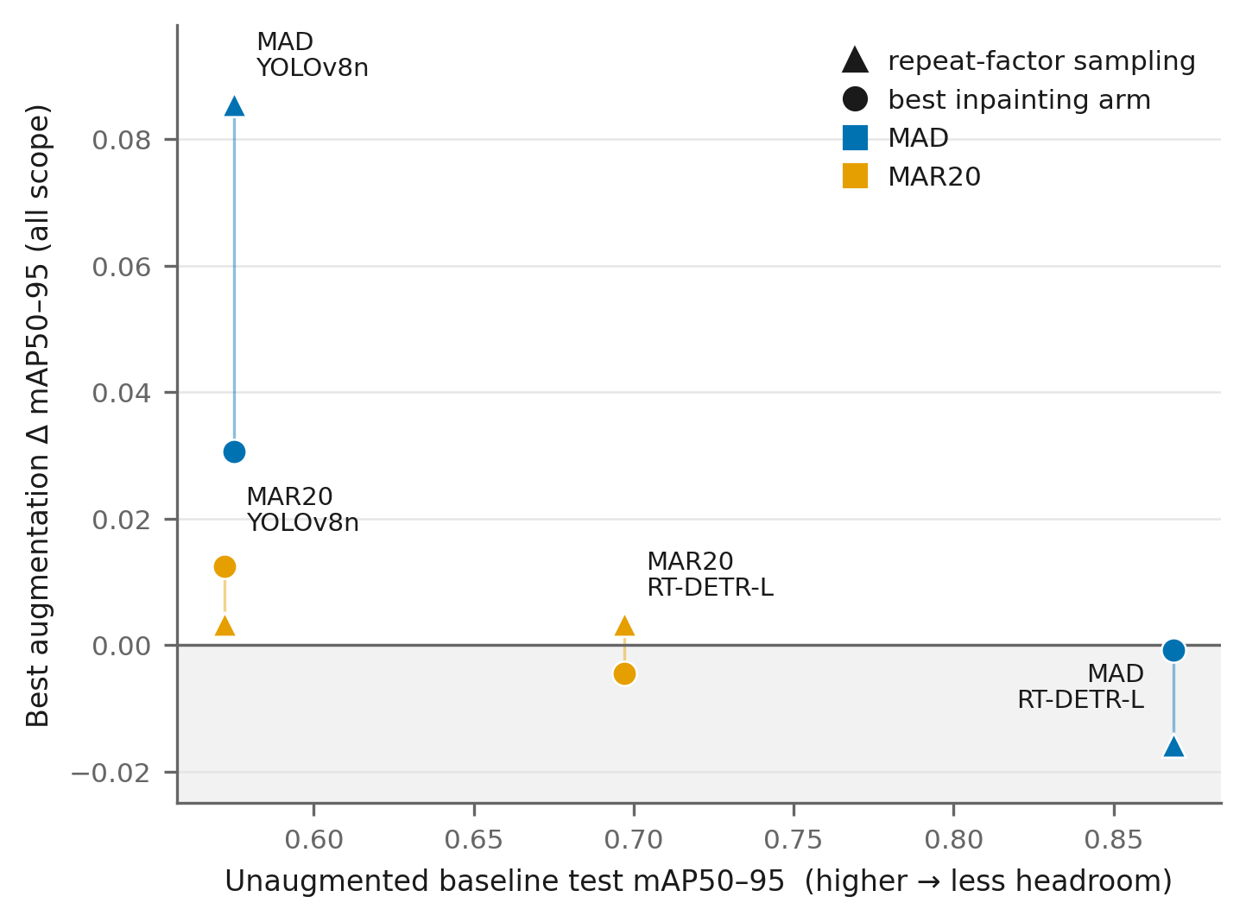
Figure 4. Condition map across the four cells. Best augmentation Δ mAP50–95 (all scope) against the unaugmented baseline of each cell; triangles denote repeat-factor sampling, circles the best inpainting arm; color denotes the dataset. Gains shrink to zero under the high-baseline RT-DETR-L cells (right), and resampling and inpainting exchange ranks between MAD and MAR20 (left).
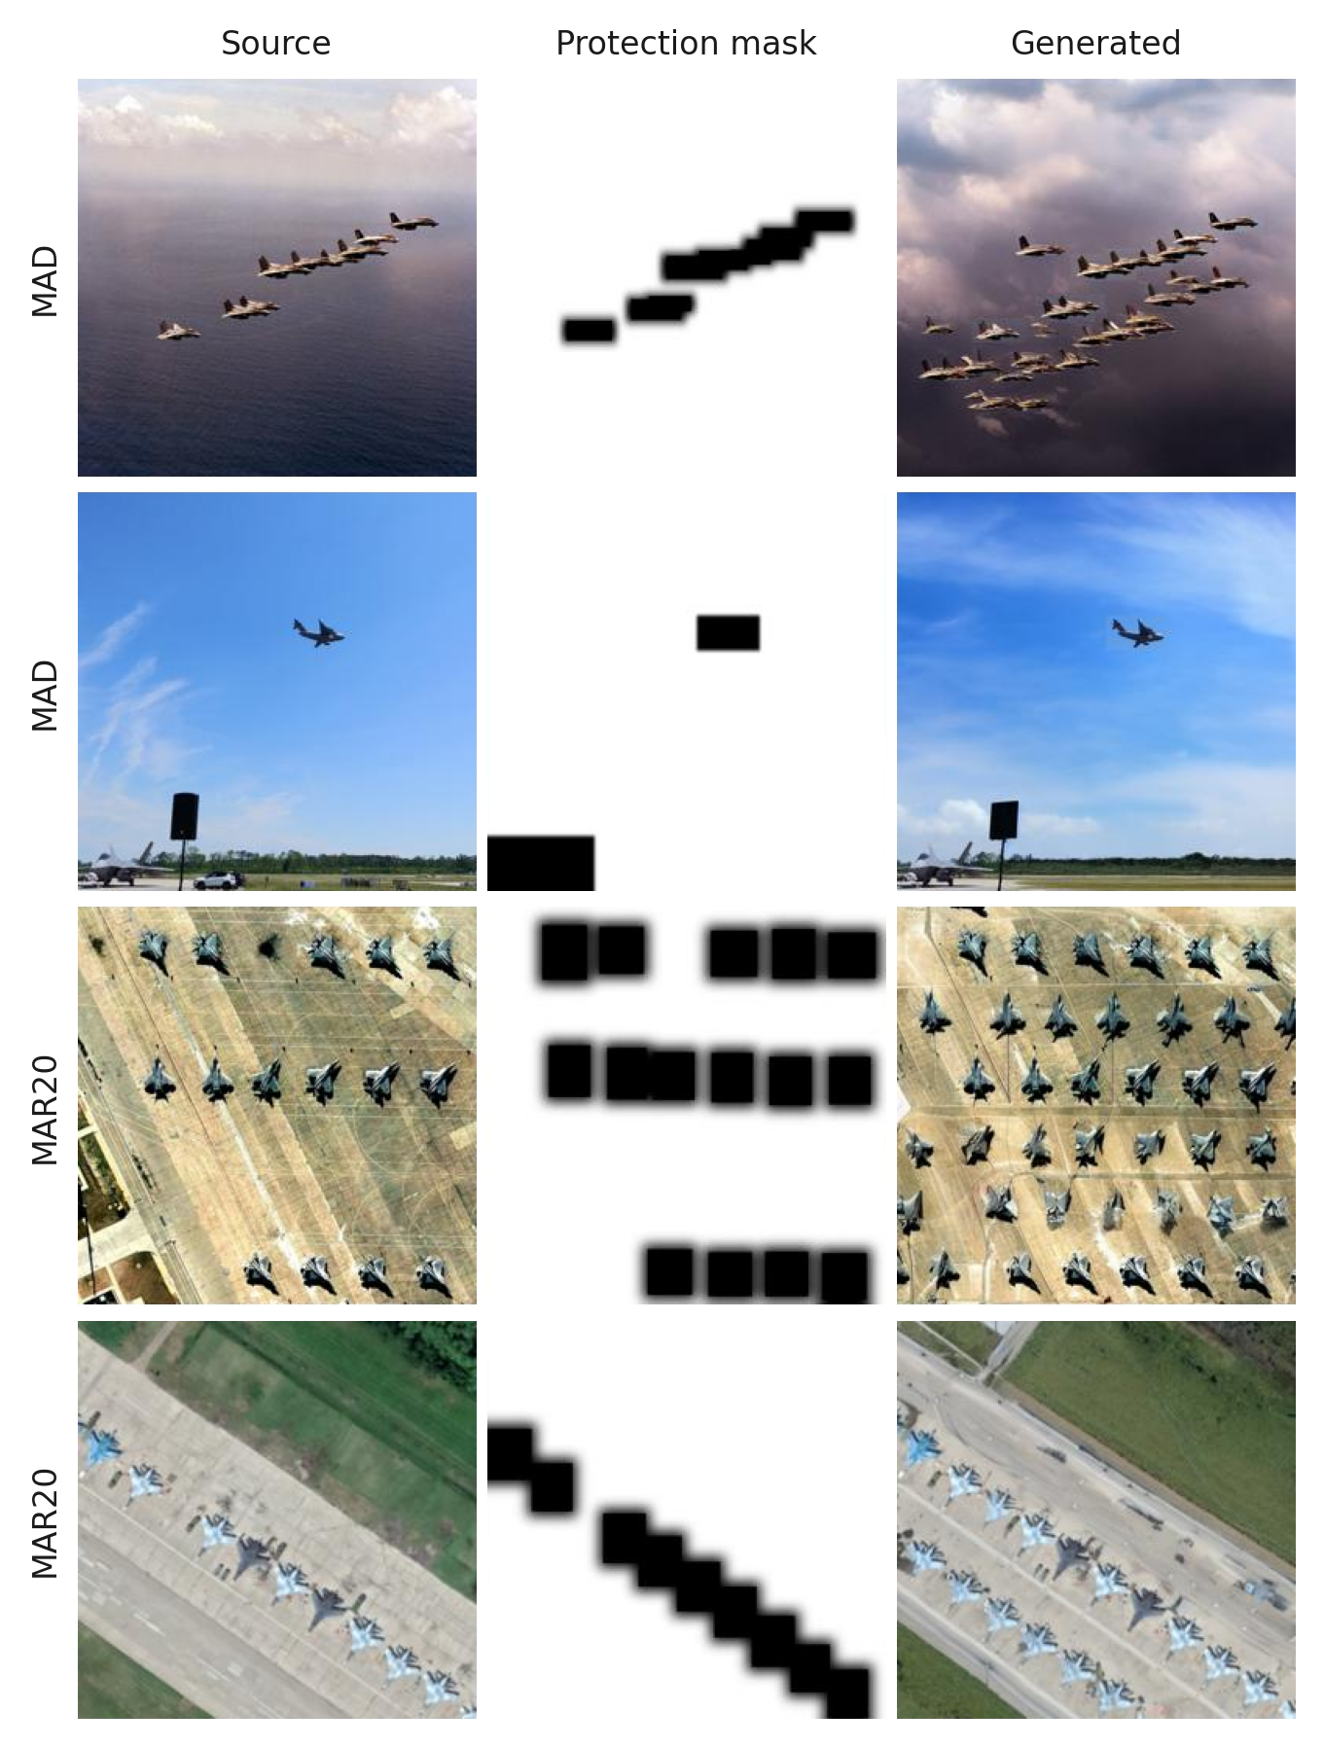
Figure 5. Generation examples (source, protection mask, output; mask black = protected). Rows: two MAD and two MAR20 cases spanning formation, airshow, apron, and airbase scenes. The top row also illustrates the hallucination failure mode quantified in Section 5.4 — diffusion has painted additional, unlabeled aircraft into the regenerated sky — which motivates the detector-based audit and the object-gate robustness check.

6. Discussion

6.1 Engineering guidance: a three-step decision rule
Read together, the four cells yield an actionable procedure for practitioners who must decide whether — and how — to spend a synthetic-data budget on a detection system.
Step 1: assess detector headroom before investing in augmentation. The largest single improvement observed in this study came not from any data intervention but from replacing the detector: the pretrained transformer’s unaugmented baseline exceeded the best augmented result of the compact detector by 0.21 mAP50–95 on MAD (0.869 vs. 0.661), and once the stronger detector was in place, every augmentation we measured was ineffective and resampling was mildly harmful (Section 5.2). We stress that this is a cross-cell engineering observation rather than a randomized comparison — the two detectors differ simultaneously in capacity and architecture family (both are initialized from COCO-pretrained weights; Section 4.2) — but its practical reading held in every condition we tested: when deployment constraints permit a stronger pretrained detector, the model upgrade dominated every augmentation decision we evaluated. Data-side interventions become worth considering primarily where a compact detector is mandated, for example by edge-compute budgets, and the model therefore retains visible headroom.
Step 2: use free resampling as a first attempt — and as a diagnostic. Repeat-factor sampling requires no generation compute and, on the deeply imbalanced MAD (imbalance ratio 10.5), outperformed every diffusion arm on every scope (Section 5.3). Its benefit did not transfer to the shallowly imbalanced MAR20, where it was null overall and negative on the weak scope. Because resampling can only re-expose existing images, it helps precisely when under-exposure of rare classes is the binding constraint; its failure therefore signals that the constraint lies elsewhere — in the diversity of the training distribution rather than in exposure frequency — which is the regime where injecting genuinely new variation through generation remains the available lever. In practice, RFS functions as a low-cost probe: run it first, keep it if it helps, and read a null result as evidence that a generative budget may be worth its price.
Step 3: when generating, select the class set by measured difficulty; per-class quota tuning is unnecessary. The interaction result (Section 5.1) shows that the allocation signal determines where gains occur, whereas the within-set weighting axis was null in all four pre-registered comparisons. This simplifies deployment considerably: the only consequential choice is which classes to target. Frequency is the conventional default for that choice, but it is a poor one whenever frequency and difficulty decouple, as they do here (r = −0.375). If the operational goal is to lift worst-case class performance, the per-class validation AP of the current baseline — available at no additional cost in any trained system — is the direct signal, and targeting the lowest-AP classes aligns the expected gains with that goal; within the chosen set, a uniform split of the budget suffices. The compute cost is moderate: generating and verifying one thousand 512-pixel background variants took a few GPU-hours on a single mid-range accelerator in our experiments, of the same order as one detector training run at this scale.

6.2 Why background inpainting behaves this way
Three observations jointly constrain the interpretation. First, the compact detector’s dominant error mode on MAD is missed detection: baseline recall (0.52–0.59) trails precision (0.62–0.71), and the largest off-diagonal mass in the confusion structure assigns true objects to background. Second, gains concentrate on the targeted set yet consistently spill over, attenuated, to non-targeted classes (Section 5.1). Third, all gains vanish under the higher-capacity pretrained detector (Section 5.2). These observations are consistent with a single account: background inpainting counteracts background overfitting. Re-rendering the surroundings of a geometrically protected object weakens context cues spuriously correlated with class identity, forcing the detector to rely on object appearance and thereby recovering missed detections — most strongly for classes whose contexts were re-rendered (targeting), positively but more weakly for classes that share the diversified background statistics (spillover), and not at all for a detector with the capacity to retain the broad variation of its pretraining, in which the spurious object–context coupling is already weak (headroom). The account also rationalizes the null weighting axis as saturation: once a class receives enough background variation to break the spurious correlation, additional variants of the same kind contribute little. Our data contain direct support for this reading — the weighted tail arm, whose smallest realized per-class quota was 16 images against the uniform arm’s 77, achieved statistically indistinguishable tail-scope gains. Finally, the MAR20 contrast between null resampling and effective inpainting argues that re-exposure of the protected objects cannot by itself account for the gains: the synthetic images repeat foregrounds exactly as resampling does, yet only the arm that also renews the backgrounds improved performance there. We advance this account as an interpretation consistent with all of our observations, not as a demonstrated causal chain.

6.3 Limitations and threats to validity
Four limitations bound our claims. (1) Replication power. The satellite-domain replication reproduces the interaction estimate inside the original confidence interval, but its six-class scopes leave the seed-blocked tests underpowered, and the effect does not survive Holm correction there; we accordingly claim replication of magnitude and direction, not a second confirmatory significance. (2) Set overlap. On MAR20 the frequency-defined and difficulty-defined sets share one of six classes, slightly diluting the dissociation relative to the fully disjoint MAD design. (3) Strong-detector cells: coverage and attribution. The transformer cells omit the weak-set arms, so the headroom finding rests on near-zero deltas of the measured arms rather than on an interaction test; moreover, the strong-detector comparison co-varies capacity and architecture family (the pretraining corpus is shared), so “headroom” names their joint effect rather than isolating a single factor. A full factorial on the strong detector, together with capacity-matched comparisons within one architecture family, would resolve both points. (4) External validity. All evidence comes from one application domain (aircraft), two datasets, one generator family (Stable Diffusion inpainting, at one budget point per dataset), and two detector capacity tiers. The condition map should therefore be read as a demonstrated pattern with identified moderators — detector headroom and imbalance depth — not as a parametric law. Natural next steps are budget scaling curves, a factorial combination of resampling with targeted generation to test whether their gains compose, stronger generators, and replication on broader long-tailed benchmarks.

7. Conclusion
We asked a question that the growing literature on generative augmentation leaves implicit: when a fixed budget of synthetic images is available, which classes should receive it? A 2×2 factorial over the allocation signal and the within-set weighting — run under a fixed budget, generator, and verification protocol on two public military-aircraft benchmarks and two detector families — gives a consistent answer. The class set is the decision that matters: gains land on the targeted set, confirmed by a pre-registered interaction on the natural-view benchmark and replicated in effect size on the satellite-view benchmark, while dividing the budget inside the chosen set uniformly or by priority makes no measurable difference. The choice of signal is not innocuous, because frequency and measured difficulty select disjoint classes here; practitioners whose goal is worst-case class performance should target the measured-weakest classes rather than the rarest. Both findings, however, are conditional: under a large pretrained transformer detector every augmentation effect disappears, and the zero-cost resampling baseline that dominates generation under deep imbalance turns null — and locally harmful — when the imbalance is shallow. The resulting decision rule — assess headroom, probe with free resampling, then generate for measured weakness with a uniform split — is immediately actionable, and the evaluation protocol that produced it (budget control, pre-registered contrasts, seed-blocked tests) is reusable wherever augmentation claims are made. Extending the factorial to strong detectors, tracing budget scaling curves, and testing whether resampling and targeted generation compose are the natural next steps.

References
- Ahmed, T., Kumar, A., Álvarez Casado, C., Zhang, A., Hänninen, T., Loven, L., Bordallo López, M., Tarkoma, S., 2025. Exponentially weighted instance-aware repeat factor sampling for long-tailed object detection model training in unmanned aerial vehicles surveillance scenarios. arXiv:2503.21893.
- Bozorgtabar, B., Mahapatra, D., von Teng, H., Pollinger, A., Ebner, L., Thiran, J.-P., Reyes, M., 2019. Informative sample generation using class aware generative adversarial networks for classification of chest X-rays. arXiv:1904.10781.
- Crasto, N., 2024. Class imbalance in object detection: An experimental diagnosis and study of mitigation strategies. arXiv:2403.07113.
- Fan, C., et al., 2024. DiverGen: Improving instance segmentation by learning wider data distribution with more diverse generative data. In: Proc. IEEE/CVF CVPR 2024.
- Geng, S., Hsieh, C.-Y., Ramanujan, V., Wallingford, M., Li, C.-L., Koh, P.W., Krishna, R., 2024. The unmet promise of synthetic training images: Using retrieved real images performs better. arXiv:2406.05184.
- Ghiasi, G., Cui, Y., Srinivas, A., Qian, R., Lin, T.-Y., Cubuk, E.D., Le, Q.V., Zoph, B., 2021. Simple copy-paste is a strong data augmentation method for instance segmentation. In: Proc. IEEE/CVF CVPR 2021.
- Gupta, A., Dollár, P., Girshick, R., 2019. LVIS: A dataset for large vocabulary instance segmentation. In: Proc. IEEE/CVF CVPR 2019.
- Heusel, M., Ramsauer, H., Unterthiner, T., Nessler, B., Hochreiter, S., 2017. GANs trained by a two time-scale update rule converge to a local Nash equilibrium. In: Advances in Neural Information Processing Systems 30 (NeurIPS 2017).
- Holm, S., 1979. A simple sequentially rejective multiple test procedure. Scandinavian Journal of Statistics 6 (2), 65–70.
- Jocher, G., Chaurasia, A., Qiu, J., 2023. Ultralytics YOLOv8 (software). https://github.com/ultralytics/ultralytics.
- Li, B., et al., 2022. Equalized focal loss for dense long-tailed object detection. In: Proc. IEEE/CVF CVPR 2022.
- Li, Y., et al., 2020. Overcoming classifier imbalance for long-tail object detection with balanced group softmax. In: Proc. IEEE/CVF CVPR 2020.
- Li, Y., Dong, X., Chen, C., Zhuang, W., Lyu, L., 2024. A simple background augmentation method for object detection with diffusion model. arXiv:2408.00350.
- Liang, Y., Bhardwaj, S., Zhou, T., 2025. Diffusion curriculum: Synthetic-to-real data curriculum via image-guided diffusion. In: Proc. IEEE/CVF ICCV 2025. arXiv:2410.13674.
- Radford, A., et al., 2021. Learning transferable visual models from natural language supervision. In: Proc. ICML 2021.
- Rombach, R., Blattmann, A., Lorenz, D., Esser, P., Ommer, B., 2022. High-resolution image synthesis with latent diffusion models. In: Proc. IEEE/CVF CVPR 2022.
- rookieengg, 2023. Military Aircraft Detection Dataset (YOLO format) [dataset]. Kaggle. https://www.kaggle.com/datasets/rookieengg/military-aircraft-detection-dataset-yolo-format.
- Song, G., Du, H., Zhang, X., Bao, F., Zhang, Y., 2024. Small object detection in unmanned aerial vehicle images using multi-scale hybrid attention. Engineering Applications of Artificial Intelligence. https://www.sciencedirect.com/science/article/abs/pii/S0952197623016391.
- Suri, S., et al., 2023. Gen2Det: Generate to detect. arXiv:2312.04566.
- Tang, D., et al., 2025. AeroGen: Enhancing remote sensing object detection with diffusion-driven data generation. In: Proc. IEEE/CVF CVPR 2025.
- Wang, J., et al., 2021. Seesaw loss for long-tailed instance segmentation. In: Proc. IEEE/CVF CVPR 2021.
- Wu, J., Zhao, F., Yao, G., Jin, Z., 2025. FGA-YOLO: A one-stage and high-precision detector designed for fine-grained aircraft recognition. Neurocomputing 618, 129067.
- Xie, J., et al., 2024. MosaicFusion: Diffusion models as data augmenters for large vocabulary instance segmentation. International Journal of Computer Vision. arXiv:2309.13042.
- Yaman, B., Mahmud, T., Liu, C.-H., 2023. Instance-aware repeat factor sampling for long-tailed object detection. arXiv:2305.08069. NeurIPS Workshop on Heavy Tails in Machine Learning.
- Yu, W., Cheng, G., Wang, M., Yao, Y., Xie, X., Yao, X., Han, J., 2023. MAR20: A benchmark for military aircraft recognition in remote sensing images. National Remote Sensing Bulletin 27 (12), 2688–2696.
- Zhao, H., et al., 2023. X-Paste: Revisiting scalable copy-paste for instance segmentation using CLIP and StableDiffusion. In: Proc. ICML 2023, PMLR 202.
- Zhao, Y., et al., 2024. DETRs beat YOLOs on real-time object detection. In: Proc. IEEE/CVF CVPR 2024. arXiv:2304.08069.
- Zhu, J., et al., 2024. ODGEN: Domain-specific object detection data generation with diffusion models. In: Advances in Neural Information Processing Systems 37 (NeurIPS 2024). arXiv:2405.15199.

