MyT IoT Platform.

Final Year Project Proposal  
September 2019

Daemon Macklin  
Internet of Things  
20075689

# Introduction

The Internet of Things has given rise to a number of services that allow users to upload, graph and do a number of other things with their data. Services such as WIA and Wyliodrin make it easy for users without a knowledge of cloud computing to easily create full stack IoT services. However, these services come with a number of down sides. Firstly you are relying on a third party service running. If the third party’s application crashes, or if the company goes out of business your IoT stack might go with it. These services also usually use cloud service providers like Amazon Web Services, so why not just go straight to the source and deal with AWS or your cloud service provider of choice.

The second problem is that you are trusting the existing IoT platforms with your data. There is no sure way to know where your data is stored and who can see it. The only way to ensure that your data is secure is to handle it yourself.

The MyT(My Things) Platform aims to solve both of these issues. Allowing anyone to deploy their own IoT platform on their own server or cloud service of choice. Complete with MQTT messaging, the ability for custom data processing, storage and graphing. MyT also will lower the barrier of entry to IoT and cloud computing. Giving users more control of their IoT platform.

# MyT

MyT is a cloud agnostic customizable IoT platform, designed to allow users to take control of their data and IoT applications. Allowing users to use different technologies based on their requirements. To help lower the barrier of entry will be an intelligent requirements gathering process users will go though that will recommend which technologies users should use. Once the user has chosen their technologies, the platform will be deployed to their cloud service of choice, using their account and credentials.

The deployment will use a number of different technologies.

1. Terraform – This will be used as a orchestration tool. To create the required infrastructure. Virtual Machines, Storage, etc.
2. Ansible – This will be used as a management tool, Used to install docker and do any other configuration is needed on the machine.
3. Docker – Docker will be used to manage and run the different services.

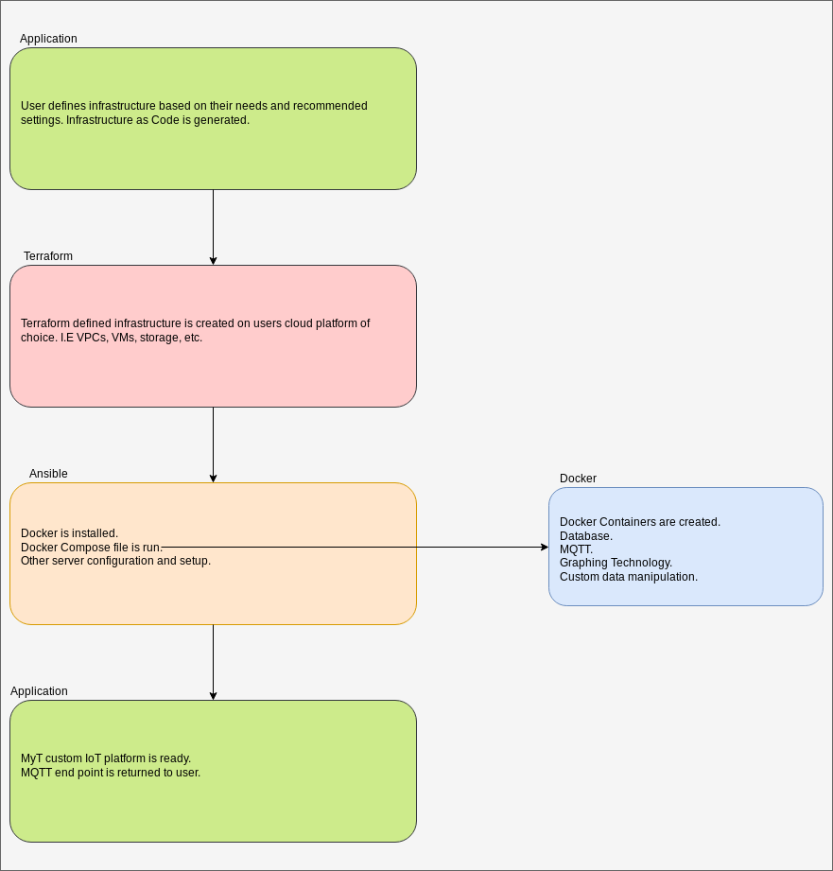

The user will now have their own IoT platform to use for just about any application they want.

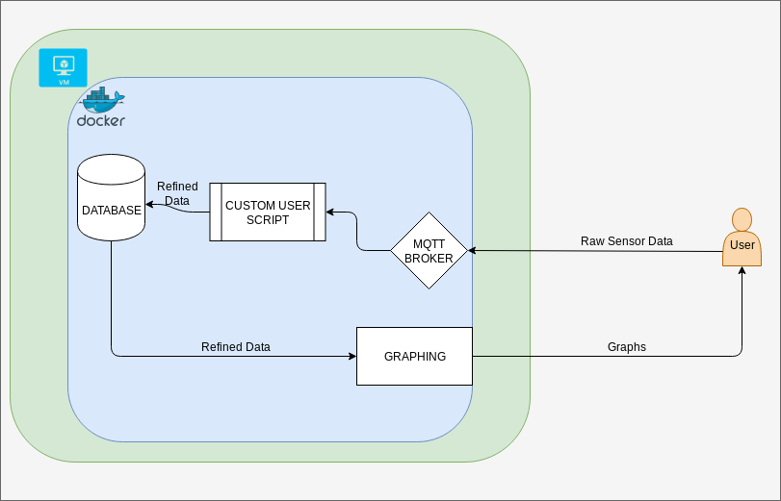

The MyT infrastructure is made of 4 main components.

1. MQTT Broker – This is used for message passing so the user can send their data there and it will be available to more than just the rest of MyT if the user wishes.
2. Custom User Script. This component will allow users to insert their own code to process the data in the cloud.
3. Database – This is where all of the users data will be stored.
4. Graphing – This will hook into the database, allowing the user to create graphs with their data.

The aim is the make some of these components dynamic, based on user requirements. For example if the user wants to upload time series sensor data, they could use a database like InfluxDB, where as if they had variant data they could use a database that is more flexible, like MongoDB.

I will try to develop this project with an agile development process. I hope to learn about cloud computing and automation. As well as improve not only my technical skills, but also, soft skills, such as communication, project and time management.