

Ice Hockey Statistics Database Implementation

Written by:
Daemon Macklin | 20075689
Departement of Computing and Science

Academic Year: 2017-2018

Table of Contents
1. Cover page
2. Table of contents
3. Normalized Tables
4. Table Mapping
7. Implementation

Normalized Tables
Conferences(conference_ID, conference_name)
Divisions(division_ID, division_name, conference_ID)
Teams(team_ID, team_Name, team_Location, team_Record, points, conference_ID, division_ID)
Coaches(coach_ID, first_name, last_name, date_of_birth, career_Record, team_ID)
Players(player_ID, player_first_name, player_last_name, draft_year, player_dob, height, weight, player_type, goals, assists, points, pim, p_m, save_percentage, gaa, shots_against, goals_against, shutouts, team_ID)
Games(game_ID, away_team, final_score, location, team)

Table Mapping

Conference
Field | Type | Size | NULL/  NOT NULL | Default | Constraints | Index | Description
conference_id | Number | 5 | NOT NULL |  | Unique | pk | UID for conference
conference_name | Varchar | 20 | NOT NULL |  |  |  | Name of conference

Division
Field | Type | Size | NULL/  NOT NULL | Default | Constraints | Index | Description
division_id | Number | 5 | NOT NULL |  | Unique | pk | UID for division
division_name | Varchar | 20 | NOT NULL |  |  |  | Name of division
conference_id | Number | 5 | NOT NULL |  |  | fk | ID for conference division is in

Coaches
Field | Type | Size | NULL/  NOT NULL | Default | Constraints | Index | Description
coach_id | Number | 5 | NOT NULL |  | Unique | pk | UID for coach
first_name | Varchar | 20 | NOT NULL |  |  |  | Coach first name
last_name | Varchar | 20 | NOT NULL |  |  |  | Coach last name
date_of_birth | Date |  | NOT NULL |  |  |  | Date of birth of coach
career_record | Varchar | 14 | NOT NULL |  |  |  | Career record for coach
team_id | Number | 5 |  |  |  | fk | ID of team coach belongs to

Team
Field | Type | Size | NULL/  NOT NULL | Default | Constraints | Index | Description
team_id | Number | 5 | NOT NULL |  | Unique | pk | UID for team
team_name | Varchar | 20 | NOT NULL |  |  |  | Name of team
team_location | Varchar | 20 | NOT NULL |  |  |  | Location of team
team_record | Varchar | 8 | NOT NULL |  |  |  | Wins-losses record for team
Points | Number | 3 | NOT NULL |  |  |  | Points team has this season
conference_id | Number | 5 | NOT NULL |  |  | fk | ID of conference team is in
division_id | Number | 5 | NOT NULL |  |  | fk | ID of division team is in

Game
Field | Type | Size | NULL/  NOT NULL | Default | Constraints | Index | Description
game_id | Number | 5 | NOT NULL |  | Unique | pk | UID for game
Team | Number | 5 | NOT NULL |  |  | fk | ID for team in game
away_team | Varchar | 20 | NOT NULL |  |  |  | Name of opponent
location | Varchar | 4 | NOT NULL |  | home or away |  | Location of match
final_score | Varchar | 5 | NOT NULL |  |  |  | Score of game

Player
Field | Type | Size | NULL/  NOT NULL | Default | Constraints | Index | Description
player_id | Number | 5 | NOT NULL |  | Unique | pk | UID for player
player_first_name | Varchar | 20 | NOT NULL |  |  |  | Player first name
player_last_name | Varchar | 20 | NOT NULL |  |  |  | Player last name
draft_year | Number | 4 | NOT NULL |  |  |  | Year player was drafted
player_dob | Date |  | NOT NULL |  |  |  | Date player was born
height | Number | 3 | NOT NULL |  |  |  | Height of player
weight | Number | 3 | NOT NULL |  |  |  | Weight of player
player_type | Varchar | 4 | NOT NULL |  | skater or goalie |  | Player type
goals | Number | 2 |  |  |  |  | Goals scored
assists | Number | 2 |  |  |  |  | Assists scored
points | Number | 3 |  |  |  |  | Total points
pim | Number | 4 |  |  |  |  | Penalty minutes
p_m | Number | 2 |  |  |  |  | Plus/minus
save_percentage | Number | 3 |  |  |  |  | Percentage of shots saves
gaa | Number | 3 |  |  |  |  | Goals against average
shots_against | Number | 3 |  |  |  |  | Shots against
goals_against | Number | 3 |  |  |  |  | Goals againts
shutouts | Number | 2 |  |  |  |  | Shutouts
team_ID | Varchar | 20 | NOT NULL |  |  |  | Name of conference

Implementation

New ER Diagram:
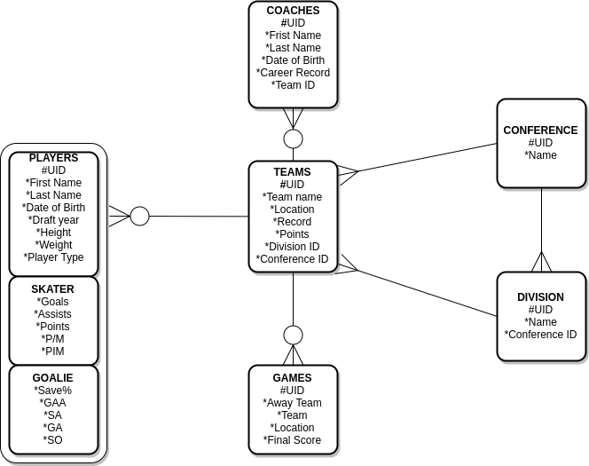

Changes made to design
- Relationship between Games and Teams has become a many optional to 1. Where one team is referenced in a single Game entity. There is a Game entity for each game one team plays this means there is duplicates of games stored.
- Points(2xGames won + OT losses) is now stored in Teams.
- Points(Assists + Goals) is now stored in Skater.
- Location and Away Team now stored in Games

Useful queries and Commands
- SELECT player_last_name, player_first_name, points, assists, goals FROM PLAYERS WHERE player_type = 'skater' ORDER BY -POINTS
This command returns a list of all players listed by the number of points highest to lowest..
By changing ORDER BY -POINTS you can chose the primary stat the list will be ordered by for example ORDER BY -GOALS would list the players by number of goals, highest to lowest.
- SELECT player_last_name, player_first_name,save_percentage , gaa, shutouts FROM PLAYERS WHERE player_type = 'goalie' ORDER BY -SAVE_PERCENTAGE
This command returns a list of all goalies listed by save percentage highest to lowest.
By changing ORDER BY --SAVE_PERCENTAGE you can chose the primary stat the list will be ordered by for example ORDER BY -SHOTS_AGAINST would list the goalies by number of shots they have faced in game, highest to lowest.
- SELECT TEAM_NAME, TEAM_LOCATION, TEAM_RECORD, POINTS, CONFERENCE_NAME FROM TEAMS JOIN CONFERENCES USING (CONFERENCE_ID) ORDER BY -POINTS
This command returns a list of all the teams listed by points highest to lowest. It displays the conference name using the a using clause.
- SELECT TEAM_NAME, TEAM_LOCATION, TEAM_RECORD, POINTS, CONFERENCE_NAME FROM TEAMS JOIN CONFERENCES USING (CONFERENCE_ID) WHERE CONFERENCE_NAME = 'Eastern Conference' ORDER BY -POINTS
This command refines the teams list returned by the last command to a specific conference.
- SELECT player_last_name, player_first_name, points, assists, goals FROM PLAYERS WHERE player_type = 'skater' AND player_first_name = 'Matt'
This command is used to search for specific players based on their first name. The command ca be altered by changing ‘skater’ to ‘goalie’ this will return a list of goalies with the first name ‘Matt’. The second condition can be changed based on which stat or data you want to base the search on i.e. player_last_name, points, save_percentage etc.
- SELECT AVG(points) FROM Players
This command returns the average amount of goals scored by players. Can also be used for many other stats like save percentage.
- SELECT team_name, away_team, final_score, location FROM GAMES JOIN TEAMS ON (team = team_id) WHERE team = 1
This command will return a list of all the games a team has played. The team ID is used to select which teams games you want to view.
- UPDATE PLAYERS set team_id = 8 WHERE player_id = 12
This command is used to change the team a player is on.

Privileges
Due to the business there isn’t many privilege levels. All tables are view-able by any user. Tables can only be change (insert, update, delete etc.) by the hockey league. Teams can request trades but the changes will only be made by admins at the league. Games and Player statistics are recorded by the league and inputed into the system.

