Blazor CA Report

Daemon Cullen X00182575

  - Table of contents:
- Description of the App
- Tests Performed
- References

1. Description of the App
The purpose of the Blazor app that I created was to allow users to learn about countries all around the world. To help me achieve this I used an API from the REST Countries website which was inspired by restcountries.eu by Fayder Florez. There were a few different reasons that led me to choose this one. Firstly, not only does it contain all the countries of the world, but it contains a lot of useful and fun information such as the flag. This allows for a lot of visuals to be created so that not only can you search through every country, but you can also view the design that represents each country. Another reason I choose the REST Countries API is just because I have an interest in the world and how each country connects and the patterns that show up between countries.
The app is broken up into three sections, Home, Countries and Statistics. Home is just a little introduction to the user, describing the app and explaining the features present. It is just a welcome so that when a user opens the app, they aren’t bombarded with too much on the screen at once.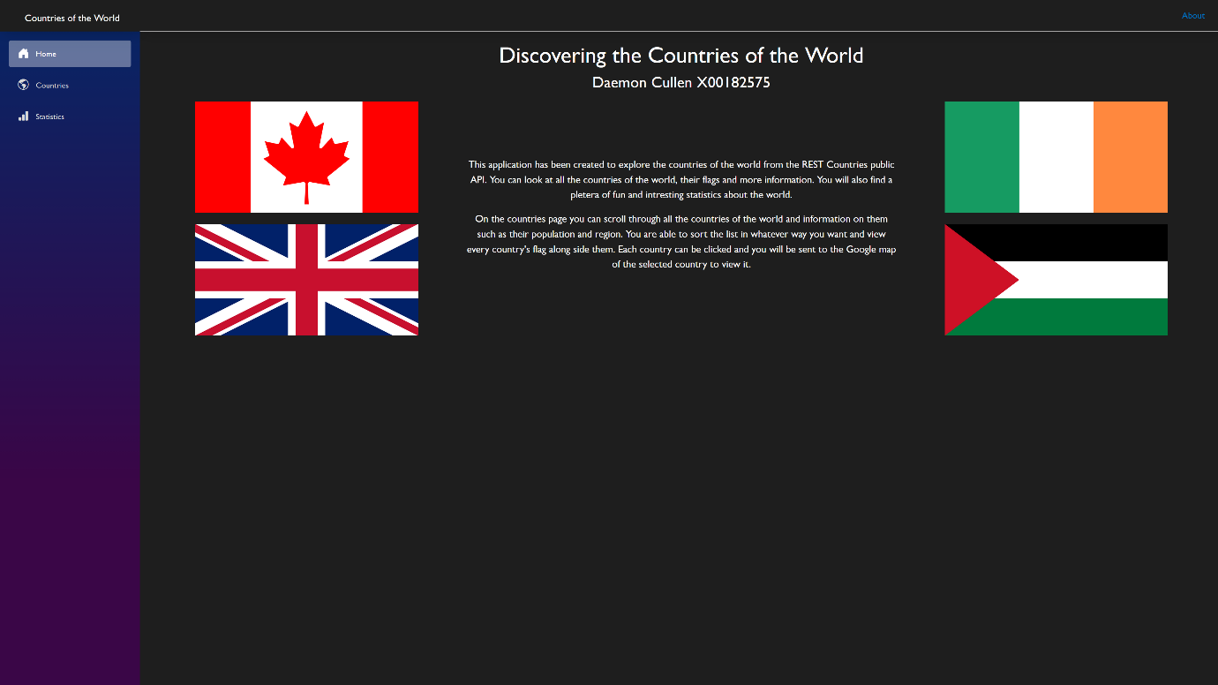
Figure 1.0

The Countries page (see Figure 2.0) is the page that contains a list of all the countries of the world. This list shows each country in a separate box containing the information of that country such as its name, region, population and more. This information is nice to have but is very difficult to look at when it’s in one big list, which is where the first feature comes into play, sorting. Sorting allows the user to sort the list of countries in order of population, area, population density and by name. This allows the user to learn about the actual statistic of the world and to find patterns for themselves. The next feature is the search bar (see Figure 2.1). The search bar allows the user to find any country they desire to view its specific data. The final feature is the maps. Clicking on the name of any country brings the user directly to the google maps location of the selected country so that they can view it for themselves and see where it is and what’s nearby it. 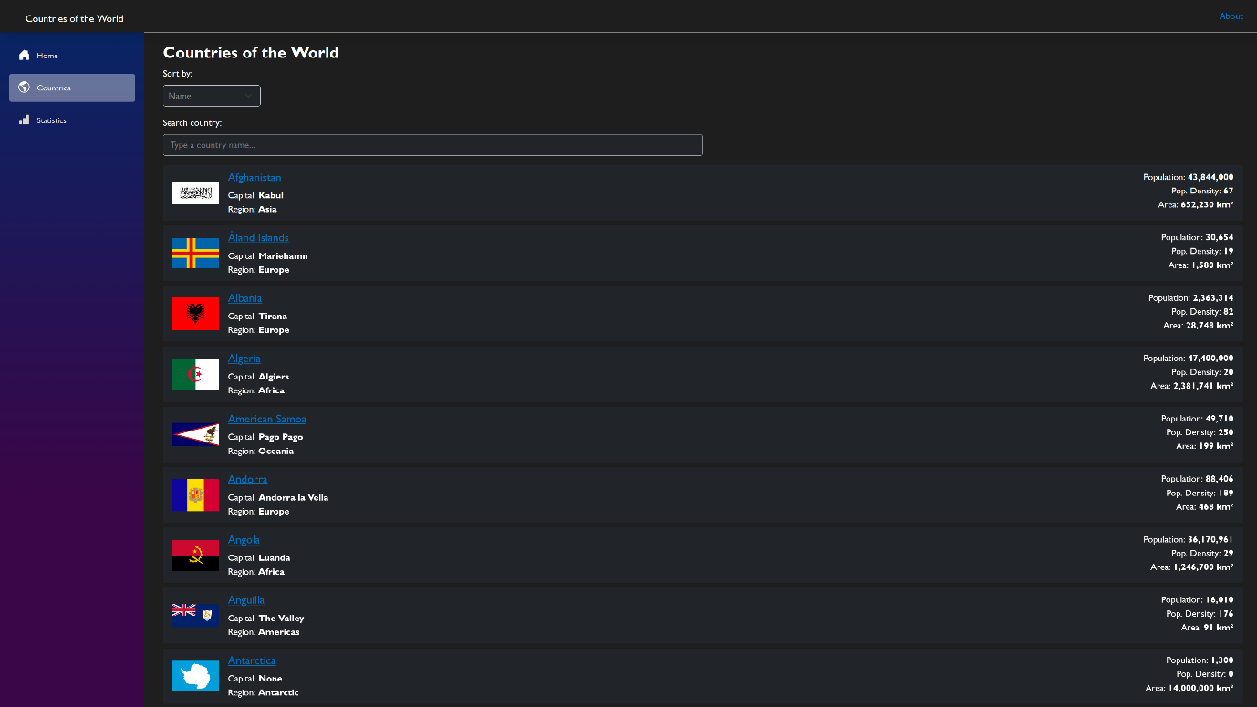
Figure 2.0
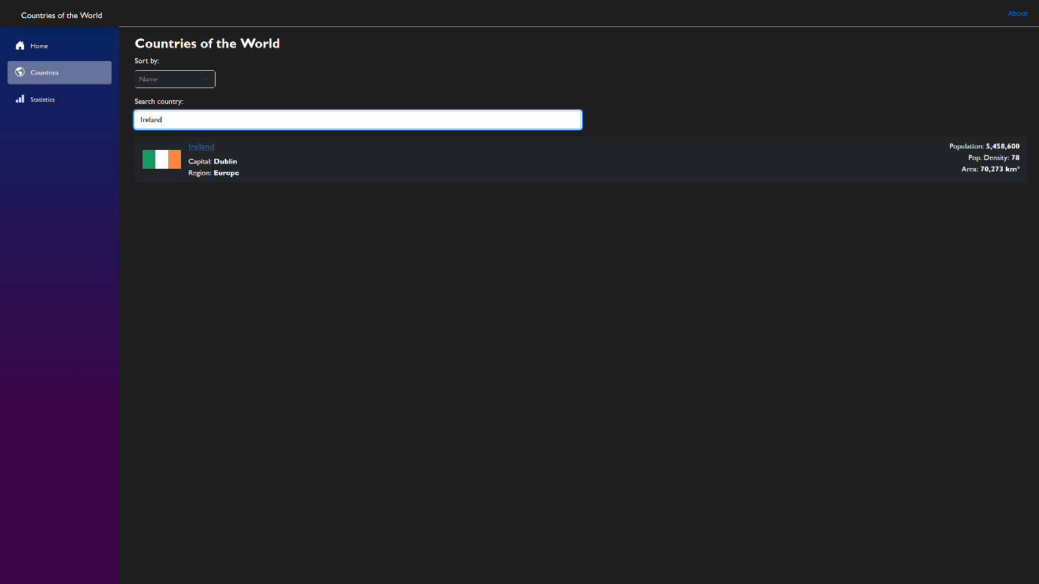
Figure 2.1

The Statistics page (see Figure 3.0) is a collection of charts that show data from countries in a more elegant and visual way using charts. For these charts I used a library called Blazor Bootstrap as it is both easy to use and incredibly beautiful. The charts display the top countries in their respective areas and each chart can be hovered over to supply the user with more information. Each chart is also complemented with a short description of the chart and the information it contains.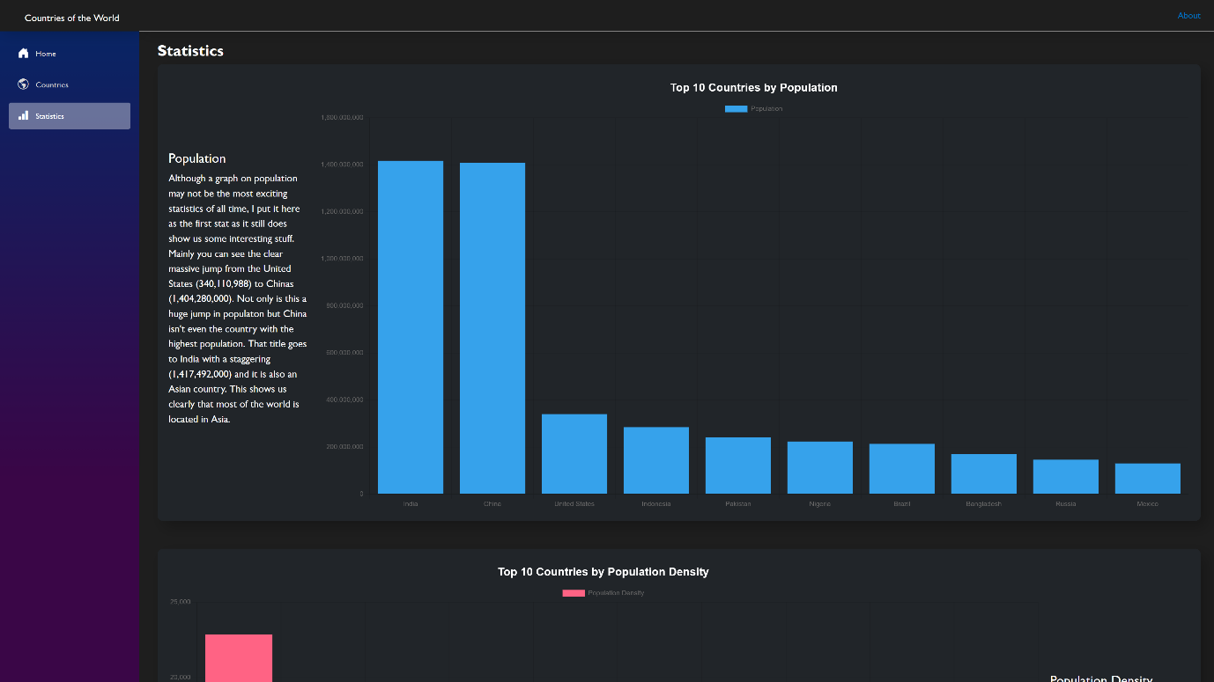

2. Tests Performed

3. References
Chart library – Blazor Bootstrap
https://demos.blazorbootstrap.com

