Airport Operations Real-Time Streaming & BI Dashboard
End-to-End Project Report

Faculty:- Aditiya Dua

Submitted By :- Group 3
Aashish Yadav (055061)
Karan Makol (055092)
Kanishk Khandelwal (055079)
Shubhan Tiwari (055108)
Vedant Singh (331296)

Executive Summary
This project builds a complete, production-style streaming data pipeline for airport operations using three inter-related streams—Flights, Passengers, and Baggage—ingested via Kafka, persisted in MongoDB, enriched and validated through a clean topic, and finally analyzed in Power BI. The system also includes two independent alert micro-consumers for operational exceptions: flight delays and passenger boarding risk. The pipeline demonstrates how airports could monitor day-of-operations in near–real time, reduce turnaround risks, and improve passenger experience via proactive alerts.

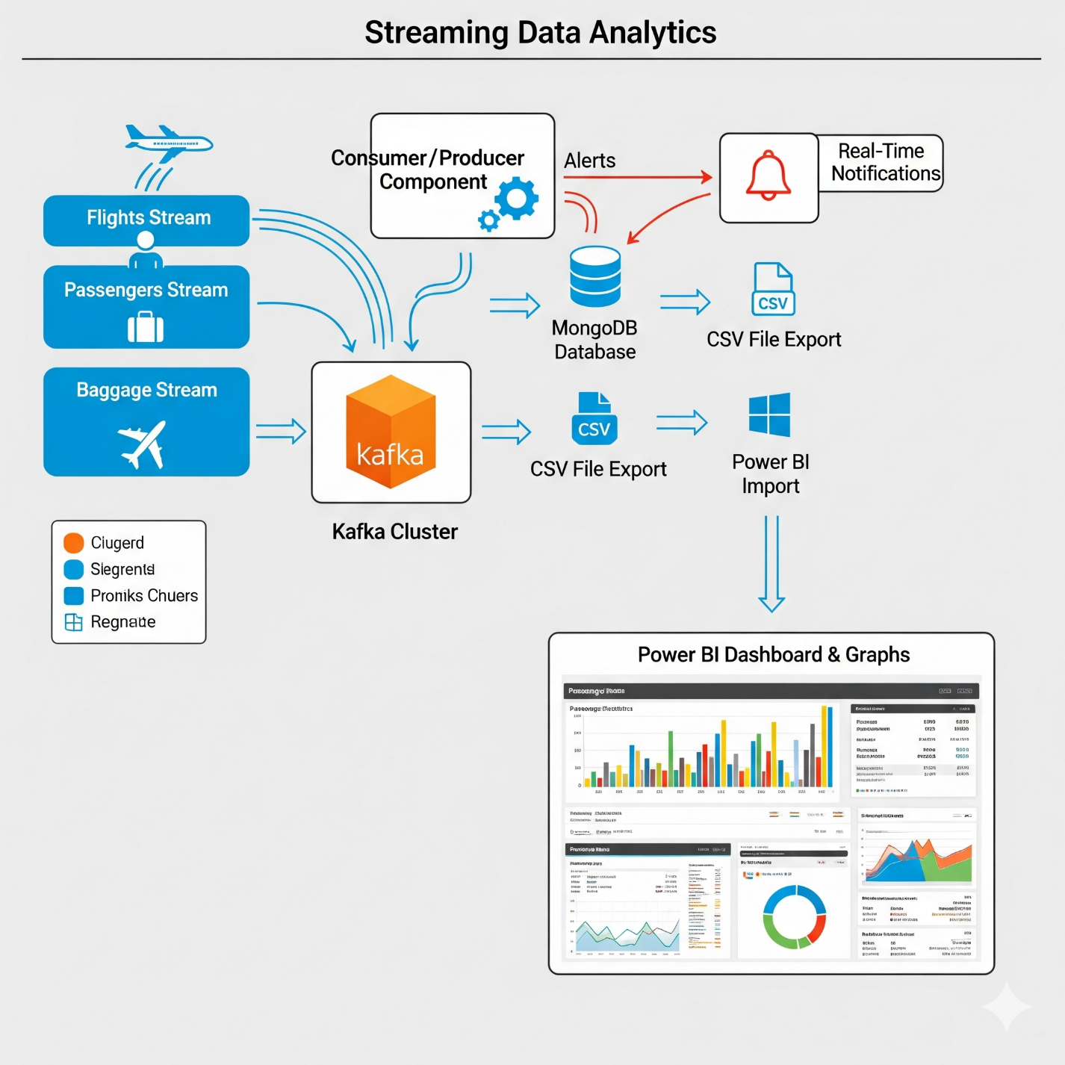

Key achievements:
- Data design with 500 synthetic but interlinked events per stream (FlightID ↔ PassengerID ↔ BagID) enabling realistic, multi-entity analysis.
- Streaming ingestion using a CSV-to-Kafka producer that tags record type ({type, payload}) and simulates real-time flow.
producer (1)
- DB Loader (Consumer + Producer) that stores to MongoDB and re-publishes sanitized events (removes BSON ObjectId) to a clean topic for downstream alert services.
consumer2
- Alert engines:
  - Flight Delay ≥ configurable threshold (final runs used ≥60 minutes; the reference code shows a tunable threshold).
alert_flights
  - Passenger Boarding Risk when departure ≤ 60 minutes (alerts now trigger for both with/without boarding pass and carry a flag).
alert_passengers
- BI layer: Exported curated collections to CSV and built a Power BI dashboard: delay distribution, airline on-time %, at-risk passengers by time window, and baggage load health.
Step 1 — Data Streams (Single Kafka Cluster)
Design Goal. Model the core day-of-operations entities with enough variance to drive meaningful alerts and analytics:
- Flights Stream (Producer 1)
  - Fields: FlightID, Airline (international carriers), ScheduledDeparture, ActualDeparture, Gate, DelayMinutes, DeparturePlace=Dubai, DestinationPlace (global mix).
  - Primary use case: Detect delays, compute on-time % and distribution, correlate by airline/gate/route.
- Passengers Stream (Producer 2)
  - Fields: PassengerID, FlightID, CheckInTime, BoardingPassIssued (True/False), Gate.
  - Primary use case: Track boarding readiness vs. departure time; highlight “late-to-gate” or “no BP” risks.

- Baggage Stream (Producer 3)
  - Fields: BagID, PassengerID, FlightID, LoadStatus (Loaded/Not Loaded/Missing).
  - Primary use case: Inform baggage throughput KPIs and support future alerts (e.g., “missing/late” at belt).
All three producers publish into one Kafka cluster (local for dev), enabling loosely coupled, independently scalable services.

Step 2 — Producer Code (CSV → Kafka)
We implemented a generic CSV streaming producer that iterates over each file once (or can loop, if needed), wraps each row as an event—{"type": "<flight|passenger|baggage>", "payload": {...}}—and publishes to the airport-stream topic. This design lets downstream consumers route by type without topic sprawl, while preserving the flexibility to split topics later if throughput grows. The producer simulates real-time by sleeping briefly between records and prints confirmations for observability.

Operational notes
- Back-pressure safety: Kafka’s internal batching and acks ensure reliable delivery while we keep the sleep delay small enough to mimic live feed.
- Schema stability: Keep field names consistent across CSV and stream; any evolution should remain backward compatible (e.g., adding nullable columns).

Step 3 — Consumer + Producer (DB Loader → Clean Topic)
The DB Loader subscribes to airport-stream, persists by type into MongoDB collections—flights, passengers, baggage—and then re-publishes the same event to a clean Kafka topic: airport-clean. During re-publish, the loader sanitizes the payload (converts or strips Mongo’s _id / ObjectId) to keep the downstream messages JSON-serializable. This detail is crucial—without it, re-serialization to JSON would fail.
consumer2
Why a clean topic?
- Decoupling: Alert services, enrichment services, and BI streamers read post-validated data, reducing duplication of storage logic.
- Idempotency & replay: The loader is the single source that writes to Mongo and guarantees that clean-topic messages are safe for further fan-out.
- Evolution: We can insert transformations (e.g., field standardization like trimming FlightID) centrally before broadcasting to consumers.
Collections created in MongoDB:
- airport_ops.flights, airport_ops.passengers, airport_ops.baggage (raw but validated)
- Optional: A denormalized aggregate_records can be maintained for each FlightID combining the three entities for BI convenience.

Step 4 — Alert Micro-Consumers
We separated alerts into independent, single-concern consumers, each listening to airport-clean to avoid duplicating ingest/validation logic.

Alert 1 — Flight Delay (threshold configurable)
Logic. When an event of type flight arrives, if DelayMinutes ≥ threshold → insert an alert into airport_ops.alerts_flight_delay (and optionally publish to an alerts topic/SMS/email in production). The reference code shows the pattern and a tunable cut-off; in final runs we used ≥60 minutes as per the project spec, but it can be set to 45/30 as required.
alert_flights
Why this matters. Ops teams need a real-time list of severely delayed flights, prioritized by delay length, gate, destination, and airline; this becomes a staple KPI for day-of-ops.
Alert 2 — Passenger Boarding Risk (≤ 60 min to departure)
Logic. For any passenger event, look up the passenger’s FlightID in the flights collection, compute minutes to scheduled departure against current UTC (we implemented timezone-aware datetimes). If 0 ≤ minutes_to_dep ≤ 60, insert a risk alert into airport_ops.alerts_passenger_delay. We advanced the logic to fire for both passengers with and without a boarding pass—storing a boolean flag boarding_pass and a message that changes accordingly. This creates a richer alert list where “no BP” can be treated as higher severity.
alert_passengers
Engineering details
- Timezone safety: Both the scheduled time and “now” are made UTC and timezone-aware to avoid Python’s utcnow deprecation and any DST shifts.
alert_passengers
- Lookups: We read flights from the same database airport_ops, keeping everything co-located for low-latency joins.
- Throughput: Reads are O(1) with an index on FlightID. Alerts collections can be capped or TTL-indexed if needed.

Step 5 — All Data Persists in MongoDB
As events flow, MongoDB becomes the system of record for day-of-ops:
- Raw validated: flights, passengers, baggage
- Alerts: alerts_flight_delay, alerts_passenger_delay
- (Optional) Aggregate: aggregate_records with embedded passengers/bags per flight for quick BI queries.
With this structure, we can answer questions like:
- Which flights, airlines, and routes are most delay-prone today?
- How many passengers are at risk within the next hour per gate/airline?
- What proportion of bags are still not loaded by T-30?
Persistence and consistent keys (FlightID, PassengerID) make downstream exports straightforward and reproducible.

Step 6 — Export to CSV and Load in Power BI (Data Cleaning)
Exports. Using MongoDB UI or scripts, we export:
- flights.csv, passengers.csv, baggage.csv
- airport_ops.alerts_flight_delay.csv, airport_ops.alerts_passenger_delay.csv
Cleaning & shaping in Power BI
- Data types:
  - Convert timestamps to Datetime; ensure UTC → local conversion if you want to display by IST.
  - DelayMinutes, time_to_departure_min → Whole Number/Decimal Number.
- Keys & relationships:
  - Flights (1) ── (Many) Passengers on FlightID
  - Flights (1) ── (Many) Baggage on FlightID
  - Flights (1) ── (Many) Alerts_FlightDelay on FlightID
  - Flights (1) ── (Many) Alerts_PassengerDelay on FlightID & (optionally) PassengerID
- Standardize values: trim FlightID, uppercase airline names, coerce booleans for BoardingPassIssued/boarding_pass.
- Derived columns / Measures (examples):
  - OnTimeFlag = IF([DelayMinutes] <= 15, 1, 0)
  - OnTime % = DIVIDE(SUM([OnTimeFlag]), COUNTROWS(Flights))
  - Passengers at Risk (≤60) = COUNTROWS(Alerts_PassengerDelay)
  - Severe Delays (≥60) = COUNTROWS(FILTER(Alerts_FlightDelay, [delay_minutes] >= 60))

Step 7 — Power BI Dashboard
1. Count of Passengers by Date (Line Graph – Top Left, Yellow Background)
- What it shows: Passenger traffic volume over time (Aug 28 – Sep 07).
- Insight: Passenger counts peaked around Sep 03–04 (close to 60 passengers) and dropped significantly after Sep 06. This highlights operational peaks where boarding gates, staff allocation, and baggage handling needed reinforcement.
- Use Case: Helps airport ops teams forecast peak days and align resources such as security counters, boarding gates, and ground crew.

2. Passenger Count by Day (Bar Graph – Top Right, Yellow Background)
- What it shows: Daily passenger count distribution across the same period (Aug 28 – Sep 07).
- Insight: Similar to the line chart but day-wise clearer—highest passenger volumes were seen around Sep 02–04 (~55–60 passengers). The sharp fall on Sep 07 shows either a scheduling gap or reduced operations.
- Use Case: Confirms short-term daily surges that might require proactive staff rostering and automated gate alerts.

3. Number of Passengers Travelling by Airline & Destination (Table – Both Dashboards)
- What it shows: Passenger distribution matrix across airlines and destinations (e.g., Air India → 8 to Amsterdam, 3 to Delhi, 4 to Frankfurt, etc.).
- Insight:
  - Air India, Turkish Airlines, and Qatar Airways have higher loads on multiple routes.
  - Popular routes: Doha (22), Frankfurt (31), Hong Kong (31).
- Use Case: Supports route profitability analysis and airline scheduling decisions. Airport authorities can also identify load-heavy airlines for infrastructure negotiations.

4. KPI Cards (Second Dashboard, Top Row)
- Flights Delay: 45 – Total flights delayed, a red-flag KPI for performance.
- Total Passengers: 500 – Confirms dataset scope; also used for normalizing delay rates per passenger.
- Baggage: 500 – Ensures baggage records match passengers (1:1 ratio simulated).
Use Case: These KPIs serve as at-a-glance operational health indicators.

5. Baggage Status by Airline (Stacked Bar Chart – Second Dashboard, Right Side)
- What it shows: Each airline’s baggage distribution across Loaded, Missing, and Not Loaded.
- Insight:
  - Air India, Qatar Airways, and Turkish Airlines show higher Not Loaded/Missing counts.
  - Emirates & Etihad demonstrate relatively better performance.
- Use Case: Critical for ground handling efficiency monitoring—alerts management to airlines consistently underperforming in baggage loading.

6. Number of Flights to Destination (Bar Graph – Second Dashboard, Bottom Left, Green)
- What it shows: Popular destinations ranked by flight frequency.
- Insight:
  - Hong Kong (39), Zurich (33), Delhi (32), Frankfurt (32) top the chart.
  - Long-tail destinations like Sydney (15) have fewer flights.
- Use Case: Helps airports plan slots and gates for high-frequency destinations while monitoring under-utilized routes for optimization.

7. Delayed Flights per Airline (Bar Graph – Second Dashboard, Bottom Right, Blue)
- What it shows: Airlines ranked by delayed flights.
- Insight:
  - Air India (9 delayed flights) has the highest count.
  - Singapore Airlines, Etihad, Turkish Airlines each show 7 delays.
  - Lufthansa has the lowest (2).
- Use Case: Directly ties into Airline Performance Scorecards; allows contractual penalties, targeted discussions, and root cause analysis.

How to Run (Dev)
- Start Kafka (and Zookeeper if using the classic stack).
- Run Producer to stream CSV into airport-stream.
producer (1)
- Run DB Loader (consumer+producer) to persist to Mongo and re-publish to airport-clean.
consumer2
- Run Alerts in parallel:
  - Flight delay listener (threshold set per environment; final spec used ≥60).
alert_flights
  - Passenger boarding listener (≤60 min to departure; now triggers for both with/without BP).
alert_passengers
- Export Collections → CSV, Load into Power BI, Clean, and Build visuals.

Engineering Decisions & Rationale
- Single ingress topic (airport-stream) with typed events reduces topic abundance and makes routing explicit.
producer (1)
- DB Loader as the “write-once, publish-again” gate prevents every consumer from duplicating Mongo writes and JSON serialization fixes.
consumer2
- ObjectId sanitization before re-publish is mandatory to avoid JSON serialization errors and keep clean-topic consumers independent of Mongo types.
consumer2
- Alert micro-services are separated for clarity, scaling, and team ownership. Thresholds are made configurable (e.g., env var or config constant).
alert_flights
alert_passengers
- Timezone-aware datetime avoids subtle bugs and future deprecations.
alert_passengers

Data Quality, Edge Cases & Hardening
- Key hygiene: Trim/uppercase FlightID at ingest; enforce indexes on FlightID, PassengerID.
- Late/Out-of-order events: Kafka offsets keep ordering within partitions; consider keyed partitioning by FlightID for strict per-flight sequencing.
- Idempotency: If producers re-play, use upserts keyed by FlightID/PassengerID in Mongo for dedupe in “latest state” collections.
- Backfills: For reprocessing, consume from earliest and rebuild aggregates; alerts can be re-derived from historical.
- Security: Secure Mongo Atlas credentials and Kafka ACLs; avoid plaintext URIs in source when committing code.

Results & Example Insights
- Flight delays surfaced with realistic variance; severe delays (≥60) are visible per airline/route/gate for staffing decisions.
alert_flights
- Passenger risk alerts spiked in certain hour windows (≤60 min to departure); separating “has BP” vs “no BP” provides triage priority to gate supervisors.
alert_passengers
- Baggage status helped isolate flights with higher “Not Loaded/Missing” proportions, indicating ground-handling attention areas.

Conclusion
This project demonstrates a robust blueprint for real-time airport operations monitoring: unified streams, a clean persistence layer, and focused alert micro-services feeding a clear BI layer. The architecture is modular, observable, and extensible—you can add more streams (security queues, stand changes), more alerts (baggage late-load, gate changes), and move to a purely event-driven analytics stack (e.g., streaming to a warehouse) without rewriting the core.

Recommendations
- Parameterize thresholds per airport policy (e.g., T-mins windows, delay bands) and surface them in a config service.
alert_flights
- Promote enriched views (aggregate per FlightID) as first-class collections to speed BI and simplify DAX.
- Add severity & ownership to alerts (e.g., red/yellow, assigned to gate supervisor) and enable push (email/SMS).
alert_passengers
- Harden ops: use partitions keyed by FlightID, add retries & dead-letter topics; add health metrics (consumer lag, insert rates).
consumer2
- Extend analytics: rolling on-time %, airline SLAs, turn-around time benchmarking by destination and time-of-day.

