1. **What is your name?**

* Jeff Daezon P. Almarez

1. **Please tell us a bit more about yourself including where you're from, hobbies, interests, etc.**

* I’m Jeff Daezon Almarez, my friends call me Daezon. I am from Brgy 4. Solid West Vigan City, Ilocos Sur. I am the kind of person that hates being alone, And I can’t focus thing If I don't have any friends with me or anyone, because when I'm alone I feel like I can't enjoy anything or something If I am doing It Alone. My hobbies are playing guitar and ukulele, watching anime sometimes, I love traveling, and learning more and more About Crypto. And I love Designing that much so that I am assigned to frontEnd Web developing and also I have a little bit knowledge in UX/UI design using Figma.

1. **How much coding experience do you already have?**

* I started coding when I was in my 3rd year college. So I Think it's a year now but I was coding more on designing at first. Using Html, Css, and a little bit javascript. Then this year my friend is now working in a company and he challenge us to us a framework so now we are using Handlebars,js and I have been struggle using it especially on pulling data and so on but I manage it atleast the help of Internet I will not going to lie that I am learning more because I am searching it on the internet and after I use the handlebars I think that I have more need to know before going to this advance frontend web developing.

1. **How did you hear about the Village88 training program? What are your goals for the program?**

* I heard about village88 from my thesis chairman. My main goal is to face my weakness because I know that I was just introduced with FrontEnd on the web and we know that it is more or designing so I want to face my weakness because I want to learn more and understand about backend also. For now I know and Admit that I'm not that good yet but It is also my dream to become a web developer of Village 88. And even if I fail so many times I will always come back until I can say that I have been qualified to be a part of it as a web developer.

1. **Please include 2 or 3 pictures of yourself and a brief context of each picture. We want to get to know you better!**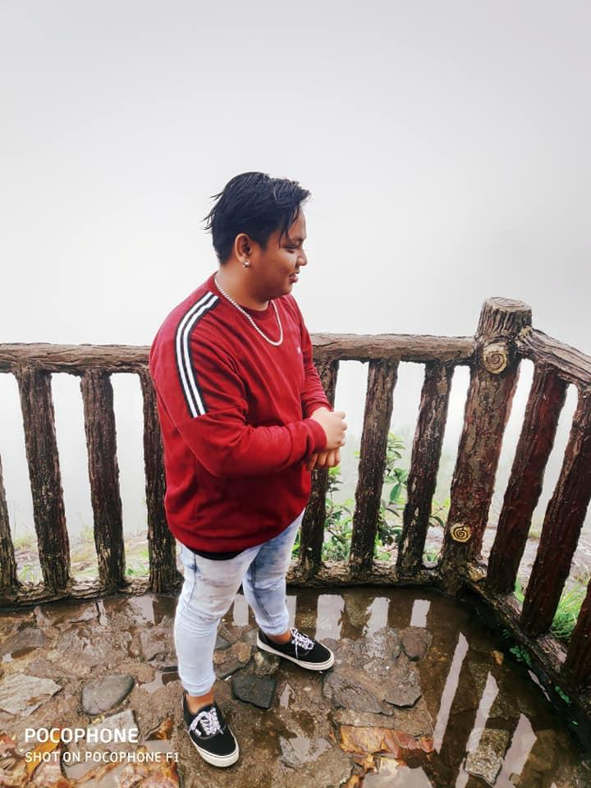

This photo is my first trip to Baguio in 2018 and I spent my vacation there in my tito’s house for 2 months. And in that thing I feel something that I really can't explain but It makes me feel like this place is my comfort zone. I feel so free after meeting some people there and they're so kind and make me feel it is a peaceful place with good people. And I promise myself to come back to Baguio again and again. But sadly pandemic came so that I couldn't go.

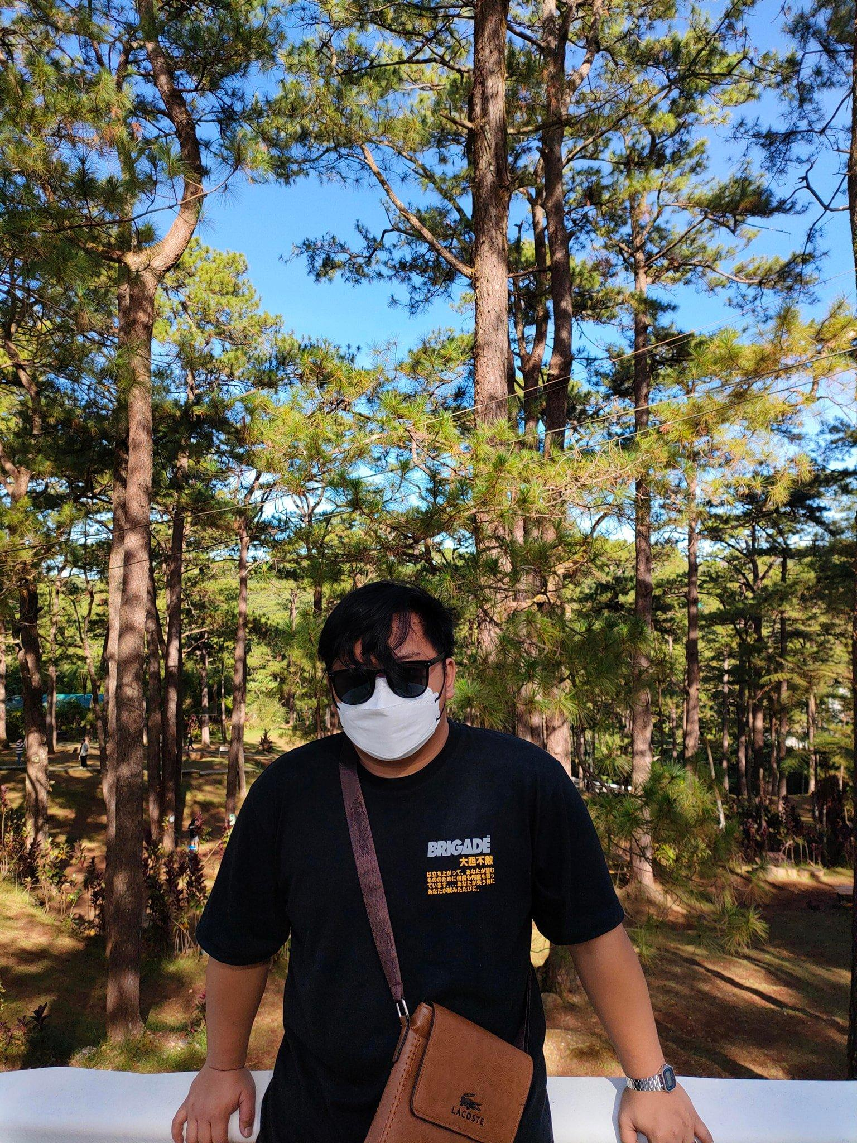

And Finally they opened baguio again so last december 2022 me and my friend decided to unwind in baguio. To relax and to take a break, and by traveling I learned a lot about life. Things don’t always go according to plan, but in other ways we will have a better time to take it not as plan but It's perfect. It's not in time but it's always surprising.