LAMPIRAN
Listing Program dan Output Aplikasi VitaCheck
Lampiran A. Listing Program Backend (Python / FastAPI)
A.1 database.py — Koneksi dan Inisialisasi Database SQLite
import os
import sqlite3
from contextlib import contextmanager

DB_PATH = os.path.join(os.path.dirname(__file__), "vitacheck.db")

def get_connection():
conn = sqlite3.connect(DB_PATH)
conn.row_factory = sqlite3.Row
return conn

@contextmanager
def get_db():
conn = get_connection()
try:
yield conn
conn.commit()
finally:
conn.close()

def init_db():
with get_db() as conn:
try:
conn.execute("ALTER TABLE users ADD COLUMN health_target TEXT")
except sqlite3.OperationalError:
pass # Column might already exist

conn.executescript("""
CREATE TABLE IF NOT EXISTS users (
id INTEGER PRIMARY KEY AUTOINCREMENT,
username TEXT UNIQUE NOT NULL,
email TEXT UNIQUE NOT NULL,
password_hash TEXT NOT NULL,
created_at TEXT DEFAULT (datetime('now'))
);

CREATE TABLE IF NOT EXISTS predictions (
id INTEGER PRIMARY KEY AUTOINCREMENT,
user_id INTEGER REFERENCES users(id),
daily_screen_time_hours REAL,
phone_usage_before_sleep_minutes INTEGER,
sleep_duration_hours REAL,
sleep_quality_score INTEGER,
physical_activity_minutes INTEGER,
notifications_received_per_day INTEGER,
caffeine_intake_cups INTEGER,
stress_level INTEGER,
mental_fatigue_score INTEGER,
risk_label TEXT,
risk_score REAL,
confidence REAL,
created_at TEXT DEFAULT (datetime('now'))
);
""")
A.2 schemas.py — Validasi Input/Output Model Pydantic
from pydantic import BaseModel, Field, field_validator

LABEL_MAP = {0: "Risiko Rendah", 1: "Risiko Sedang", 2: "Risiko Tinggi"}

class PredictionInput(BaseModel):
daily_screen_time_hours: float = Field(
..., ge=0.0, le=14.0, description="Total screen time per day in hours"
)
phone_usage_before_sleep_minutes: int = Field(
..., ge=0, le=120, description="Phone usage before sleep in minutes"
)
sleep_duration_hours: float = Field(
..., ge=4.0, le=9.0, description="Sleep duration per night in hours"
)
sleep_quality_score: int = Field(
..., ge=1, le=10, description="Sleep quality score (1-10, 10=best)"
)
physical_activity_minutes: int = Field(
..., ge=0, le=120, description="Daily physical activity in minutes"
)
notifications_received_per_day: int = Field(
..., ge=20, le=299, description="Number of notifications received per day"
)
caffeine_intake_cups: int = Field(
..., ge=0, le=4, description="Daily caffeine intake in cups"
)
stress_level: int = Field(
..., ge=1, le=10, description="Stress level (1-10, 10=highest)"
)
mental_fatigue_score: int = Field(
..., ge=1, le=10, description="Mental fatigue score (1-10, 10=worst)"
)

@field_validator(
"sleep_quality_score",
"stress_level",
"mental_fatigue_score",
)
@classmethod
def validate_one_to_ten(cls, v):
if v < 1 or v > 10:
raise ValueError("Must be between 1 and 10")
return v

class PredictionResult(BaseModel):
class_id: int = Field(..., description="0=Rendah, 1=Sedang, 2=Tinggi")
label: str = Field(..., description="Risk label in Indonesian")

class PredictionOutput(BaseModel):
model_name: str = Field(..., description="Name of the model used")
prediction: PredictionResult
confidence: float = Field(..., ge=0.0, le=1.0, description="Confidence score")
probabilities: dict[str, float] = Field(
..., description="Probability per risk class"
)

class ModelInfo(BaseModel):
model_name: str
version: str
features: list[str]
n_features: int
description: str
A.3 service.py — Logika Prediksi Model Machine Learning
import os

import joblib
import numpy as np

from schemas import LABEL_MAP

MODEL_DIR = os.path.join(os.path.dirname(os.path.dirname(__file__)), "model_final")
MODEL_PATH = os.path.join(MODEL_DIR, "final_health_risk_model.joblib")
SCALER_PATH = os.path.join(MODEL_DIR, "scaler.pkl")
MODEL_INFO_PATH = os.path.join(MODEL_DIR, "final_model_info.json")

class ModelService:
def __init__(self):
self._scaler = None
self._model = None
self._info = None

def load(self):
import json

self._scaler = joblib.load(SCALER_PATH)
self._model = joblib.load(MODEL_PATH)
with open(MODEL_INFO_PATH, "r") as f:
self._info = json.load(f)
return self

@property
def is_loaded(self) -> bool:
return self._model is not None

@property
def model_name(self) -> str:
return self._info.get("model_name", "unknown") if self._info else "unknown"

@property
def model_info(self) -> dict:
return self._info or {}

def predict(self, inputs: dict) -> dict:
features = [
inputs["daily_screen_time_hours"],
inputs["phone_usage_before_sleep_minutes"],
inputs["sleep_duration_hours"],
inputs["sleep_quality_score"],
inputs["physical_activity_minutes"],
inputs["notifications_received_per_day"],
inputs["stress_level"],
inputs["mental_fatigue_score"],
inputs["caffeine_intake_cups"],
]
X = np.array([features])
X_scaled = self._scaler.transform(X)
pred = self._model.predict(X_scaled)[0]
proba = self._model.predict_proba(X_scaled)[0]
class_id = int(pred)
label = LABEL_MAP[class_id]
return {
"class_id": class_id,
"label": label,
"confidence": float(proba[class_id]),
"probabilities": {LABEL_MAP[i]: float(proba[i]) for i in range(3)},
}
A.4 auth.py — Sistem Autentikasi Pengguna (JWT)
from datetime import datetime, timedelta, timezone

from fastapi import APIRouter, Depends, HTTPException, status
from fastapi.security import HTTPAuthorizationCredentials, HTTPBearer
from jose import JWTError, jwt
import bcrypt
from pydantic import BaseModel

from database import get_db

SECRET_KEY = "vitacheck-secret-key-change-in-production"
ALGORITHM = "HS256"
ACCESS_TOKEN_EXPIRE_DAYS = 30

security = HTTPBearer()
router = APIRouter(prefix="/auth", tags=["Auth"])

class RegisterRequest(BaseModel):
username: str
email: str
password: str

class LoginRequest(BaseModel):
username: str
password: str

from typing import Optional

class UserResponse(BaseModel):
id: int
username: str
email: str
health_target: Optional[str] = None
created_at: str

class TokenResponse(BaseModel):
access_token: str
token_type: str = "bearer"
user: UserResponse

def create_access_token(data: dict):
to_encode = data.copy()
expire = datetime.now(timezone.utc) + timedelta(days=ACCESS_TOKEN_EXPIRE_DAYS)
to_encode.update({"exp": expire})
return jwt.encode(to_encode, SECRET_KEY, algorithm=ALGORITHM)

def get_current_user(credentials: HTTPAuthorizationCredentials = Depends(security)):
try:
payload = jwt.decode(
credentials.credentials, SECRET_KEY, algorithms=[ALGORITHM]
)
user_id = payload.get("sub")
if user_id is None:
raise HTTPException(status_code=401, detail="Invalid token")
except JWTError:
raise HTTPException(status_code=401, detail="Invalid token")

with get_db() as conn:
user = conn.execute(
"SELECT id, username, email, health_target, created_at FROM users WHERE id = ?",
(user_id,),
).fetchone()
if user is None:
raise HTTPException(status_code=401, detail="User not found")
return dict(user)

@router.post("/register", response_model=TokenResponse)
def register(body: RegisterRequest):
if len(body.username) < 3:
raise HTTPException(status_code=400, detail="Username minimal 3 karakter")
if len(body.password) < 6:
raise HTTPException(status_code=400, detail="Password minimal 6 karakter")
if "@" not in body.email:
raise HTTPException(status_code=400, detail="Email tidak valid")

salt = bcrypt.gensalt()
password_hash = bcrypt.hashpw(body.password.encode("utf-8"), salt).decode("utf-8")

with get_db() as conn:
try:
cur = conn.execute(
"INSERT INTO users (username, email, password_hash) VALUES (?, ?, ?)",
(body.username, body.email, password_hash),
)
user_id = cur.lastrowid
except Exception:
raise HTTPException(
status_code=409, detail="Username atau email sudah terdaftar"
)

user = conn.execute(
"SELECT id, username, email, health_target, created_at FROM users WHERE id = ?",
(user_id,),
).fetchone()

token = create_access_token({"sub": str(user["id"])})
return TokenResponse(access_token=token, user=UserResponse(**dict(user)))

@router.post("/login", response_model=TokenResponse)
def login(body: LoginRequest):
with get_db() as conn:
user = conn.execute(
"SELECT * FROM users WHERE username = ?", (body.username,)
).fetchone()

if user is None or not bcrypt.checkpw(body.password.encode("utf-8"), user["password_hash"].encode("utf-8")):
raise HTTPException(status_code=401, detail="Username atau password salah")

token = create_access_token({"sub": str(user["id"])})
return TokenResponse(
access_token=token,
user=UserResponse(
id=user["id"],
username=user["username"],
email=user["email"],
health_target=user["health_target"],
created_at=user["created_at"],
),
)

@router.get("/me", response_model=UserResponse)
def me(user: dict = Depends(get_current_user)):
return UserResponse(**user)

class ResetPasswordRequest(BaseModel):
username: str
email: str
new_password: str

class ChangePasswordRequest(BaseModel):
current_password: str
new_password: str

class TargetRequest(BaseModel):
health_target: str

@router.post("/target")
def update_target(body: TargetRequest, user: dict = Depends(get_current_user)):
"""Update user's health target."""
with get_db() as conn:
conn.execute(
"UPDATE users SET health_target = ? WHERE id = ?",
(body.health_target, user["id"]),
)
return {"message": "Target berhasil disimpan"}

@router.post("/reset-password")
def reset_password(body: ResetPasswordRequest):
"""Reset password by verifying username + email combination."""
if len(body.new_password) < 6:
raise HTTPException(status_code=400, detail="Password baru minimal 6 karakter")

with get_db() as conn:
user = conn.execute(
"SELECT id, password_hash FROM users WHERE username = ? AND email = ?",
(body.username, body.email),
).fetchone()

if user is None:
raise HTTPException(
status_code=404,
detail="Kombinasi username dan email tidak ditemukan",
)

salt = bcrypt.gensalt()
new_hash = bcrypt.hashpw(body.new_password.encode("utf-8"), salt).decode("utf-8")
conn.execute(
"UPDATE users SET password_hash = ? WHERE id = ?",
(new_hash, user["id"]),
)

return {"message": "Password berhasil direset. Silakan login dengan password baru."}

@router.post("/change-password")
def change_password(body: ChangePasswordRequest, user: dict = Depends(get_current_user)):
"""Change password for logged-in user (requires current password)."""
if len(body.new_password) < 6:
raise HTTPException(status_code=400, detail="Password baru minimal 6 karakter")

with get_db() as conn:
row = conn.execute(
"SELECT password_hash FROM users WHERE id = ?", (user["id"],)
).fetchone()

if not bcrypt.checkpw(
body.current_password.encode("utf-8"),
row["password_hash"].encode("utf-8"),
):
raise HTTPException(status_code=401, detail="Password lama salah")

salt = bcrypt.gensalt()
new_hash = bcrypt.hashpw(body.new_password.encode("utf-8"), salt).decode("utf-8")
conn.execute(
"UPDATE users SET password_hash = ? WHERE id = ?",
(new_hash, user["id"]),
)

return {"message": "Password berhasil diubah"}
A.5 main.py — Endpoint REST API (FastAPI)
import os
from contextlib import asynccontextmanager
from typing import Optional

from fastapi import FastAPI, HTTPException, Depends, Header
from fastapi.middleware.cors import CORSMiddleware
from jose import JWTError, jwt

from schemas import ModelInfo, PredictionInput, PredictionOutput, PredictionResult
from service import ModelService
from auth import router as auth_router, SECRET_KEY, ALGORITHM
from database import init_db, get_db

svc = ModelService()

@asynccontextmanager
async def lifespan(app: FastAPI):
svc.load()
init_db()
yield

app = FastAPI(
title="VitaCheck API",
description="Health risk prediction API — memprediksi risiko kesehatan berdasarkan gaya hidup harian.",
version="1.0.0",
lifespan=lifespan,
)

app.include_router(auth_router)

# Baca CORS origins dari env var (pisahkan dengan koma untuk multiple origins)
# Contoh di Render: CORS_ORIGINS=https://vitacheck.vercel.app
# Default "*" untuk pengembangan lokal
_raw_origins = os.getenv("CORS_ORIGINS", "*")
ALLOWED_ORIGINS: list[str] = (
[o.strip() for o in _raw_origins.split(",") if o.strip()]
if _raw_origins != "*"
else ["*"]
)

app.add_middleware(
CORSMiddleware,
allow_origins=ALLOWED_ORIGINS,
# allow_credentials hanya boleh True jika origins bukan wildcard "*"
allow_credentials=ALLOWED_ORIGINS != ["*"],
allow_methods=["*"],
allow_headers=["*"],
)

def get_optional_user_id(authorization: Optional[str] = Header(None)) -> Optional[int]:
"""Extract user_id from Bearer token if present, otherwise return None."""
if not authorization or not authorization.startswith("Bearer "):
return None
token = authorization.split(" ", 1)[1]
try:
payload = jwt.decode(token, SECRET_KEY, algorithms=[ALGORITHM])
user_id = payload.get("sub")
return int(user_id) if user_id else None
except (JWTError, ValueError):
return None

@app.get("/", response_model=ModelInfo, tags=["Info"])
def root():
info = svc.model_info
return ModelInfo(
model_name=info.get("model_name", "unknown"),
version="1.0.0",
features=info.get("features", []),
n_features=len(info.get("features", [])),
description=(
"Model prediksi risiko kesehatan berdasarkan 9 fitur gaya hidup. "
f"Dipilih dari {', '.join(info.get('selection_scope', []))} "
f"dengan prioritas recall kelas Risiko Tinggi."
),
)

@app.get("/health", tags=["Info"])
def health():
return {
"status": "ok",
"model_loaded": svc.is_loaded,
"model_name": svc.model_name,
}

@app.post("/predict", response_model=PredictionOutput, tags=["Prediction"])
def predict(body: PredictionInput, user_id: Optional[int] = Depends(get_optional_user_id)):
if not svc.is_loaded:
raise HTTPException(status_code=503, detail="Model not loaded")

try:
result = svc.predict(body.model_dump())
except Exception as e:
raise HTTPException(status_code=500, detail=f"Prediction failed: {str(e)}")

# Save to database if user is logged in
if user_id is not None:
inputs = body.model_dump()
low = result["probabilities"].get("Risiko Rendah", 0)
med = result["probabilities"].get("Risiko Sedang", 0)
high = result["probabilities"].get("Risiko Tinggi", 0)
risk_score = round((low * 0) + (med * 50) + (high * 100))
try:
with get_db() as conn:
conn.execute(
"""INSERT INTO predictions
(user_id, daily_screen_time_hours, phone_usage_before_sleep_minutes,
sleep_duration_hours, sleep_quality_score, physical_activity_minutes,
notifications_received_per_day, caffeine_intake_cups, stress_level,
mental_fatigue_score, risk_label, risk_score, confidence)
VALUES (?, ?, ?, ?, ?, ?, ?, ?, ?, ?, ?, ?, ?)""",
(
user_id,
inputs["daily_screen_time_hours"],
inputs["phone_usage_before_sleep_minutes"],
inputs["sleep_duration_hours"],
inputs["sleep_quality_score"],
inputs["physical_activity_minutes"],
inputs["notifications_received_per_day"],
inputs["caffeine_intake_cups"],
inputs["stress_level"],
inputs["mental_fatigue_score"],
result["label"],
risk_score,
result["confidence"],
),
)
except Exception:
pass # Don't fail prediction if save fails

return PredictionOutput(
model_name=svc.model_name,
prediction=PredictionResult(
class_id=result["class_id"],
label=result["label"],
),
confidence=result["confidence"],
probabilities=result["probabilities"],
)

@app.get("/predictions/history", tags=["Prediction"])
def get_prediction_history(authorization: str = Header(...)):
"""Get prediction history for the logged-in user."""
if not authorization.startswith("Bearer "):
raise HTTPException(status_code=401, detail="Invalid token")
token = authorization.split(" ", 1)[1]
try:
payload = jwt.decode(token, SECRET_KEY, algorithms=[ALGORITHM])
user_id = payload.get("sub")
if user_id is None:
raise HTTPException(status_code=401, detail="Invalid token")
except JWTError:
raise HTTPException(status_code=401, detail="Invalid token")

with get_db() as conn:
rows = conn.execute(
"""SELECT id, daily_screen_time_hours, phone_usage_before_sleep_minutes,
sleep_duration_hours, sleep_quality_score, physical_activity_minutes,
notifications_received_per_day, caffeine_intake_cups, stress_level,
mental_fatigue_score, risk_label, risk_score, confidence, created_at
FROM predictions WHERE user_id = ? ORDER BY created_at DESC""",
(user_id,),
).fetchall()

return [dict(row) for row in rows]

Lampiran B. Listing Program Frontend (React / JavaScript)
B.1 App.jsx — Konfigurasi Routing Aplikasi
import { BrowserRouter, Routes, Route } from 'react-router-dom'
import { AuthProvider } from './context/AuthContext'
import Layout from './components/layout/Layout'
import ProtectedRoute from './components/ProtectedRoute'
import Landing from './pages/Landing'
import Predict from './pages/Predict'
import Login from './pages/Login'
import Register from './pages/Register'
import ForgotPassword from './pages/ForgotPassword'
import Dashboard from './pages/Dashboard'
import History from './pages/History'
import Profile from './pages/Profile'

export default function App() {
return (
<BrowserRouter>
<AuthProvider>
<Routes>
<Route element={<Layout />}>
<Route path="/" element={<Landing />} />
<Route path="/predict" element={<Predict />} />
<Route path="/login" element={<Login />} />
<Route path="/register" element={<Register />} />
<Route path="/forgot-password" element={<ForgotPassword />} />
<Route
path="/dashboard"
element={
<ProtectedRoute>
<Dashboard />
</ProtectedRoute>
}
/>
<Route
path="/history"
element={
<ProtectedRoute>
<History />
</ProtectedRoute>
}
/>
<Route
path="/profile"
element={
<ProtectedRoute>
<Profile />
</ProtectedRoute>
}
/>
</Route>
</Routes>
</AuthProvider>
</BrowserRouter>
)
}
B.2 AuthContext.jsx — Context Global Autentikasi
import { createContext, useContext, useState, useEffect } from 'react'
import { getMe } from '../api/auth'

const AuthContext = createContext(null)

export function AuthProvider({ children }) {
const [user, setUser] = useState(null)
const [loading, setLoading] = useState(true)

useEffect(() => {
const token = localStorage.getItem('token')
if (token) {
getMe()
.then((u) => setUser(u))
.catch(() => {
localStorage.removeItem('token')
localStorage.removeItem('user')
})
.finally(() => setLoading(false))
} else {
setLoading(false)
}
}, [])

const login = (token, userData) => {
localStorage.setItem('token', token)
localStorage.setItem('user', JSON.stringify(userData))
setUser(userData)
}

const updateTarget = (target) => {
if (user) {
const updated = { ...user, health_target: target }
localStorage.setItem('user', JSON.stringify(updated))
setUser(updated)
}
}

const logout = () => {
localStorage.removeItem('token')
localStorage.removeItem('user')
setUser(null)
}

return (
<AuthContext.Provider value={{ user, loading, login, logout, updateTarget }}>
{children}
</AuthContext.Provider>
)
}

export function useAuth() {
const ctx = useContext(AuthContext)
if (!ctx) throw new Error('useAuth must be inside AuthProvider')
return ctx
}
B.3 client.js — Konfigurasi Axios HTTP Client
import axios from 'axios'

const client = axios.create({
baseURL: import.meta.env.VITE_API_URL || '/api',
headers: { 'Content-Type': 'application/json' },
})

client.interceptors.request.use((config) => {
const token = localStorage.getItem('token')
if (token) {
config.headers.Authorization = `Bearer ${token}`
}
return config
})

client.interceptors.response.use(
(res) => res,
(err) => {
// Jangan redirect jika 401 berasal dari endpoint login/register itu sendiri
// (artinya user salah memasukkan kredensial, bukan sesi yang expired)
const isAuthEndpoint =
err.config?.url?.includes('/auth/login') ||
err.config?.url?.includes('/auth/register')
if (err.response?.status === 401 && !isAuthEndpoint) {
localStorage.removeItem('token')
localStorage.removeItem('user')
window.location.href = '/login'
}
return Promise.reject(err)
},
)

export default client
B.4 auth.js — Fungsi API Autentikasi Frontend
import client from './client'

export async function loginRequest(username, password) {
const res = await client.post('/auth/login', { username, password })
return res.data
}

export async function registerRequest(username, email, password) {
const res = await client.post('/auth/register', { username, email, password })
return res.data
}

export async function getMe() {
const res = await client.get('/auth/me')
return res.data
}

export async function resetPassword(username, email, new_password) {
const res = await client.post('/auth/reset-password', { username, email, new_password })
return res.data
}

export async function changePassword(current_password, new_password) {
const res = await client.post('/auth/change-password', { current_password, new_password })
return res.data
}

export async function updateHealthTarget(health_target) {
const res = await client.post('/auth/target', { health_target })
return res.data
}
B.5 prediction.js — Fungsi API Prediksi Frontend
import client from './client'

export async function predict(data) {
const res = await client.post('/predict', data)
return res.data
}

export async function getHistory() {
const res = await client.get('/predictions/history')
return res.data
}

Lampiran C. Output Aplikasi VitaCheck
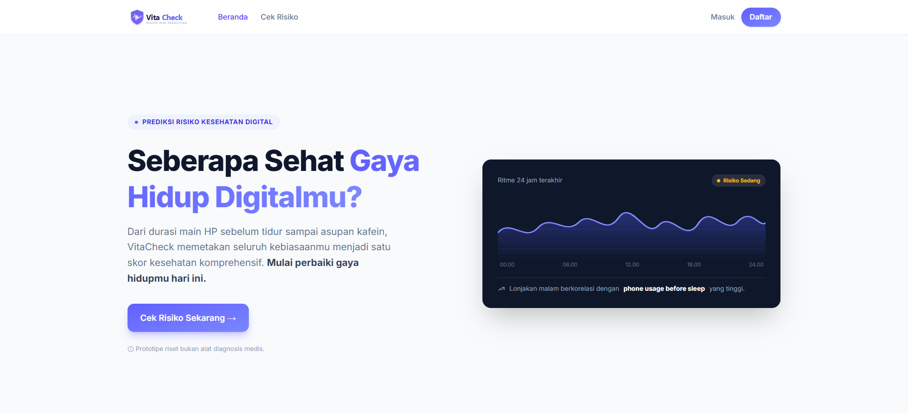
Gambar C.1. Tampilan Halaman Beranda (Landing Page) Aplikasi VitaCheck
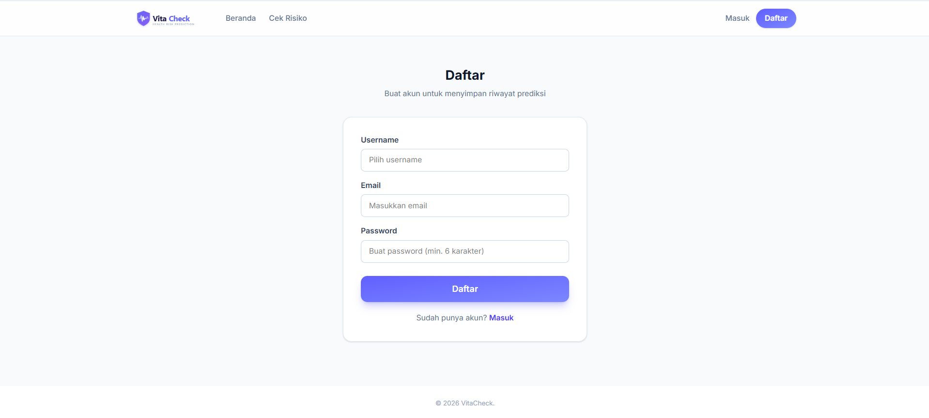
Gambar C.2. Tampilan Halaman Daftar Akun (Register)
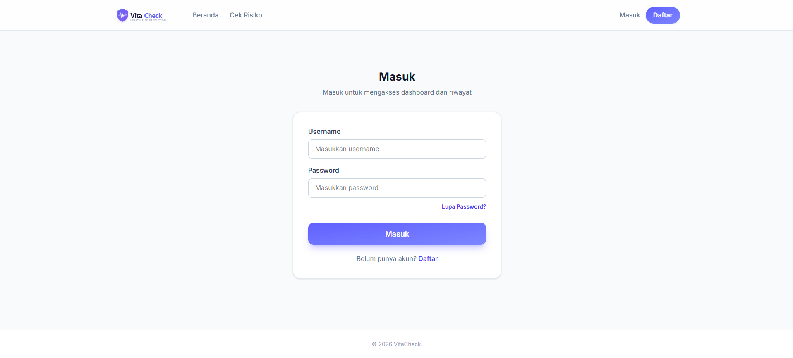
Gambar C.3. Tampilan Halaman Masuk (Login)
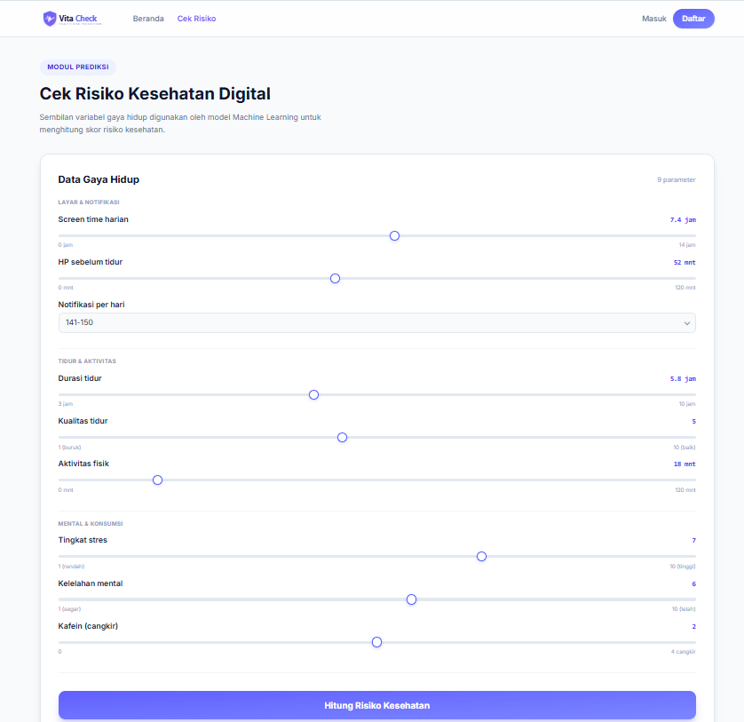
Gambar C.4. Tampilan Halaman Form Input Cek Risiko Kesehatan
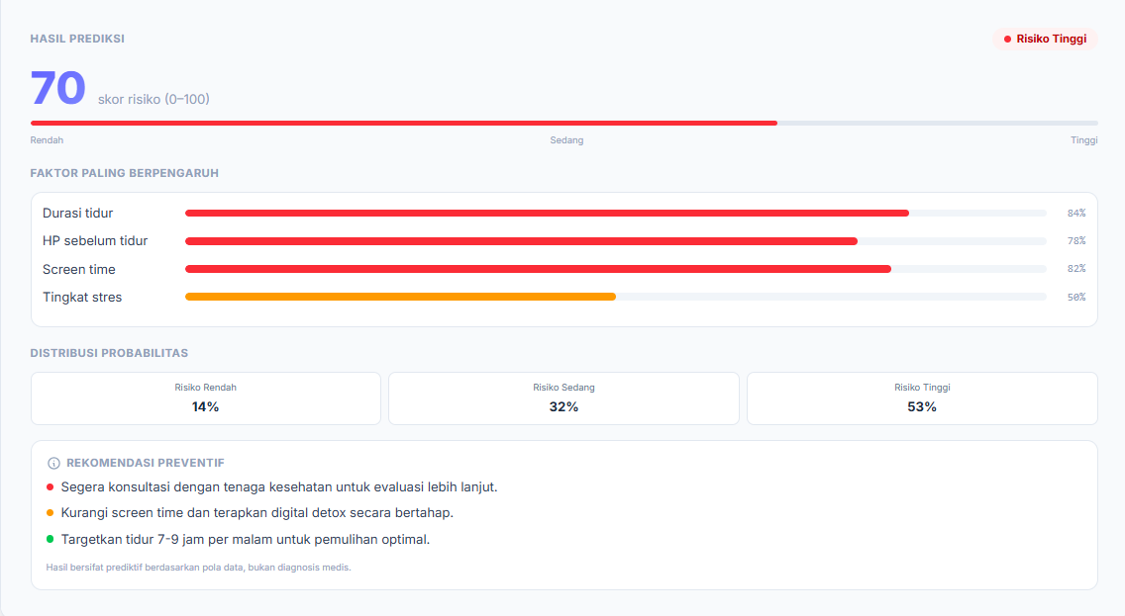
Gambar C.5. Tampilan Hasil Prediksi dengan Label Risiko Tinggi (Skor 70)
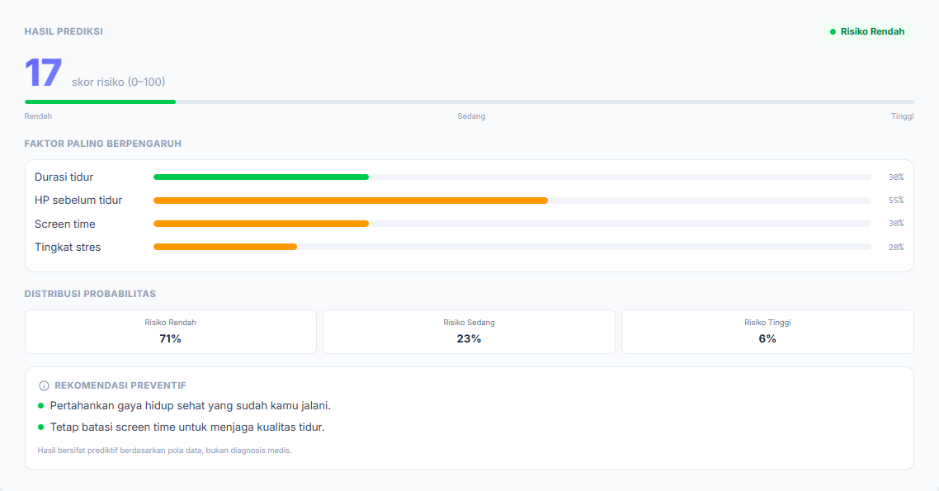
Gambar C.6. Tampilan Hasil Prediksi dengan Label Risiko Rendah (Skor 17)
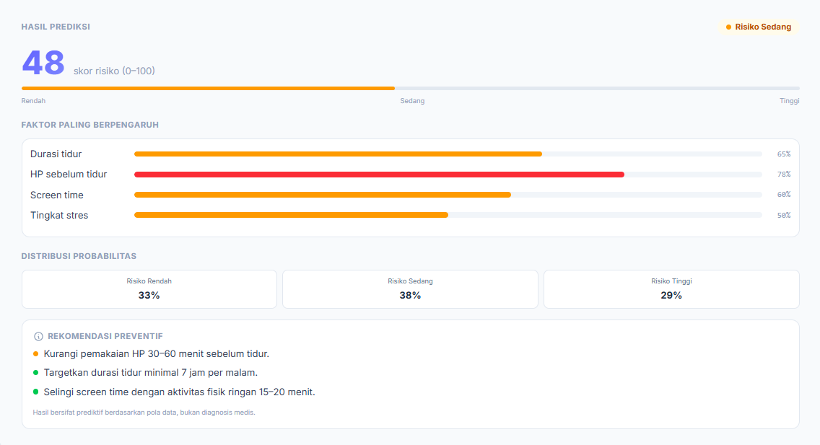
Gambar C.7. Tampilan Hasil Prediksi dengan Label Risiko Sedang (Skor 48)
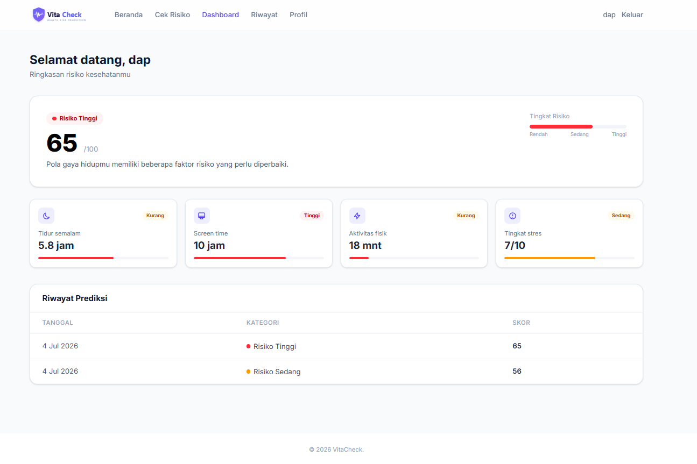
Gambar C.8. Tampilan Halaman Dashboard Pengguna
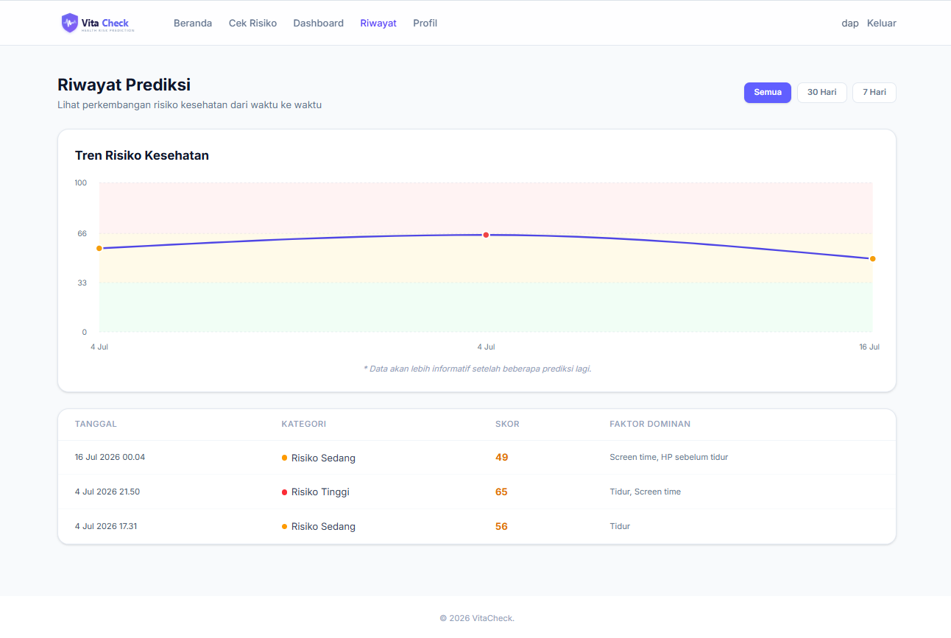
Gambar C.9. Tampilan Halaman Riwayat Prediksi Kesehatan
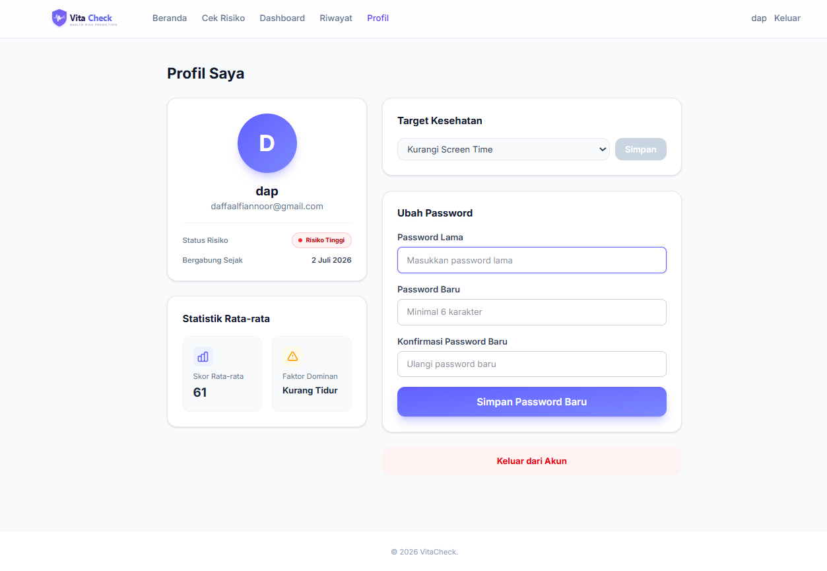
Gambar C.10. Tampilan Halaman Profil Pengguna

