Plots

### Packages + functions

##   
## Attaching package: 'dplyr'

## The following objects are masked from 'package:stats':  
##   
## filter, lag

## The following objects are masked from 'package:base':  
##   
## intersect, setdiff, setequal, union

### Data

## Cod (NIVA and HI)

### Plots, metals

Codes for trend: 0 = no trend calculated, 1 = zero time trend, 2 = up, 3 = down  
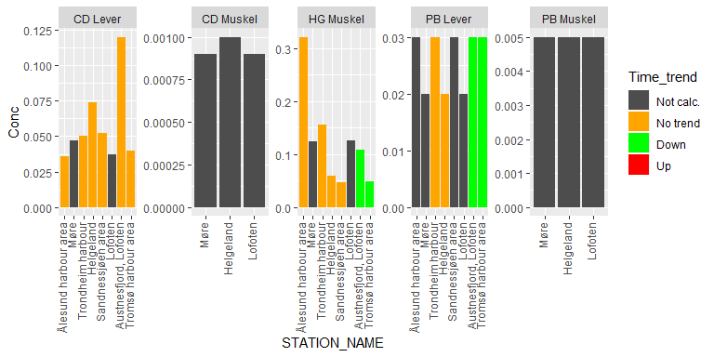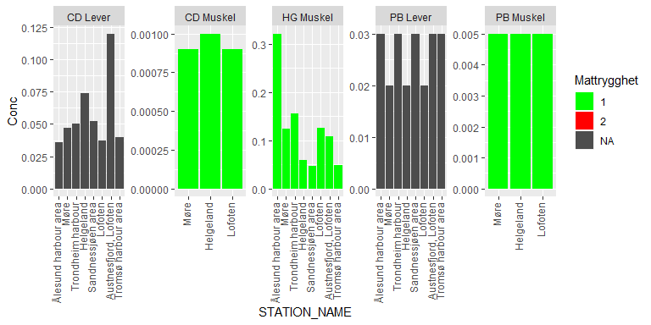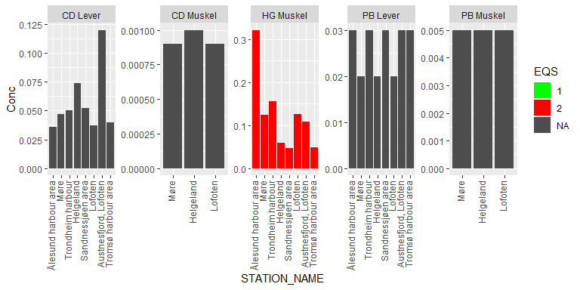

### Plots, non-metals

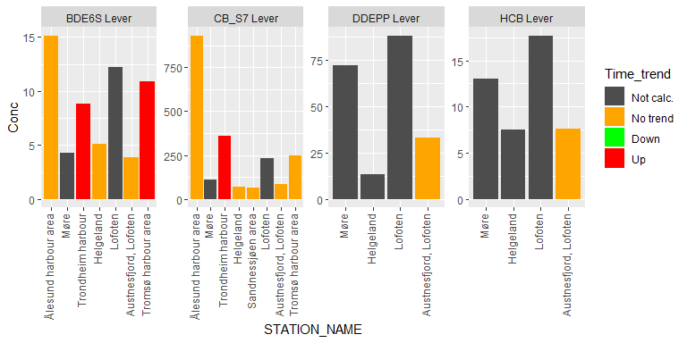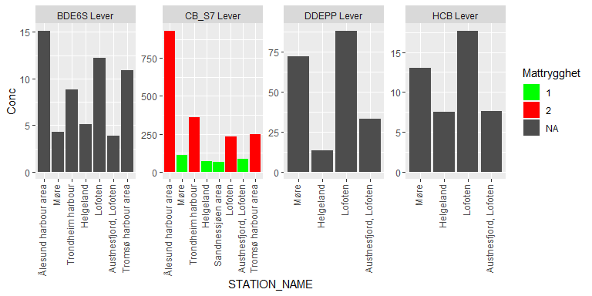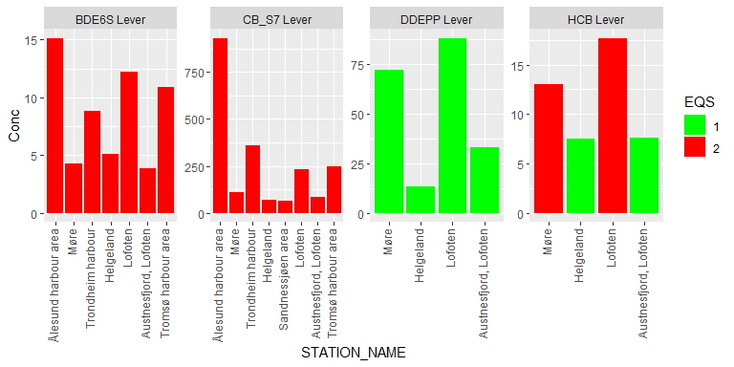

## Graphs for blue mussel

### Plots, metals

Codes for trend: 0 = no trend calculated, 1 = zero time trend, 2 = up, 3 = down  
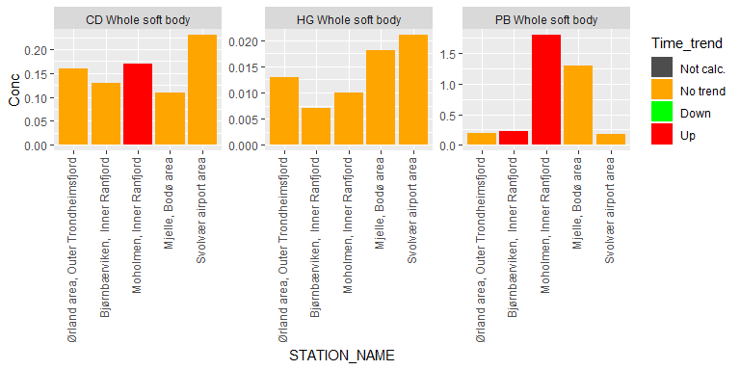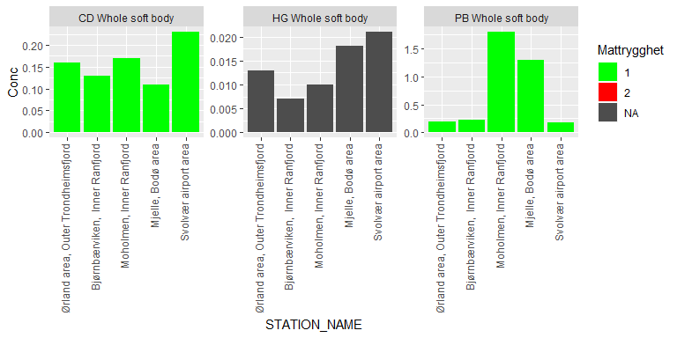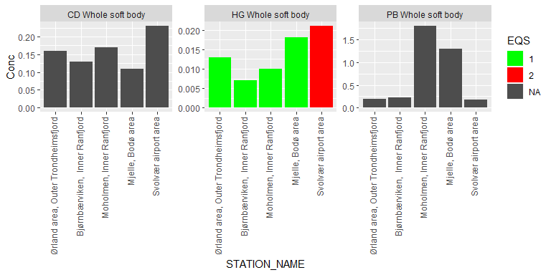

### Plots, non-metals

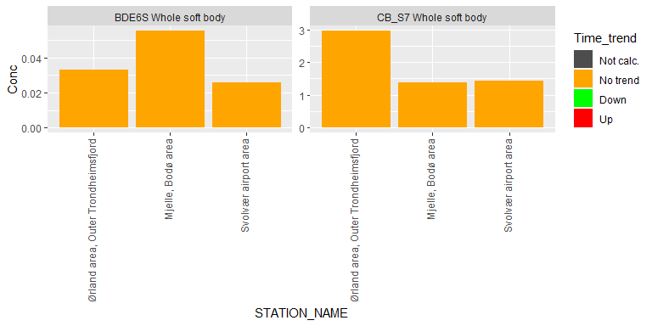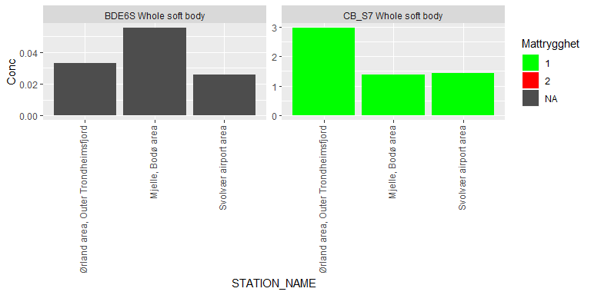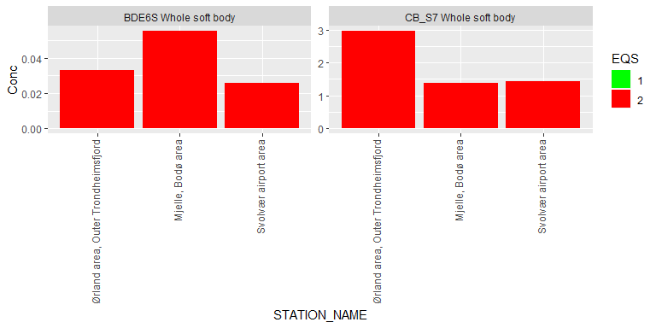

## Plot time series of medians

### NIVA data

### NIVA + HI data

## [1] 315

## [1] 735

## [1] 420

### Plot liver concentrations

## Warning: Removed 198 rows containing non-finite values (stat_smooth).

## Warning: Removed 198 rows containing missing values (geom_point).

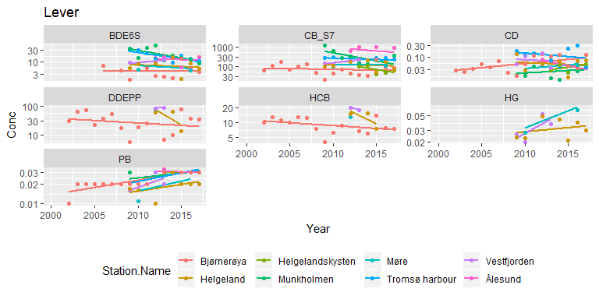

## Warning: Removed 46 rows containing non-finite values (stat_smooth).

## Warning: Removed 46 rows containing missing values (geom_point).

