IPCW - analyses of changes and levels in NO3 and TOC/TON

DHJ

18 10 2021

## Overview of analyses

* We performed four analyses:
  1. How sites with decreasing NO3 differed from the other sites (i.e., a categorical response variable)
     + response variable = no3_decline, defined as 1 if there was a significant decrease in NO3 over the period 1992-2016 (slope_no3_vs_time < 0 & p_no3_vs_time <= 0.05)
     + I.e., sites with no NO3 trend and with increasing NO3 were treated the same
  2. How sites with decreasing TOC/TON differed from the other sites
  3. How median NO3 2012-2016 differed among sites (i.e., a continuous response variable)
     + response variable = log10(median_no3 + 0.1)
  4. How median TOC/TON ratio 2012-2016 differed among sites
     + response variable = log10(median_tocton)
* For analyses 1, we performed analyses using the following sets of predictor variables (N given for analysis 1):
  + 1. All variables - N = 375 (none of the US stations have catchment area, so they are excluded)
    2. All variables except catchment area - N = 450 (lacking all Italian, Latvian, Irish stations, plus some German and Swedish ones)
    3. All variables except catchment area and TOC - N = 474 (getting most IT,LV,IE,DE,SE stations, still lacking CH + 16 US stations)
    4. All variables except catchment area and altitude - N = 450 (same stations as in b)
* For analyses 2, we performed analyses using the following sets of predictor variables (N given for analysis 1):
  + 1. All variables including the slope of TOC and the slope of TON
    2. All variables excluding the slopes (TOC and TON)
    3. All variables excluding the slopes, and excludong TOC (in order to include 6 Italian stations)
* For analyses 3, we performed analyses using the following sets of predictor variables:
  + 1. All variables - N = 377 (no USA stations)
    2. All variables except catchment area and TOC - N = 457 (still lacking 16 US stations, plus most (9/11) Irish stations)
* For analyses 4, we performed analyses using the following sets of predictor variables:
  + 1. All variables including TOC and TON medians
    2. All variables excluding TOC and TON medians
* All analysis were performed with ‘random forest analysis’ is an extension of ‘decision tree analysis’

## Short intro about trees and forests

* In decision tree analysis, one first looks for the best variable A, an the best ‘splitting value’ x of that variable, to split the data in order to the response variable. In analysis 1 for instance, it may turn out that for stations with A < x, 20% of the stations have no3_decline= 1, while for stations with A > x, 80% of the stations have no3_decline= 1. After this first split of the dataset, the procedure is repeated on each part of the data set (the A < x part and the A > x). This results in a single decision tree.
* The figure below is an example for ‘NO3 decrease’, where the data set is first split according to altitude (below or above 227 m.a.s.l.), then each subset is split again two times (the first-split variable, altitude in this case, can have been used again for the next splits, but in this case it was outcompeted by other variables)
  + The columns at the bottom shows the predictions of the model. E.g. for a site above 227 m.a.s.l. and with > 70% deciduous/mixed forest, only 10% of the stations had decreasing NO3_decline 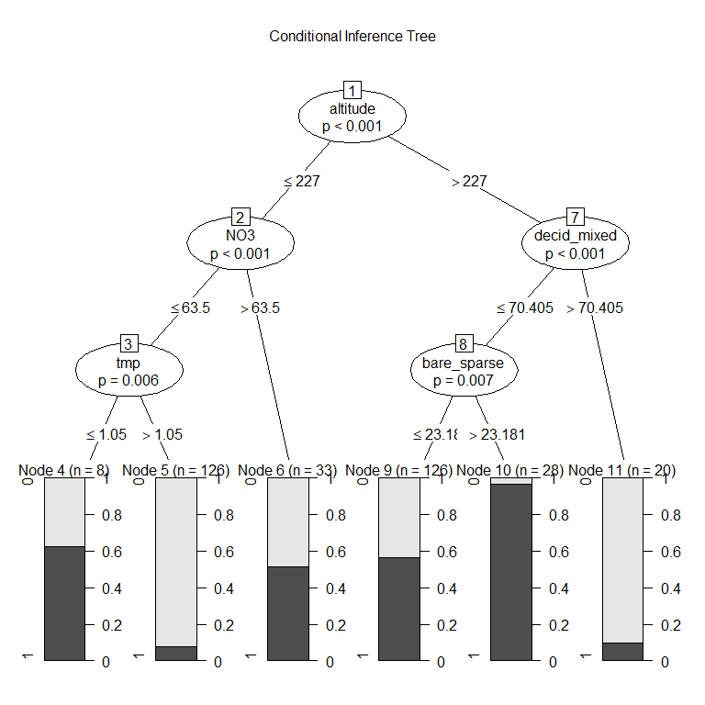
* Two good things about decision trees are 1) they incorporate interactions between variables easily, and 2) they are easy to interpret. The bad thing is that we have no idea bout the uncertainty of the model and whether small changes in the data could have given us a very different tree. The random forest algorithm tries to fix that by making a large number of trees (e.g., 100 trees), where the data used to make each tree differs slightly, in two ways: First, at each split, the algorithm randomly selects a subset of features which can be used as candidates for splitting the data. Secondly, each tree draws a random sample of data from the training dataset when generating its splits.
* For further explanation, see this [non-technical introduction](https://victorzhou.com/blog/intro-to-random-forests/) or a [slightly more in-depth introduction](https://www.keboola.com/blog/random-forest-regression)
* A main disadvantage of the random forest method is that it is hard to summarize the (e.g.) 100 different decision trees resulting from the method. There are mainly two aspects of this: Variable importance and model predictions.

### Measurements of variable importance

* *times_a_root*: how often the variable is the selected for the first split (the ‘root’ of the tree).
* *mean_min_depth*: The ‘minimum depth’ of a variable in one tree is the level where it first was used (e.g. decid_mixed has level 2 above). Then the mean of ‘minimum depth’ across trees is calculated. So this measure is related to ‘times_a_root’: If ‘times_a_root’ is low and ‘mean_min_depth’ is high, it means that this variable is important for only a subset of the data (after the data set first has been split up using other variables).
* Example: When plotting these two measures against each other (see below), they show some level of agreement, with altitude and proportion of deciduous/mixed forest occupying the upper left corner, i.e. competing for being most important following these measures.

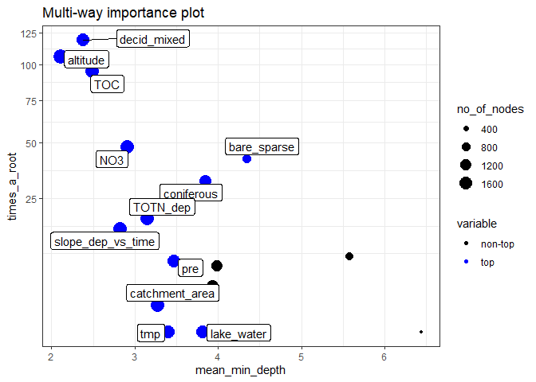

scatter plot of times_a_root vs mean_min_depth

* *gini_decrease*: the “Gini-Simpson index” (related to the ecological Simpson index) is a measure of “impurity” in the data set (ecologists would say ‘diversity’), and equals the probability that two stations picked at random have the same classification (e.g., both have decreasing NO3). Each the data set is split in two in a decision tree, the Gini index decreases (one of the two data sets will have more no3_decline = 1 stations, the other will have more no3_decline = 0 stations). The Gini decrease for a variable measures how much the Gini-Simpson index decreases when the data set is split using that variable.
* *accuracy_decrease* measures how much the accuracy decreases when the variable is removed from the model (where accuracy is measured by out-of-bag cross validated predictions)
* Example: When plotting these two measures against each other (see below), they agree quite closely for the 6-7 most important variables. The most important variables occupy the upper right corner (which agree with the upper left corner of the plot above). In addition, this plot shows by color which variables that are statistically significant (in this case no less than 10 variables).

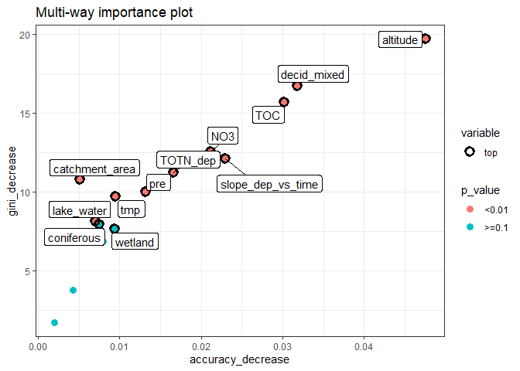

scatter plot of gini_decrease vs accuracy_decrease

### Variable effects / predictions of the model

For a single decision tree, prediction is simple, as shown above. For a random forest, predicting the outcome for a certain value of variable *X* is done by letting all other variables vary randomly, making predictions for each tree, and then averaging the result across all trees. This is repeated for a range of values for *X*. As the effect of other variaables is “removed” by drawing randiom values, this is called the *partial effect of X*. In order to visualise interactions, one can also predict the outcome of combinations of values for two predictor variables (letting the other variables vary randomly). In the figures shown in the results, we have made predictions for two predictor variables at a time (starting with the two most important ones by the ‘Gini decrease’ index, then number 3 and 4, etc.), making a ‘map’ where the colours of each cell indicate the probability for NO3 decline for a station with this combination of values.

* Example: In the figure below, we show the models’ predictions for a different combinations of TOTN_dep (deposition) and slope_dep_vs_time (change in deposition vs. time). The uncoloured areas of the graph (the white areas) are non-existent combinations of the two variables, here showing that only areas with a generally high deposition has low variables of ‘slope_dep_vs_time’ (i.e., strong decrease). The dark parts towards the bottom right indicates that stations with a low deposition, which also have changed little over time, also have no NO3 decline. The yellow area in the middle shows that the highest chance/proportion of NO3 change is found for stations with a medium deposition and medium change in deposition.

Note that the color scales of the figures differ (see legend in figures) - dark blue vs. yellow represents a bigger difference for the first figure in each analysis.

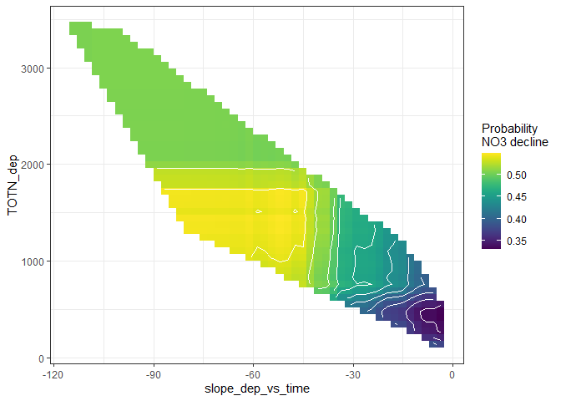

## Results for NO3 decrease

### a. Full model

**N = 375, all predictor variables included (lacking all US, IE, IT, LT stations)** (*Same results as examples above.*)

## -------------------------------------------------------------  
## Variables:   
## no3_decline,catchment_area, TOC,slope_dep_vs_time, NO3, TOTN_dep, latitude, longitude, altitude,pre, tmp, urban, cultivated, coniferous, decid_mixed, total_shrub_herbaceous,wetland, lake_water, bare_sparse  
##   
## Number of complete observations by country:   
## complete  
## FALSE TRUE  
## Canada 0 114  
## Czech Republic 1 7  
## Estonia 1 0  
## Finland 0 26  
## Germany 5 18 # lacking some  
## Ireland 3 0 # no stations included  
## Italy 6 0 # no stations included  
## Latvia 3 0 # no stations included  
## Netherlands 1 2  
## Norway 0 83  
## Poland 0 6  
## Slovakia 0 12  
## Sweden 6 86 # lacking some  
## Switzerland 6 0  
## United Kingdom 0 21  
## United States 91 0 # no stations included  
##   
##   
## Original data: n = 498   
## Analysis: n = 375

**Variable importance:** Altitude, proportion of deciduous/mixed forest and TOC level are the three most important variables (indicated by all four measures of importance), followed by NO3, TOTN_dep and slope_vs_time.

 

**Variable effects:** The partial effects for the two most important variables show increasing probability of NO3 decline with increasing altitude and for stations with very little deciduous/mixed forest. The next figure shows that the combination of very low TOC but not very low NO3 has a higher probability of NO3 decline. (But note that the color scale in the second figure has a smaller range than in the first one!) The final figure shows (as explained above) that the highest chance/proportion of NO3 change is found for stations with a medium deposition and medium change in deposition.

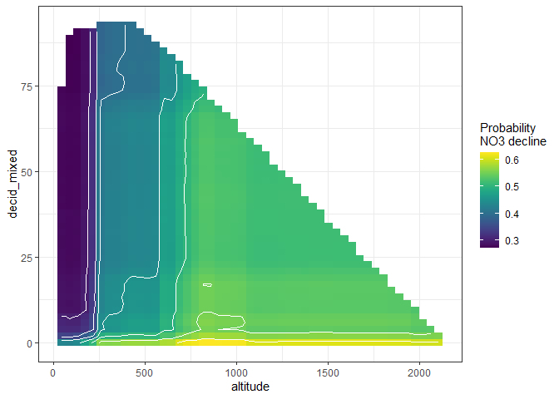  
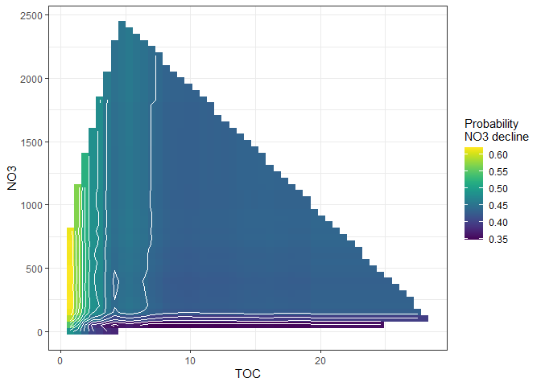  


### b. All variables except catchment area

**N = 450 - Getting in most US staitons, but still lacking all Italian, Latvian, Irish stations, plus some German and Swedish ones)**

## -------------------------------------------------------------  
## Variables:   
## no3_decline,TOC,slope_dep_vs_time, NO3, TOTN_dep, latitude, longitude, altitude,pre, tmp, urban, cultivated, coniferous, decid_mixed, total_shrub_herbaceous,wetland, lake_water, bare_sparse  
##  
## Number of complete observations by country:   
## complete  
## FALSE TRUE  
## Canada 0 114  
## Czech Republic 1 7  
## Estonia 1 0  
## Finland 0 26  
## Germany 5 18 # still lacking partly  
## Ireland 3 0 # still lacking  
## Italy 6 0 # still lacking  
## Latvia 3 0 # still lacking  
## Netherlands 1 2  
## Norway 0 83  
## Poland 0 6  
## Slovakia 0 12  
## Sweden 6 86 # still lacking partly  
## Switzerland 6 0  
## United Kingdom 0 21  
## United States 16 75 # most stations included  
##   
##   
## Original data: n = 498   
## Analysis: n = 450

**Variable importance:** Similar results as above: Altitude, proportion of deciduous/mixed forest and TOC level are the three most important variables, followed by NO3, TOTN_dep and slope_vs_time. The importance of altitude relative to the others has increased by including the US data.

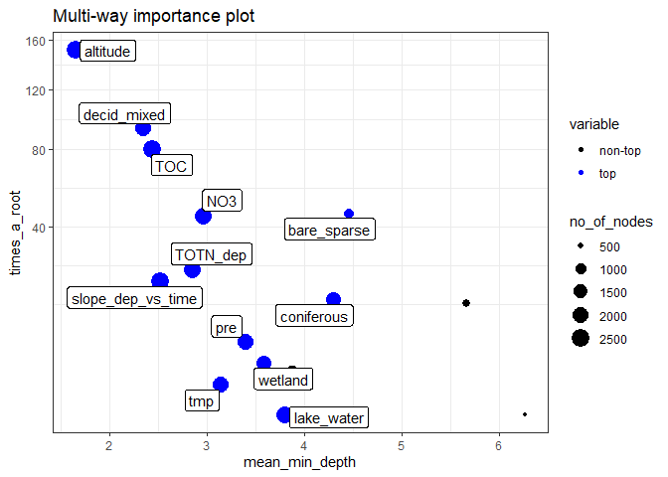 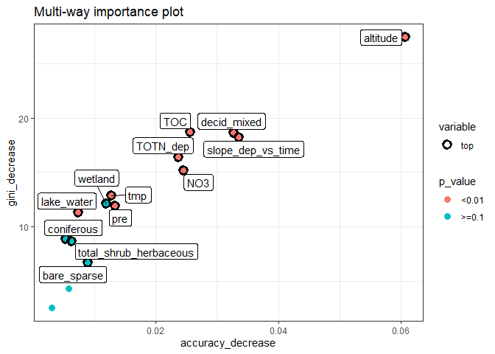

**Variable effects:** The partial effects graphs are a bit different as the variables have reordered themselves according to th ‘gini-decrease’ index, which was used for selecting variables for these plots. E.g., in the first plot, decid_mixed has been replaced by TOC, but the effct of the TOC appears similar: low TOC is associated with high probability of NO3 decline, but the effect of TOC appears non-linear (little difference between TOC = 3 and TOC = 15).

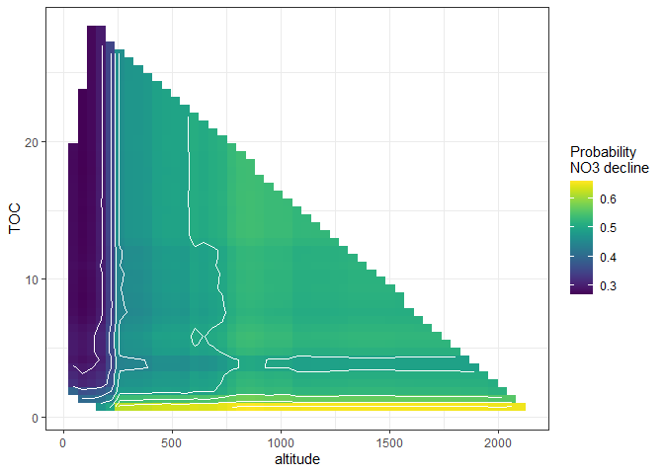  
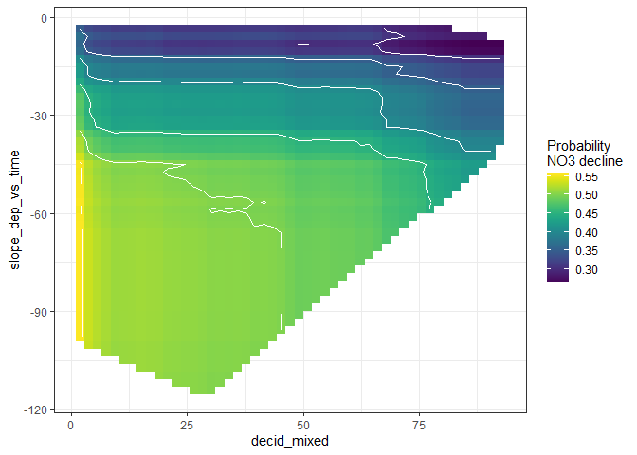  
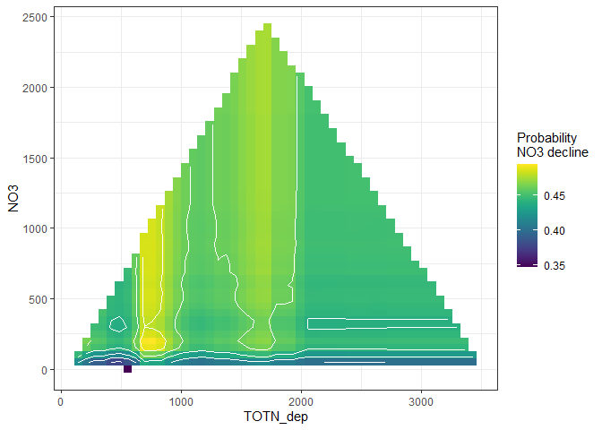

### c. All variables except catchment area and TOC

**N = 474 (getting most IT,LV,IE,DE,SE stations, still lacking CH + 16 US stations)**

## -------------------------------------------------------------  
## Variables:   
## no3_decline,slope_dep_vs_time, NO3, TOTN_dep, latitude, longitude, altitude,pre, tmp, urban, cultivated, coniferous, decid_mixed, total_shrub_herbaceous,wetland, lake_water, bare_sparse  
##  
## Number of complete observations by country:   
## complete  
## FALSE TRUE  
## Canada 0 114  
## Czech Republic 0 8  
## Estonia 1 0  
## Finland 0 26  
## Germany 0 23  
## Ireland 1 2  
## Italy 0 6  
## Latvia 0 3  
## Netherlands 0 3  
## Norway 0 83  
## Poland 0 6  
## Slovakia 0 12  
## Sweden 0 92  
## Switzerland 6 0  
## United Kingdom 0 21  
## United States 16 75  
##   
##   
## Original data: n = 498   
## Analysis: n = 474

**Variable importance:** Altitude and proportion of deciduous/mixed forest are equally important. NO3, TOTN_dep and slope_vs_time still quite important.

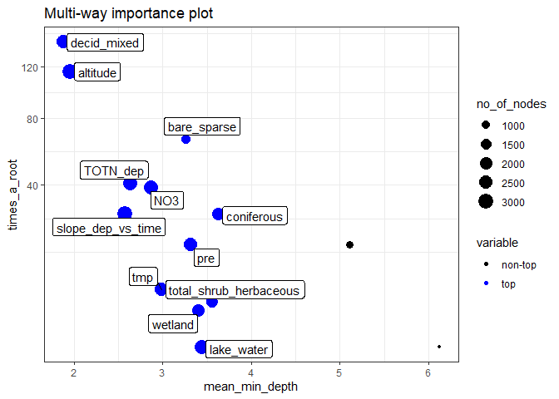 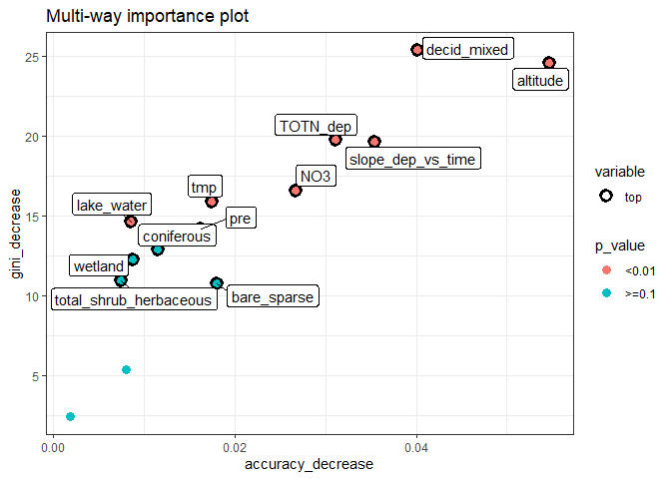

**Variable effects:** Interaction between altitude and decid_mixed: Below altitude 250 masl, decid_mixed has no effect. Over 250 masl, the probability of NO3 decline decreases steadily as the proportion fof deciduous/mixed forest increases. Also, the probability of NO3 decline decreases as tmp (temperature) increases (proxy for altitude?).

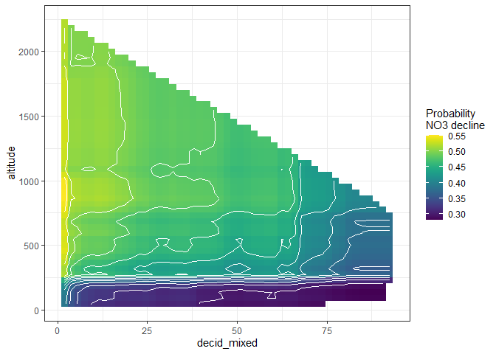  
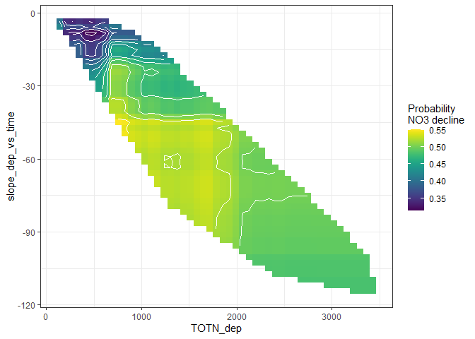  
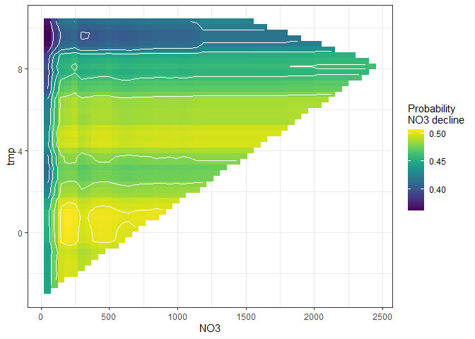

### d. All variables except catchment area and altitude

**N = 450 (same stations as in b)**

**Variable importance:** TOC “takes over for” altitude in variable importance. TOTN_dep and slope_dep_vs_time still quite important, NO3 a little less important (see graph 2), while precipitation (pre) and temperature (tmp) becomes more important.

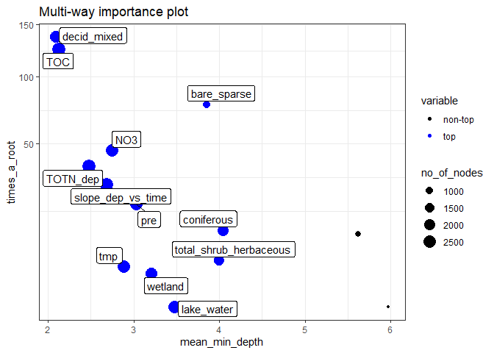 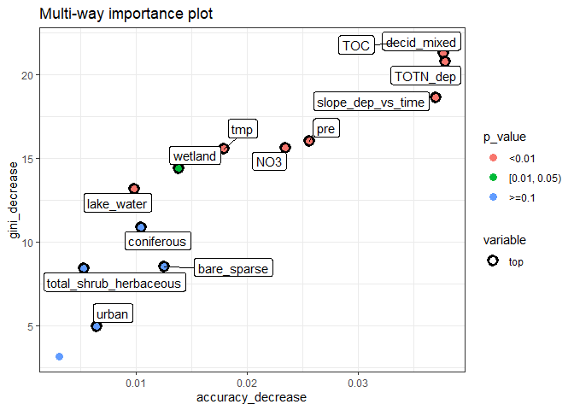

**Variable effects:** Largest probability of NO3 decline for stations with very low TOC, or very little deciduous/mixed forest, or (especially) both. Also, larger probability of NO3 decline when precipitation is over 1500 mm (for a range of NO3 values).

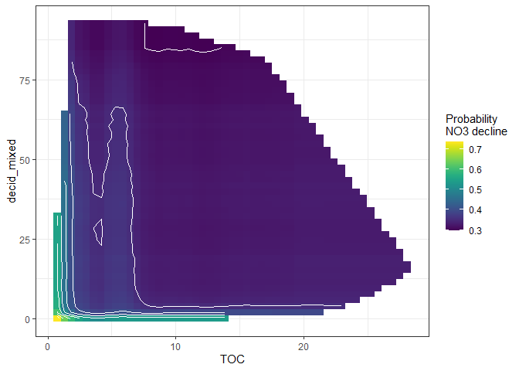  
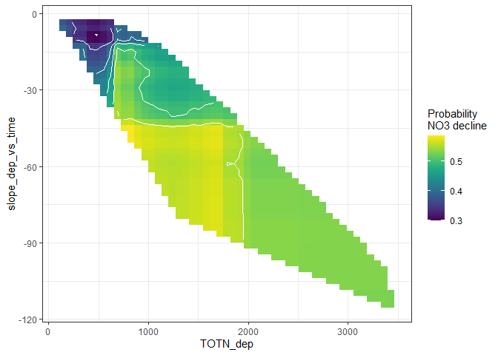  
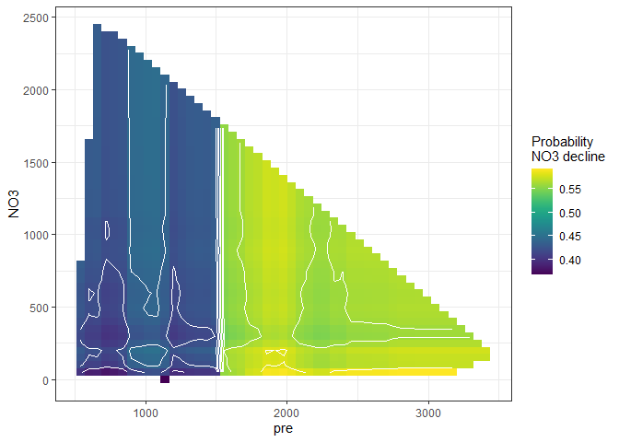

**Multiple regression:** The results from a multiple regression (model with best AIC, picked automatically) confirms a strong relationship to the trend in deposition (in interaction with current deposition) and a strong effect of land cover variables. TOC has a weak/uncertain effect.

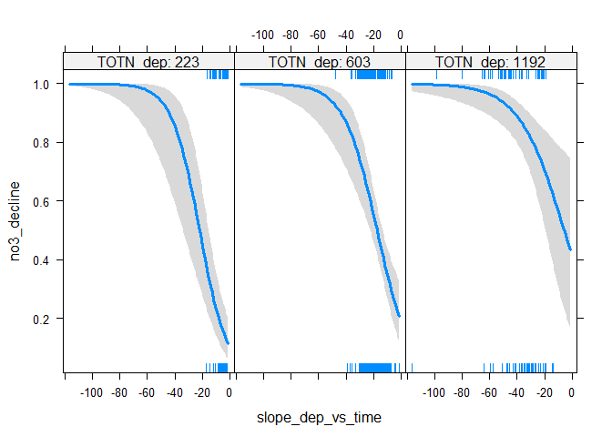

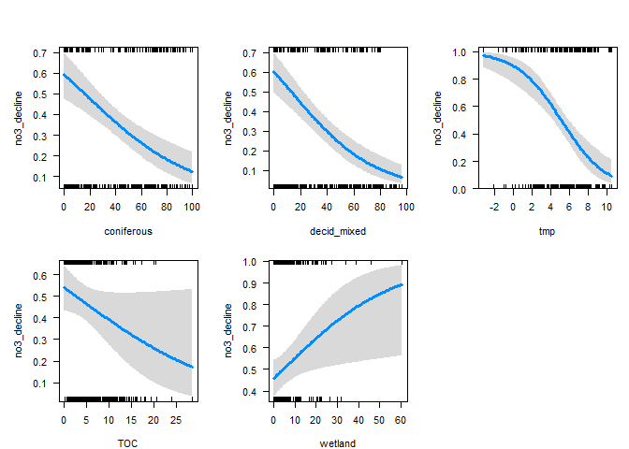

## Results for TOC/TON ratio decrease

**Note: in all of these results, ‘AtlCan’ data are excluded**

### a. Full model

**Variable importance:** The slopes of TON and TOC over time has a big effect, not so surprising.

161a_Time_series_tocton_

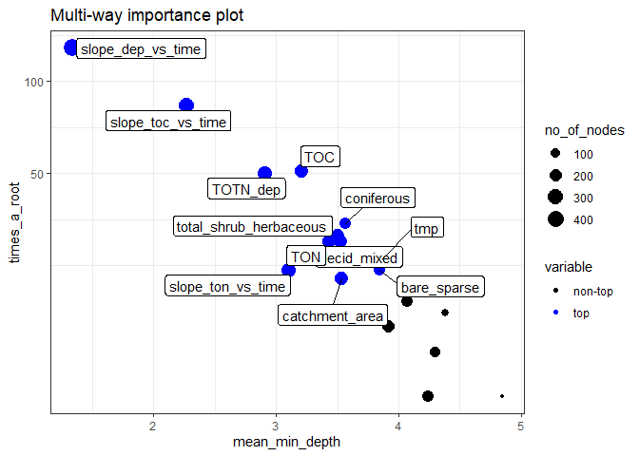 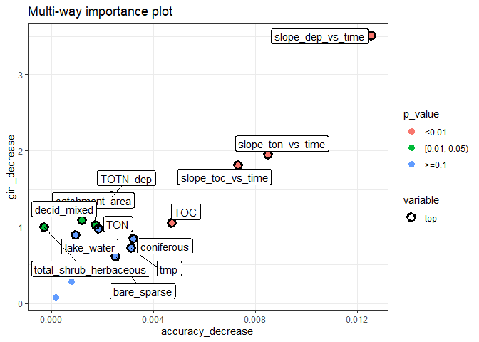

**Variable effects:** Dominated by the slopes over time - see next analyses

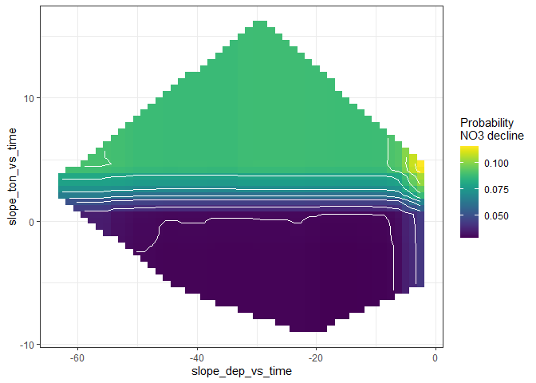  
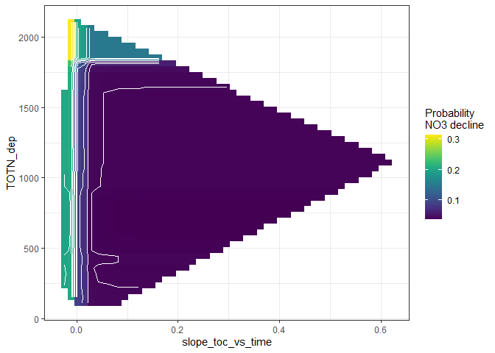  
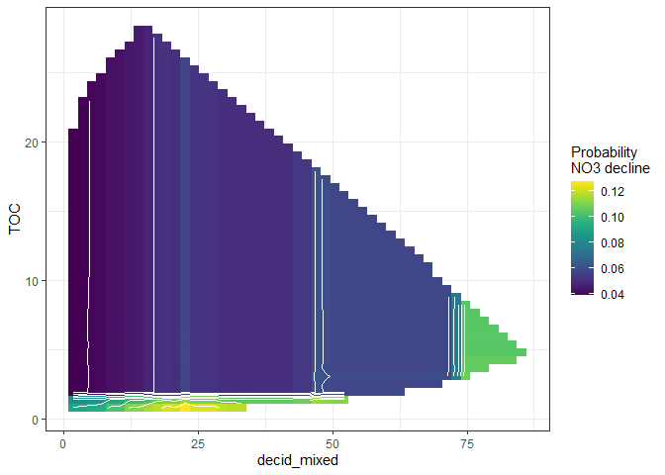

### b. Not including the slopes of TOC and TON

**N = 224 - Missing the Italian ones, due to TOC**

## Variables:   
## tocton_decrease,catchment_area, TOC, TON,slope_dep_vs_time, TOTN_dep, latitude, longitude, altitude,pre, tmp, urban, cultivated, coniferous, decid_mixed, total_shrub_herbaceous,wetland, lake_water, bare_sparse  
##  
##   
## Number of complete observations by country:   
## complete  
## FALSE TRUE  
## Canada 0 7  
## Finland 0 26  
## Germany 0 1  
## Italy 6 0  
## Norway 0 83  
## Sweden 0 86  
## United Kingdom 0 21  
##   
##   
## Original data: n = 293   
## Data after filtering: n = 230   
## Analysis: n = 224

**Variable importance:** Decrease of deposition (slope_dep_vs_time) most important. TOC and TOT_dep (mean value of deposition also important)

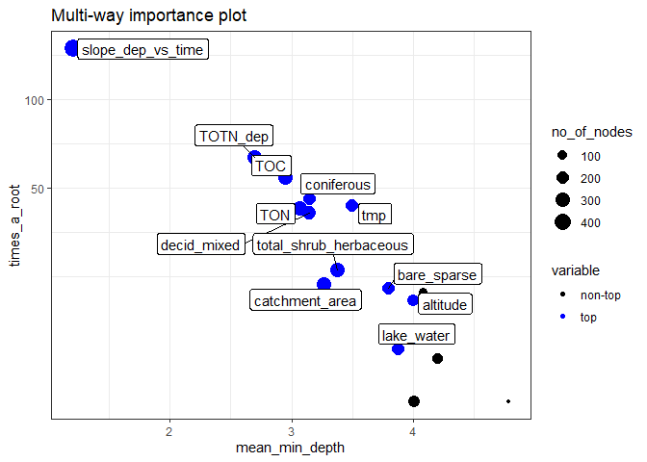 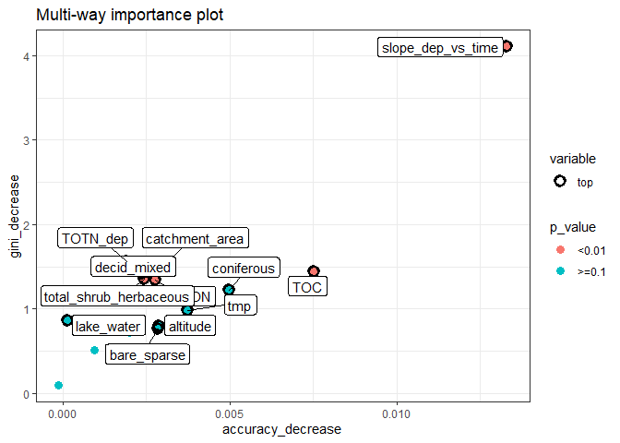 **Variable effects:** A decline in TOC/TON ratio is mostl likely if there is a big decline in TOTN deposition and deposition is over ca. 1600.

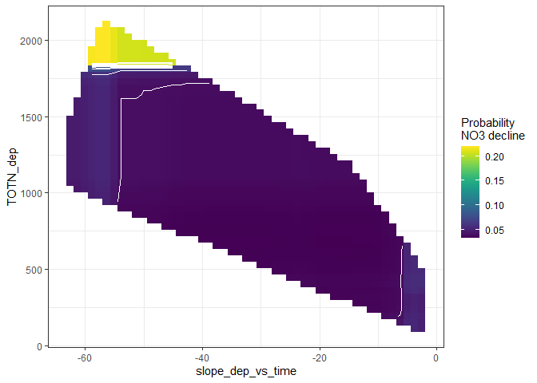  
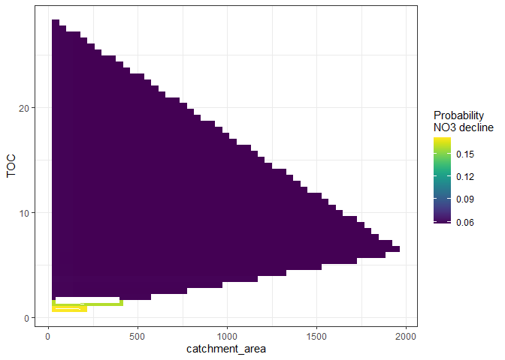  
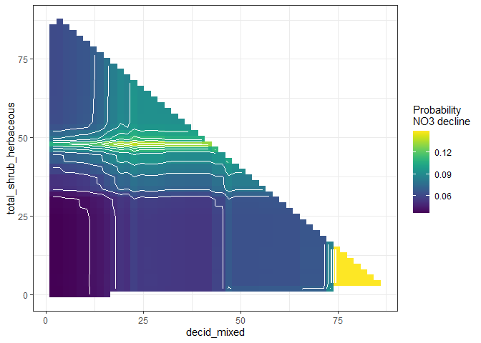  
**Multiple regression:** Only the efects of deposition, deposition trend and TON really show up here.

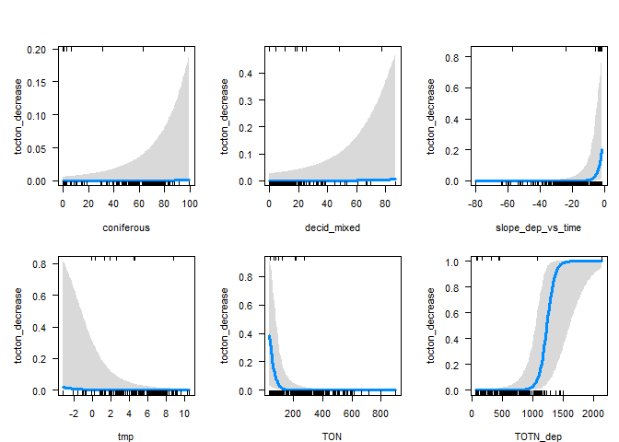

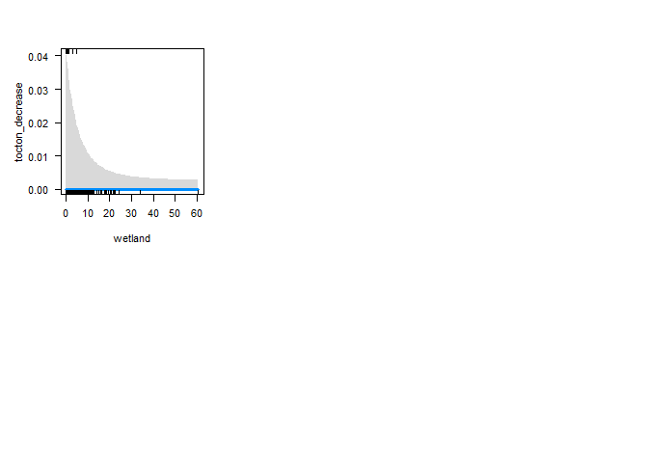

### c. Also removing TOC

**N = 230 (all countries included)**

## Variables:   
## tocton_decrease,TON,slope_dep_vs_time, TOTN_dep, latitude, longitude, altitude,pre, tmp, urban, cultivated, coniferous, decid_mixed, total_shrub_herbaceous,wetland, lake_water, bare_sparse  
##   
## Number of complete observations by country:   
## complete  
## TRUE  
## Canada 7  
## Finland 26  
## Germany 1  
## Italy 6  
## Norway 83  
## Sweden 86  
## United Kingdom 21  
##   
##   
## Original data: n = 293   
## Data after filtering: n = 230   
## Analysis: n = 230

**Variable importance:** Decrease of deposition (slope_dep_vs_time) still most important. Total_shrub_herbacous comes in as quite important.

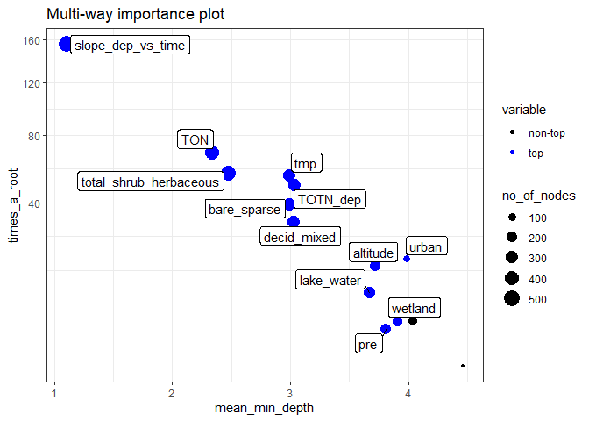 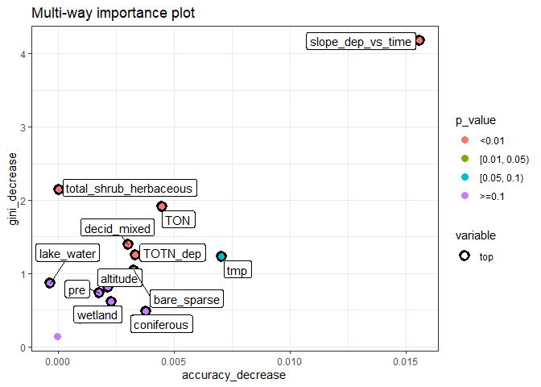

**Variable effects:** The probability of TOC/TON decline is highest for some intermediate proportion of shrubs/herbacous (40-50%). A bit suspicuous?

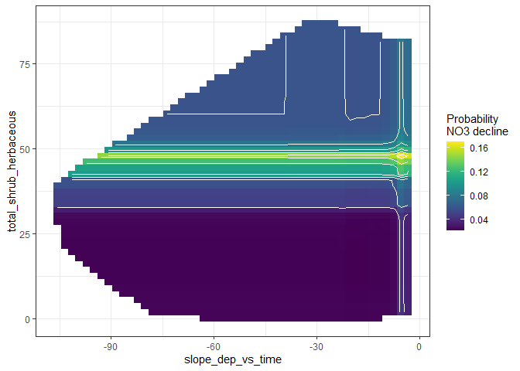  
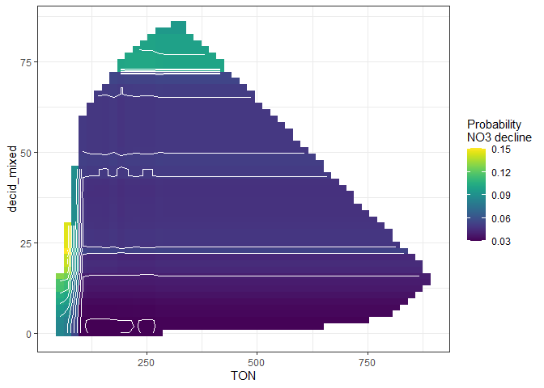  
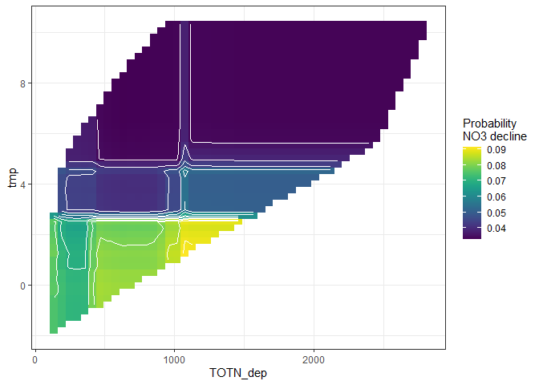

## Results for Current status, NO3

### a. Full model

**N = 377 (no USA stations)**

## Variables   
## log_median_no3,catchment_area, log_median_toc,slope_dep_vs_time, TOTN_dep, latitude, longitude, altitude,pre, tmp, urban, cultivated, coniferous, decid_mixed, total_shrub_herbaceous,wetland, lake_water, bare_sparse  
  
##   
## Number of complete observations by country:   
## complete  
## FALSE TRUE  
## Canada 0 115  
## Czech Republic 0 8  
## Estonia 1 0  
## Finland 0 23  
## Germany 0 3  
## Ireland 9 2  
## Italy 0 4  
## Latvia 0 5  
## Moldova 2 0  
## Netherlands 1 2  
## Norway 0 83  
## Poland 3 6  
## Slovakia 0 12  
## Sweden 0 92  
## Switzerland 9 0  
## United Kingdom 0 22  
## United States 91 0  
##   
##   
## Original data: n = 493  
## Analysis: n = 376

**Variable importance:** Current level of depositon (TOTN_dep) and its trend (slope_dep_vs_time) are the two most important variables by far, and temperature (tmp) is clearly number 3.

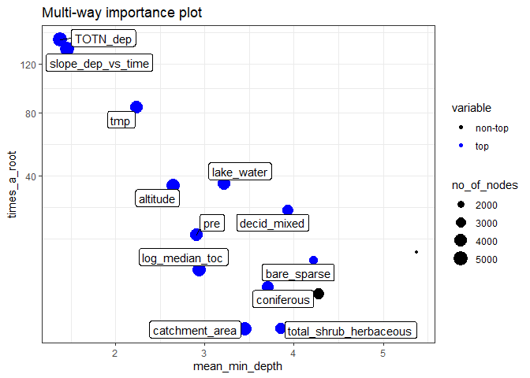 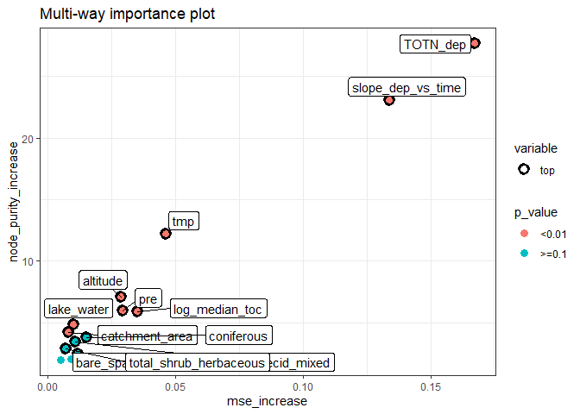

**Variable effects:** Current deposition and its trend are clearly correlated (forming a diagonal ‘bar’), but there is clearly an effect of both. For high levels of current deposition, there seems to be little or none effect of the deposition trend (i.e. deposition history), but for stations with current deposition < 500, deposition history matters: there is higher NO3 levels if the deposition trend has been more negative (i.e. if past deposition was higher). There is also high NO3 levels for stations with high temperature (tmp) and low TOC, and smaller effects of prcipitation and altitude.

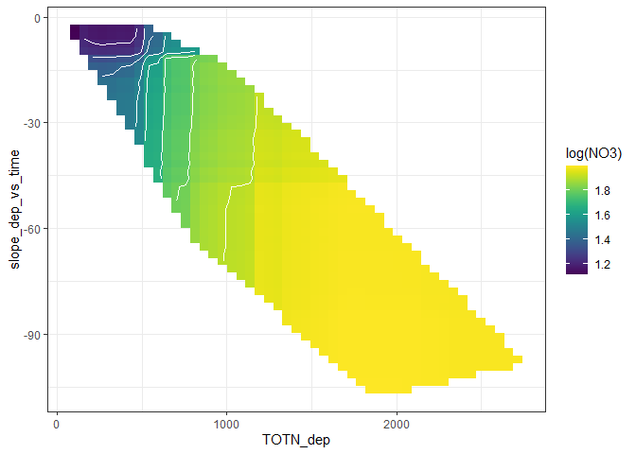  
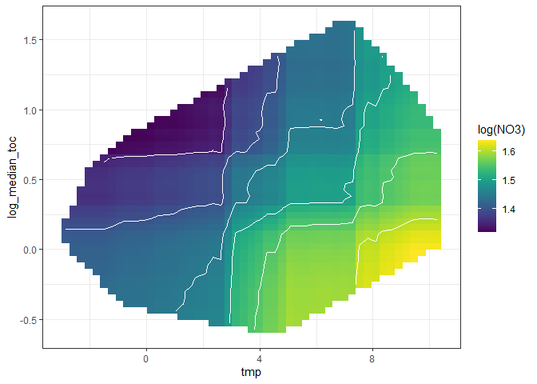  
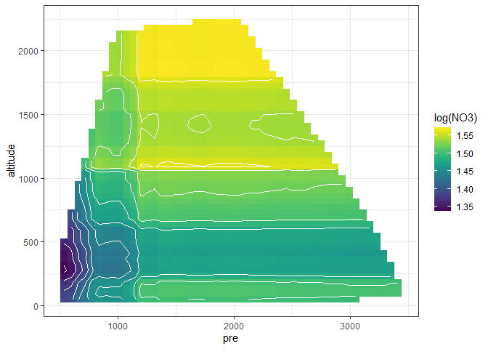

### b. All variables except catchment area and TOC

**N = 457** (still lacking 16 US stations, plus most (9/11) Irish stations)

## -------------------------------------------------------------  
## Variables:   
## log_median_no3,slope_dep_vs_time, TOTN_dep, latitude, longitude, altitude,pre, tmp, urban, cultivated, coniferous, decid_mixed, total_shrub_herbaceous,wetland, lake_water, bare_sparse  
## -------------------------------------------------------------  
##   
## Number of complete observations by country:   
## complete  
## FALSE TRUE  
## Canada 0 115  
## Czech Republic 0 8  
## Estonia 1 0  
## Finland 0 23  
## Germany 0 3  
## Ireland 9 2  
## Italy 0 4  
## Latvia 0 5  
## Moldova 2 0  
## Netherlands 0 3  
## Norway 0 83  
## Poland 0 9  
## Slovakia 0 12  
## Sweden 0 92  
## Switzerland 9 0  
## United Kingdom 0 22  
## United States 16 75  
##   
##   
## Original data: n = 493  
## Analysis: n = 456

**Variable importance:** Quite similar as above.

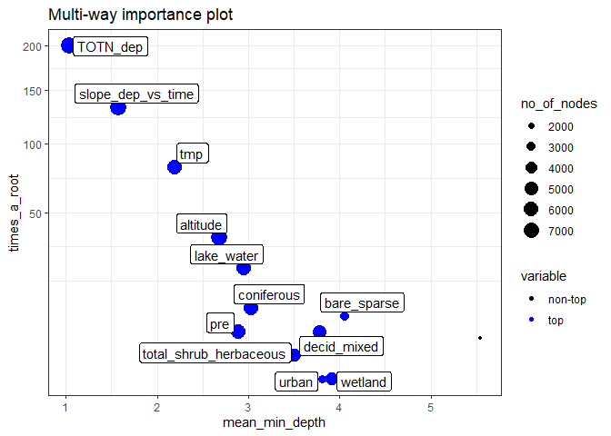 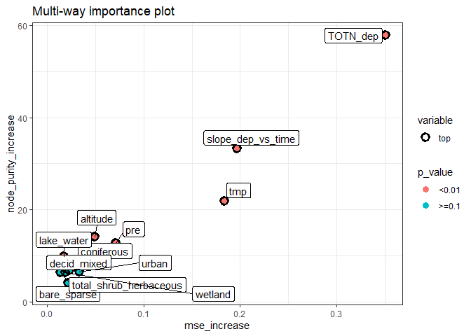

**Variable effects:** The effects of current deposition and deposition trend are similar to the previous analyses only with stronger contrasts. Effects pf temperature, precipitation and altitude appears similar.

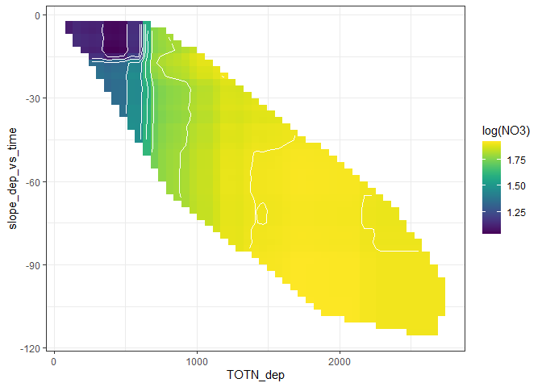  
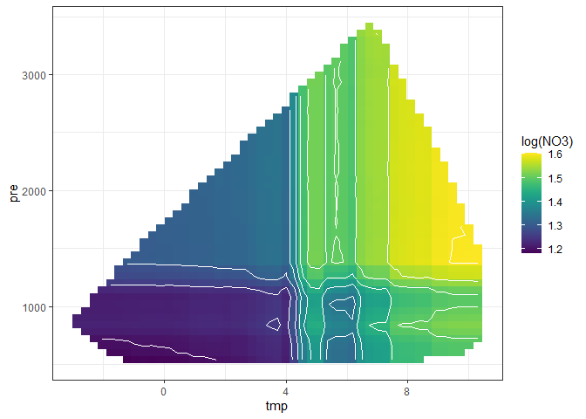  
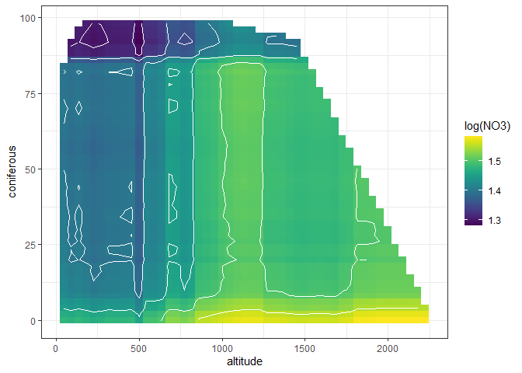  
**Multiple regression:** The results from a multiple regression (model with best AIC, picked automatically) confirms an interaction effect bewteen current deposition and deposition trend, as well as effects of someland cover variables, altitude and temperature.

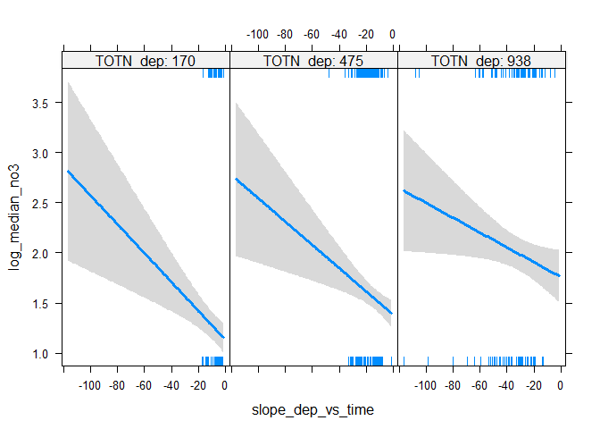

lin regr

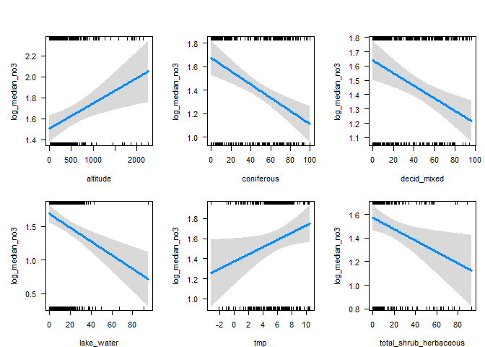

lin regr

## Results for Current status, TOC/TON ratio

### a. All variables including TOC and TON medians

**N = 310 (no USA stations)**

## Variables:   
## log_median_tocton,catchment_area, log_median_ton, log_median_toc,slope_dep_vs_time, TOTN_dep, latitude, longitude, altitude,pre, tmp, urban, cultivated, coniferous, decid_mixed, total_shrub_herbaceous,wetland, lake_water, bare_sparse  
## -------------------------------------------------------------  
##   
## Number of complete observations by country:   
## complete  
## TRUE  
## Canada 78  
## Czech Republic 2  
## Finland 23  
## Germany 1  
## Italy 4  
## Latvia 5  
## Norway 83  
## Sweden 92  
## United Kingdom 22  
##   
##   
## Original data: n = 310   
## Analysis: n = 310

**Variable importance:** This is very much dominated by TOC levels (log_median_toc)

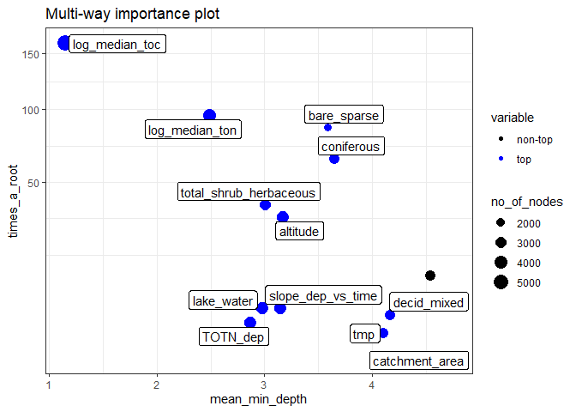 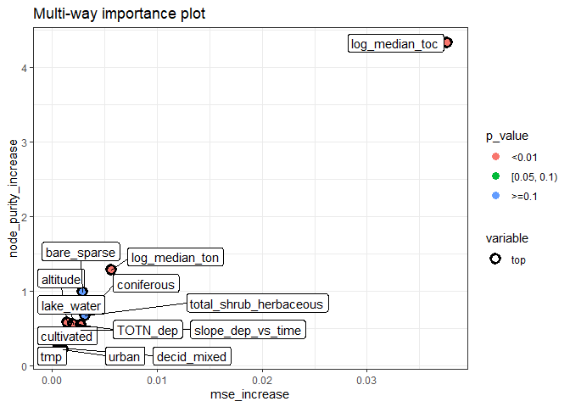

**Variable effects:** Again, TOC levels seems by far most important.

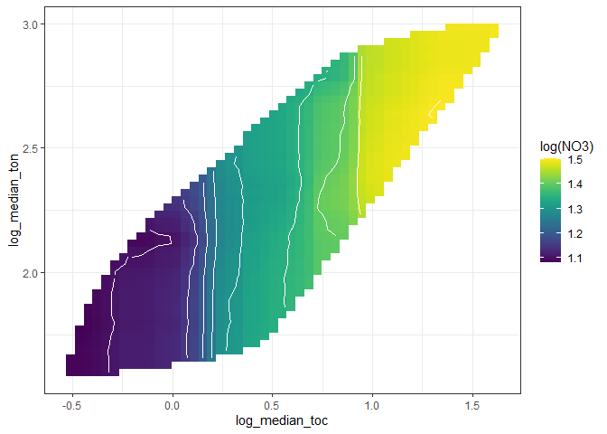  
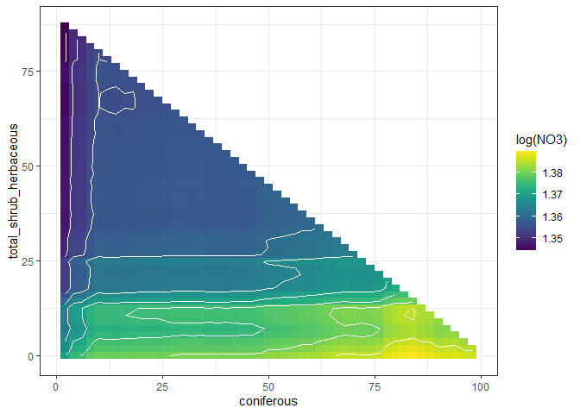  
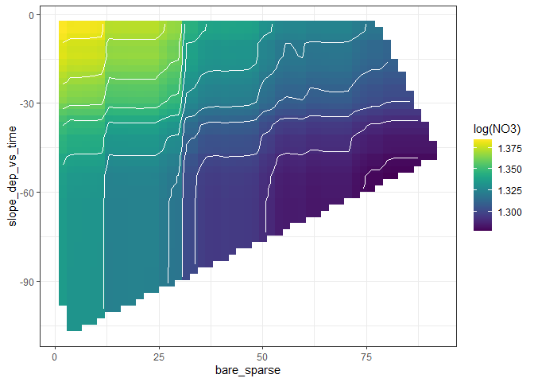

### b. All variables except TOC and TON medians

**N = 310 (no USA stations)** - same stations as the previous

**Variable importance:** The to 3 variables are all vegetation parameters. total_shrub_herbaceous seems slightly more important than bare_sparse and coniferous. Altitude and lake_water comes next, followed by level and trend of TotN deposition.

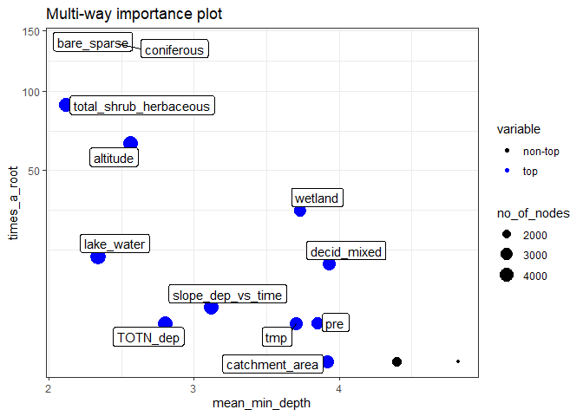 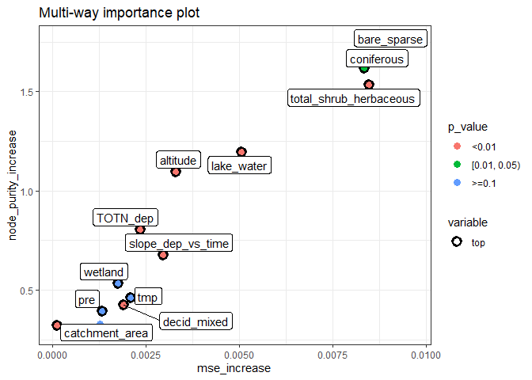

**Variable effects:** High TOC/TON ratios are associated with little shrub/herbaceous vegetation, little bare/sparse vegetation, little lake/water and much coniferous forest. There is also a weaker effect of TotN deposition at lower (< 750 m.a.s.l).

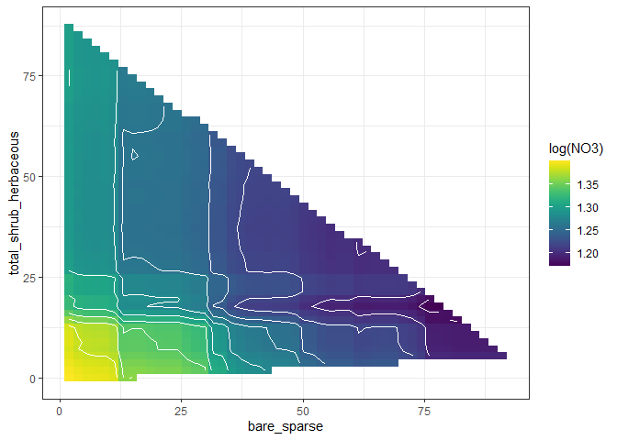  
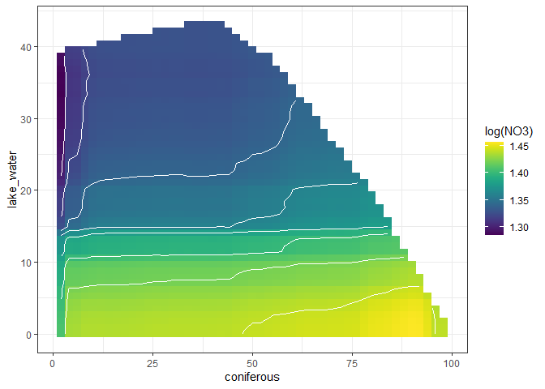  
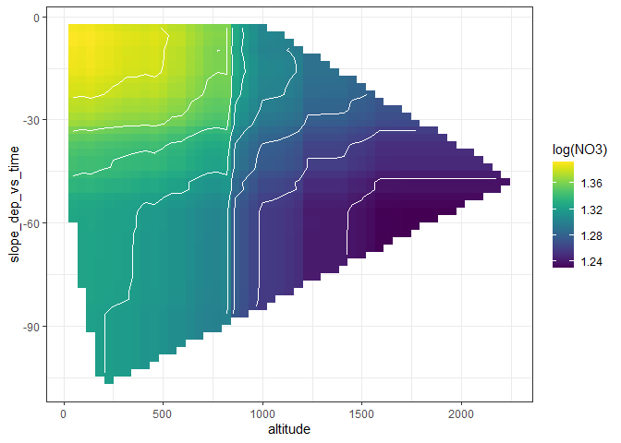

**Multiple regression:** The results from a multiple regression (model with best AIC, picked automatically) are shown below. Most notably, total_shrub_herbaceous isn’t picked.  
