Third Sprint

Group 5: Dagan Hemker, Mya Shanahan, Peilan Zhang, Colin Zhou, Qingying Liu

GitHub link: <https://github.com/Dagan789/Sprint-3.git>

Trello board: <https://trello.com/invite/b/0zvUykIo/ATTI7380814445025dffe369cc40e73f4cd267F5CBAC/sprint-3>

Burndown charts

Day 6

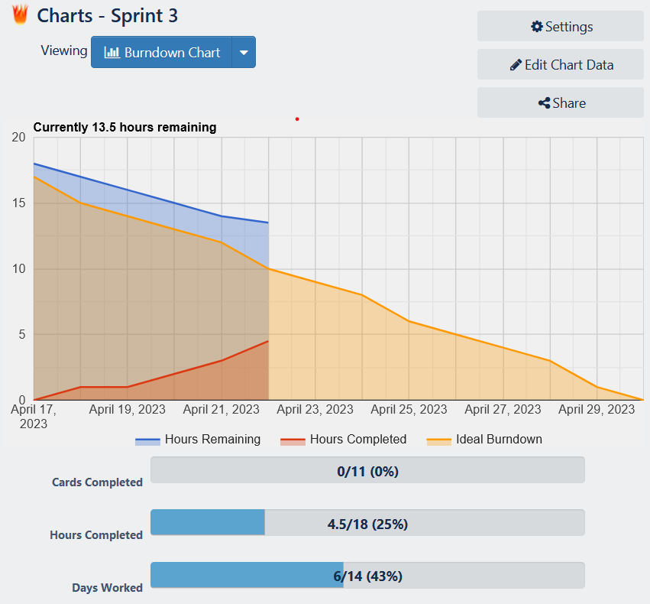

Day 9

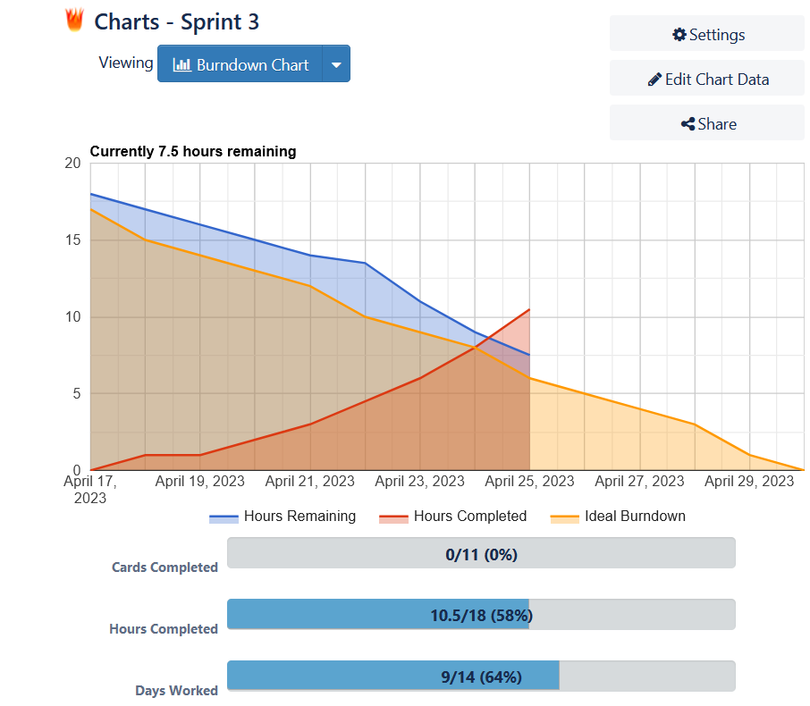

Day 14

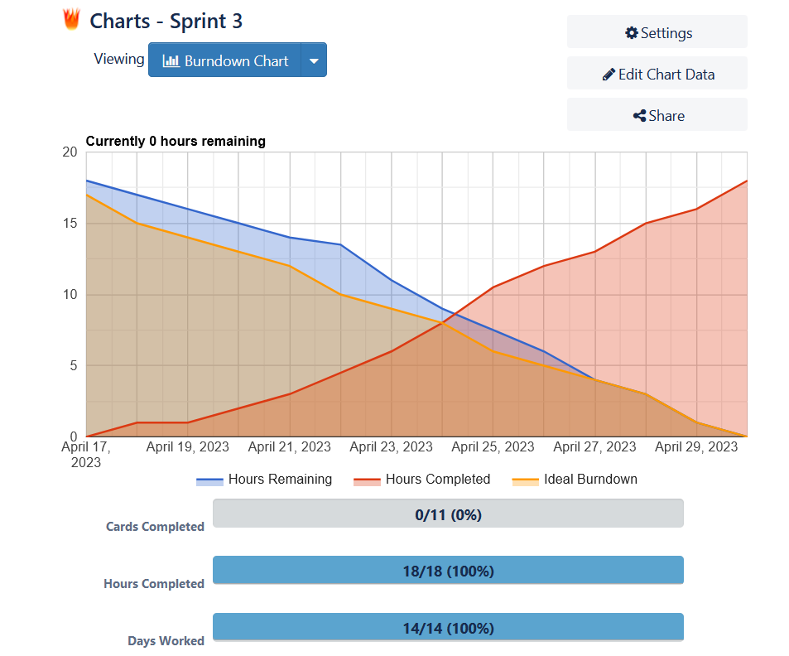

**User stories:**

1. As a user of OutfitPro, I would like to be able to save outfits I have found on previous visits to be able to easily find them again.
2. As the admin of OutfitPro I would like to be able to edit and delete all uploaded content from the site.

**Daily Scrum:**

**Meeting 1: 4/24/2023**

**Dagan**

a. What did you do yesterday?

Create User stories

b. What are you planning to do today?

Security rules

c. Any problems are you facing?

None

**Mya**

a. What did you do yesterday?

Make upload outfit functional

b. What are you planning to do today?

Keep working on upload outfit function

c. Any problems are you facing?

None

**Colin**

a. What did you do yesterday?

Security rules

b. What are you planning to do today?

Adding firebase collections

c. Any problems are you facing?

None

**Peilan**

a. What did you do yesterday?

Final edit to UI

b. What are you planning to do today?

Changing the website background

c. Any problems are you facing?

I was struggling with the background design of the homepage. Doing a split background caused complications with the survey.

**Qingyang**

a. What did you do yesterday?

Creating test outfits

b. What are you planning to do today?

Daily scrum

c. Any problems are you facing?

none

**Meeting 2:4/27/2023**

**Dagan**

a. What did you do yesterday?

Security rules

b. What are you planning to do today?

Sprint review

c. Any problems are you facing?

None

**Mya**

a. What did you do yesterday?

Upload outfit function

b. What are you planning to do today?

Favorite functionality

c. Any problems are you facing?

None

**Colin**

a. What did you do yesterday?

Survey functionality

b. What are you planning to do today?

Admin functionality

c. Any problems are you facing?

none

**Peilan**

a. What did you do yesterday?

Changing the background

b. What are you planning to do today?

Create slideshow of outfits for homepage

c. Any problems are you facing?

none

**Qingyang**

a. What did you do yesterday?

Editing the layout of the website

b. What are you planning to do today?

Beautify the survey page

c. Any problems are you facing?

It took me some time to beautify and adjust the survey and search result to make the page look more visually pleasing.

**Sprint review**

**a. What did you learn from doing our third sprint?**

We learned that It’s important to assess the work needed to be completed beforehand so that we wouldn’t need to rush at the end of the sprint. Our initial idea of time needed to complete our goals was off.

**b. What did go well? Why?**

Our ability to work efficiently toward the end and get done what we planned to do went well even it wasn’t how we should have done it.

**c. What didn’t go well? Why not?**

We had problems deciding the layout of the website, for example, we weren’t sure if it was best to do a split color layout as it was causing complications with the survey output display.

**d. How can you make things better next time?**

We didn’t fully understand how much more work was still left for the website. We worked on it each day but didn’t get as much done and we should have, which caused us to have to work more toward the end of the sprint.

**e. Are you satisfied with what you already completed?**

We still have a bit of work to do before finalizing the project and could have maybe done more in this sprint, however, we are confident we’ll be able to finish on time.

**f. Which group was invited? What are your observations/notes?**

**Everybody was present?**

We invited Group 7 and everyone was present. They liked the changes made to the homepage and the ability to favorite posts. They also liked the rotating images on the homepage but suggested that we make each photo a uniform size.