**Chapter Four**

**C# Windows Forms Controls**

# C# Windows Forms

Windows Forms Applications make use of something called a Form. The Form is blank at first. You then add controls to your form, things like buttons, text boxes, menus, check boxes, radio buttons, etc.

C# programmers have made extensive use of forms to build user interfaces. Each time you create a Windows application, Visual Studio will display a default blank form, onto which you can drag the controls onto your applications main form and adjust their **size and position.**

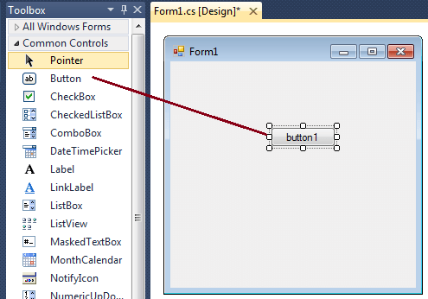

The first step is to start a new project and build a form. Open your Visual Studio and select File->New Project and from the new project dialog box select Other Languages->Visual C# and select Windows Forms Application. Enter a project name at the bottom of the dialogue box and click OK button. The following picture shows how to create a new Form in Visual Studio.

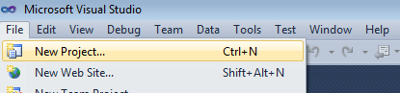

Select Windows Forms Application from New Project dialog box.

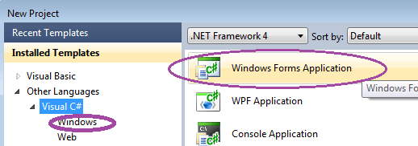

After selecting Windows Forms Application , you can see a default Form (Form1) in your new C# project. The Windows Form you see in Designer view is a visual representation of the window that will open when your application is opened. You can switch between this view and Code view at any time by right-clicking the design surface or code window and then clicking View Code or View Designer. The following picture shows how is the default Form (Form1) looks like.

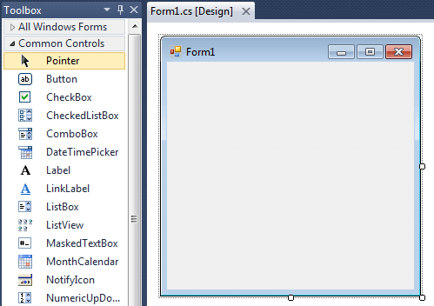

At the top of the form there is a **title bar** which displays the forms title.

* Form1 is the default name, and you can change the name to your convenience .
* The title bar also includes the control box, which holds the minimize, maximize, and close buttons.
* If you want to set any properties of the Form, you can use **Visual Studio Property window** to change it.
* If you do not see the Properties window, on the View menu, click Properties window. This window lists the properties of the currently selected Windows Form or control, and it's here that you can change the existing values.

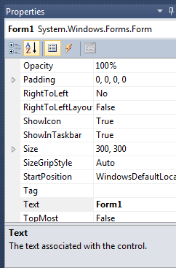

* For example, to change the forms title from Form1 to MyForm, click on Form1 and move to the right side down Properties window, set Text property to MyForm.
* Then you can see the Title of the form is changed. Likewise you can set any properties of Form through Properties window.
* You can also set the properties of the Form1 through coding.
* For coding, you should right-click the design surface or code window and then clicking View Code.

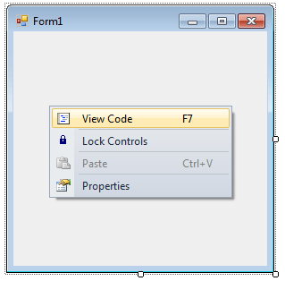

When you right click on Form then you will get code behind window, there you can write your code For example, if you want to change the back color of the form to Brown, you can code in the Form1_Load event like the following.

***private void Form1_Load(object sender, EventArgs e)***

***{***

***this.BackColor = Color.Brown;***

***}***

Likewise you can change other properties of Form1 through coding.

The following C# source code shows how to change the Title, BackColor, Size, Location and MaximizeBox properties of Form1.

***using System;***

***using System.Drawing;***

***using System.Windows.Forms;***

***namespace WindowsFormsApplication1***

***{***

***public partial class Form1 : Form***

***{***

***public Form1()***

***{***

***InitializeComponent();***

***}***

***private void Form1_Load(object sender, EventArgs e)***

***{***

***this.Text = "Change Prperties Through Coding";***

***this.BackColor = Color.Brown;***

***this.Size = new Size(350, 125);***

***this.Location = new Point(300, 300);***

***this.MaximizeBox = false;***

***}***

***}***

***}***

When you execute (press F5 key) the program the form is look like the following image.   
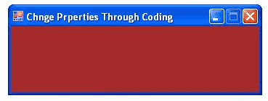  
  
The Windows based programs you create using C# run in the context of a form. When you close the form, the application also ends.

**Adding Controls to a Blank Form**

If you want to add a control to a form, you can use the Toolbox on the left of Visual Studio. Move your mouse over to the Toolbox, and click the arrow symbol (or plus symbol) next to **Common Controls**. You should see the following list of things that you can add to your form:

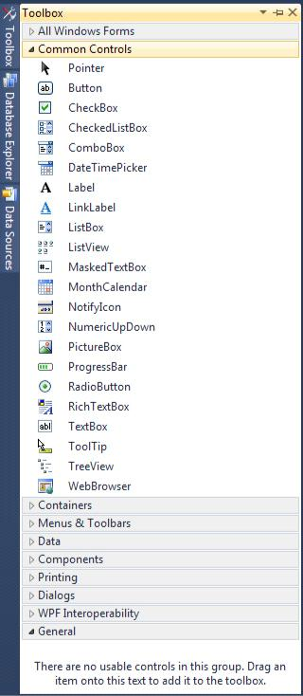

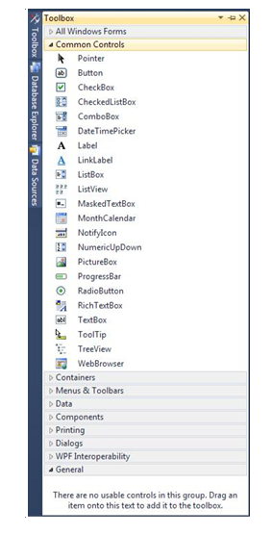

**C# Button Control**

Windows Forms controls are reusable components that encapsulate user interface functionality and are used in client side Windows applications.

* A button is a control, which is an interactive component that enables users to communicate with an application.
* The Button class inherits directly from the ButtonBase class.
* A Button can be clicked by using the mouse, ENTER key, or SPACEBAR if the button has focus.

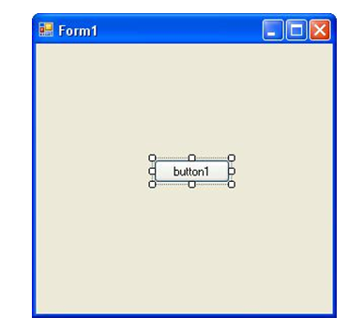

**Properties of a Control**

The controls you add to a form have something called **Properties**. A property of a control is things like its Height, its Width, its Name, its Text, and a whole lot more besides. To see what properties are available for a button, make sure the button is selected, as in the image above. If a control is selected, it will have white squares surrounding it. If your button is not selected, simply click it once.

Now look in the bottom right of Visual C# Express, just below the Solution Explorer. You should see the Properties Window (if it’s not there, select it from the **View** menu at the top.

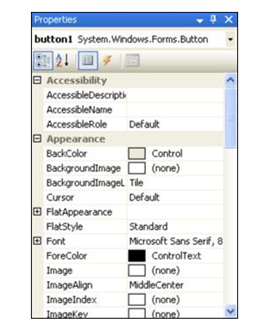

* To view the list of Properties in alphabetical order, click the AZ symbol at the top, circled in red in the image below:

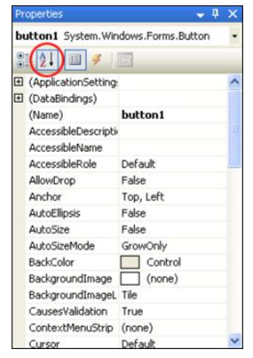

* As you can see, there’s a lot of Properties for a button. Scroll down to the bottom and locate the **Text** Property: Then type **A message**:
* The Text part of your Properties Window will then look like this:

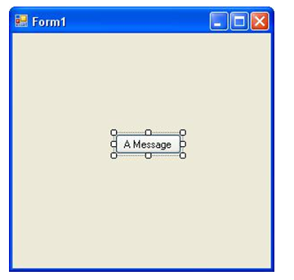

**Adding code to a Button**

What we want to do is to display a message box whenever the button is clicked. So we need the coding window. To see the code for the button, double click the button you added to the Form. When you do, the coding window will open, and your cursor will be flashing inside of the button code. It will look like this:

using System;

using System.Collections.Generic;

using System.ComponentModel;

using System.Data;

using System.Drawing;

using System.Linq;

using System.Text;

using System.Threading.Tasks;

using System.Windows.Forms;

namespace WindowsFormsApplication27

{

public partial class Form1 : Form

{

public Form1()

{

InitializeComponent();

}

private void button1_Click(object sender, EventArgs e)

{

}

} }

This code:

private void button1_Click(object sender, EventArgs e)

{

}

This is just another Method, a piece of code that does something. The name of the Method is **button1_Click**. It’s called button1 because that’s currently the Name of the button. When you changed the Text, Location, and Size properties of the button, you could have also changed the **Name** property from button1 (the default Name) to something else.

The _Click part after button1 is called an **Event**. Other events are MouseDown, LocationChanged, TextChanged, and lots more. You’ll learn more about Events later.

After _Click, and in between a pair of round brackets, we have this:

object sender, EventArgs e

These two are known as arguments. One argument is called **sender**, and the other is called **e**. Again, you’ll learn more about arguments later, so don’t worry about them for now.

Notice that there is a pair of curly brackets for the button code:

private void button1_Click(object sender, EventArgs e)

**{**

**}**

If you want to write code for a button, it needs to go between the two curly brackets. We’ll add a single line of code.

**A MessageBox**

We want to display a message box, with some text on it. This is quite easy to do in C#.Code this code in button click event.

private void button1_Click(object sender, EventArgs e)

{

MessageBox.Show("My first Message");

}

To try it out, save your work by clicking **File** from the menu bar at the top of Visual Studio. From the File menu, click **Save All**. You’ll then see the same **Save** box you saw for the Console Application. Save the project.

Run your programme by clicking **Debug > Start Debugging**. Or just press the F5 key on your keyboard. Your programme will look like this:

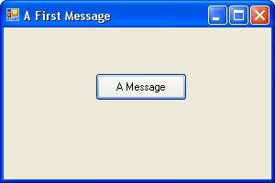

* Click your button to see your Message Box:

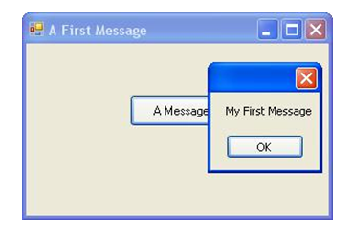

**Other things to do with the Message Box**

If you look at the message box in the image above, you’ll notice there’s no Title in the blue area to the left of the red X – it’s blank. You can add a Title quite easily.

private void button1_Click(object sender, EventArgs e)

{

MessageBox.Show("My first Message","Message");

}

After you write the above code Click your button and you should see a Title on your Message Box:

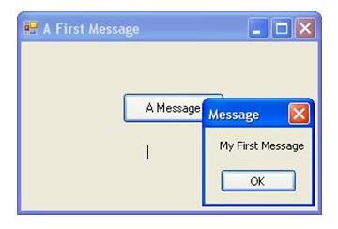

**Other Button Options**

Rather than having just an OK button, you can add buttons like Yes, No, and Cancel. We’ll add a **Yes** and a **No** button.

private void button1_Click(object sender, EventArgs e)

{

MessageBox.Show("My first Message","Message",MessageBoxButtons.YesNo);

}

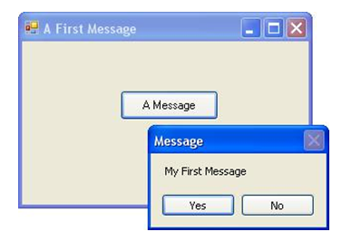

**Adding Icons to a Message Box**

Another thing you can add to brighten up your Message Box is an Icon. It’s easier to see what these are than to explain!

Type another comma after **MessageBoxButtons.YesNo**. After the comma, type a capital letter “M” again. From the IntelliSense list that appears, double click **MessageBoxIcon**. After MessageBoxIcon, type a full stop to see the availableicons:

private void button1_Click(object sender, EventArgs e)

{

MessageBox.Show("My first Message","Message",MessageBoxButtons.YesNo,MessageBoxIcon.Asterisk);

}

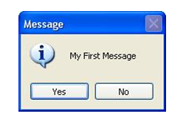

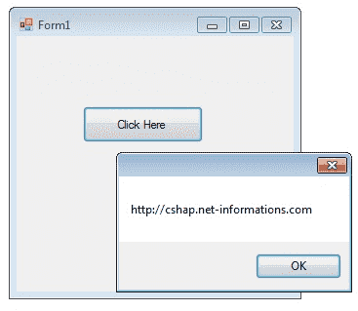

When you want to change display text of the Button, you can change the Text property of the button.

**button1.Text = "Click Here";**

Similarly if you want to load an Image to a Button control, you can code like this

**button1.Image = Image.FromFile("C:\\testimage.jpg");**

The following C# source code shows how to change the button Text property while Form loading event and to display a message box when pressing a Button Control.

using System;

using System.Drawing;

using System.Windows.Forms;

namespace WindowsFormsApplication1

{

public partial class Form1 : Form

{

public Form1()

{

InitializeComponent();

}

private void Form1_Load(object sender, EventArgs e)

{

button1.Text = "Click Here";

}

private void button1_Click(object sender, EventArgs e)

{

MessageBox.Show("http://cshap.net-informations.com");

}

}

}

**C# Label Control**

Labels are one of the most frequently used C# control.

* We can use the Label control to display text in a set location on the page.
* Label controls can also be used to add descriptive text to a Form to provide the user with helpful information.
* The Label class is defined in the System.Windows.Forms namespace.

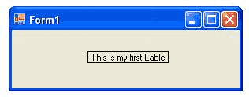

Add a Label control to the form - Click Label in the Toolbox and drag it over the forms Designer and drop it in the desired location.

If you want to change the display text of the Label, you have to set a new text to the Text property of Label.

***label1.Text = "This is my first Label";***

In addition to displaying text, the Label control can also display an image using the Image property, or a combination of the ImageIndex and ImageList properties.

**label1.Image = Image.FromFile("C:\\testimage.jpg");**

The following C# source code shows how to set some properties of the Label through coding.

using System;

using System.Drawing;

using System.Windows.Forms;

namespace WindowsFormsApplication1

{

public partial class Form1 : Form

{

public Form1()

{

InitializeComponent();

}

private void Form1_Load(object sender, EventArgs e)

{

label1.Text = "This is my first Lable";

label1.BorderStyle = BorderStyle.FixedSingle;

label1.TextAlign = ContentAlignment.MiddleCenter;

}

}

}

# Variables - Strings

# Programmes work by manipulating data stored in memory. These storage areas come under the general heading of Variables. In this section, you’ll see how to set up and use variables. You’ll see how to set up both text and number variables.

# String Variables

# String variables are always text. We’ll write a little programme that takes text from a text box, store the text in a variable, and then display the text in a message box.

# But bear in mind that a variable is just a storage area for holding things that you’ll need later. Think of them like boxes in a room. The boxes are empty until you put something in them. You can also place a sticker on the box, so that you’ll know what’s in it.

# Example:

# Add a button to the form

# Add Properties for the button

# Name: btnStrings

# Location: 90, 175

# Size: 120, 30

# Text: Get Text Box Data

# 

# We can add two more controls to the form, a Label and a Text Box. When the button is clicked, we’ll get the text from the text box and display whatever was entered in a message box.

# A Label is just that: a means of letting your users know what something is, or what it is for.

# Change the following properties of your label, just like you did for the button:

# Location: 10, 50

# Text: Name

# You don’t really need to set a size, because Visual Studio will automatically resize your label to fit your text.

# 

# Add textbox control

# 

# Code for the Button

private void btnString_Click(object sender, EventArgs e)

{

string fristName;

fristName = textBox1.Text;

MessageBox.Show(fristName);

# }

# Assigning text to a String Variable

private void btnString_Click(object sender, EventArgs e)

{

string fristName;

fristName = "C# programming is for me";

MessageBox.Show(fristName);

# }

# Concatenation

# Concatenation is joining things together. You can join direct text with variables, or join two or more variables to make a longer string.

When the message box displays, we want it to say something like “Your name is John”. The variable we’ve called **messageText** holds the first part of the string, “Your name is ”. And we’re getting the person’s name from the text box:

**firstName = textBox1.Text;**

The person’s name is being stored in the variable called **firstName**. To join the two together (concatenate) C# uses the plus symbol ( +).

**messageText + firstName**

Instead of just **firstName** between the round brackets of MessageBox.Show( ), we can add the **messageText** variable and the plus symbol:

MessageBox.Show( **messageText + firstName** );

Amend your MessageBox line so it’s the same as the one above. Here’s the coding window:

private void btnString_Click(object sender, EventArgs e)

{

string fristName;

string messegeText;

messegeText = textBox1.Text;

fristName = "C# programming is for me";

MessageBox.Show(messegeText + fristName);

# }

# Variables – Numbers

# Integers

# An integer is a whole number

# Add a button to your form, and set the following properties for it in the Properties Window:

# Name: btnIntegers

# Text: Integers

# Location: 110, 20

private void btnIntegers_Click(object sender, EventArgs e)

{

int myInteger;

myInteger = 67;

MessageBox.Show (myInteger) ;}

# The error is: “Cannot convert from int to string”. The reason you get this error is because myInteger holds a number. But the Message Box only displays text. C# does not convert the number to text for you.

private void btnString_Click(object sender, EventArgs e)

{

int myInteger;

myInteger = 25;

MessageBox.Show(myInteger.ToString());

# }

# 

# Double and Float

private void btnInteger_Click(object sender, EventArgs e)

{

int myIntegers;

myIntegers = 78;

MessageBox.Show(myIntegers.ToString());

}

private void btnFloat_Click(object sender, EventArgs e)

{

float myFloat;

myFloat = 50.224766636666666F;

MessageBox.Show(myFloat.ToString());

}

private void btnDouble_Click(object sender, EventArgs e)

{

double myDouble;

myDouble = 87.56;

MessageBox.Show(myDouble.ToString());

# }

# 

# Simple addition

private void btnInteger_Click(object sender, EventArgs e)

{

int firstInteger;

int secondInteger;

int integerAnswer;

firstInteger = 45;

secondInteger = 13;

integerAnswer = firstInteger + secondInteger;

MessageBox.Show(integerAnswer.ToString());

# }

# Getting numbers from text boxes

private void btnGetingFromTexbox_Click(object sender, EventArgs e)

{

int a;

int b;

int c;

a = int.Parse(textBox1.Text);

b = int.Parse(textBox1.Text);

c = a + b;

MessageBox.Show(c.ToString());

# }

# C# TextBox Control

A TextBox control is used to display, or accept as input, a single line of text. This control has additional functionality that is not found in the standard Windows text box control, including

* Multiline editing and
* Password character masking.

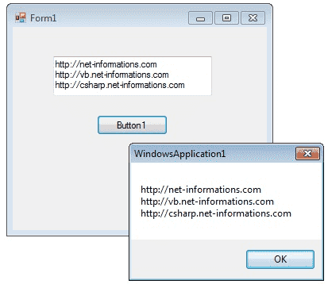

* A text box object is used to display text on a form or to get user input while a C# program is running.
* In a text box, a user can type data or paste it into the control from the clipboard.

For displaying a text in a TextBox control, you can code like this

**textBox1.Text = "http://csharp.net-informations.com";**

You can also collect the input value from a TextBox control to a variable like this way

**string var;**

**var = textBox1.Text;**

**C# Text-Box Properties**

You can set TextBox properties through Property window or through program. You can open Properties window by pressing F4 or right click on a control and select Properties menu item

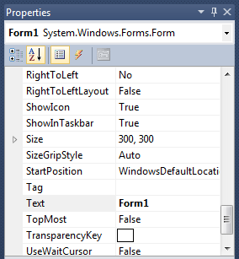

The below code set a textbox width as 250 and height as 50 through source code.

textBox1.Width = 250;

textBox1.Height = 50;

**Background Color and Foreground Color**

You can set background color and foreground color through property window and programmatically.

textBox1.BackColor = Color.Blue;

textBox1.ForeColor = Color.White;

**Textbox Border Style**

You can set 3 different types of border style for textbox, they are None, FixedSingle and fixed3d.

textBox1.BorderStyle = BorderStyle.Fixed3D;

**Textbox Maximum Length**

Sets the maximum number of characters or words the user can input into the text box control.

**textBox1.MaxLength = 40;**

**Textbox Read-Only**

When a program wants to prevent a user from changing the text that appears in a text box, the program can set the controls Read-only property is to True.

**textBox1.ReadOnly = true;**

**Multiline Text-Box**

You can use the Multiline and Scroll-Bars properties to enable multiple lines of text to be displayed or entered.

**textBox1.Multiline = true;**

***Textbox password character***

TextBox controls can also be used to accept passwords and other sensitive information. You can use the PasswordChar property to mask characters entered in a single line version of the control

**textBox1.PasswordChar = '*';**

The above code set the PasswordChar to * , so when the user enter password then it display only * instead of typed characters.

***How to Newline in a Text-Box***

You can add new line in a textbox using many ways.

**textBox1.Text += "your text" + "\r\n";**

or

**textBox1.Text += "your text" + Environment.NewLine;**

**Text-Box Events**

**Key-down event**

You can capture which key is pressed by the user using Key-Down event

e.g.

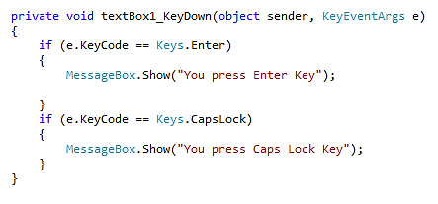

**Text Changed Event**

When user input or setting the Text property to a new value raises the TextChanged event

e.g.

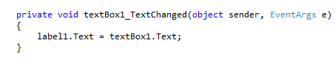

***How to retrieve integer values from Text-Box?***

**int i;**

**i = int.Parse (textBox1.Text);**

Parse method converts the string representation of a number to its integer equivalent.

*String* to *Float* conversion

**float i;**

**i = float.Parse (textBox1.Text);**

*String* to *Double* conversion

**double i;**

**i = float.Parse (textBox1.Text);**

From the following C# source code you can see some important property settings to a TextBox control.

using System;

using System.Drawing;

using System.Windows.Forms;

namespace WindowsFormsApplication1

{

public partial class Form1 : Form

{

public Form1()

{

InitializeComponent();

}

private void Form1_Load(object sender, EventArgs e)

{

textBox1.Width = 250;

textBox1.Height = 50;

textBox1.Multiline = true;

textBox1.BackColor = Color.Blue;

textBox1.ForeColor = Color.White;

textBox1.BorderStyle = BorderStyle.Fixed3D;

}

private void button1_Click(object sender, EventArgs e)

{

string var;

var = textBox1.Text;

MessageBox.Show(var);

}

}

}

# C# Combo-Box Control

C# controls are located in the Toolbox of the development environment, and you use them to create objects on a form with a simple series of mouse clicks and dragging motions.

* A ComboBox displays a text box combined with a ListBox, which enables the user to select items from the list or enter a new value .

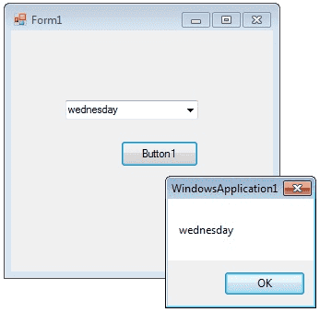

The user can type a value in the text field or click the button to display a drop down list. You can add individual objects with the Add method. You can delete items with the Remove method or clear the entire list with the Clear method.

## How to add an item to combobox

**comboBox1.Items.Add("Sunday");**

**comboBox1.Items.Add("Monday");**

**comboBox1.Items.Add("Tuesday");**

## ComboBox SelectedItem

### How to retrieve value from ComboBox

If you want to retrieve the displayed item to a string variable, you can code like this

**string var;**

**var = comboBox1.Text;**

**Or**

**var item = this.comboBox1.GetItemText(this.comboBox1.SelectedItem);**

**MessageBox.Show(item);**

**How to remove an item from ComboBox**

You can remove items from a combobox in two ways. You can remove item at the specified index or giving a specified item by name.

**comboBox1.Items.RemoveAt(1);**

The above code will remove the second item from the combobox.

**comboBox1.Items.Remove("Friday");**

The above code will remove the item "Friday" from the combobox.

**DropDownStyle**

The DropDownStyle property specifies whether the list is always displayed or whether the list is displayed in a drop-down. The DropDownStyle property also specifies whether the text portion can be edited.

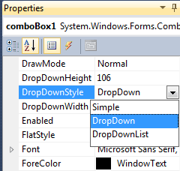

**comboBox1.DropDownStyle = ComboBoxStyle.DropDown;**

## ComboBox Selected Value

### How to set the selected item in a comboBox

You can display selected item in a combobox in two ways.

**comboBox1.Items.Add("test1");**

**comboBox1.Items.Add("test2");**

**comboBox1.Items.Add("test3");**

**comboBox1.SelectedItem = "test3";**

**or**

**comboBox1.SelectedIndex = comboBox1.FindStringExact("test3");**

**Combobox SelectedIndexChanged event**

The SelectedIndexChanged event of a combobox fire when you change the selected item in a combobox. If you want to do something when you change the selection, you can write the program on SelectedIndexChanged event. From the following code you can understand how to set values in the SelectedIndexChanged event of a combobox. Drag and drop two combobox on the Form and copy and paste the following source code.

**using System;**

**using System.Windows.Forms;**

**namespace WindowsFormsApplication1**

**{**

**public partial class Form1 : Form**

**{**

**public Form1()**

**{**

**InitializeComponent();**

**}**

**private void Form1_Load(object sender, EventArgs e)**

**{**

**comboBox1.Items.Add("weekdays");**

**comboBox1.Items.Add("year");**

**}**

**private void comboBox1_SelectedIndexChanged(object sender, EventArgs e)**

**{**

**comboBox2.Items.Clear();**

**if (comboBox1.SelectedItem == "weekdays")**

**{**

**comboBox2.Items.Add("Sunday");**

**comboBox2.Items.Add("Monday");**

**comboBox2.Items.Add("Tuesday");**

**}**

**else if (comboBox1.SelectedItem == "year")**

**{**

**comboBox2.Items.Add("2012");**

**comboBox2.Items.Add("2013");**

**comboBox2.Items.Add("2014");**

**}**

**}**

**}**

**}**

**Output**

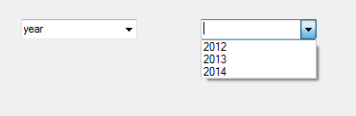

## ComboBox Default Value

### How to set a default value for a Combo Box

You can set combobox default value by using SelectedIndex property

**comboBox1.SelectedIndex = 6;**

Above code set 6th item as combobox default value

## ComboBox readonly

### How to make a combobox read only

You can make a ComboBox readonly, that means a user cannot write in a combo box but he can select the given items, in two ways.

* By default, DropDownStyle property of a Combobox is DropDown. In this case user can enter values to combobox.
* When you change the DropDownStyle property to DropDownList, the Combobox will become read only and user cannot enter values to combobox.
* Second method, if you want the combobox completely read only, you can set comboBox1.Enabled = false.

### ComboBox Example

The following C# source code add seven days in a week to a combo box while load event of a Windows Form and int Button click event it displays the selected text in the Combo Box.

using System;

using System.Drawing;

using System.Windows.Forms;

namespace WindowsFormsApplication1

{

public partial class Form1 : Form

{

public Form1()

{

InitializeComponent();

}

private void Form1_Load(object sender, EventArgs e)

{

comboBox1.Items.Add("Sunday");

comboBox1.Items.Add("Monday");

comboBox1.Items.Add("Tuesday");

comboBox1.Items.Add("wednesday");

comboBox1.Items.Add("Thursday");

comboBox1.Items.Add("Friday");

comboBox1.Items.Add("Saturday");

comboBox1.SelectedIndex = comboBox1.FindStringExact("Sunday");

}

private void button1_Click(object sender, EventArgs e)

{

string var;

var = comboBox1.Text;

MessageBox.Show(var); } } }

**C# ListBox Control**

The ListBox control enables you to display a list of items to the user that the user can select by clicking.

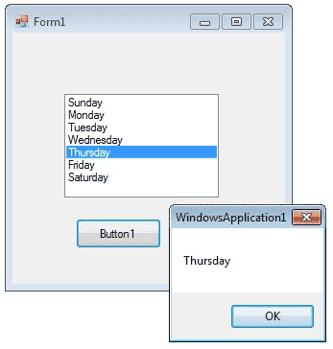

In addition to display and selection functionality, the ListBox also provides features that enable you to efficiently add items to the ListBox and to find text within the items of the list. You can use the Add or Insert method to add items to a list box. The Add method adds new items at the end of an unsorted list box.

**listBox1.Items.Add("Sunday");**

If you want to retrieve a single selected item to a variable, you can code like this

**string var;**

**var = listBox1.Text;**

The *SelectionMode* property determines how many items in the list can be selected at a time.

* A ListBox control can provide single or multiple selections using the SelectionMode property.
* If you change the selection mode property to multiple select, then you will retrieve a collection of items from ListBox1.SelectedItems property.

**listBox1.SelectionMode = SelectionMode.MultiSimple;**

The following C# program initially fill seven days in a week while in the form load event and set the selection mode property to MultiSimple. At the Button click event it will display the selected items.

**using System;**

**using System.Drawing;**

**using System.Windows.Forms;**

**namespace WindowsFormsApplication1**

**{**

**public partial class Form1 : Form**

**{**

**public Form1()**

**{**

**InitializeComponent();**

**}**

**private void Form1_Load(object sender, EventArgs e)**

**{**

**listBox1.Items.Add("Sunday");**

**listBox1.Items.Add("Monday");**

**listBox1.Items.Add("Tuesday");**

**listBox1.Items.Add("Wednesday");**

**listBox1.Items.Add("Thursday");**

**listBox1.Items.Add("Friday");**

**listBox1.Items.Add("Saturday");**

**listBox1.SelectionMode = SelectionMode.MultiSimple;**

**}**

**private void button1_Click(object sender, EventArgs e)**

**{**

**foreach (Object obj in listBox1.SelectedItems )**

**{**

**MessageBox.Show(obj.ToString ());**

**} } } }**

**How to bind a ListBox to a List ?**

First you should create a fresh List Object and add items to the List.

**List<string> nList = new List<string>();**

**nList.Add("January");**

**nList.Add("February");**

**nList.Add("March");**

**nList.Add("April");**

The next step is to bind this List to the Listbox. In order to do that you should set datasource of the Listbox.

**listBox1.DataSource = nList;**

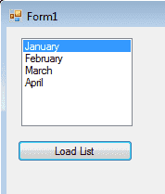

**Full Source code**

**private void button1_Click(object sender, EventArgs e)**

**{**

**List<string> nList = new List<string>();**

**nList.Add("January");**

**nList.Add("February");**

**nList.Add("March");**

**nList.Add("April");**

**listBox1.DataSource = nList;**

**}**

**How to SelectedIndexChanged event in ListBox ?**

This event is fired when the item selection is changed in a ListBox.

* You can use this event in a situation that you want select an item from your listbox and according to this selection you can perform other programming needs.
* You can add the event handler using the Properties Window and
* selecting the Event icon and double-clicking on SelectedIndexChanged as you can see in following image.

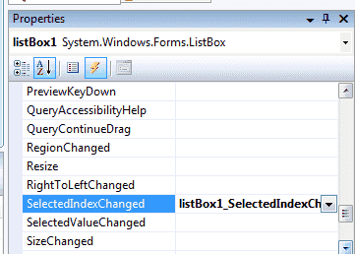

The event will fire again when you select a new item.

* You can write your code within SelectedIndexChanged event.
* When you double click on ListBox the code will automatically come in you code editor like the following code.

SelectedIndexChanged

From the following example you can understand how to fire the SelectedIndexChanged event

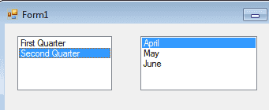

First you should drag two listboxes on your Form.

* First listbox you should set the List as Datasource, the List contents follows:

**List<string> nList = new List<string>();**

**nList.Add("First Quarter");**

**nList.Add("Second Quarter");**

When you load this form you can see the listbox is populated with List and displayed first quarter and second quarter.

* When you click the "Fist Quarter" the next listbox is populated with first quarter months
* When you click "Second Quarter" you can see the second listbox is changed to second quarter months.

From the following program you can understand how this happened.

**using System;**

**using System.Data;**

**using System.Data.SqlClient;**

**using System.Windows.Forms;**

**using System.Collections.Generic;**

**namespace WindowsFormsApplication1**

**{**

**public partial class Form1 : Form**

**{**

**public Form1()**

**{**

**InitializeComponent();**

**}**

**List < string > fQ = new List < string > ();**

**List < string > sQ = new List < string > ();**

**private void Form1_Load(object sender, EventArgs e)**

**{**

**fQ.Add("January");**

**fQ.Add("February");**

**fQ.Add("March");**

**sQ.Add("April");**

**sQ.Add("May");**

**sQ.Add("June");**

**List < string > nList = new List < string > ();**

**nList.Add("First Quarter");**

**nList.Add("Second Quarter");**

**listBox1.DataSource = nList;**

**}**

**private void listBox1_SelectedIndexChanged(object sender, EventArgs e)**

**{**

**if (listBox1.SelectedIndex == 0)**

**{**

**listBox2.DataSource = null;**

**listBox2.DataSource = fQ;**

**}**

**else if (listBox1.SelectedIndex == 1)**

**{**

**listBox2.DataSource = null;**

**listBox2.DataSource = sQ;**

**}**

**}**

**}**

**}**

**C# Checked ListBox Control**

The CheckedListBox control gives you all the capability of a list box and also allows you to display a check mark next to the items in the list box.

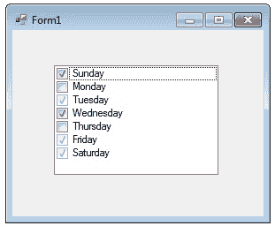

The user can place a check mark by one or more items and the checked items can be navigated with

* The CheckedListBox.CheckedItemCollection
* And CheckedListBox.CheckedIndexCollection.

To add objects to the list at run time, assign an array of object references with the AddRange method.

The list then displays the default string value for each object.

**Dim days As String() = {"Sunday", "Monday", "Tuesday"};**

**checkedListBox1.Items.AddRange(days);**

You can add individual items to the list with the Add method.

* The CheckedListBox object supports three states through the CheckState enumeration: Checked, Indeterminate, and Unchecked.

**checkedListBox1.Items.Add("Sunday", CheckState.Checked);**

**checkedListBox1.Items.Add("Monday", CheckState.Unchecked);**

**checkedListBox1.Items.Add("Tuesday", CheckState.Indeterminate);**

**using System;**

**using System.Drawing;**

**using System.Windows.Forms;**

**namespace WindowsFormsApplication1**

**{**

**public partial class Form1 : Form**

**{**

**public Form1()**

**{**

**InitializeComponent();**

**}**

**private void Form1_Load(object sender, EventArgs e)**

**{**

**checkedListBox1.Items.Add("Sunday", CheckState.Checked);**

**checkedListBox1.Items.Add("Monday", CheckState.Unchecked);**

**checkedListBox1.Items.Add("Tuesday", CheckState.Indeterminate);**

**checkedListBox1.Items.Add("Wednesday", CheckState.Checked);**

**checkedListBox1.Items.Add("Thursday", CheckState.Unchecked);**

**checkedListBox1.Items.Add("Friday", CheckState.Indeterminate);**

**checkedListBox1.Items.Add("Saturday", CheckState.Indeterminate);**

**}**

**}**

**}**

**C# RadioButton Control**

A radio button or option button enables the user to select a single option from a group of choices when paired with other RadioButton controls. When a user clicks on a radio button, it becomes checked, and all other radio buttons with same group become unchecked

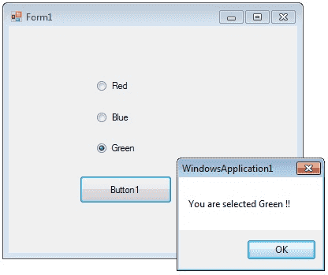

* The RadioButton control can display text, an Image, or both.
* Use the Checked property to get or set the state of a RadioButton.

**radioButton1.Checked = true;**

The radio button and the check box are used for different functions.

* Use a radio button when you want the user to choose only one option.
* When you want the user to choose all appropriate options, use a check box.
* Like check boxes, radio buttons support a Checked property that indicates whether the radio button is selected.

**using System;**

**using System.Drawing;**

**using System.Windows.Forms;**

**namespace WindowsFormsApplication1**

**{**

**public partial class Form1 : Form**

**{**

**public Form1()**

**{**

**InitializeComponent();**

**}**

**private void Form1_Load(object sender, EventArgs e)**

**{**

**radioButton1.Checked = true;**

**}**

**private void button1_Click(object sender, EventArgs e)**

**{**

**if (radioButton1.Checked == true)**

**{**

**MessageBox.Show ("You are selected Red !! ");**

**return;**

**}**

**else if (radioButton2.Checked == true)**

**{**

**MessageBox.Show("You are selected Blue !! ");**

**return;**

**}**

**else**

**{**

**MessageBox.Show("You are selected Green !! ");**

**return; } } } }**

**C# CheckBox Control**

CheckBoxes allow the user to make multiple selections from a number of options.

* CheckBox to give the user an option, such as true/false or yes/no.
* You can click a check box to select it and click it again to deselect it.

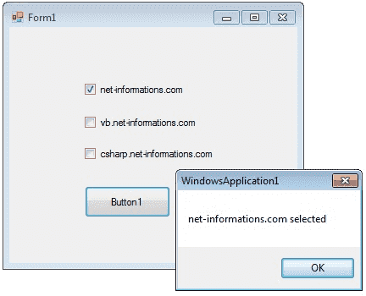

The CheckBox control can display an image or text or both. Usually CheckBox comes with a caption, which you can set in the Text property.

**checkBox1.Text = "Net-informations.com";**

* You can use the CheckBox control Three State property to direct the control to return the Checked, Unchecked, and Indeterminate values.
* You need to set the check boxs ThreeState property to True to indicate that you want it to support three states.

**checkBox1.ThreeState = true;**

The radio button and the check box are used for different functions.

* Use a radio button when you want the user to choose only one option.
* When you want the user to choose all appropriate options, use a check box.

**using System;**

**using System.Drawing;**

**using System.Windows.Forms;**

**namespace WindowsFormsApplication1**

**{**

**public partial class Form1 : Form**

**{**

**public Form1()**

**{**

**InitializeComponent();**

**}**

**private void button1_Click(object sender, EventArgs e)**

**{**

**string msg = "";**

**if (checkBox1.Checked == true)**

**{**

**msg = "net-informations.com";**

**}**

**if (checkBox2.Checked == true)**

**{**

**msg = msg + " vb.net-informations.com";**

**}**

**if (checkBox3.Checked == true)**

**{**

**msg = msg + " csharp.net-informations.com";**

**}**

**if (msg.Length > 0)**

**{**

**MessageBox.Show (msg + " selected ");**

**}**

**else**

**{**

**MessageBox.Show ("No checkbox selected");**

**}**

**checkBox1.ThreeState = true;**

**}**

**}**

**}**

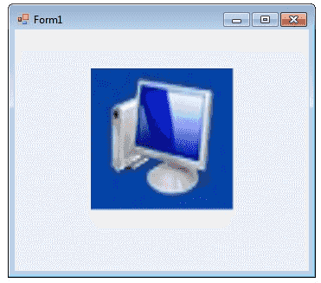**C# PictureBox Control**

The Windows Forms PictureBox control is used to display images in bitmap, GIF , icon , or JPEG formats.

You can set the Image property to the Image you want to display, either at design time or at run time.

* You can programmatically change the image displayed in a picture box, which is particularly useful when you use a single form to display different pieces of information.

**pictureBox1.Image = Image.FromFile("c:\\testImage.jpg");**

The SizeMode property, which is set to values in the PictureBoxSizeMode enumeration, controls the clipping and positioning of the image in the display area.

**pictureBox1.SizeMode = PictureBoxSizeMode.StretchImage;**

There are five different PictureBoxSizeMode is available to PictureBox control.

**AutoSize - Sizes the picture box to the image.**

**CenterImage - Centers the image in the picture box.**

**Normal - Places the upper-left corner of the image at upper**

**left in the picture box**

**StretchImage - Allows you to stretch the image in code**

The PictureBox is not a selectable control, which means that it cannot receive input focus. The following C# program shows how to load a picture from a file and display it in streach mode.

**using System;**

**using System.Drawing;**

**using System.Windows.Forms;**

**namespace WindowsFormsApplication1**

**{**

**public partial class Form1 : Form**

**{**

**public Form1()**

**{**

**InitializeComponent();**

**}**

**private void Form1_Load(object sender, EventArgs e)**

**{**

**pictureBox1.Image = Image.FromFile("c:\\testImage.jpg");**

**pictureBox1.SizeMode = PictureBoxSizeMode.StretchImage;**

**}**

**}**

**}**

**C# Progress Bar Control**

A progress bar is a control that an application can use to indicate the progress of a lengthy operation such as calculating a complex result, downloading a large file from the Web etc.

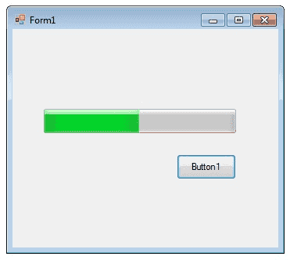

ProgressBar controls are used whenever an operation takes more than a short period of time. The Maximum and Minimum properties define the range of values to represent the progress of a task.

**Minimum : Sets the lower value for the range of valid values for progress.**

**Maximum : Sets the upper value for the range of valid values for progress.**

**Value : This property obtains or sets the current level of progress.**

* By default, Minimum and Maximum are set to 0 and 100.
* As the task proceeds, the ProgressBar fills in from the left to the right.
* To delay the program briefly so that you can view changes in the progress bar clearly.

The following C# program shows a simple operation in a progressbar .

**using System;**

**using System.Drawing;**

**using System.Windows.Forms;**

**namespace WindowsFormsApplication1**

**{**

**public partial class Form1 : Form**

**{**

**public Form1()**

**{**

**InitializeComponent();**

**}**

**private void button1_Click(object sender, EventArgs e)**

**{**

**int i;**

**progressBar1.Minimum = 0;**

**progressBar1.Maximum = 200;**

**for (i = 0; i <= 200; i++)**

**{**

**progressBar1.Value = i;**

**}**

**}**

**}**

**}**

**C# Scroll-Bars Control**

A ScrollBar allows you to view content that is outside of the current viewing area by sliding the Thumb to make the content visible.

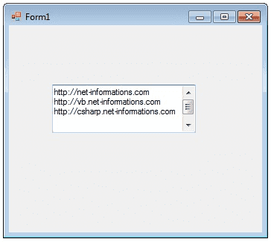

The ScrollBar control contains a Track control.

* The Track control consists of a Thumb control and two RepeatButton controls.
* You can increase and decrease the Value property of the ScrollBar control by pressing the RepeatButton controls or by moving the Thumb.
* You can set the Value property yourself in code, which moves the scroll box to match.
* The Minimum and Maximum properties determine the range of values that the control can display.
* The default range of values for the Value property is from 0 to 1.

The following C# program shows a TextBox control with scrollbars.

**using System;**

**using System.Drawing;**

**using System.Windows.Forms;**

**namespace WindowsFormsApplication1**

**{**

**public partial class Form1 : Form**

**{**

**public Form1()**

**{**

**InitializeComponent();**

**}**

**private void Form1_Load(object sender, EventArgs e)**

**{**

**textBox1.Multiline = true;**

**textBox1.ScrollBars = ScrollBars.Both;**

**}**

**}**

**}**

# C# DateTimePicker Control

The DateTimePicker control allows you to display and collect date and time from the user with a specified format.

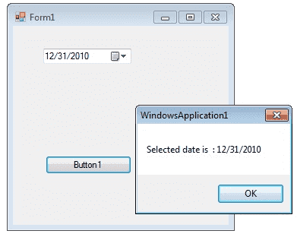

The DateTimePicker control has two parts are:-

* A label that displays the selected date and
* A popup calendar that allows users to select a new date.

The most important property of the DateTimePicker is the Value property, which holds the selected date and time.

**dateTimePicker1.Value = DateTime.Today;**

The Value property contains the current date and time the control is set to. You can use the Text property or the appropriate member of Value to get the date and time value.

**DateTime iDate;**

**iDate = dateTimePicker1.Value;**

The control can display one of several styles, depending on its property values.

* The values can be displayed in four formats, which are set by the Format property: Long, Short, Time, or Custom.

**dateTimePicker1.Format = DateTimePickerFormat.Short;**

### Convert String to DateTime

You can use the methods like *Convert.ToDateTime(String)*, *DateTime.Parse()* and *DateTime.ParseExact()* methods for converting a string-based date to a System.DateTime object.

### How to find date difference?

The DateTime.Substract method may be used in order to find the date-time difference between two instances of the DateTime method.

### How to to set datetime object to null?

By default DateTime is not nullable because it is a Value Type, using the nullable operator

The following C# program shows how to set and get the value of a *DateTimePicker1* control.

**using System;**

**using System.Drawing;**

**using System.Windows.Forms;**

**namespace WindowsFormsApplication1**

**{**

**public partial class Form1 : Form**

**{**

**public Form1()**

**{**

**InitializeComponent();**

**}**

**private void Form1_Load(object sender, EventArgs e)**

**{**

**dateTimePicker1.Format = DateTimePickerFormat.Short;**

**dateTimePicker1.Value = DateTime.Today;**

**}**

**private void button1_Click(object sender, EventArgs e)**

**{**

**DateTime iDate;**

**iDate = dateTimePicker1.Value;**

**MessageBox.Show("Selected date is " + iDate);**

**}**

**}**

**}**

**C# Tree-view Control**

The TreeView control contains a hierarchy of TreeViewItem controls.

* It provides a way to display information in a hierarchical structure by using collapsible nodes.
* 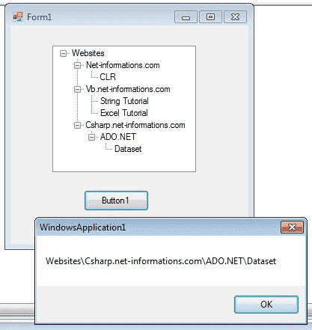The top level in a tree view are root nodes that can be expanded or collapsed if the nodes have child nodes.

You can explicitly define the Tree-View content or a data source can provide the content.

* The user can expand the Tree-Node by clicking the plus sign (+) button, if one is displayed next to the Tree-Node, or you can expand the Tree-Node by calling the TreeNode.Expand method.
* You can also navigate through tree views with various properties: FirstNode, LastNode, NextNode, PrevNode, NextVisibleNode, PrevVisibleNode.

The fullpath method of treeview control provides the path from root node to the selected node.

**treeView1.SelectedNode.FullPath.ToString ();**

* Tree nodes can optionally display check boxes.
* To display the check boxes, set the Check-Boxes property of the Tree-view to true.

**treeView1.CheckBoxes = true;**

The following C# program shows a simple demonstration of tree-view control

**using System;**

**using System.Drawing;**

**using System.Windows.Forms;**

**namespace WindowsFormsApplication1**

**{**

**public partial class Form1 : Form**

**{**

**public Form1()**

**{**

**InitializeComponent();**

**}**

**private void Form1_Load(object sender, EventArgs e)**

**{**

**TreeNode tNode ;**

**tNode = treeView1.Nodes.Add("Websites");**

**treeView1.Nodes[0].Nodes.Add("Net-informations.com");**

**treeView1.Nodes[0].Nodes[0].Nodes.Add("CLR");**

**treeView1.Nodes[0].Nodes.Add("Vb.net-informations.com");**

**treeView1.Nodes[0].Nodes[1].Nodes.Add("String Tutorial");**

**treeView1.Nodes[0].Nodes[1].Nodes.Add("Excel Tutorial");**

**treeView1.Nodes[0].Nodes.Add("Csharp.net-informations.com");**

**treeView1.Nodes[0].Nodes[2].Nodes.Add("ADO.NET");**

**treeView1.Nodes[0].Nodes[2].Nodes[0].Nodes.Add("Dataset");**

**}**

**private void button1_Click(object sender, EventArgs e)**

**{**

**MessageBox.Show(treeView1.SelectedNode.FullPath.ToString ());**

**}**

**}**

**}**

**C# ListView Control**

The List-View control is an Items Control that is derived from List-Box.

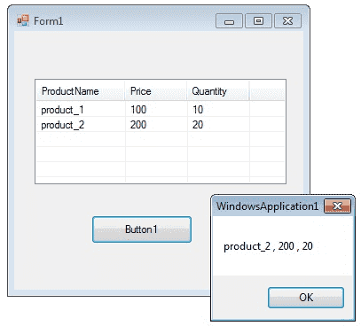

**Add Columns in List View**

You can add columns in List view by using Columns.Add() method. This method takes two arguments,

* First one is the Column heading and
* Second one the column width.

**listView1.Columns.Add("ProductName", 100);**

In the above code, "Product Name" is column heading and 100 is column width.

**Add Item in Listview**

You can add items in listbox using ListViewItem which represents an item in a ListView control.

**string[] arr = new string[4];**

**ListViewItem itm; //add items to ListView**

**arr[0] = "product_1";**

**arr[1] = "100";**

**arr[2] = "10";**

**itm = new ListViewItem(arr);**

**listView1.Items.Add(itm);**

**Get selected item from ListView**

**productName = listView1.SelectedItems[0].SubItems[0].Text;**

Above code will return the item from first column of first row.

**Sorting Listview Items**

If the Sorted property of Listview is set to true, then the ListView items are sorted. The following code sorts the ListView items:

**ListView1.Sorted = true;**

**Add Checkbox in Listview**

You can add checkbox in Listview columns.

**myListView.CheckBoxes = true;**

**myListView.Columns.Add(text, width, alignment);**

ListView provides a large number of properties that provide flexibility in appearance and behavior.

* The View property allows you to change the way in which items are displayed.
* The SelectionMode property for a ListView determines how many items a user can select at one time.

The following C# program first set its view property as *Details* and GridLines property as *true* and FullRowSelect as *true*.

**listView1.View = View.Details;**

**listView1.GridLines = true;**

**listView1.FullRowSelect = true;**

Finally at the button click event, it will display the selected row values in a message box.

**using System;**

**using System.Drawing;**

**using System.Windows.Forms;**

**namespace WindowsFormsApplication1**

**{**

**public partial class Form1 : Form**

**{**

**public Form1()**

**{**

**InitializeComponent();**

**}**

**private void Form1_Load(object sender, EventArgs e)**

**{**

**listView1.View = View.Details;**

**listView1.GridLines = true;**

**listView1.FullRowSelect = true;**

**//Add column header**

**listView1.Columns.Add("ProductName", 100);**

**listView1.Columns.Add("Price", 70);**

**listView1.Columns.Add("Quantity", 70);**

**//Add items in the listview**

**string[] arr = new string[4];**

**ListViewItem itm ;**

**//Add first item**

**arr[0] = "product_1";**

**arr[1] = "100";**

**arr[2] = "10";**

**itm = new ListViewItem(arr);**

**listView1.Items.Add(itm);**

**//Add second item**

**arr[0] = "product_2";**

**arr[1] = "200";**

**arr[2] = "20";**

**itm = new ListViewItem(arr);**

**listView1.Items.Add(itm);**

**}**

**private void button1_Click(object sender, EventArgs e)**

**{**

**string productName = null;**

**string price = null;**

**string quantity = null;**

**productName = listView1.SelectedItems[0].SubItems[0].Text;**

**price = listView1.SelectedItems[0].SubItems[1].Text;**

**quantity = listView1.SelectedItems[0].SubItems[2].Text;**

**MessageBox.Show (productName + " , " + price + " , " + quantity);**

**}**

**}**

**}**

**C# Menu Control**

A Menu on a Windows Form is created with a MainMenu object, which is a collection of MenuItem objects.

* MainMenu is the container for the Menu structure of the form and menus are made of MenuItem objects that represent individual parts of a menu.
* You can add menus to Windows Forms at design time by adding the MainMenu component and then appending menu items to it using the *Menu Designer*.

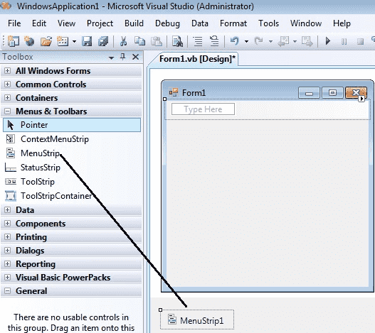

After drag the Menustrip on your form you can directly create the menu items by type a value into the "Type Here" box on the menubar part of your form. From the following picture you can understand how to create each menu items on mainmenu Object.

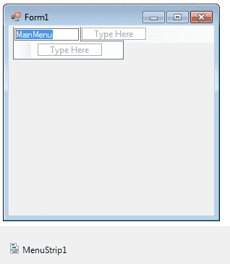

If you need a seperator bar , right click on your menu then go to Insert->Seperator.

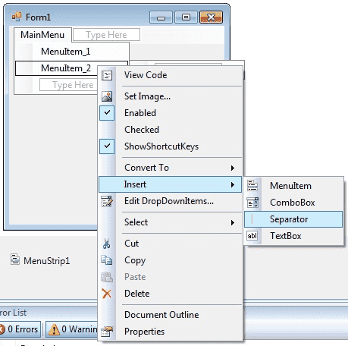

After creating the Menu on the form, you have to double click on each menu item and write the programs there depends on your requirements. The following C# program shows how to show a messagebox when clicking a Menu item.

**using System;**

**using System.Drawing;**

**using System.Windows.Forms;**

**namespace WindowsFormsApplication1**

**{**

**public partial class Form1 : Form**

**{**

**public Form1()**

**{**

**InitializeComponent();**

**}**

**private void menu1ToolStripMenuItem_Click(object sender, EventArgs e)**

**{**

**MessageBox.Show("You are selected MenuItem_1");**

**}**

**}**

**}**

**C# MDI Form**

A Multiple Document Interface (MDI) programs can display multiple child windows inside them. This is in contrast to single document interface (SDI) applications, which can manipulate only one document at a time.

* Visual Studio Environment is an example of Multiple Document Interface (MDI) and notepad is an example of an SDI application.
* MDI applications often have a Window menu item with submenus for switching between windows or documents.

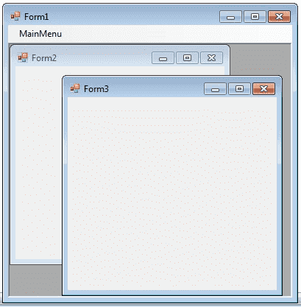

Any windows can become an MDI parent, if you set the IsMdiContainer property to True.

**IsMdiContainer = true;**

The following C# program shows a MDI form with two child forms.

* Create a new C# project, then you will get a default form Form1 .
* Then add two more forms in the project (Form2 , Form 3) .
* Create a Menu on your form and call these two forms on menu click event.

NOTE: If you want the MDI parent to auto-size the child form you can code like this.

**form.MdiParent = this;**

**form.Dock=DockStyle.Fill;**

**form.Show();**

**using System;**

**using System.Drawing;**

**using System.Windows.Forms;**

**namespace WindowsFormsApplication1**

**{**

**public partial class Form1 : Form**

**{**

**public Form1()**

**{**

**InitializeComponent();**

**}**

**private void Form1_Load(object sender, EventArgs e)**

**{**

**IsMdiContainer = true;**

**}**

**private void menu1ToolStripMenuItem_Click(object sender, EventArgs e)**

**{**

**Form2 frm2 = new Form2();**

**frm2.Show();**

**frm2.MdiParent = this;**

**}**

**private void menu2ToolStripMenuItem_Click(object sender, EventArgs e)**

**{**

**Form3 frm3 = new Form3();**

**frm3.Show();**

**frm3.MdiParent = this;**

**}**

**}**

**}**

**C# Color Dialog Box**

There are several classes that implement common dialog boxes, such as color selection , print setup etc.

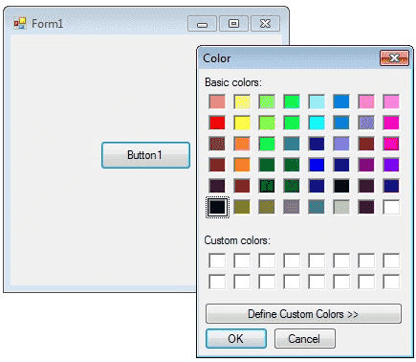

A ColorDialog object is a dialog box with a list of colors that are defined for the display system.

* The user can select or create a particular color from the list, which is then reported back to the application when the dialog box exits.
* You can invite a color dialog box by calling ShowDialog() method.

**ColorDialog dlg = new ColorDialog();**

**dlg.ShowDialog();**

The following C# program invites a color dialog box and retrieve the selected color to a string.

**using System;**

**using System.Drawing;**

**using System.Windows.Forms;**

**namespace WindowsFormsApplication1**

**{**

**public partial class Form1 : Form**

**{**

**public Form1()**

**{**

**InitializeComponent();**

**}**

**private void button1_Click(object sender, EventArgs e)**

**{**

**ColorDialog dlg = new ColorDialog();**

**dlg.ShowDialog();**

**if (dlg.ShowDialog() == DialogResult.OK)**

**{**

**string str = null;**

**str = dlg.Color.Name;**

**MessageBox.Show (str);**

**}**

**}**

**}**

**}**

**C# Font Dialog Box**

Font dialog box represents a common dialog box that displays a list of fonts that are currently installed on the system.

* The Font dialog box lets the user choose attributes for a logical font, such as font family and associated font style, point size, effects, and a script.

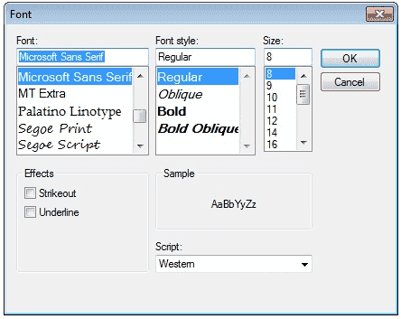

The following C# program invites a Font Dialog Box and retrieve the selected Font Name and Font Size.

**using System;**

**using System.Drawing;**

**using System.Windows.Forms;**

**namespace WindowsFormsApplication1**

**{**

**public partial class Form1 : Form**

**{**

**public Form1()**

**{**

**InitializeComponent();**

**}**

**private void button1_Click(object sender, EventArgs e)**

**{**

**FontDialog dlg = new FontDialog();**

**dlg.ShowDialog();**

**if (dlg.ShowDialog() == DialogResult.OK)**

**{**

**string fontName;**

**float fontSize;**

**fontName = dlg.Font.Name;**

**fontSize = dlg.Font.Size;**

**MessageBox.Show(fontName + " " + fontSize );**

**}**

**}**

**}**

**}**

**C# OpenFile Dialog Box**

The OpenFileDialog component allows users to browse the folders of their computer or any computer on the network and select one or more files to open. The dialog box returns the path and name of the file the user selected in the dialog box.

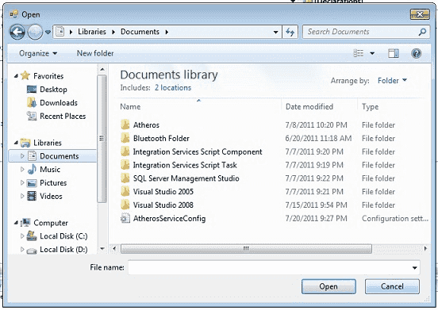

The FileName property can be set prior to showing the dialog box.

* This causes the dialog box to initially display the given filename.
* In most cases, your applications should set the InitialDirectory, Filter, and FilterIndex properties prior to calling ShowDialog.

The following C# program invites an OpenFile Dialog Box and retrieve the selected filename to a string.

**using System;**

**using System.Drawing;**

**using System.Windows.Forms;**

**namespace WindowsFormsApplication1**

**{**

**public partial class Form1 : Form**

**{**

**public Form1()**

**{**

**InitializeComponent();**

**}**

**private void button1_Click(object sender, EventArgs e)**

**{**

**OpenFileDialog dlg = new OpenFileDialog();**

**dlg.ShowDialog();**

**if (dlg.ShowDialog() == DialogResult.OK)**

**{**

**string fileName;**

**fileName = dlg.FileName;**

**MessageBox.Show(fileName);**

**}**

**}**

**}**

**}**

**C# Print Dialog Box**

A user can use the Print dialog box to select a printer, configure it, and perform a print job. Print dialog boxes provide an easy way to implement Print and Print Setup dialog boxes in a manner consistent with Windows standards.

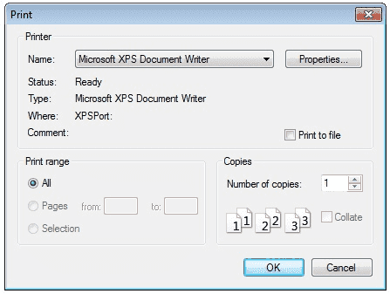

The Print dialog box includes a Print Range group of radio buttons that indicate whether the user wants to print all pages, a range of pages, or only the selected text.

* The dialog box includes an edit control in which the user can type the number of copies to print.
* By default, the Print dialog box initially displays information about the current default printer.

**using System;**

**using System.Drawing;**

**using System.Windows.Forms;**

**namespace Win**

**dowsFormsApplication1**

**{**

**public partial class Form1 : Form**

**{**

**public Form1()**

**{**

**InitializeComponent();**

**}**

**private void button1_Click(object sender, EventArgs e)**

**{**

**PrintDialog dlg = new PrintDialog();**

**dlg.ShowDialog();**

**}**

**}**

**}**